The below attached are the Screenshots of the Power consumption data from the device having following specifications:

* Processor 11th Gen Intel(R) Core(TM) i5-1135G7 @ 2.40GHz 2.42 GHz
* Installed RAM 8.00 GB (7.78 GB usable)

1. Overview:

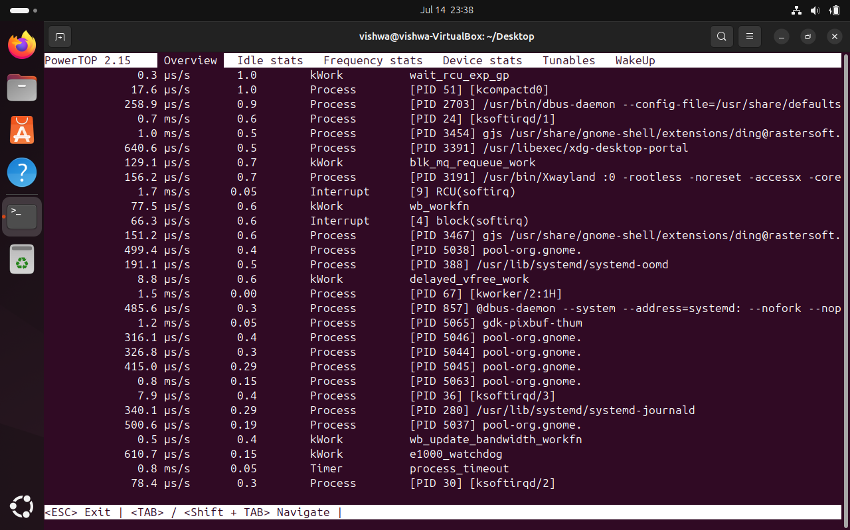

1. Tunables:

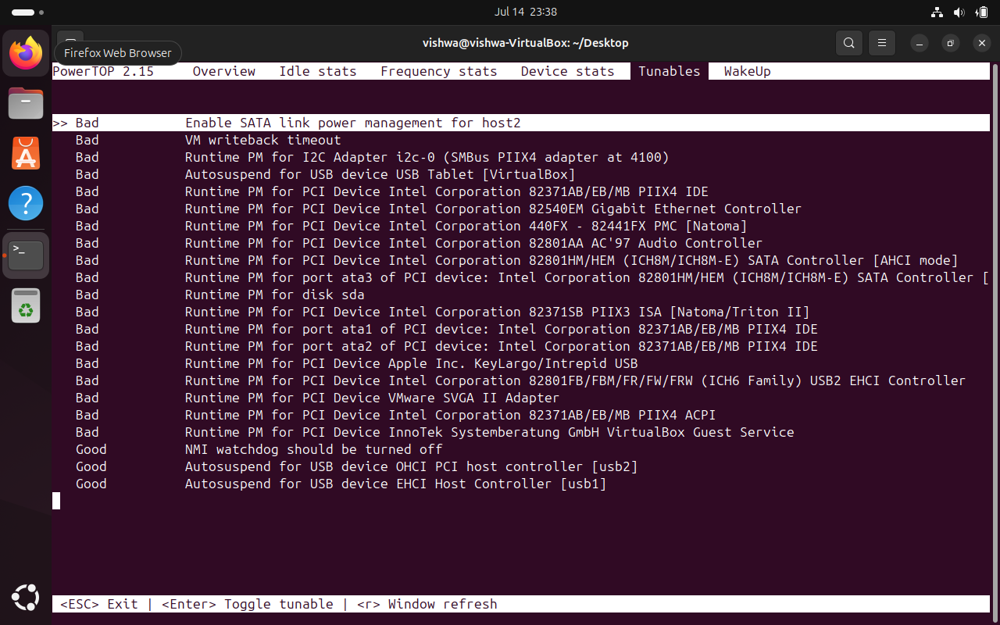

1. Device stats:

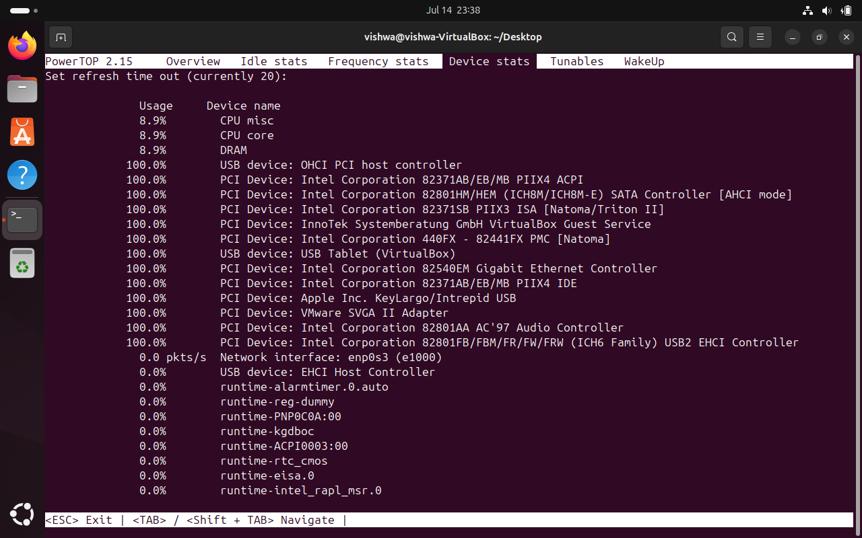

1. Frequency Stats:

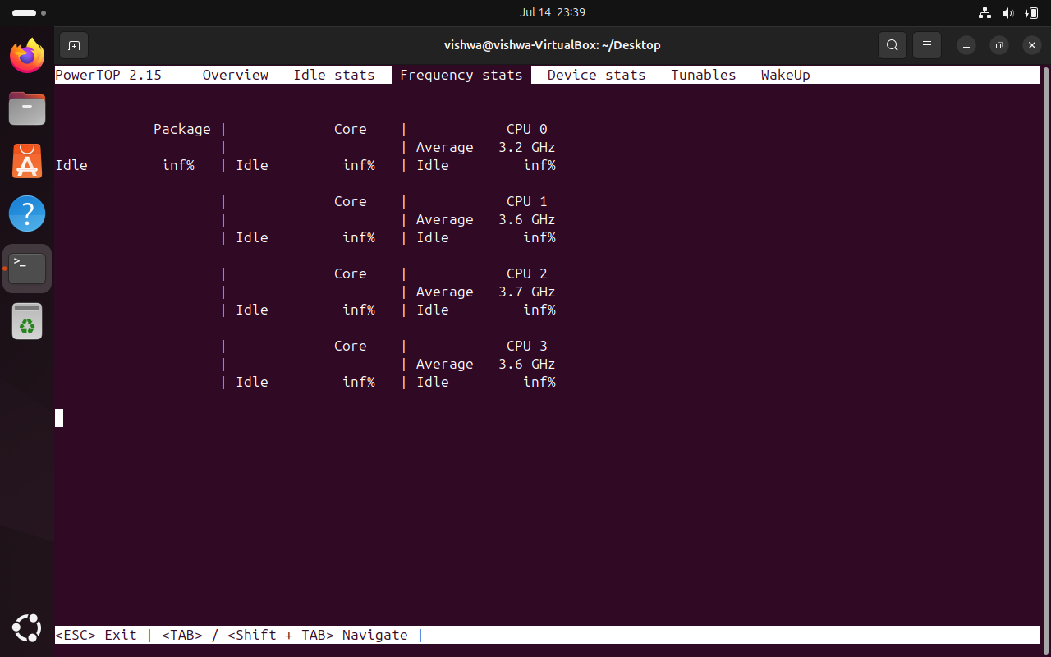

1. Idle Stats:

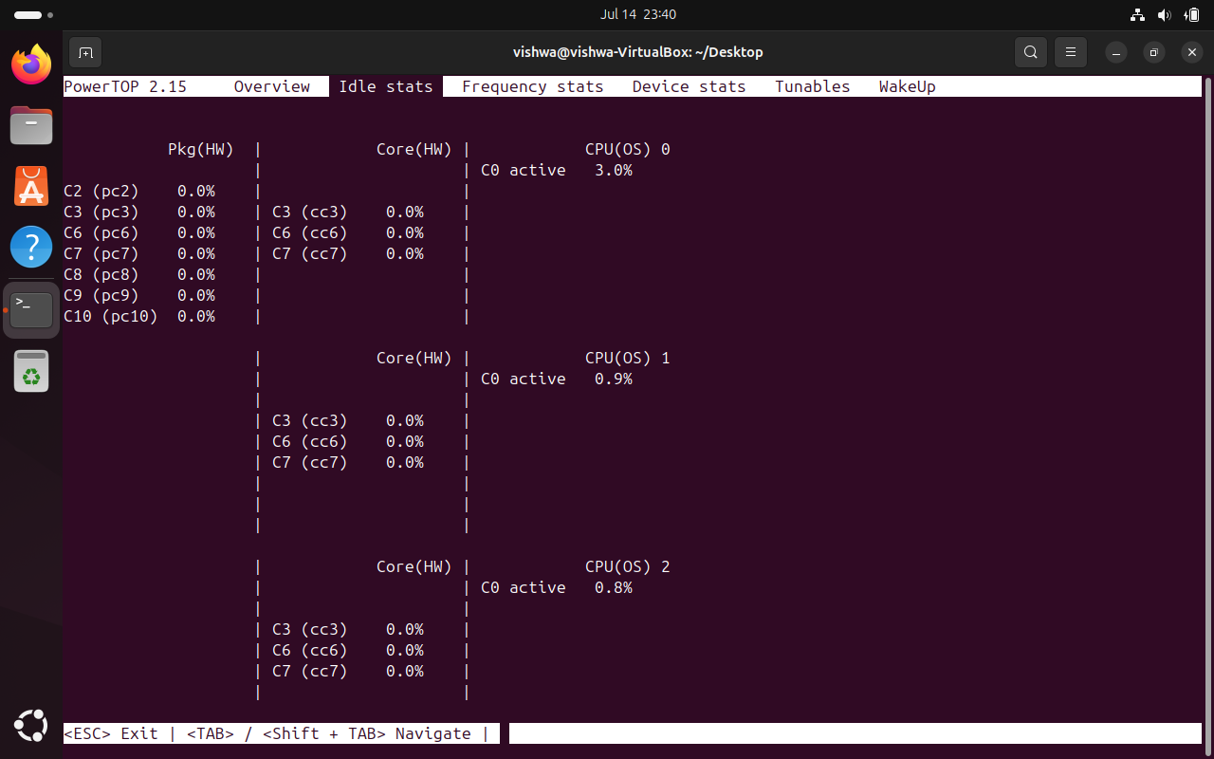

* The Following Screenshots are the Error formed while reading the data:

