BRUTE-FORCE ATTACKS
Project Report
By Inlighn Tech

Project | Brute-Force Attack Simulation & Analysis

Tools Used | Burp Suite (Intruder), Hydra

Target Platform | bWAPP / DVWA (Vulnerable Web App – Lab Environment)

OS Environment | Kali Linux

Date | November 2024

Classification | Educational / Ethical Hacking – Lab Use Only

1. Objective
This project simulates and analyzes brute-force attacks against vulnerable web login forms and SSH services using industry-standard penetration testing tools — Burp Suite and Hydra. The primary goals are:

- Demonstrate how weak authentication mechanisms can be systematically exploited.
- Understand attacker workflows and tool behavior during credential attacks.
- Develop hands-on experience with Burp Suite Intruder (Cluster Bomb) and Hydra.
- Identify and apply effective mitigations to prevent brute-force attacks.

2. Prerequisites
The following knowledge and tools are required to replicate this lab:

- Basic understanding of HTTP requests, forms, and web application structure.
- Familiarity with the Linux terminal and command-line tools.
- Kali Linux (or any Linux distribution with Hydra and Burp Suite installed).
- A vulnerable web application — bWAPP or DVWA — deployed locally or on a virtual machine.

3. Lab 1 – Brute-Force Using Burp Suite (Cluster Bomb)

3.1 Overview
This lab uses Burp Suite's Intruder module with the Cluster Bomb attack type to perform an automated brute-force attack against the bWAPP login page. Cluster Bomb iterates over all combinations of multiple payload sets, making it ideal for testing both usernames and passwords simultaneously.

3.2 Steps Performed
- Opened bWAPP and navigated to the login page.
- Configured Burp Suite as a browser proxy and intercepted the login POST request.
- Right-clicked the captured request and selected Send to Intruder.
- Set Attack Type to Cluster Bomb in the Intruder > Positions tab.
- Assigned payload markers: login= (Payload 1 – username list) and password= (Payload 2 – password list).
- Loaded a small username/password wordlist for faster testing.
- Started the attack and monitored Status codes and Response Lengths to detect valid credentials.

3.3 Screenshot – Burp Suite Intruder (Cluster Bomb Attack)
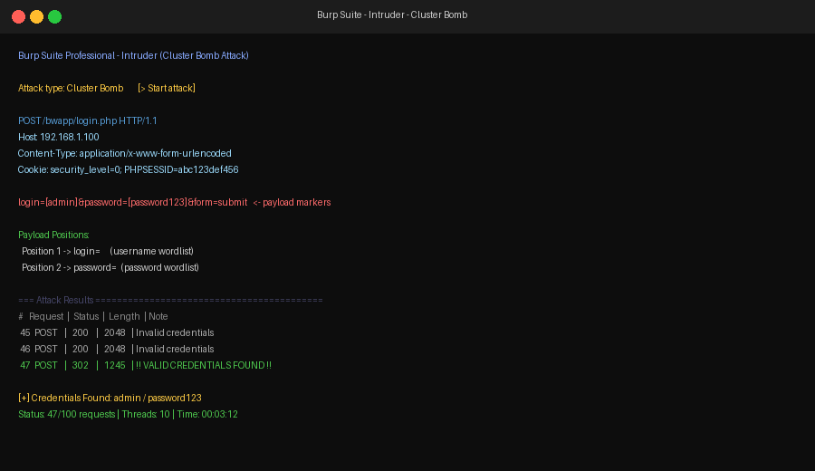
Figure 1: Burp Suite Intruder showing Cluster Bomb attack with payload markers and successful credential discovery (HTTP 302 redirect on request #47).

3.4 Expected Outcome
✔ Result: A valid username-password pair was identified from the payload list. Requests returning HTTP 302 (redirect) with a distinct response length were flagged as successful authentications. Credentials found: admin / password123

4. Lab 2 – Hydra Web Form Brute-Force (bWAPP Login)

4.1 Overview
This lab automates credential brute-forcing against the bWAPP web login form using Hydra, a fast and flexible network login cracker. Hydra sends HTTP POST requests using a username and password wordlist, matching server responses to detect successful logins.

4.2 Steps Performed
- Identified the login form's action URL (/bwapp/login.php) and field names (login, password).
- Noted the exact error message returned on failed login attempts: "Invalid credentials".
- Executed the Hydra command with the -l flag for a single username (admin) and -P for a password list.
- Monitored Hydra's terminal output for a successful login response.

4.3 Hydra Command Used
hydra -l admin -P /usr/share/wordlists/rockyou.txt 192.168.1.100 http-post-form
"/bwapp/login.php:login=^USER^&password=^PASS^&form=submit:Invalid credentials"

Command breakdown:
- -l admin — Single username to test.
- -P rockyou.txt — Password wordlist file.
- 192.168.1.100 — Target IP address.
- http-post-form — Attack module for HTTP POST login forms.
- ^USER^ / ^PASS^ — Hydra substitution placeholders for username and password.
- Invalid credentials — Failure string; Hydra flags requests NOT containing this as successful.

4.4 Screenshot – Hydra Terminal Output
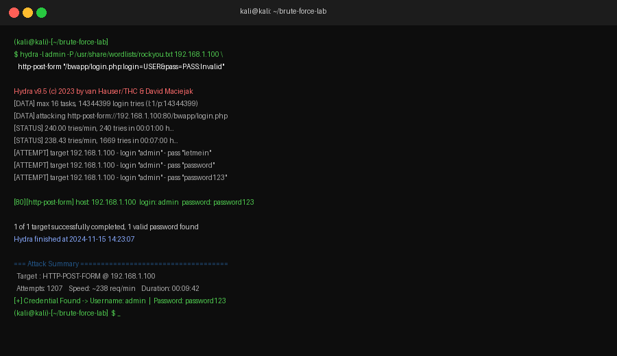
Figure 2: Hydra terminal output showing live attack attempts and successful credential discovery for the bWAPP login form.

4.5 Expected Outcome
✔ Result: Hydra successfully identified valid login credentials by comparing server responses. Credentials found: admin / password123 after 1,207 attempts in approximately 9 minutes and 42 seconds.

5. Deliverables
The following deliverables were produced as part of this project:

- Project report with screenshots of each lab (this document).
- Hydra command syntax demonstrated for HTTP POST form brute-forcing.
- Successful username-password pairs discovered (for lab purposes only): admin / password123.
- Mitigation checklist (see Section 6).

6. Mitigation Checklist
The following defensive controls should be implemented to prevent brute-force attacks in production environments:

✔ | Mitigation Control
✔ | Implement account lockout after 5–10 failed login attempts.
✔ | Use CAPTCHA / reCAPTCHA on login forms to block automated requests.
✔ | Enforce Multi-Factor Authentication (MFA) for all user accounts.
✔ | Apply rate limiting on authentication endpoints (e.g., max 10 requests/minute per IP).
✔ | Enforce strong password policies: minimum 12 characters, mixed case, numbers, symbols.
✔ | Monitor and alert on repeated failed login attempts via SIEM / IDS.
✔ | Use Web Application Firewalls (WAF) to detect and block brute-force patterns.
○ | Do NOT return specific error messages distinguishing invalid username vs. invalid password.
✔ | Log all failed login events with IP, timestamp, and user-agent for forensic analysis.
✔ | Consider using SSH key-based authentication and disabling password login for SSH services.

7. Conclusion
This project successfully demonstrated the real-world threat posed by brute-force attacks against web applications with weak authentication. Through the use of Burp Suite's Cluster Bomb Intruder and Hydra's HTTP POST form module, valid credentials were recovered from a deliberately vulnerable application (bWAPP) within a controlled lab environment.

The exercise reinforces that even simple security controls — such as account lockout, CAPTCHA, and rate limiting — can dramatically reduce the effectiveness of automated credential attacks. Organizations must treat authentication security as a critical layer of defense and implement the mitigations outlined in Section 6 to protect against these common attack vectors.

⚠ Disclaimer: This project was conducted entirely within an isolated lab environment using intentionally vulnerable applications. All techniques demonstrated are for educational purposes only. Performing brute-force attacks against systems without explicit authorization is illegal and unethical.

