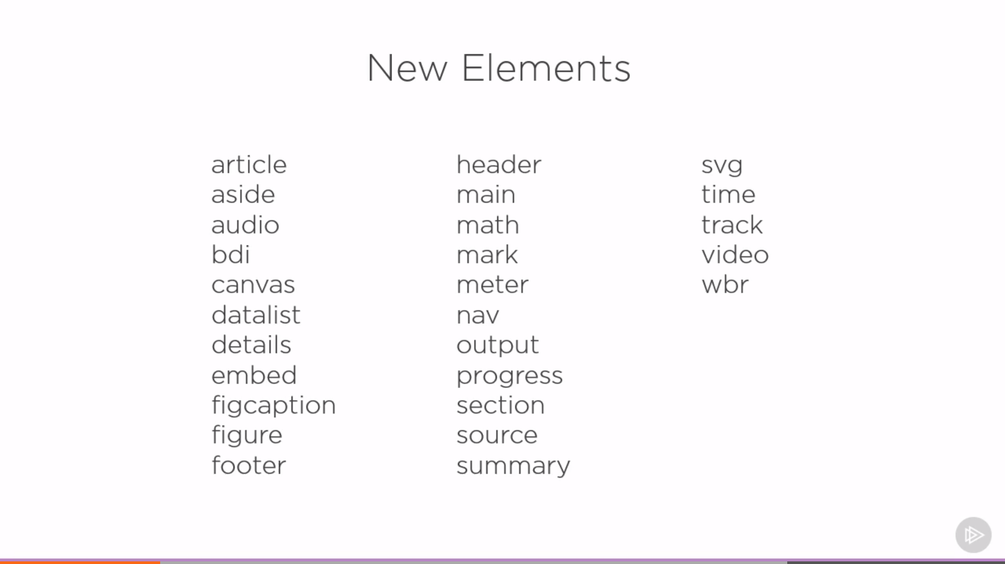

Main –

Article – more primarily element : important content

Aside – important but not crucial content : side bar

Section – logical Grouping: kind of div

Header -

Footer –

Nav – for links in the web pages

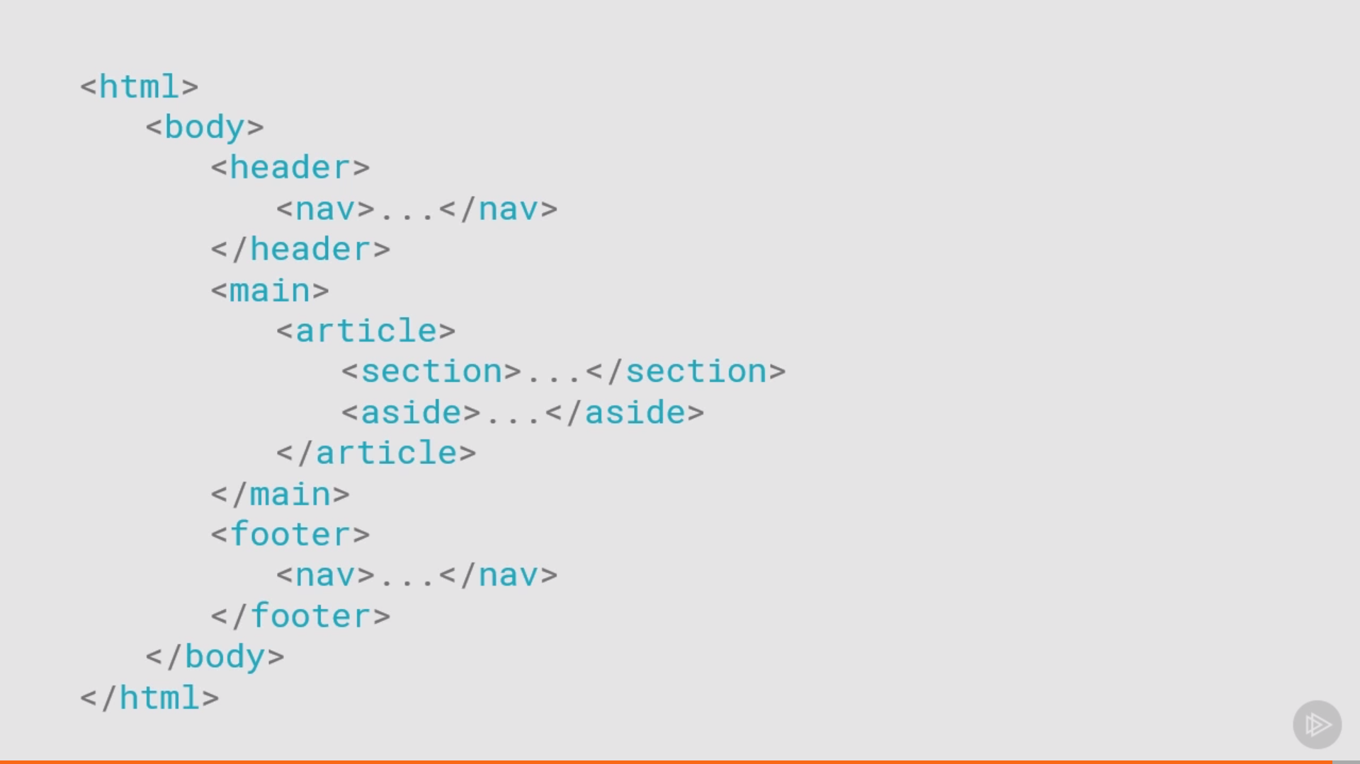

Some More Elements :

Time –

Figure and Figcaption –

Details –

Summary –

Mark –

Bid – bidirectional isolated element

Wbr – word break element

Output –

Embed –

Canvas –

Video and Audio –

Meter -

Progress –

Math –

Datalist -

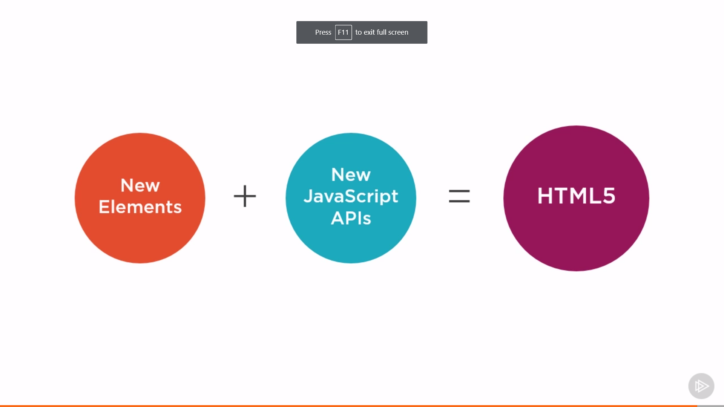

# New Javascript APIs, works with HTML5

