Module -1: Understanding of Hardware and Its Components

Section 1: Multiple Choice

1. Which of the following is NOT a component of the CPU?

⇒ RAM

2. What is the function of RAM in a computer?

⇒ RAM (Random Access Memory) helps your computer run fast and smooth. It temporarily stores the data and programs your computer is using right now, so the processor (CPU) can get to them quickly.

**Stores temporary data:** It holds the things your computer is working on right now.

**Makes your computer faster:** Because RAM is much faster than a hard drive, it helps things load and run quickly.

**Helps with multitasking:** RAM allows you to run many programs at once without slowing down your computer.

**Helps in smooth performance:** When you're watching videos, playing games, or editing files, RAM helps things run without freezing or lag.

3. Which of the following is a primary storage device?

-> RAM

4. What is the purpose of a GPU?

-> A **GPU** is a part of the computer that helps create and display images, videos, and animations on your screen

**how images and videos:** It helps display everything you see on your monitor like games, movies, or websites.

**Makes graphics smoother:** It makes videos and games look better and run without lag or delays.

**Takes pressure off the CPU:** It handles heavy graphics work so the main processor (CPU) can focus on other tasks.

**Helps in special tasks:** GPUs are also used in tasks like video editing, 3D design, and even artificial intelligence (AI) because they are very fast at doing many calculations at once.

**Section 2: True or False**

5. True or False: The motherboard is the main circuit board of a computer where other components are attached.

⇒ true

6. True or False: A UPS (Uninterruptible Power Supply) is a hardware device that provides emergency power to a load when the input power source fails.

⇒ true

7. True or False: An expansion card is a circuit board that enhances the functionality of a component.

⇒ true

Section 3: Short Answer

8. Explain the difference between HDD and SSD.

⇒

**Speed:**

* **HDD** is slower. It takes more time to boot up your computer and open files.
* **SSD** is much faster. It starts your system quickly and loads files faster.

**Storage Type:**

* **HDD** uses spinning disks and a moving read/write head (like an old record player).
* **SSD** uses flash memory with no moving parts (like a fast USB drive).

**Durability:**

* **HDD** can be damaged easily if dropped because it has moving parts.
* **SSD** is more durable since it has no moving parts.

**Noise:**

* **HDD** makes some noise while working.
* **SSD** is completely silent.

**Power Usage:**

* **HDD** uses more power.
* **SSD** uses less power, which is better for laptops.

**Cost:**

* **HDD** is cheaper and gives more storage for less money.
* **SSD** is more expensive for the same amount of storage.

**Lifespan:**

* **HDD** has a longer lifespan when storing large data constantly.
* **SSD** has a limited number of write cycles, but technology is improving.

9. Describe the function of BIOS in a computer system.

⇒ **BIOS** stands for **Basic Input/Output System**. It is the first software that runs when you turn on your computer.

**Starts the computer:** It checks if all the main parts (like RAM, keyboard, and hard drive) are working properly. This process is called **POST** (Power-On Self-Test).

**Provides basic settings:** You can enter the BIOS setup screen (by pressing keys like F2, DEL, or ESC during startup) to change basic computer settings like boot order, time/date, etc.

In short, BIOS is like a **starter guide** for your computer. it checks the hardware, gets things ready, and starts the system.

10. List and briefly explain three input devices commonly used with computers.

⇒ **Keyboard**

* It is used to type letters, numbers, and commands into the computer.
* It lets you write documents, enter passwords, and control the computer using keys.

**Mouse**

* A pointing device used to move the cursor on the screen.
* You can click, drag, and select items using the mouse buttons.

**Microphone**

* It allows you to input sound into the computer.
* You can use it for voice recording, video calls, or giving voice commands.

Section 4: Practical Application

11. Identify and label the following components on a diagram of a motherboard:

⇒

● CPU

● RAM slots

● SATA connectors

● PCI-E slot

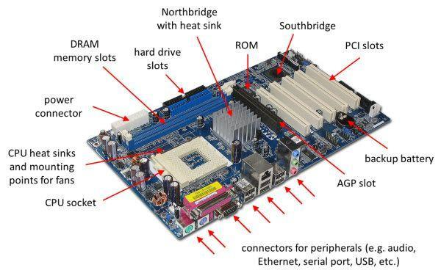

12. Demonstrate how to install a RAM module into a computer.

⇒

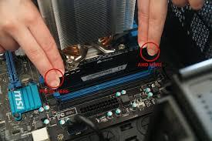

### **Step-by-Step Guide:**

1. **Open the computer case**
   * Use a screwdriver to remove the side panel of the CPU cabinet.
2. **Find the RAM slots**
   * Look for long slots next to the CPU. These are called **RAM or DIMM slots** (usually 2 or 4 slots).
3. **Open the clips**
   * Push down the small clips at both ends of the RAM slot. They will move outward.
4. **Align the RAM module**
   * Look at the notch (small cut) on the RAM stick and match it with the slot—it only fits one way.
5. **Insert the RAM**
   * Gently but firmly press the RAM straight down into the slot.
   * The clips on the side will automatically click into place when the RAM is properly seated.
6. **Close the case and reconnect**
   * Put the side panel back on.
   * Plug your computer back in.
7. **Turn on the computer**
   * If everything is correct, your computer will turn on and recognize the new RAM.

Section 5: Essay

13. Discuss the importance of proper cooling mechanisms in a computer system. Include examples of cooling methods and their effectiveness.

⇒ Computers produce heat when they are working, especially the CPU and GPU. If they get too hot, the system can slow down, freeze, or even get damaged. That’s why **cooling is very important** to keep the computer running safely and smoothly.

### **Why Cooling is Important:**

* **Prevents overheating** – Too much heat can damage computer parts.
* **Improves performance** – Cool parts work better and faster.
* **Increases lifespan** – Keeping the system cool helps it last longer.
* **Avoids shutdowns or crashes** – Overheated computers may suddenly shut down.

### **Examples of Cooling Methods:**

1. **Air Cooling (Fans)**
   * Fans pull in cool air and push out hot air.
   * Easy to install and affordable.
   * **Effective for normal use** like browsing, watching videos, and office work.
2. **Heat Sinks**
   * A metal block placed on top of the CPU or GPU.
   * Absorbs heat and spreads it out so fans can cool it better.
   * Works well with air cooling.
3. **Liquid Cooling (Water Cooling)**
   * Uses water or coolant to absorb heat and move it away.
   * **Very effective** for gaming, video editing, and other heavy tasks.
   * Quieter than fans but more expensive and complex.
4. **Thermal Paste**
   * A special paste between the CPU and heat sink.
   * Helps transfer heat better.
   * Important for efficient cooling.

| Cooling Method | Description | Effectiveness |
| --- | --- | --- |
| Air Cooling (Fans) | Uses fans to move air across heat sinks and out of the case. | Cost-effective, good for general use. |
| Heat Sinks | Metal components that absorb and disperse heat from chips. | Passive cooling; often paired with fans. |
| Liquid Cooling | Circulates coolant through tubes and radiators to cool components. | Highly effective for gaming, overclocking. |
| Thermal Paste | Paste applied between CPU and heat sink to improve heat transfer. | Essential for effective heat dissipation. |
| Case Ventilation | Ensures proper airflow within the case using intake/exhaust fans. | Helps maintain overall system temperature. |

14. Explain the concept of bus width and its significance in computer architecture.

⇒ **Bus width** means the number of bits a computer can move at one time between components (like the CPU and memory).

### **Why is Bus Width Important?**

* A **wider bus** can carry **more data** at once.
* For example, a **32-bit bus** moves 32 bits of data at a time, while a **64-bit bus** moves 64 bits.
* This means **faster performance** and **better multitasking**.