|  |  |
| --- | --- |
|  |  |
| Operating System |  |
| PROJECT REPORT | **NAME: VISHWAS M**  **SRN: PES2UG20CS390**  **SEC:F**  **DATE:29/04/2022** |
|  |  |
|  |  |

|  |  |  |  |
| --- | --- | --- | --- |
|  |  |  |  |
|  | ABSTRACT:**The kernel is a**[**computer program**](https://en.wikipedia.org/wiki/Computer_program)**at the core of a computer's**[**operating system**](https://en.wikipedia.org/wiki/Operating_system)**and generally has complete control over everything in the system.**[**[1]**](https://en.wikipedia.org/wiki/Kernel_(operating_system)#cite_note-Linfo-1)**It is the portion of the operating system code that is always resident in memory,**[**[2]**](https://en.wikipedia.org/wiki/Kernel_(operating_system)#cite_note-2)**and facilitates interactions between hardware and software components. A full kernel controls all hardware resources (e.g. I/O, memory, cryptography) via device drivers, arbitrates conflicts between processes concerning such resources, and optimizes the utilization of common resources e.g. CPU & cache usage, file systems, and network sockets. On most systems, the kernel is one of the first programs loaded on**[**startup**](https://en.wikipedia.org/wiki/Booting)**(after the**[**bootloader**](https://en.wikipedia.org/wiki/Bootloader)**). It handles the rest of startup as well as memory,**[**peripherals**](https://en.wikipedia.org/wiki/Peripheral)**, and**[**input/output**](https://en.wikipedia.org/wiki/Input/output)**(I/O) requests from**[**software**](https://en.wikipedia.org/wiki/Software)**, translating them into**[**data-processing**](https://en.wikipedia.org/wiki/Data_processing)**instructions for the**[**central processing unit**](https://en.wikipedia.org/wiki/Central_processing_unit). | |  |

|  |  |  |  |
| --- | --- | --- | --- |
|  |  |  |  |

**PROJECT TITLE:**

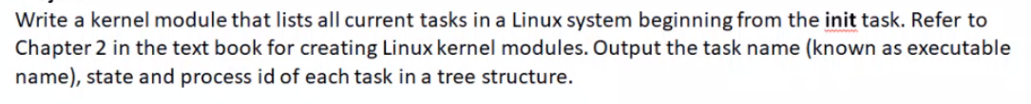

**CODE:**

#include <linux/init_task.h>

#include <linux/kernel.h>

#include <linux/module.h>

//#include <linux/sched.h>

void dfs(struct task_struct *task)

{

  struct task_struct *task_next;

  struct list_head *list;

  list_for_each(list, &task->children) {

    task_next = list_entry(list, struct task_struct, sibling);

    printk(KERN_INFO "pid: %d | pname: %s | state: %ld\n", task_next->pid, task_next->comm, task_next->state);

    dfs(task_next);

  }

}

int tasks_lister_dfs_init(void)

{

  printk(KERN_INFO "Loading module...\n");

  dfs(&init_task);

  printk(KERN_INFO "Module loaded.\n");

  return 0;

}

void tasks_lister_dfs_exit(void)

{

  printk(KERN_INFO "Module removed.\n");

}

module_init(tasks_lister_dfs_init);

module_exit(tasks_lister_dfs_exit);

MODULE_LICENSE("GPL 2.0");

MODULE_DESCRIPTION("List tasks using DFS");

MODULE_AUTHOR("ViSHWAS M");

**MAKEFILE:**

obj-m += tasks_lister_dfs.o

KERNELDIR ?= /lib/modules/$(shell uname -r)/build

PWD := $(shell pwd)

all:

    $(MAKE) -C $(KERNELDIR) M=$(PWD)

clean:

    $(MAKE) -C $(KERNELDIR) M=$(PWD) clean

**STEPS TO RUN THE KERNEL MODULE:**

1. **OPEN THE TERMINAL**
2. **MAKE SURE THE MAIN FILE CONTAINING THE CODE SNIPPET AND THE MAKEFILE ARE IN THE SAME DIRECTORY.**
3. **USING “ cd ” COMMAND GO TO THE DIRECTORY WHERE THE FILES ARE PRESENT.**
4. **WITH THE HELP OF THE COMMAND “make” WE ARE GOING TO EXTRACT ALL THE KERNEL MODULES**

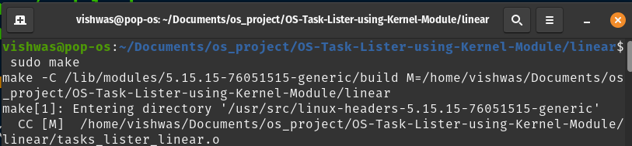

1. **THEN WE HAVE TO EXEXUTE THE COMMAND “ insmod <filename>.ko”.THIS COMMAND INSTALLS ALL THE MODULES MENTIONED IN THE CODE.**
2. **TO SEE THE REQUIRE OUTPUT OF THE PROGRAM WE HAVE TO RUN THE CODE “ dmesg ”. HERE WE CAN SEE ALL THE REQUIRED OUTPUT i.e, THE PROCESS NAME, PROCESS ID AND PROCESS STATE.**

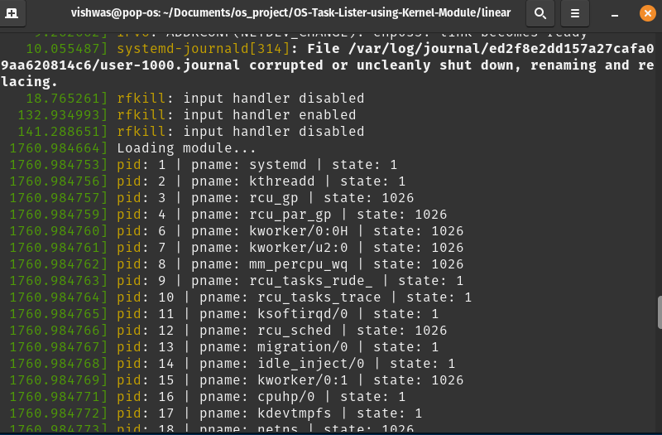

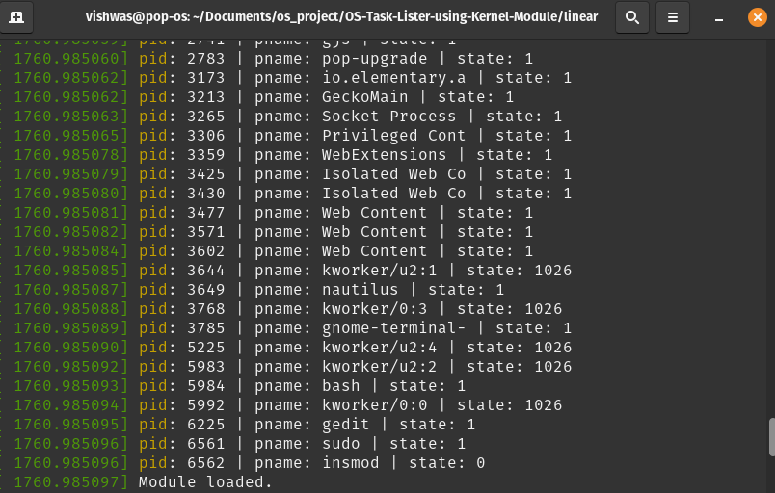

1. **TO SEE THE TREE STRUCTURE OF THE PROGRAM WE HAVE TO TYPE THE COMMAND**

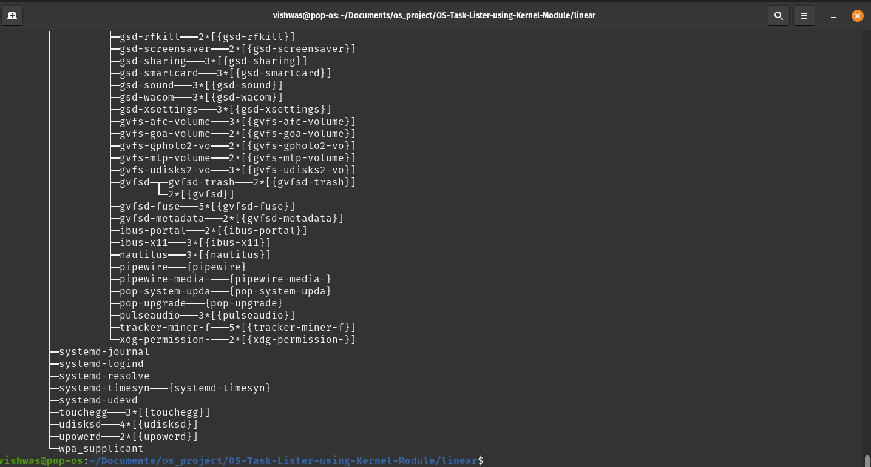**“ pstree ”.**

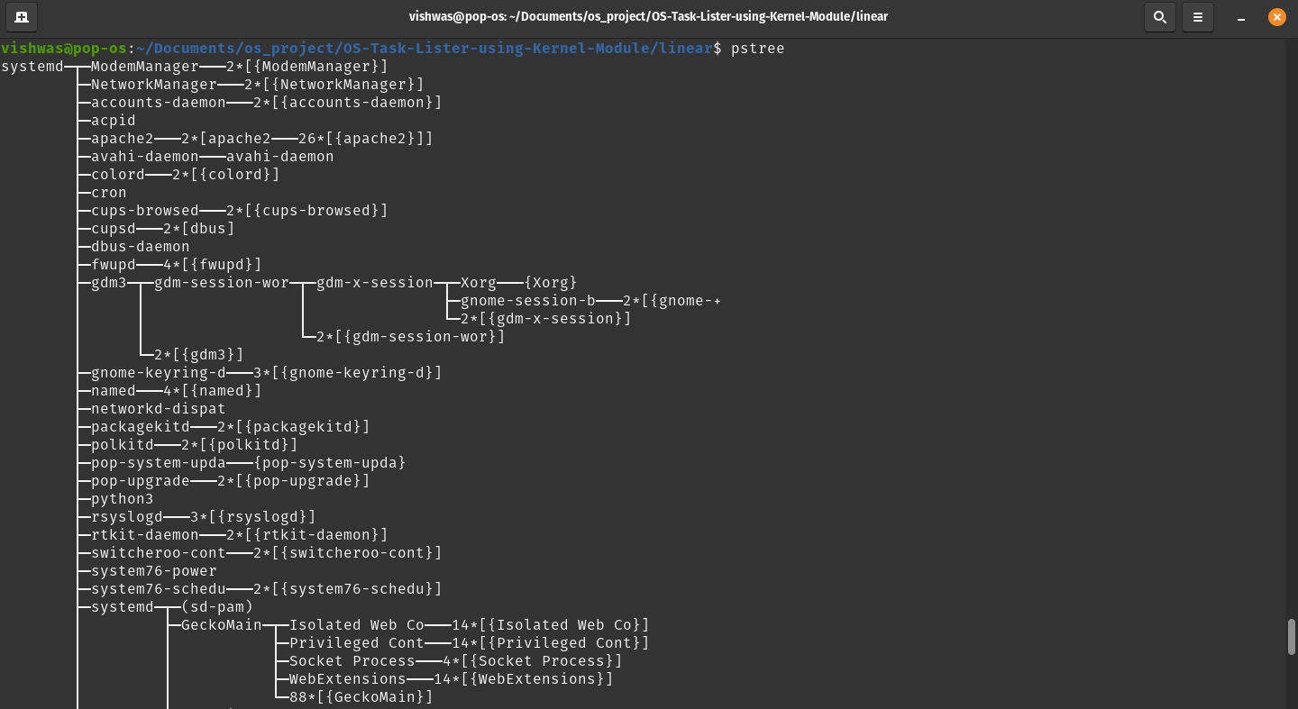

**CONCLUSION:**

**APART FROM LISTING ALL THE PROCESSES RUNNING ON THE OPERATING SYSTEMS,WE CAN USE THESE KERNEL PROGRAMMING IN:**

1. **Process Management**
2. **Memory Management**
3. **Device Management**
4. **Interrupt Handling**
5. **Input Output Communication**