Business Requirements Document (BRD)
Hospital Online Consultation Portal
Full client-style requirements with UI design expectations, patient journey, mockup images, happy-path test cases, and acceptance criteria.
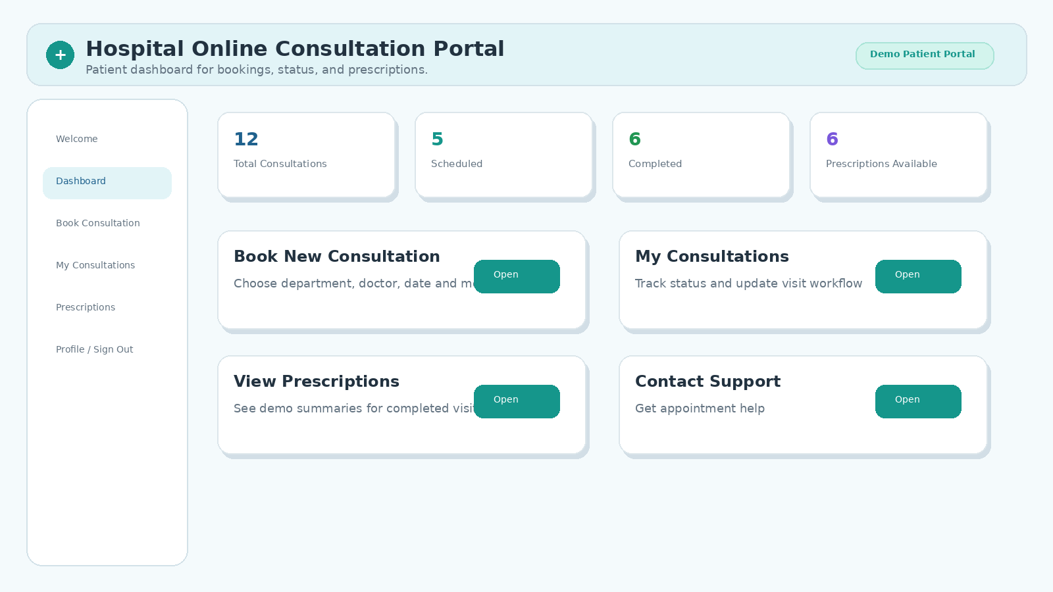
Figure 1: Proposed patient dashboard direction for hospital online consultation portal

1. Executive Summary
The hospital client wants a modern online consultation portal where patients can securely log in, book virtual consultations, track consultation status, view demo prescription summaries, and safely sign out. The application should support a patient-friendly workflow and should be suitable for a hospital operations team demonstration.
This BRD is designed for an AI software engineering agent. The agent must convert this document into an app contract, generate the Streamlit application, generate logic and tests, execute unit and UI validations, and produce a final report.

2. Business Goal
Create a modern hospital online consultation portal that allows patients to log in, view hospital services, book online consultations, choose doctors, track consultation status, view prescriptions, and sign out safely.
The app should feel like a real hospital client application with a clean, trusted, healthcare-friendly user interface.

3. Target Users
- Patients
- Hospital Admin Staff
- Doctors
- Customer Support Team
- Care Coordinators
Primary user role for this app: Patient

4. Core Features
- Patient can log in.
- Patient can view a welcome page.
- Patient can view hospital services.
- Patient can book an online consultation.
- Patient can select department and doctor.
- Patient can select consultation date and time.
- Patient can enter symptoms.
- Patient can select consultation mode: Video Call, Audio Call, Chat.
- Patient can view all booked consultations.
- Patient can update consultation status.
- Patient can filter consultations by status.
- Patient can search consultations by patient name, doctor name, or department.
- Patient can view prescription status.
- Patient can see consultation metrics.
- Patient can sign out.

5. Application Pages and Visual Mockups
The app can be implemented as a single Streamlit app with page-like sections, sidebar navigation, or tabs. If the generator supports multipage Streamlit, pages can be separated. The UI/UX should be selected by the AI based on this BRD and should remain accessible for Playwright browser tests.
Page | Purpose
Login Page | Secure patient access before dashboard content is visible.
Welcome Page | Friendly landing section after successful login.
Main Dashboard Page | Metrics, quick actions, and patient consultation overview.
Book Consultation Page | Appointment booking form.
Consultation List Page | Consultation tracking, status update, filters, and search.
Prescription / Medical Summary Page | Demo prescription availability and placeholder summary.
Profile / Sign Out Page | Safe logout confirmation and return to login.

5.1 Login Page Design Expectation
- Hospital logo placeholder at the top.
- Clean login card in the center.
- Background should feel calm and medical.
- Suggested visual theme: doctor consultation, hospital building, or patient care illustration.
- Login card should contain Patient ID or Email, Password, Login button, secure patient access note, and support/help text.
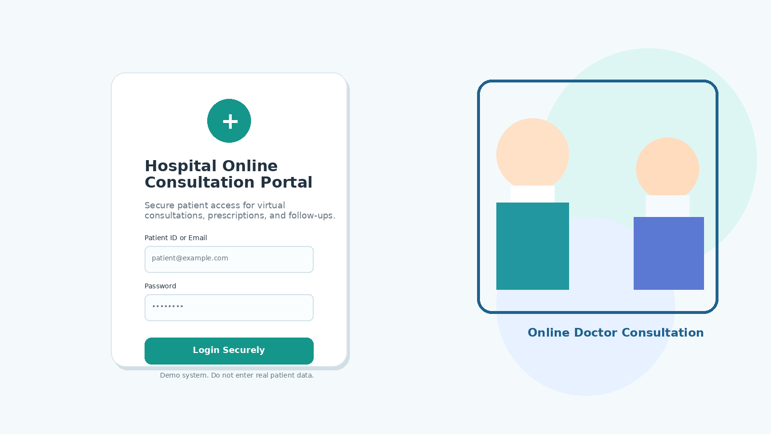
Figure 2: Login page mockup with secure patient access card

5.2 Welcome Page Design Expectation
- Hero section with greeting.
- Short hospital message.
- Illustration of online doctor consultation.
- Quick action button: Book Consultation.
- Quick action button: View My Consultations.
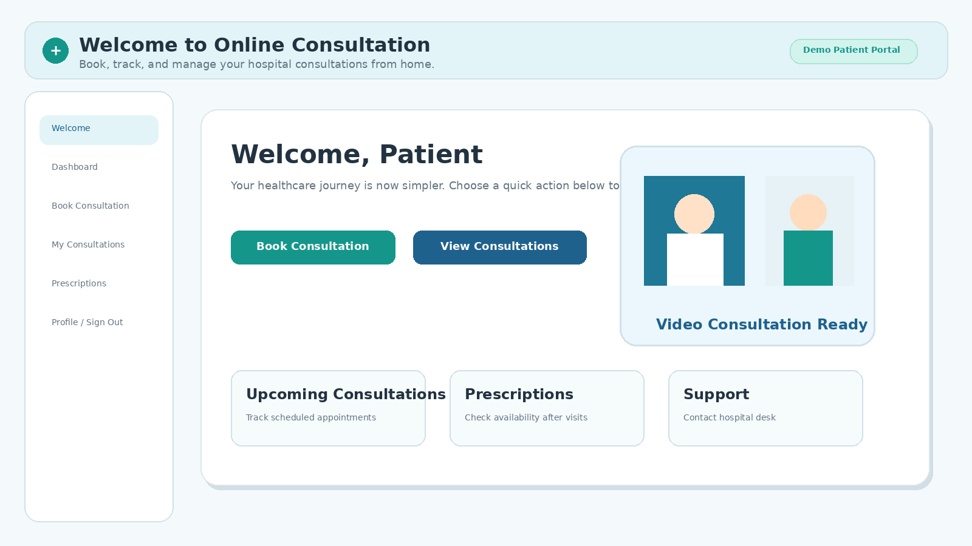
Figure 3: Welcome page mockup with quick patient actions

5.3 Main Dashboard Design Expectation
- Top header with hospital name and patient greeting.
- Metric cards for total consultations, scheduled consultations, completed consultations, and prescriptions available.
- Quick action cards for booking, tracking, prescriptions, and support.
- Clean dashboard layout with visual hierarchy.

Figure 4: Main dashboard mockup with metrics and quick actions

5.4 Book Consultation Design Expectation
- Easy appointment form inside a clean card.
- Department, doctor, date, time, symptoms, and consultation mode fields.
- Clear submit button and helpful instruction text.
- Visible labels for every control.
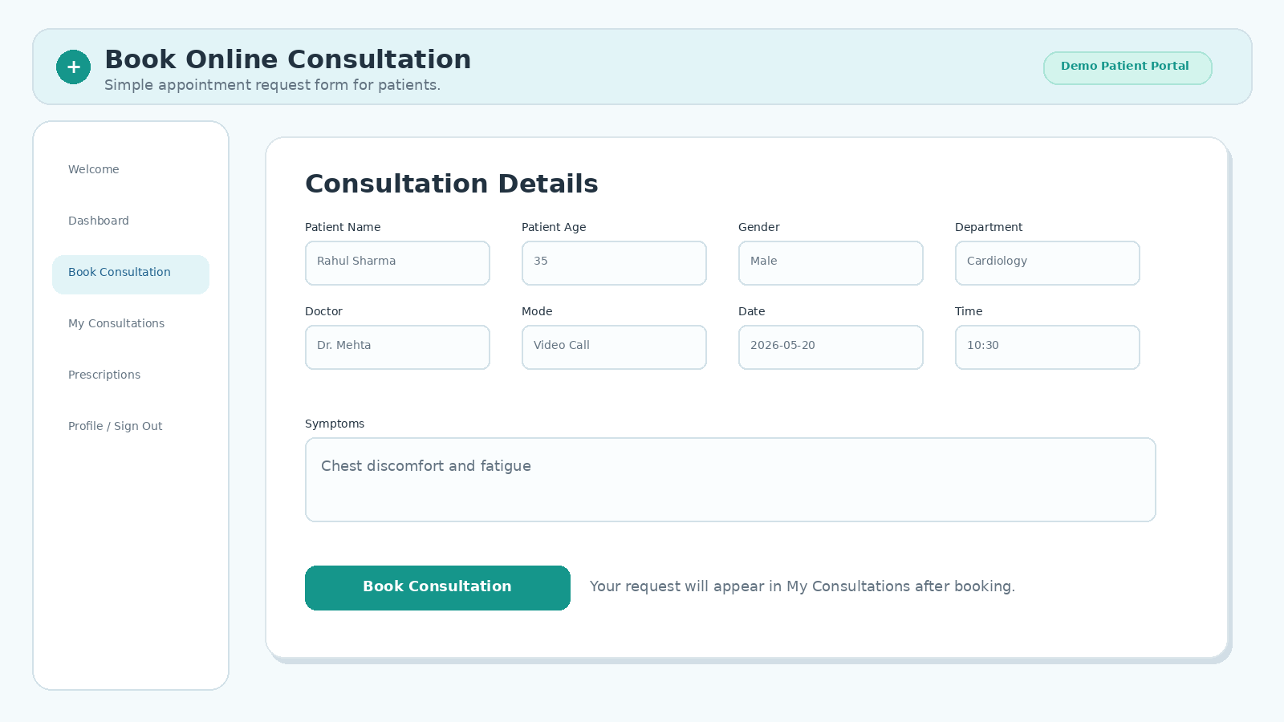
Figure 5: Book consultation page mockup

5.5 Consultation List Design Expectation
- Filter section and search input above the list.
- Consultation cards or table.
- Status badges.
- Doctor name, department, date/time, consultation mode, and status update option.
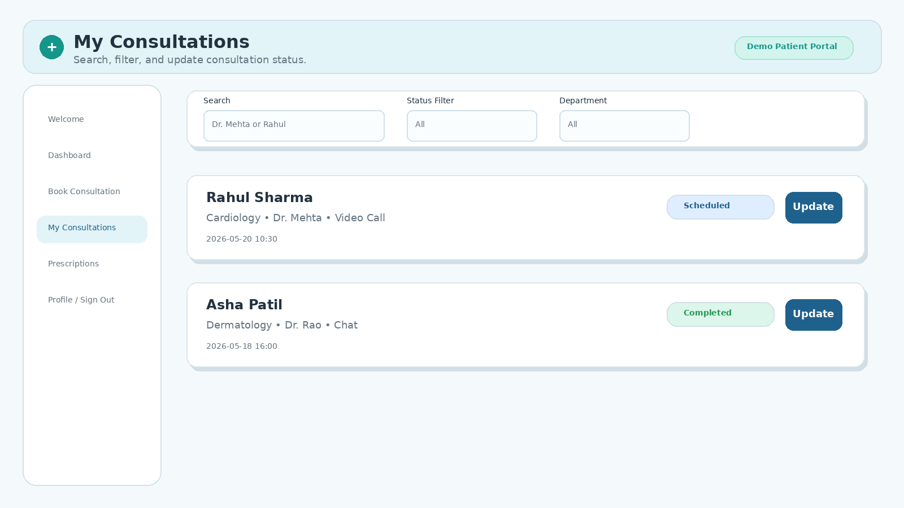
Figure 6: Consultation tracking page mockup

5.6 Prescription / Medical Summary Design Expectation
- Prescription status for completed consultations.
- Doctor advice placeholder.
- Medication summary placeholder.
- Follow-up recommendation placeholder.
- Clear note that this is a demo prescription summary.
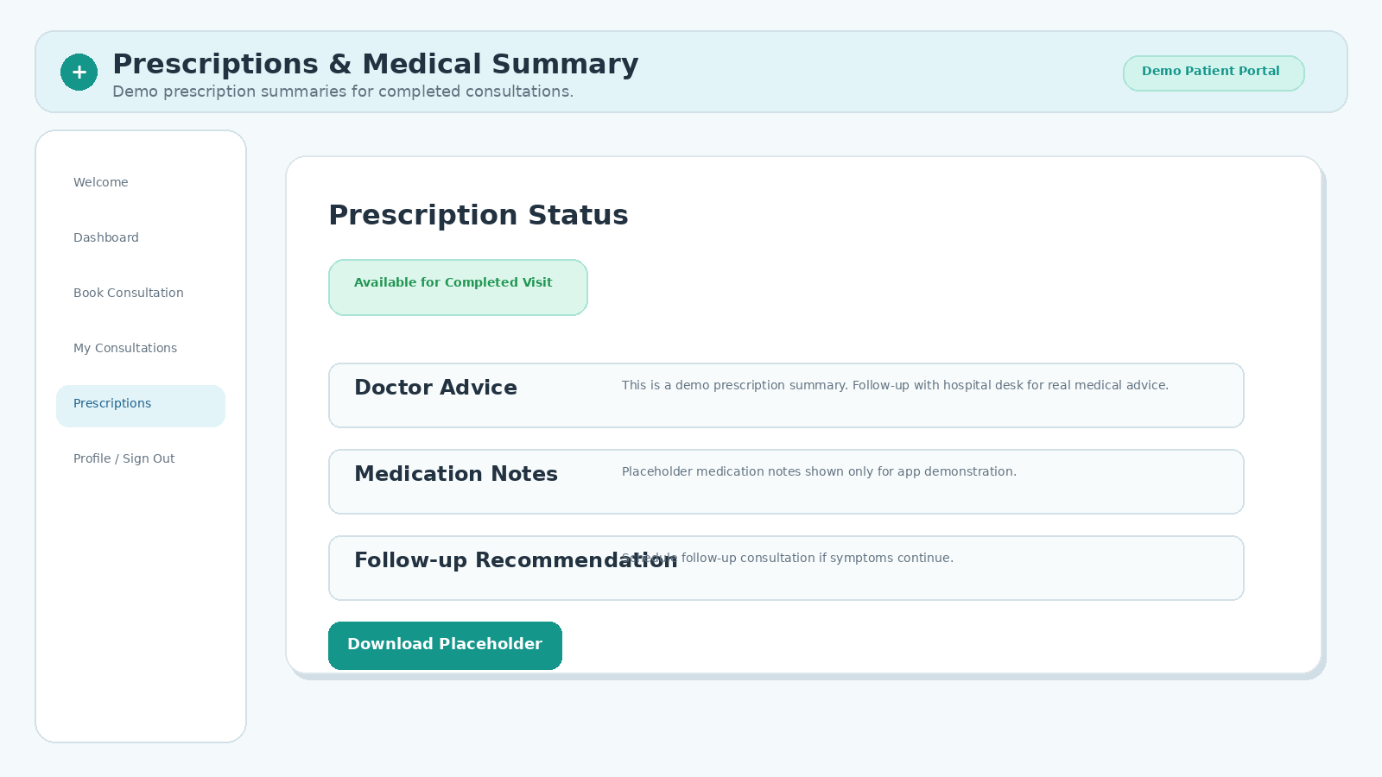
Figure 7: Prescription and medical summary mockup

5.7 Sign Out Design Expectation
- Confirmation message.
- Friendly goodbye message.
- Button: Sign Out.
- Security note: You have safely ended your session.
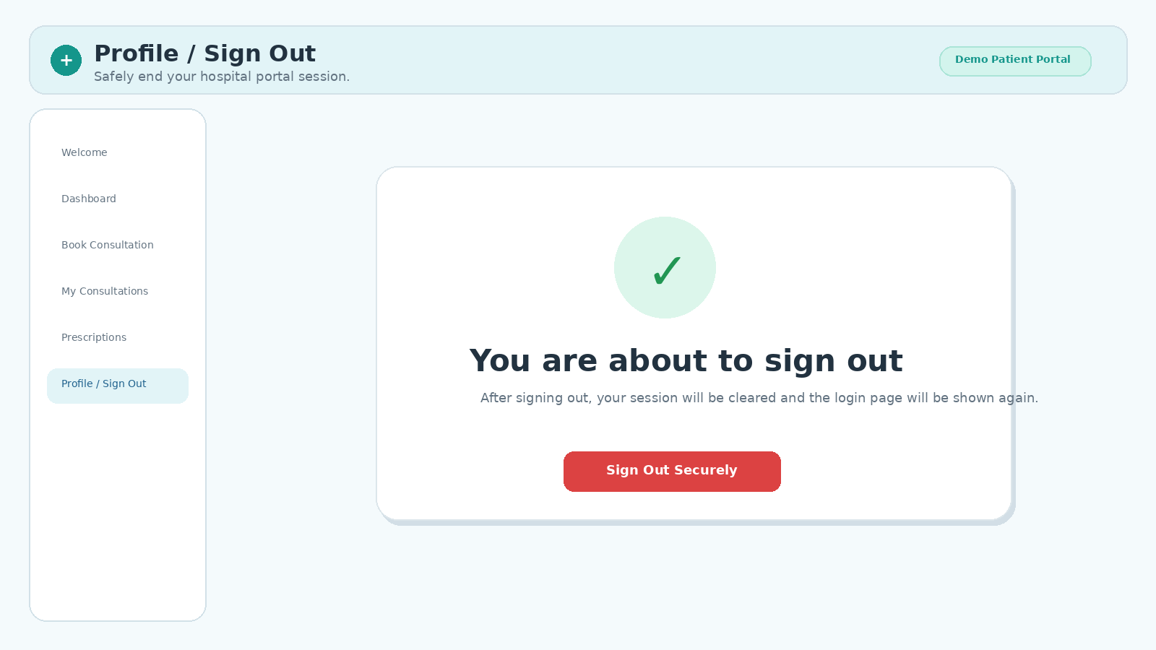
Figure 8: Sign out page mockup

5.8 High-Level User Flow
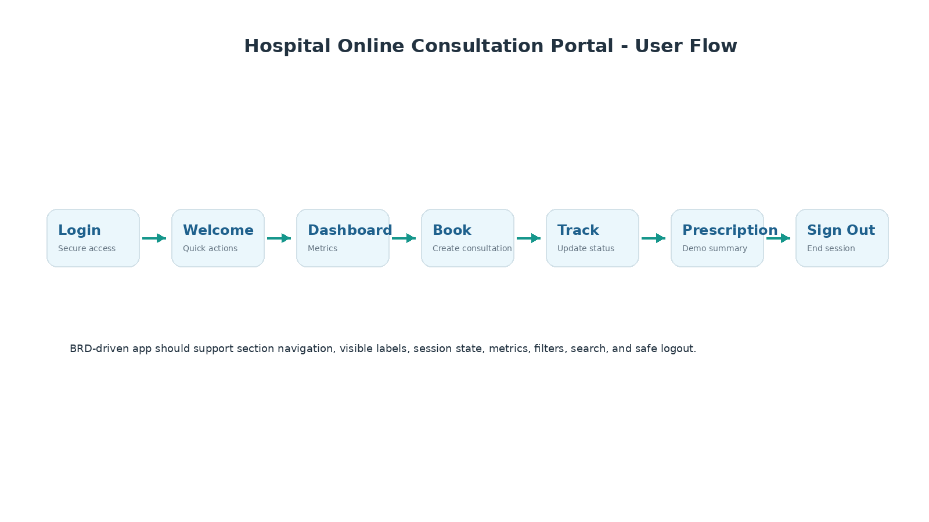
Figure 9: Patient portal flow from login to sign out

6. Functional Requirements

6.1 Login Page
- App must show a login page before showing the main dashboard.
- App must show input field for patient ID or email.
- App must show password input.
- App must show Login button.
- Patient should be able to log in with sample credentials.
- After login, patient should be redirected to Welcome Page or Main Dashboard.
- App should store login state using st.session_state.
- App should not show dashboard before login.

6.2 Welcome Page
- App must show a welcome message after successful login.
- Welcome page must show hospital portal name.
- Welcome page must show quick action to book consultation.
- Welcome page must show quick action to view consultations.
- Welcome page must be clean and user-friendly.

6.3 Main Dashboard
- App must show patient greeting.
- App must show consultation metrics: Total consultations, Scheduled consultations, Completed consultations, Prescriptions available.
- App must show quick actions: Book Consultation, My Consultations, Prescriptions, Sign Out.
- Metrics must update after booking or updating consultations.

6.4 Book Online Consultation
- App must show an input field for patient name.
- App must show an input field for patient age.
- App must show a gender dropdown with Male, Female, Other.
- App must show a department dropdown with General Medicine, Cardiology, Dermatology, Orthopedics, Pediatrics, Neurology.
- App must show a doctor dropdown with Dr. Mehta, Dr. Sharma, Dr. Rao, Dr. Iyer, Dr. Khan.
- App must show a consultation mode dropdown with Video Call, Audio Call, Chat.
- App must show a consultation status dropdown with Requested, Scheduled, In Consultation, Completed, Cancelled.
- App must show a date input for consultation date.
- App must show an input field for consultation time.
- App must show a symptoms text area.
- User must be able to click Book Consultation button.
- After booking, consultation should appear in My Consultations list.

6.5 My Consultations
- App must show all booked consultations.
- Each consultation must display patient name, age, gender, department, doctor, consultation mode, consultation status, date, time, and symptoms.
- Each consultation must have an option to update consultation status.
- User must be able to change status from Requested to Scheduled.
- User must be able to change status from Scheduled to Completed.
- Updated status must reflect immediately in the UI.

6.6 Consultation Filters
- App must provide consultation status filter.
- Filter options must be All, Requested, Scheduled, In Consultation, Completed, Cancelled.
- If user selects Scheduled, only Scheduled consultations should be visible.
- If user selects Completed, only Completed consultations should be visible.
- If user selects All, all consultations should be visible.

6.7 Search Consultations
- App must provide search input.
- User can search by patient name.
- User can search by doctor name.
- User can search by department.
- Search results must update the visible consultation list.

6.8 Prescription / Medical Summary
- App must show prescription section.
- For completed consultations, prescription status should show Available.
- For non-completed consultations, prescription status should show Pending.
- App should show a simple placeholder prescription summary for completed consultations: Doctor advice, Medication notes, Follow-up recommendation.
- App must not show real medical advice beyond placeholder text.
- App must clearly say: This is a demo prescription summary.

6.9 Sign Out
- App must show Sign Out option.
- User must be able to click Sign Out.
- After sign out, login state must be cleared.
- App should return to Login Page.
- App must show a friendly signed-out message.

7. Sample Login Credentials
Field | Value
Patient ID or Email | patient@example.com
Password | patient123

8. Data Fields and Values
Field | Expected Type / Values
id | Auto-generated unique identifier
patient_name | Text
patient_age | Number
gender | Male, Female, Other
department | General Medicine, Cardiology, Dermatology, Orthopedics, Pediatrics, Neurology
doctor | Dr. Mehta, Dr. Sharma, Dr. Rao, Dr. Iyer, Dr. Khan
consultation_mode | Video Call, Audio Call, Chat
consultation_status | Requested, Scheduled, In Consultation, Completed, Cancelled
consultation_date | Date
consultation_time | Text/time
symptoms | Textarea
prescription_status | Pending or Available

9. Metrics
- Total consultations
- Requested consultations count
- Scheduled consultations count
- Completed consultations count
- Prescriptions available count

10. Positive Happy Path Test Cases

TC_001_LOGIN
- Open the app
- Verify login page is visible
- Enter patient ID or email: patient@example.com
- Enter password: patient123
- Click Login
- Verify welcome page or dashboard is visible

TC_002_WELCOME
- Verify welcome message is visible
- Verify Book Consultation action is visible
- Verify My Consultations action is visible

TC_003_BOOK_CONSULTATION
- Navigate to Book Consultation
- Enter patient name: Rahul Sharma
- Enter patient age: 35
- Select gender: Male
- Select department: Cardiology
- Select doctor: Dr. Mehta
- Select consultation mode: Video Call
- Select consultation status: Requested
- Select consultation date: 2026-05-20
- Enter consultation time: 10:30
- Enter symptoms: Chest discomfort and fatigue
- Click Book Consultation
- Verify consultation appears in My Consultations list

TC_004_METRICS_AFTER_BOOKING
- Verify total consultations count becomes 1
- Verify Requested consultations count becomes 1
- Verify Completed consultations count is 0
- Verify Prescriptions available count is 0

TC_005_UPDATE_STATUS
- Change consultation status from Requested to Scheduled
- Verify consultation status shows Scheduled
- Verify Scheduled consultations count becomes 1
- Verify Requested consultations count becomes 0

TC_006_COMPLETE_CONSULTATION
- Change consultation status from Scheduled to Completed
- Verify consultation status shows Completed
- Verify Completed consultations count becomes 1
- Verify Prescriptions available count becomes 1

TC_007_FILTER_COMPLETED
- Select consultation status filter: Completed
- Verify Rahul Sharma consultation is visible

TC_008_SEARCH_BY_DOCTOR
- Select consultation status filter: All
- Search by doctor name: Dr. Mehta
- Verify Rahul Sharma consultation is visible

TC_009_PRESCRIPTION
- Navigate to Prescription section
- Verify prescription status shows Available for completed consultation
- Verify demo prescription summary is visible

TC_010_SIGN_OUT
- Click Sign Out
- Verify signed-out message is visible
- Verify login page is visible again

11. UI Requirements
- App title must be: Hospital Online Consultation Portal.
- Login page should be simple, secure, and healthcare-friendly.
- Welcome page should feel warm and guided.
- Main dashboard should show metrics and quick actions.
- Booking form should be easy for patients to understand.
- Consultation list should be readable.
- Status values should look visually clear.
- Prescription section should be easy to read.
- Sign out should clearly confirm safe logout.
- UI should be modern, clean, professional, and hospital-client ready.
- UI must be user-friendly for non-technical patients.
- All fields and controls must have visible accessible labels.
- App must not display raw Python list or raw dictionary.
- App must not expose technical exception details to user during normal flow.

12. Accessibility Requirements
- All input fields must have visible labels.
- Buttons must have clear action names.
- Status labels must be readable.
- Search and filters must be easy to find.
- UI should support Playwright tests using accessible locators.

13. Security / Privacy Requirements
- This is a demo app and must not store real patient data permanently.
- App must not ask for sensitive medical documents.
- App must not show real medical diagnosis.
- Password should not be displayed in plain text.
- Use password input type for password field.
- App should include a small note: Demo system. Do not enter real patient data.

14. Technical Requirements
- Use Streamlit.
- Use st.session_state for login state and consultation data.
- Keep business logic in separate file named consultation_logic.py.
- Keep Streamlit UI code in app.py.
- Create test_app.py for Python logic tests.
- Create ui_test.py for Playwright browser happy path validation.
- Create app_contract.json.
- Create brd_analysis.json.
- Create ui_design_plan.json.
- Create test_plan.json.
- Create traceability_matrix.json.
- Create bug_report.md.
- Create final_report.md.
- Do not hardcode UI or logic for any previous app.
- Do not use hidden labels for clickable controls.
- Do not directly modify Streamlit widget state after widget creation.
- Use clear page or section navigation.

15. Expected Output Files
- app.py
- consultation_logic.py
- test_app.py
- ui_test.py
- app_contract.json
- brd_analysis.json
- ui_design_plan.json
- test_plan.json
- traceability_matrix.json
- bug_report.md
- final_report.md

16. Acceptance Criteria
- Patient can log in successfully.
- Patient can see welcome/dashboard page after login.
- Patient can book an online consultation.
- Booked consultation is visible in My Consultations.
- Consultation status can be updated.
- Consultation status filter works correctly.
- Search works correctly for patient name, doctor name, and department.
- Metrics update correctly after booking and status update.
- Prescription section shows Available for completed consultations.
- Patient can sign out successfully.
- App returns to login page after sign out.
- All positive happy path tests pass.
- App should not crash during normal usage.
- Final report should show APPROVED only if validation, unit tests, and UI tests pass.

17. Important Demo Disclaimer
This BRD is for a demo hospital client application. The generated app must not claim to provide real medical advice, diagnosis, treatment, emergency support, or permanent storage of real patient records. The app must include visible demo/privacy language telling users not to enter real patient data.

