**INDEX**

1. What does the program do?
2. How to configure and run.
3. Errors.
4. Run in debug mode.

**WHAT DOES THE PROGRAM DO?**

1. This program checks if the balm data uploaded to the table(**tblProductTotals**) has been correct or not for any As On Date.
2. We are considering columns **SubType_ID|As_On|Currency_ID** combination as primary key

This combination can have either of 2 possible combinations of values in **SLRorIRS** column.

Combination 1:

SubType_ID|As_On|Currency_ID = “ALL”

Combination 2:

SubType_ID|As_On|Currency_ID = “IRS”

SubType_ID|As_On|Currency_ID = “INT”

SubType_ID|As_On|Currency_ID = “SLR”

1. If values do not match with either of the 2 combinations the program panics, writes error to the log file and exits the program.
2. We are maintaining a hashmap of key value pairs,
3. if SubType_ID|As_On|Currency_ID has “IRS”, “INT” or “SLR”

We add -1 to the value of this key combination.

For ex:

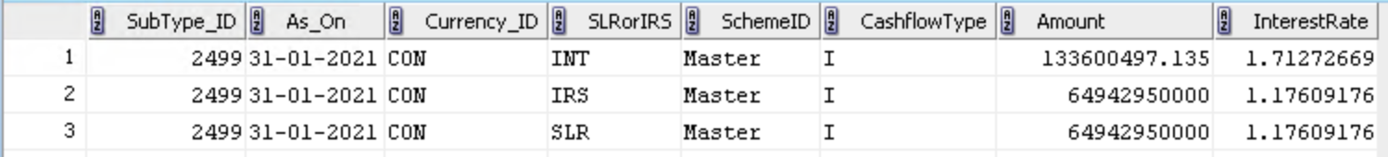

Key = 2499|31-01-2021|CON

value= -3 which is correct

1. If SubType_ID|As_On|Currency_ID has “ALL” then we add +1 to the value of this key combination.

For Ex:



Key = 2499|31-01-2021|CON

Value = +1 which is correct

5. If we get any other value other than +1 or -3 then the program panics and exits the programs

6. For combinations which are wrong, please check the **ERRORS** section of the document.

**HOW TO CONFIGURE AND RUN**

Step 1:

Update log files path in the script.

Step 2:

Update connection string as shown below.

Syntax:

“DB_USER_NAME|PASSWORD|SERVER_IP_ADDRESS"

For fef:

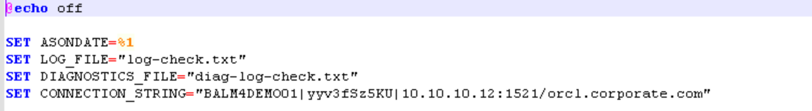

Step 3:

Run as follows with the As On date you are verifying.

script_name.bat dd-mm-yyyy

ex: balm_upload_check.bat 31-01-2021

**ERRORS**

1. If we get any other combination other than combination 1 and combination 2 as discussed **above**, we treat it as an error.

For ex:

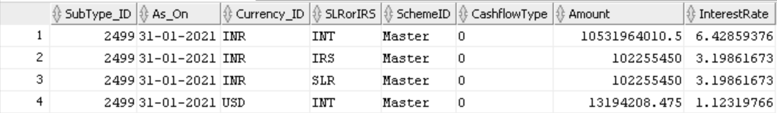

Here,

Key = 2499|31-01-2021|CON

Value = -2 which is wrong

Program panics and exits with the following error in log file as shown below

For ref:

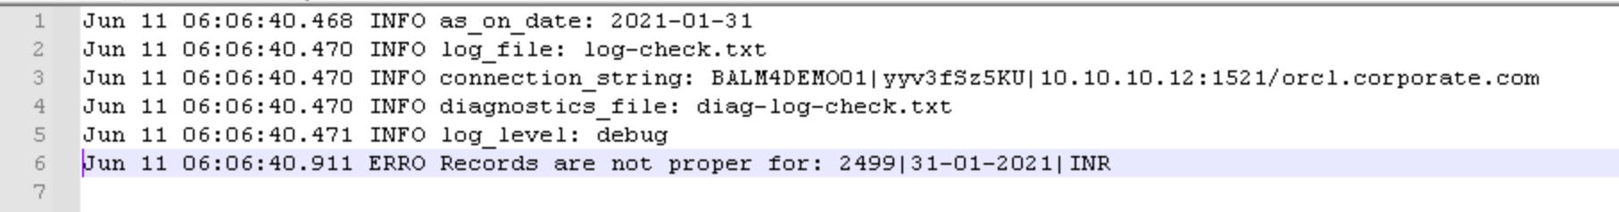

You can see in log file that “Records are not proper for:

2499|31-01-2021|CON

**RUN IN DEBUG MODE**

1. If you get any error and want to check all records combinations and their values then we can run the program in debug mode and get all records in the log file.
2. In run script set config parameter

--log-level debug

For ref:

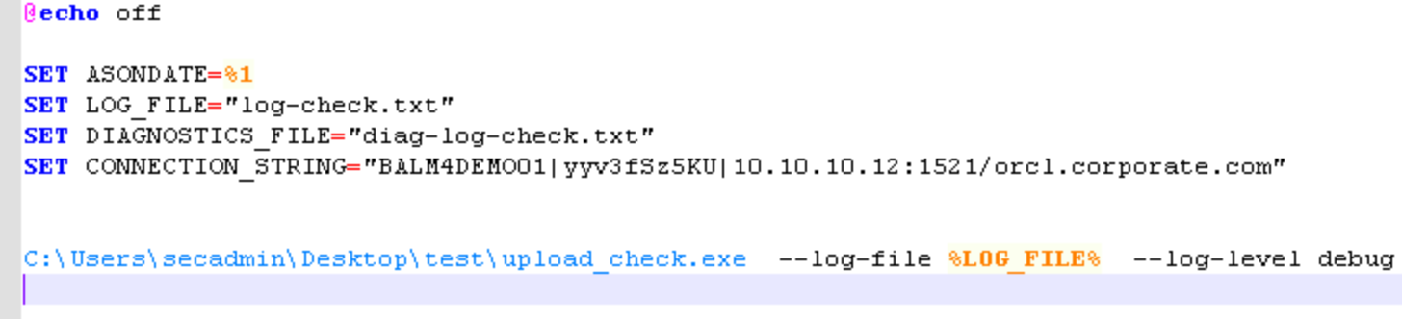

1. In log file we get all record combinations

For ref:

