How to configure and run:

**Step 1:** Open scenario_download.bat and update

1. DB_CONNECTION_NAME

For Ref:

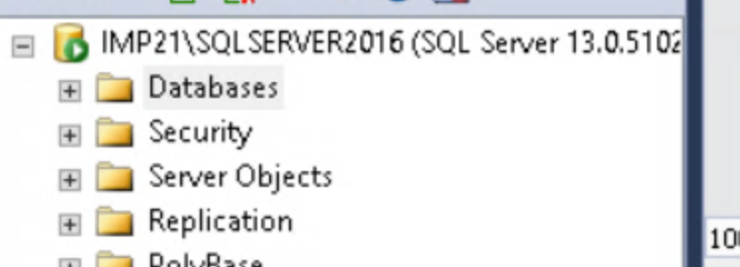

Here the DB_CONNECTION_NAME is **IMP21\SQLSERVER2016**

1. RUNCONTROL_NAME

For Ref:

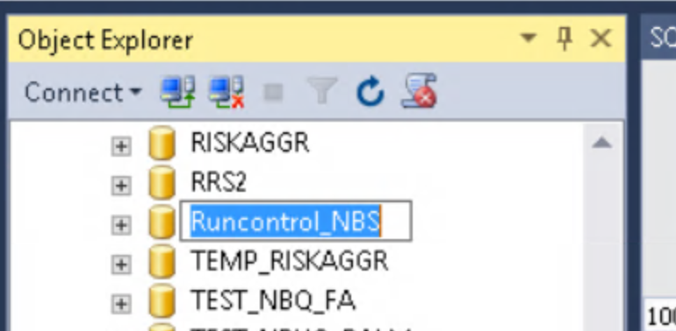

Here the RUNCONTROL_NAME is **Runcontrol_NBS**

1. RUNCONTROL_USER_NAME

Give runcontrol login user name

Ex: runcontrol

1. RUNCONTROL_PASSWORD

Ex: surya@123

**Step 2:**  Verify if bcp.fmt file is present where download_scenario.bat is present.If it's not

Present.

Repeat **step 1** for create_fmt.bat script

Then

Run create_fmt.bat as shown in the figure below.

For ref:

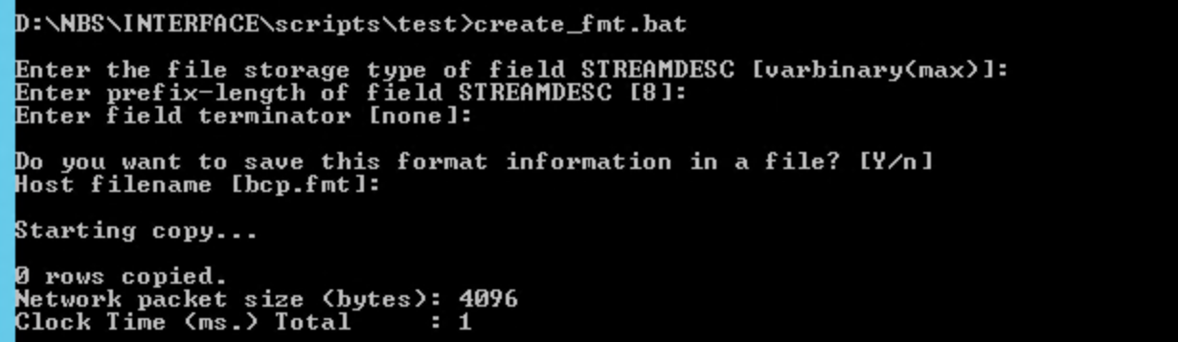

After starting the script, press enter for all the queries.

Ater the script run is completed. bcp.fmt file will be created

For ref:

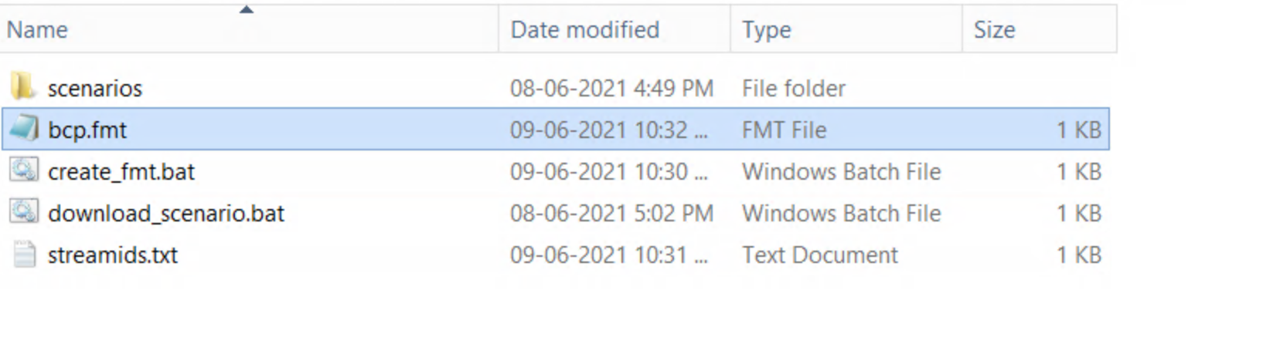

For Ref: Content of bcp.fmt file

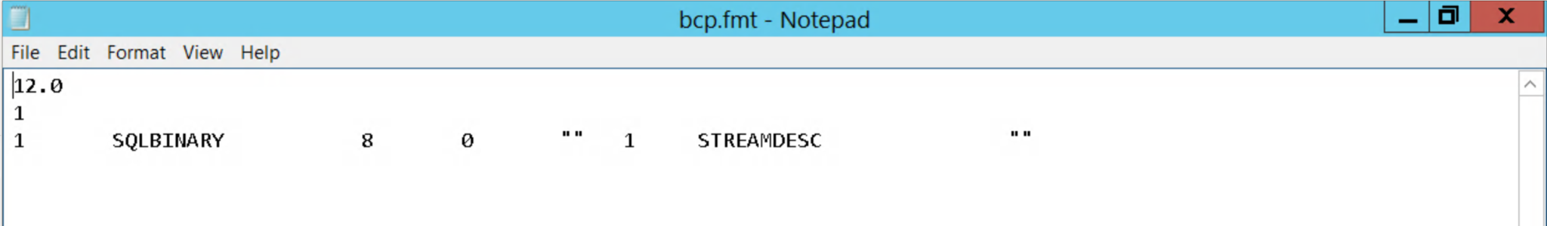

**Step 3:** Run download_scenario.bat as shown in figure below.

Enter the base path, where scenarios need to be downloaded.

