ASSIGNMENT 1
CartPole Balancing with PPO
Reinforcement Learning with Stable-Baselines3 — 20 Marks

1. Objective
This assignment trains a Proximal Policy Optimization (PPO) agent, implemented with Stable-Baselines3 (SB3), to solve the CartPole-v1 control task from Gymnasium. The deliverables are: (1) training code, (2) an evaluation report, (3) a learning curve plot, and (4) conclusions on the algorithm's performance.

2. Environment
CartPole-v1 is a classic control benchmark. A pole is attached by an unactuated joint to a cart, which moves along a frictionless track. The agent applies a force to push the cart left or right, and the episode's goal is to keep the pole upright.
Property | Value
Observation space | Box(4,) — cart position, cart velocity, pole angle, pole angular velocity
Action space | Discrete(2) — 0: push left, 1: push right
Reward | +1 for every timestep the pole remains upright
Episode ends when | Pole angle exceeds ±12°, cart leaves the track, or 500 steps are reached

3. Method

3.1 Algorithm and hyperparameters
PPO ("MlpPolicy") was used with the following configuration, matching the recommended defaults from the course material:
- learning_rate = 0.0003
- gamma = 0.99
- gae_lambda = 0.95
- clip_range = 0.2
- batch_size = 64
- total_timesteps = 100,000

3.2 Training procedure
The environment was wrapped with SB3's Monitor wrapper to log the reward and length of every episode during training, giving the raw data behind the learning curve in Section 4. An EvalCallback ran a 10-episode evaluation every 5,000 timesteps and checkpointed the best-performing model, in line with the callback pattern described in the course notes.

4. Results

4.1 Learning curve
Training produced 485 episodes over 100,000 timesteps. The agent's reward rose quickly from short, random-looking episodes (10–30 steps) to consistently hitting the maximum of 500 steps by episode 316, after which performance stayed saturated at the ceiling for the remainder of training.
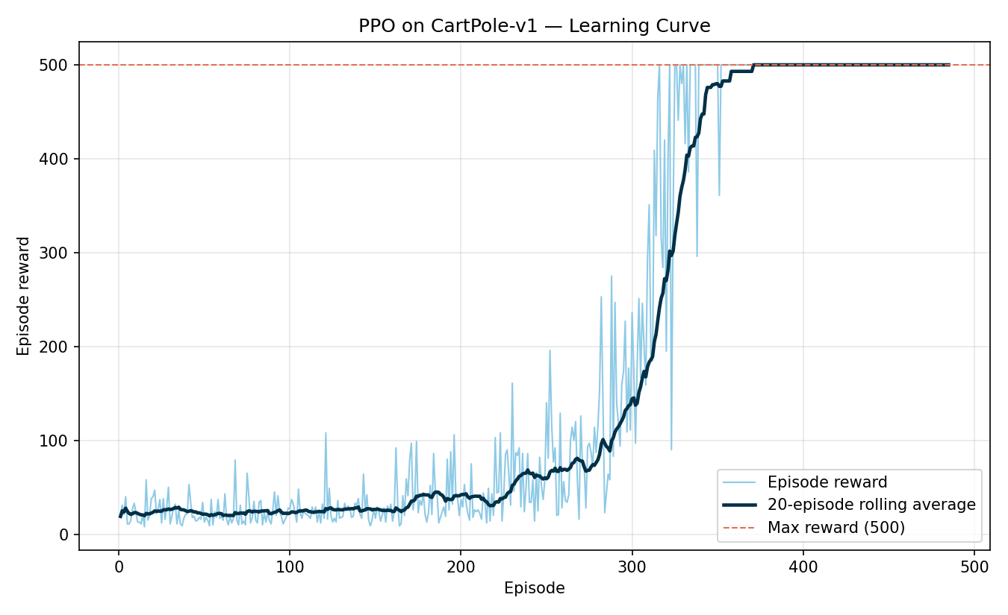
Figure 1. Episode reward (light) and 20-episode rolling average (dark) vs. training episode. The dashed line marks the environment's maximum possible reward (500).

4.2 Quantitative evaluation
The trained model (loaded from the saved checkpoint) was evaluated over 20 independent episodes using evaluate_policy, with deterministic action selection:
Eval episodes  20 | Mean reward  500.00 | Std. deviation  0.00

A mean reward of 500.00 with zero standard deviation means the agent balanced the pole for the full 500-step episode limit in every single evaluation run — the maximum achievable score on CartPole-v1.

4.3 Qualitative check
A separate rollout was recorded frame-by-frame and used to build an interactive playback visualizer (see accompanying HTML file), which lets a reader step through the trained agent's behaviour, watch the cart/pole animation, and inspect the raw state variables (cart position/velocity, pole angle/angular velocity) and the agent's chosen action at every timestep.

5. Conclusions
- PPO reliably solves CartPole-v1: the agent reached and sustained the maximum reward (500) well before training completed, converging around episode 316 of ~485 logged episodes.
- Default hyperparameters were sufficient. No hyperparameter tuning was required beyond the values suggested in the course material — this matches the course's framing of CartPole as an "Easy" difficulty benchmark suited to PPO's stable, low-variance updates.
- Evaluation confirms robustness, not just a lucky training run: 20/20 evaluation episodes hit the maximum score with zero variance, indicating the learned policy generalizes across the environment's reset-state distribution rather than overfitting to one trajectory.
- The main practical costs were implementation-light: using SB3 meant no algorithm code had to be written; effort instead went into logging (Monitor), evaluation (EvalCallback, evaluate_policy), and communicating results (learning curve, interactive visualizer).
- This exercise validates the course's broader claim that the hard part of an RL project is usually the environment and reward design, not the algorithm — CartPole's environment and reward were given, so PPO essentially trained itself.

6. Deliverables Summary
- train.py — trains the PPO agent and saves the model + Monitor logs
- evaluate.py — loads the saved model and reports mean/std reward over 20 episodes
- plot_learning_curve.py — generates the learning-curve figure from the Monitor log
- record_episode.py — records a deterministic rollout for the interactive visualizer
- cartpole_ppo_visualizer.html — interactive, step-through playback of the trained agent
- cartpole_ppo.zip — the trained PPO model checkpoint

