|  |
| --- |
| **Artificial Intelligence and Machine**  **Learning**    Project Report  Semester-IV (Batch-2022)    **Stock Price Prediction**        **Supervised By: Submitted By:**  Vishesh Singal (2210992541)  Vishwash bharti (2210992544)  Yatharth (2210992568)  Vivekanand (2210992547)      **Department of Computer Science and Engineering**  **Chitkara University Institute of Engineering & Technology**,  **Chitkara University, Punjab** |

TABLE OF CONTENT

|  |  |  |
| --- | --- | --- |
| Sr. No. | Section | Page No. |
| 1. | Introduction | 1 |
| 2. | Problem Definition and Requirements | 4 |
| 3. | Proposed Design & Methodology | 6 |
| 4. | Key Features | 10 |
| 5. | Results |  |

1. **Introduction:**

In today's dynamic financial markets, the ability to accurately predict stock prices is crucial for investors, traders, and financial institutions alike. Traditional methods of analysis often struggle to keep pace with the rapid influx of data and the complex interplay of various market factors. However, with recent advancements in Artificial Intelligence (AI) and Machine Learning (ML), predictive models have emerged as powerful tools for forecasting stock prices with greater precision and efficiency.

This project aims to leverage the capabilities of AI and ML techniques to develop a robust stock price prediction model. By harnessing vast amounts of historical market data, along with relevant economic indicators and news sentiment analysis, we seek to build a predictive framework that can anticipate future price movements with a high degree of accuracy.

* 1. **Background**

1. Traditional Methods:

Historically, the prediction of stock prices has relied heavily on traditional methods of financial analysis. These methods often include fundamental analysis, which assesses a company's financial health and market position based on factors such as earnings, revenue, and industry trends. Additionally, technical analysis has been widely used, focusing on historical price patterns and trading volumes to forecast future price movements. While these methods have provided valuable insights, they are often limited by their reliance on manual interpretation and a narrow scope of factors considered.

2. Emergence of Data-Driven Approaches:

In recent years, the proliferation of data and advancements in computing power have paved the way for a new era of predictive analytics in finance. Data-driven approaches, particularly those based on Artificial Intelligence (AI) and Machine Learning (ML), have gained prominence for their ability to leverage vast amounts of historical market data and identify complex patterns that traditional methods may overlook. These approaches offer a more systematic and data-driven framework for predicting stock prices, incorporating a broader range of variables and adapting to changing market dynamics in real-time.

3. Data Processing and Visualization:

Central to the success of data-driven stock price prediction models is the process of data processing and visualization. Raw financial data, including historical stock prices, trading volumes, and economic indicators, often requires extensive preprocessing to clean outliers, handle missing values, and normalize variables. Moreover, effective visualization techniques play a crucial role in uncovering insights from the data, facilitating exploratory analysis, and identifying relevant features for predictive modeling. By employing robust data processing pipelines and interactive visualization tools, researchers and practitioners can gain deeper insights into market trends and patterns, ultimately enhancing the accuracy and interpretability of stock price predictions.

* 1. **Objectives**

This project aims to achieve several key objectives in the domain of stock price prediction using AI and ML techniques:

Development of Robust Predictive Models: The primary objective is to develop robust predictive models capable of forecasting stock prices with a high degree of accuracy. By harnessing the power of machine learning algorithms such as linear regression, support vector machines, and neural networks, we seek to identify patterns and relationships within historical market data that can inform future price movements. The ultimate goal is to build models that outperform traditional methods and provide actionable insights for investors and financial institutions.

Evaluation of Prediction Performance: An essential aspect of this project is the rigorous evaluation of prediction performance. We aim to assess the accuracy, reliability, and generalizability of our predictive models through comprehensive validation and testing procedures. By employing appropriate evaluation metrics such as mean squared error, root mean squared error, and correlation coefficients, we seek to quantitatively measure the predictive capabilities of our models across different time horizons and market conditions.

Feature Engineering and Selection: To enhance the predictive accuracy of our models, we will conduct extensive feature engineering and selection processes. This involves identifying and extracting relevant features from raw market data, such as price trends, trading volumes, economic indicators, and news sentiment analysis. Through systematic experimentation and feature importance analysis, we aim to identify the most informative features that contribute significantly to the prediction of stock prices.

Optimization of Model Parameters: Another objective is the optimization of model parameters to improve prediction performance further. We will explore various optimization techniques, including grid search, random search, and Bayesian optimization, to fine-tune hyperparameters and optimize model architectures. By systematically tuning model parameters, we aim to maximize predictive accuracy while avoiding overfitting and enhancing the robustness of our predictive models.

Real-Time Prediction and Deployment: In addition to offline evaluation, we aim to implement our predictive models for real-time prediction and deployment. This involves integrating our models into scalable and efficient prediction pipelines capable of processing streaming market data in real-time. By deploying our models in production environments, we aim to provide timely and actionable predictions to end-users, including individual investors, traders, and financial institutions.

Interpretability and Explainability: Ensuring the interpretability and explainability of our predictive models is crucial for gaining stakeholders' trust and understanding the underlying factors driving predictions. We will employ interpretability techniques such as feature importance analysis, model explainers, and visualization tools to elucidate the decision-making process of our models. By providing interpretable insights, we aim to enhance the usability and adoption of our predictive models in real-world financial applications.

Contribution to Research and Knowledge: Finally, this project seeks to contribute to the broader research community by advancing the state-of-the-art in stock price prediction using AI and ML techniques. Through empirical validation, comparative analysis, and documentation of best practices, we aim to disseminate valuable insights and lessons learned from our research. By sharing our findings and methodologies, we hope to foster collaboration and drive further innovation in the field of predictive analytics in finance.

**1.3 Significance**

Enhanced Decision-Making: Accurate stock price predictions empower investors, traders, and financial institutions to make informed decisions, leading to improved portfolio management and risk mitigation strategies.

Market Efficiency: By leveraging AI and ML techniques to forecast stock prices, the project contributes to the overall efficiency and stability of financial markets, fostering fairer pricing mechanisms and reducing market inefficiencies.

Innovation in Finance: The project represents an innovative application of cutting-edge technology in the finance domain, showcasing the potential of AI and ML to revolutionize traditional methods of stock price prediction and financial analysis.

Risk Management: Reliable stock price predictions facilitate better risk management practices, enabling stakeholders to identify and mitigate potential risks associated with investment strategies, asset allocation, and portfolio diversification.

Research Advancement: Through empirical validation and documentation of best practices, the project contributes to the advancement of research in predictive analytics, providing valuable insights and methodologies for future studies in the field of finance and machine learning.

1. **Problem Definition and Requirements:**

**2.1 Problem Statement**

The problem at hand revolves around the inherent difficulty in accurately predicting stock prices amidst the complexities of financial markets. Traditional methods of analysis often fall short in capturing the intricate relationships between various market factors, leading to unreliable forecasts and suboptimal decision-making. Moreover, the sheer volume and velocity of financial data present significant challenges in extracting meaningful insights and identifying predictive patterns. In light of these challenges, the aim of this project is to develop a robust predictive model leveraging AI and ML techniques to overcome the limitations of traditional methods and provide accurate forecasts of stock prices. By addressing this problem statement, we seek to enhance decision-making processes, improve market efficiency, and empower stakeholders with actionable insights for navigating the dynamic landscape of financial markets.

**2.2 Hardware Requirements**:

* Dedicated server : For large-scale training tasks or real-time inference in production environments, dedicated servers or cloud-based infrastructure may be necessary. Cloud platforms such as Amazon Web Services (AWS), Google Cloud Platform (GCP), and Microsoft Azure offer scalable computing resources tailored to AI and machine learning workloads.
* Network: A high-speed internet connection is required for downloading the dataset and for accessing cloud-based resources.

**2.3 Software Requirements:**

* Programming Language: Python is a popular choice for building machine learning models due to its simplicity and the availability of numerous libraries and frameworks.
* Libraries: NumPy, Pandas, scikit-learn and Matplotlib are some of the essential libraries required for data preprocessing, analysis, and visualization.
* Integrated Development Environment (IDE): Google Collab used for data manipulation and visualization; Jupyter Notebook IDEs used for building machine learning model.
* Version Control System: Git is a widely used version control system that helps to manage the codebase and collaborate with other developers.

1. **Proposed Design & Methodology**

The proposed design and methodology entail a systematic approach to developing and evaluating predictive models for stock price forecasting. We will begin by collecting and preprocessing historical market data, including stock prices, trading volumes, economic indicators, and news sentiment analysis. This data will undergo rigorous cleaning, normalization, and feature engineering to extract relevant information for predictive modeling. Subsequently, we will explore a variety of machine learning algorithms, such as linear regression, support vector machines, and neural networks, to identify the most suitable approach for our prediction task. Model training will involve partitioning the data into training, validation, and testing sets, employing techniques such as cross-validation to optimize model hyperparameters and mitigate overfitting. Throughout the development process, we will adopt best practices in model evaluation, employing appropriate performance metrics and conducting comprehensive validation tests to assess predictive accuracy and generalizability. Furthermore, we will explore techniques for model interpretability, ensuring stakeholders can understand and trust the predictions generated. By following this proposed design and methodology, we aim to build robust predictive models that provide actionable insights for stakeholders in the financial domain.

**3.1 Technical details:**

NumPy:

* Perform mathematical operations on data arrays, such as calculating means, medians, and standard deviations.
* Use NumPy arrays to represent and manipulate numerical data efficiently.

Pandas:

* Use pandas to load, clean, and preprocess your dataset.
* Perform data manipulation tasks such as filtering, grouping, and aggregating data.
* Handle missing values, outliers, and data formatting issues.

Matplotlib:

* Create static, publication-quality visualizations using Matplotlib.
* Plot various types of charts, including line plots, scatter plots, histograms, and bar charts

Seaborn:

* + - Use Seaborn to create more visually appealing and informative statistical visualizations.
    - Generate complex plots such as scatter plots with regression lines, box plots, violin plots, and pair plots

Scikit Learn.

* + - Scikit-learn, often referred to as sklearn, is a popular machine learning library for Python
    - Scikit-learn, often referred to as sklearn, is a popular machine learning library for Python.

.

* 1. **Plots Used**

1. Pie chart: It show the pie chart for gender Distribution of population

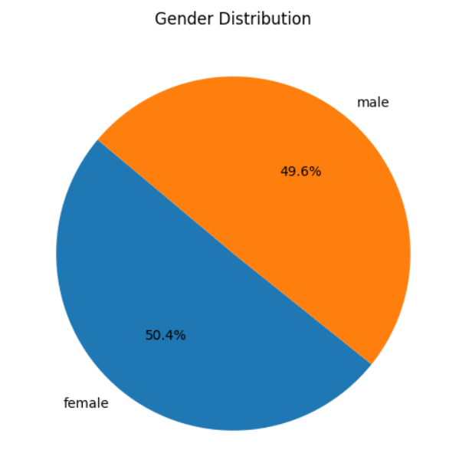

1. Bar chart : Bar chart compare Average body temp vs age group

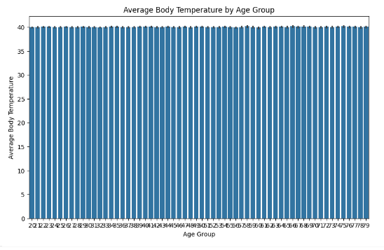

1. Scatterplot :effectively reveals patterns or correlations between calories burnt and duration

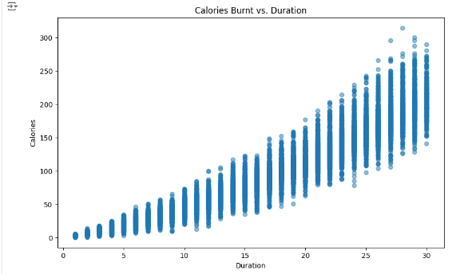

1. Box plot : is chosen to compare calories burnt vs gender effectively display central tendancy

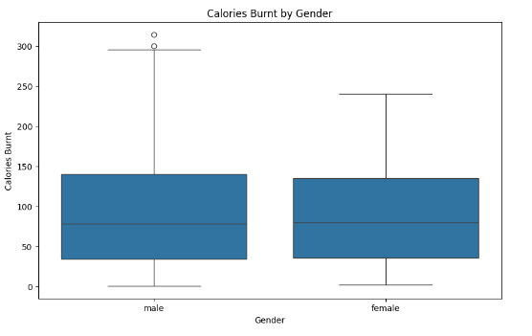

1. Correlation Heatmap - displays how much each variable is related to other by a number and colour

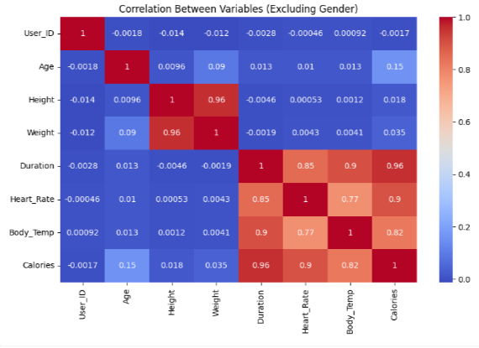

1. Pair plot - Represent - visualizes pairwise relationship between multiple variable

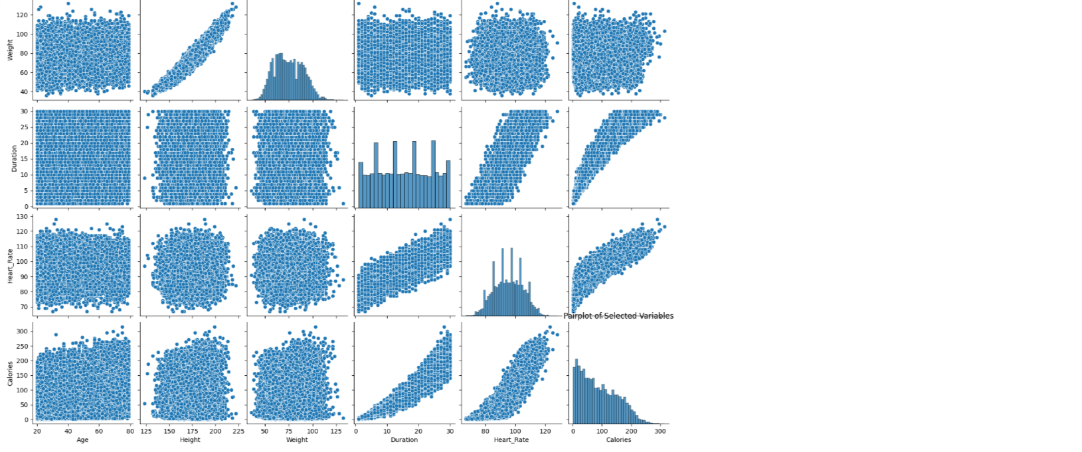

**4. Key Features**

1. Scatter plot: Scatter plots are effective for visualizing the relationship between two continuous variables, such as calories burnt vs duration . Key features include:
   * Trend lines or regression lines to highlight the overall trend in the data.
   * Different colors or markers represent categorical variables (e.g.,Calories burnt vs Duration).
   * Transparency or alpha blending to visualize overlapping data points.
2. Histogram plots: Histograms are useful for visualizing the distribution of numerical variables, such as calories burnt over frequency. Key features include:
   * Customizable bin sizes to control the granularity of the distribution.
   * Multiple histograms or density plots for different categories or subsets of data.
3. Box plot or violin plot : Box plots and violin plots provide insights into the distribution of numerical variables across different categories or groups, such as gender vs duration Key features include:
   * Median lines and interquartile ranges to summarize the central tendency and spread of the data.
   * Outlier detection to identify unusual or extreme data points.
   * Grouping and stacking to compare distributions side by side or within the same plot.
4. Line plot: Time series plots are useful for visualizing changes in calorie burnt over time. Key features include:
   * Line plots with time on the x-axis and the variable of interest on the y-axis.
   * Smoothed or aggregated time series to highlight long-term trends while reducing noise.
   * Annotations or vertical lines to mark significant events or milestones.
5. Heatmaps and Correlation Matrices: Heatmaps and correlation matrices are effective for visualizing relationships between multiple variables in the dataset. Key features include:
   * Color-coded cells to represent the strength and direction of correlations between variables.
   * Hierarchical clustering to group similar variables based on their correlation patterns.
   * Annotations or labels to identify variables and highlight interesting patterns.
6. Pair Plot: Pair plots and joint plots allow for the visualization of pairwise relationships between multiple variables in the dataset. Key features include:
   * Scatter plots with marginal histograms or density plots to visualize individual distributions.
   * Pearson correlation coefficients or other measures of association between variables.
   * Non-linear fits or regression lines to capture complex relationships.

HYPOTHESIS TESTING

* + BASED ON OUR MODEL GIVEN ARE THE THREE HYPOTHESIS STATEMENT

1. Age has a significant effect on the number of calories burnt during a workout.
2. There is a difference in average number of calories burnt between males and female
3. There is a significant correlation between heart rate and calories burnt.