AIM:- Design a luminous intensity meter such that light intensity falling on LDR is sensed and displayed on the serial monitor upon the press of a switch.

CONSTRUCTION DIAGRAM:-

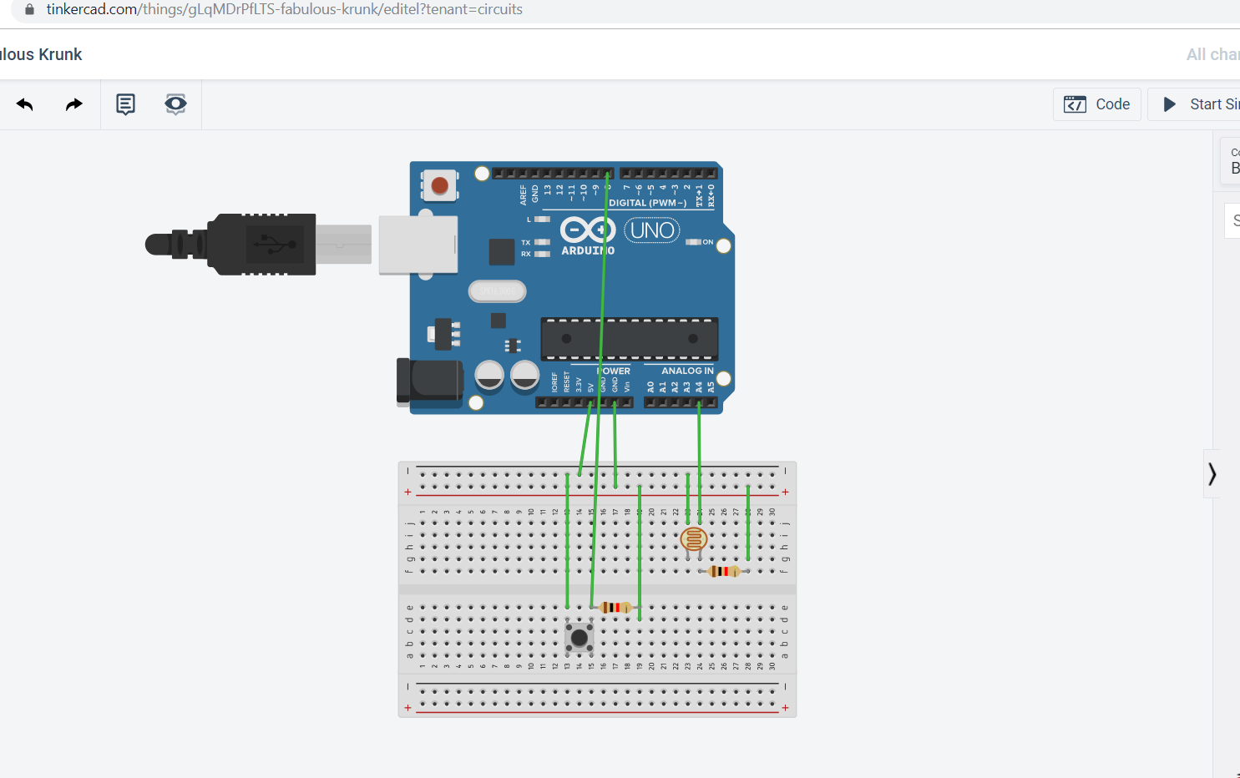

APPARTUS REQUIRED:- Arduino Uno, Connecting wires ,LDR,10K Ohm resistor,breadboard,switch.

Theory :- **luminous intensity** is a measure of the [wavelength](https://en.wikipedia.org/wiki/Wavelength)-weighted [power](https://en.wikipedia.org/wiki/Power_(physics)) emitted by a [light source](https://en.wikipedia.org/wiki/Light_source) in a particular direction per unit [solid angle](https://en.wikipedia.org/wiki/Solid_angle), based on the [luminosity function](https://en.wikipedia.org/wiki/Luminosity_function), a standardized model of the sensitivity of the [human eye](https://en.wikipedia.org/wiki/Human_eye). The [SI](https://en.wikipedia.org/wiki/SI) unit of luminous intensity is the [candela](https://en.wikipedia.org/wiki/Candela) (cd) . luminous intensity is the measurement of lumionous flux per unit solid angle.

Luminous intensity meter- it measures the intensity of light as perceived by the human eye ,of light that hits or passes through a surface.

Light dependent resistors(LDR)- A **photoresistor** (or **light-dependent resistor**, **LDR**, or **photo-conductive cell**) is a light-controlled variable resistor. The resistance of a photoresistor decreases with increasing incident light intensity; in other words, it exhibit phothoconductivity. A photoresistor can be applied in light-sensitive detector circuits, and light-activated and dark-activated switching circuits.

A photoresistor is made of a high resistance semiconductor. In the dark, a photoresistor can have a resistance as high as several mega ohms (MΩ), while in the light, a photoresistor can have a resistance as low as a few hundred ohms.

Arduino Uno:- The **Arduino Uno** is an [open-source](https://en.wikipedia.org/wiki/Open-source) [microcontroller board](https://en.wikipedia.org/wiki/Microcontroller_board) based on the [Microchip](https://en.wikipedia.org/wiki/Microchip_Technology) [ATmega328P](https://en.wikipedia.org/wiki/ATmega328P) microcontroller and developed by [Arduino.cc](https://en.wikipedia.org/wiki/Arduino).[[2]](https://en.wikipedia.org/wiki/Arduino_Uno#cite_note-2)[[3]](https://en.wikipedia.org/wiki/Arduino_Uno#cite_note-What_is_Arduino?-3) The board is equipped with sets of digital and analog [input/output](https://en.wikipedia.org/wiki/Input/output) (I/O) pins that may be interfaced to various [expansion boards](https://en.wikipedia.org/wiki/Expansion_board) (shields) and other circuits.[[1]](https://en.wikipedia.org/wiki/Arduino_Uno#cite_note-Makerspace-1) The board has 14 Digital pins, 6 Analog pins, and programmable with the [Arduino IDE](https://en.wikipedia.org/wiki/Arduino#Software) (Integrated Development Environment) via a type B [USB cable](https://en.wikipedia.org/wiki/USB_cable).[[4]](https://en.wikipedia.org/wiki/Arduino_Uno#cite_note-priceton-4) It can be powered by the USB cable or by an external [9-volt battery](https://en.wikipedia.org/wiki/9-volt_battery)

The easiest way to measure the light intensity with an Arduino is with an LDR. LDR,s have a low resistance in bright light and a high resistance in the darkness.

Formula :- resistance of an LDR to the light in Lux.

Rldr=500/Lux

Lux=500/Rldr(in KOhm)

Learning outcomes :-

1: learn how to code in Arduino Uno to measure luminous intensity.

2: luminous intensity is the measurement of luminous flux per unit solid angle.

3:LDR have a low resistance in bright light and a high resistance in the darkness this can be used to make a luminous intensity meter.

Precautions/source of error :-

1: never plug Arduino USB cable on defected USB PORT.

2: Do not use a voltage in excess of the operating voltage range.

3:make sure corrections are right otherwise it will burn the Arduino.