

Name: Vishwata Avinash Rongare

**Credit Card Portfolio**

**And**

**Customer Distribution Analysis**

Power BI Project Report

**Dashboard 1: Credit Card Analysis**

**Objective**

The objective of this **Credit Card Analysis Dashboard** is to provide insights into key financial metrics, customer spending behaviour, and credit utilization patterns. This dashboard helps financial institutions and credit providers in:

* Tracking **revenue, profit, and delinquent accounts**.
* Analysing **customer spending trends** to improve financial decision-making.
* Monitoring **credit utilization and exceeded credit limits** for risk assessment.
* Identifying **high-value customers** based on their expenditure and credit limit usage.

**Data Source & Preparation**

* **Data Source:** The primary data source for this project is a credit card transaction and customer dataset provided by [ My Professor's] for the purpose of this analysis. Briefly describe how the data was cleaned and transformed.
* **Data Preparation:** The data was cleaned and transformed using Power Query in Power BI. This involved:
* **Data Type Conversion:** Ensuring that numerical columns were correctly formatted as numbers, date columns as dates, etc.
* **Data Quality Checks:** I inspected each column for any unexpected or invalid entries.
* **Consistency Checks:** I looked for any inconsistencies in data entry, such as variations in spelling or capitalization, and standardized them to ensure uniformity.

**Derived Metrics & Calculated Fields**

To enhance the analytical capability of the dashboard, the following calculated columns and measures were created:

**4.1 Calculated Columns**

• **Exceed Credit Limit**

DAX

Exceed_credit_limit = IF(credit_card[Total_Trans_Amt] > credit_card[Credit_Limit], "Exceed", "None")

• **Exceeded Amount**

DAX

Exceeded_Amount =

IF(

credit_card[Total_Trans_Amt] > credit_card[Credit_Limit],

credit_card[Total_Trans_Amt] - credit_card[Credit_Limit],

0

)

• **Credit Limit (Bins)**

* Groups credit limits into different categories for better visualization.

• **Revenue Column**

DAX

Revenue_Column = CALCULATE(SUM(credit_card[Annual_Fees]) + SUM(credit_card[Interest_Earned]))

• **Extracting Current Year from Date**

DAX

Current_Year = YEAR(credit_card[Week_Start_Date])

* Either use this formula or can also do the same in power query editor without code.

• **Converted Avg Utilization Ratio to Percentage**

DAX

Converts utilization ratio into a readable percentage format.

• **Profit Calculation**

DAX

Profit1 = CALCULATE(

(SUM(credit_card[Annual_Fees]) + SUM(credit_card[Interest_Earned])) - SUM(credit_card[Customer_Acq_Cost])

)

**4.2 Measures**

1. **Active Customers**

DAX

Active_Customers = CALCULATE(COUNT(credit_card[Activation_30_Days]), credit_card[Activation_30_Days]=1)

1. **Count of Customers Exceeding Credit Limit**

DAX

Count_exceed = COUNT(credit_card[Exceed_credit_limit])

1. **Percentage of Delinquent Accounts**

DAX

Percentage_Delinquent_Accounts =

VAR TotalAccounts = [Total_Accounts]

VAR DelinquentAccounts = [Total_Delinquent_Accounts]

RETURN

IF(

TotalAccounts > 0,

DIVIDE(DelinquentAccounts, TotalAccounts) * 100,

0

)

1. **Revenue Calculation**

DAX

Revenue = CALCULATE(SUM(credit_card[Annual_Fees]) + SUM(credit_card[Interest_Earned]))

1. **Profit Calculation**

DAX

Profit = CALCULATE(

(SUM(credit_card[Annual_Fees]) + SUM(credit_card[Interest_Earned])) - SUM(credit_card[Customer_Acq_Cost])

)

1. **Total Delinquent Accounts**

DAX

Total_Delinquent_Accounts = COUNTROWS(FILTER(credit_card, credit_card[Delinquent_Acc] = 1))

1. **Total Accounts**

DAX

Total_Accounts = COUNTROWS(credit_card)

**Dashboard Overview**

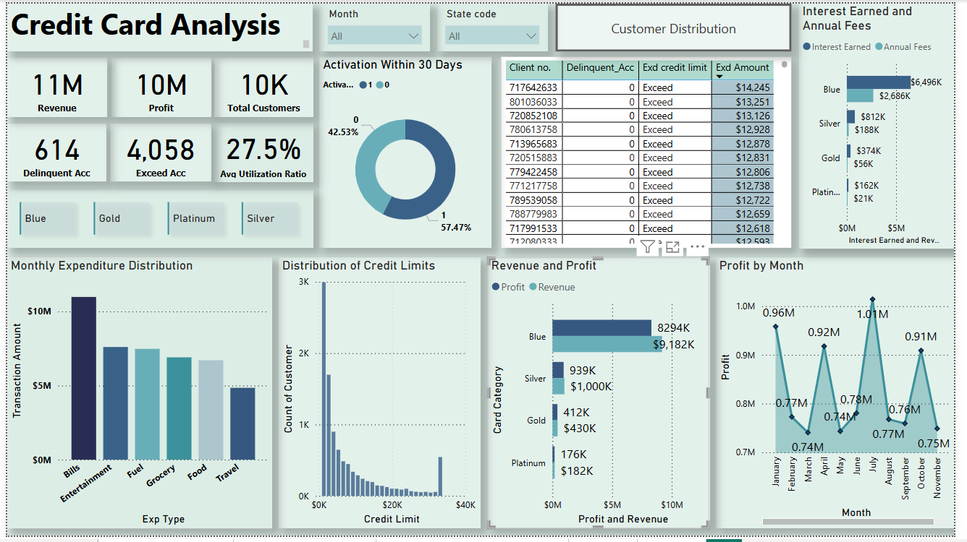

### **Visualizations Used**

This dashboard provides a comprehensive overview of the credit card portfolio's performance, enabling users to analyse key metrics and trends. The dashboard is designed for interactive exploration and includes the following visualizations:

* **KPI Cards:** Displaying key performance indicators such as "Revenue" (11M), "Profit" (10M), "Total Customers" (10K), "Delinquent Account" (614), "Exceed Account" (4,058), and "Average Utilization Ratio" (27.5%). These cards provide a quick snapshot of the overall portfolio health.

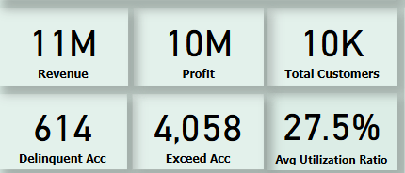

• **Donut Chart:** 42.53% of customers activate their cards within 30 days.

• **Bar Charts:**

* Interest & Fees: Breakdown by card type (Blue, Silver, Gold, Platinum).
* Revenue & Profit: Highlights strong performance of the "Blue" card.

• **Table:** Lists customers who exceeded credit limits with key details.

• **Slicers:** Filters for Month, State Code, and Card Category for focused analysis.

• **Expenditure Chart:** Shows spending by category (Bills, Entertainment, etc.), with total values displayed.

• **Profit Trend Chart:** Tracks monthly profit fluctuations and seasonal trends.

• **Credit Limit Distribution:** Displays customer distribution across credit limit ranges.

• **Navigation Button:** Directs users to the Customer Distribution dashboard for deeper insights.

**Key Insights**

**1.** **Customer Behaviour & Segmentation**

* **Cardholder Distribution:** "Blue" cardholders form the largest segment, followed by "Silver," "Gold," and "Platinum." This highlights an opportunity for segment-specific marketing and tailored financial products.
* **Spending Trends:** Bills and Entertainment are the top spending categories. Leveraging this data, the business can design targeted promotions, merchant partnerships, and rewards programs aligned with customer preferences.
* **Credit Limit Utilization:** A majority of customers have credit limits below $20,000, suggesting a potential credit line increase for eligible users, which could drive higher spending and revenue.

**2.** **Product Performance & Profitability**

* **Revenue Drivers:** The Blue card category generates the highest total revenue and profit, despite lower individual spending limits. Retention strategies for this segment are crucial for sustained profitability.
* **Income Sources:** Interest income is the primary revenue contributor, with annual fees playing a secondary role. Enhancing interest-based strategies, such as balance transfer offers or personalized interest rates, could further boost revenue.

**3. Operational Efficiency & Risk Management**

* **Profit Trends:** Fluctuations in monthly profit indicate seasonal variations in revenue generation. Identifying peak and low seasons can optimize marketing efforts, resource allocation, and credit risk strategies.
* **Credit Limit Exceedance:** Customers exceeding their credit limits pose a potential credit risk. Proactive interventions, such as adjusting credit limits, offering financial counselling, or promoting responsible spending, can mitigate default risks.

**4. Decision-Making Impact**

* **Customer Segmentation & Personalization:** The insights enable data-driven customer segmentation, allowing for personalized marketing campaigns, loyalty programs, and tailored financial solutions.
* **Product Strategy & Optimization:** Analysing card category performance helps in refining product features, pricing structures, and promotional offers to maximize profitability.
* **Profitability Enhancement**: By analysing revenue streams, profit margins, and cost structures, businesses can implement strategies to optimize costs and maximize returns.

**Challenges & Solutions**

1. **Data Cleaning & Preparation**
   * **Challenge:** Data needed restructuring, format adjustments, and new calculated fields.
   * **Solution:** Used Power Query and DAX to format values, create columns (e.g., Credit Limit bins), and improve data visualization.
2. **DAX Calculations & Accuracy**
   * **Challenge:** Finding the right formulas for accurate results was difficult.
   * **Solution:** Used DAX functions like CALCULATE, FILTER, and IF, testing outputs manually to ensure correctness.
3. **Credit Limit Bins & Grouping**
   * **Challenge:** No predefined categories for credit limits.
   * **Solution:** Created DAX-based bins for better segmentation and analysis.
4. **Dashboard Navigation**
   * **Challenge:** Users needed an easy way to switch between pages.
   * **Solution:** Added navigation buttons for smooth transitions.
5. **Formatting & User Experience**
   * **Challenge:** Maintaining a professional, visually appealing dashboard.
   * **Solution:** Used consistent colours, proper alignment, and clear labels for readability.

**Conclusion**

**Project Outcome:**

The Credit Card Portfolio Performance Analysis dashboard successfully provides key insights into customer behaviour, spending patterns, credit utilization, and profitability trends. By leveraging interactive visuals and DAX calculations, the dashboard enables stakeholders to:

* **Understand cardholder distribution**, with "Blue" cardholders forming the largest segment.
* **Analyse spending habits**, where "Bills" and "Entertainment" emerge as the top categories.
* **Evaluate credit utilization**, identifying customers exceeding their credit limits.
* **Assess revenue drivers**, highlighting the role of **interest income** as the primary source.
* **Monitor profitability trends**, detecting fluctuations in monthly profits.
* **Identify delinquent accounts**, allowing proactive risk management strategies.

**Future Improvements**

Looking ahead, the following enhancements could further enrich the dashboard and unlock even greater analytical capabilities:

* **Predictive Analytics:** Incorporating predictive models to forecast future performance, such as credit risk or customer churn, would enhance proactive decision-making.
* **Customer Segmentation:** Implementing more advanced segmentation techniques, such as clustering or machine learning algorithms, could reveal deeper insights into customer behaviour and preferences.
* **Real-time Data Integration:** Integrating real-time data feeds would enable monitoring of up-to-the-minute trends and performance indicators.

**Dashboard 2: Customer Distribution Analysis**

**Objective**

This Power BI dashboard provides a **comprehensive analysis of the customer base**, focusing on **demographics, financial indicators, and customer satisfaction**. The goal is to identify key customer segments, income distributions, and personal loan adoption patterns to help businesses make **data-driven decisions** for targeted marketing and improved engagement.

**Data Source & Preparation**

* **Data Source:** The primary data source for this project is a credit card transaction and customer dataset provided by [ My Professor's] for the purpose of this analysis.
* **Data Preparation:** The data was cleaned and transformed using Power Query in Power BI. Ensuring proper data types, removing inconsistencies, and creating meaningful groups for better visualization.

**Derived Metrics & Calculated Fields**

To enhance the analytical capability of the dashboard, the following calculated columns and measures were created:

1. **Average Customer Satisfaction Score**

DAX

Ave_Cust_Satis_Score = AVERAGE(customer[Cust_Satisfaction_Score])

1. **Average Income of Customers**

DAX

AVG_Income = AVERAGE(customer[Income])

1. **Total Customers Count**

DAX

Total_customers = COUNT(customer[Client_Num])

1. **Count of Personal Loan Customers**

DAX

Count_Personal_Loan_Customers =

CALCULATE(COUNT(Customer[Client_Num]), Customer[Personal_Loan] = "yes")

1. **Personal Loan Percentage**

DAX

Personal_Loan_Percent =

FORMAT(

DIVIDE(

CALCULATE(COUNT(Customer[Client_Num]), Customer[Personal_Loan] = "yes"),

CALCULATE(COUNT(Customer[Client_Num]), ALL(Customer)),

0

),

"0.0%" // Formats the number as a percentage with one decimal place

)

1. **Highest Income in Each State**

DAX

Highest_Income_in_State = MAX(customer[Income])

1. **Lowest Income in Each State**

DAX

Lowest_Income_in_State = MIN(customer[Income])

**Calculated Columns:**

* **Customer_Age (groups):** I created this calculated column in the Power Query Editor to categorize customers into different age groups based on their Customer_Age.
* **Income (bins):** I created this calculated column to categorize customer income into different ranges, enabling analysis of income distribution and its relationship with other variables.

**Dashboard Overview**

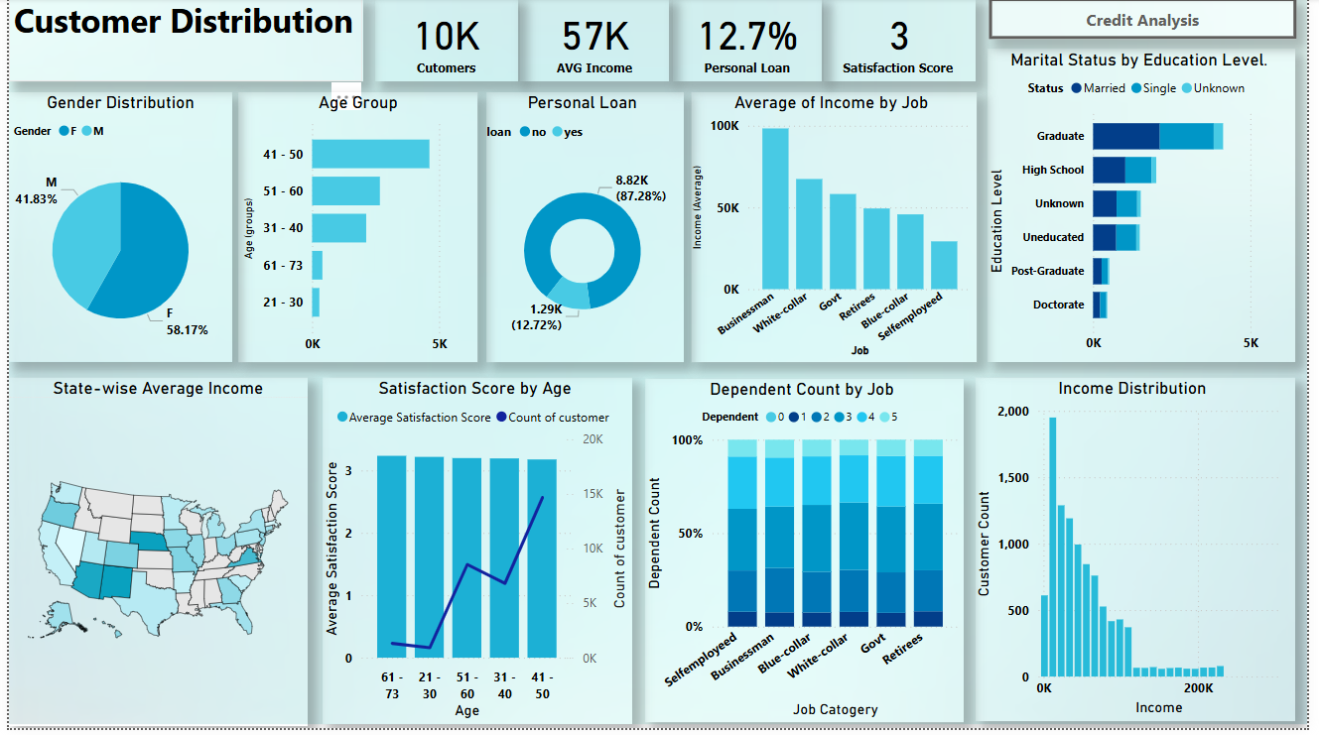

**Key Metrics (KPI Cards):**

The dashboard highlights key financial and customer insights:

* **Total Customers:** **10K**
* **Average Income:** **$57K**
* **Personal Loan Holders:** **12.7%**
* **Average Satisfaction Score:** **3**

**Key Visuals & Components**

* **Gender Distribution (Pie Chart)**  
  Represents the proportion of male and female customers.
* **Age Group Distribution (Bar Chart)**  
  Displays customer count across different age groups.
* **Personal Loan Status (Donut Chart)**  
  Shows the proportion of customers with and without a personal loan.
* **Income Distribution (Histogram)**  
  Categorizes customers based on income bins, providing an overview of income levels.
* **Average Income by Job (Bar Chart)**  
  Compares average income across different job categories.
* **Marital Status vs. Education Level (Stacked Bar Chart)**  
  Displays the distribution of marital status across various education levels.
* **State-wise Income Analysis (Map Visualization)**  
  Visualizes income distribution across different states.

**Tooltips include:**

* + Average Income
  + Highest Income in the State
  + Lowest Income in the State
* **Satisfaction Score by Age (Line Chart)**  
  Represents the average satisfaction score across different age groups.
* **Dependent Count by Job (Stacked Bar Chart)**  
  Displays the number of dependents per job category.
* **Navigation Button**  
  A **"Credit Analysis"** button allows users to navigate to the **"Credit Card Portfolio Analysis"** dashboard.

**Key Insights**

1. **Customer Satisfaction Trends (Line Chart)**
   * Satisfaction scores range from 3.18 to 3.23 across age groups.
   * Most Satisfied: 61-73 years (3.23).
   * Least Satisfied: 41-50 years (3.18), a focus area for improvement.
2. **Customer Distribution by Gender (Pie Chart)**
   * Male: 41.83%
   * Female: 58.17% (majority), indicating possible gender-based service preferences.
3. **Age Group Distribution (Bar Chart)**
   * Largest Group: 41-50 years (4,619 customers).
   * Second Largest: 51-60 years (2,669 customers).
   * Helps in targeted marketing.
4. **Personal Loan Status (Donut Chart)**
   * Loan Holders: 12.72%
   * Non-Loan Holders: 87.28% (potential for loan promotions).
5. **Income Distribution (Histogram)**
   * Shows customer income ranges, aiding financial planning and product targeting.
6. **Average Income by Job (Bar Chart)**
   * Highest Income: Businessman.
   * Lowest Income: Self-employed.
   * Helps tailor financial products by job category.
7. **Marital Status vs. Education Level (Stacked Bar Chart)**
   * Married individuals with higher education likely have better financial stability.
   * Singles with lower education may need tailored financial products.
8. **State-wise Income Analysis (Map)**
   * Displays average, highest, and lowest incomes per state.
   * Helps businesses adjust strategies based on regional income disparities.
9. **Dependent Count by Job (Stacked Bar Chart)**
   * High dependents in Self-employed, Businessman, and Blue-collar jobs.
   * Retirees have fewer dependents.

**Challenges & Solutions**

• **Income distribution needed more clarity:**

* **Solution:** Created **Income Bins** to categorize salary levels properly.

• **Satisfaction score variations were unclear:**

* **Solution:** Added **Satisfaction Score by Age** for better segmentation.

**Conclusion & Future Improvements**

**Project Outcome:**

The Customer Distribution Dashboard provides valuable insights into demographics, financial behaviour, and satisfaction levels, enabling businesses to make data-driven decisions to enhance customer engagement and financial service offerings. Key takeaways include:

* **Customer Base Analysis:** The dashboard highlights 10K total customers, with 58.17% female and 41.83% male.
* **Satisfaction Trends:** Customer satisfaction scores range from 3.18 to 3.23, with the 41-50 age group showing the lowest satisfaction levels.
* **Income Insights:** The average income is $57K, with clear income disparities across states and job categories.
* **Loan Adoption Rate:** 12.7% of customers have personal loans, presenting an opportunity for financial institutions to expand offerings.
* **Demographic Trends:** The analysis of age, job, and dependents provides a deeper understanding of customer profiles and financial needs.

**Future Enhancements**

To further improve the dashboard and enhance its analytical depth, the following enhancements are recommended:

* **Advanced Customer Segmentation:** Implement AI-driven segmentation to analyse customer behaviour more effectively.
* **Interactive Filters:** Allow users to dynamically filter data based on job, region, and income level for customized analysis.
* **Predictive Analytics**: Introduce forecasting models to predict customer behaviour, loan adoption trends, and satisfaction shifts.
* **Enhanced Satisfaction Analysis:** Analyse satisfaction by gender and income to uncover deeper insights.
* **Improved Income Analysis:** Show income ranges or distributions within each job category and explore correlations with credit utilization or loan defaults.
* **Loan & Income Relationship**: Investigate how dependents, job type, and income levels influence loan adoption rates.

By integrating these enhancements, the dashboard will offer deeper insights, helping businesses make strategic decisions to enhance customer experience, financial services, and targeted marketing strategies.

**Dashboard Pictures**

**Dashboard 1: Credit Card Analysis**

**Customer Behaviour & Segmentation**

**Fig 1: Using Slicer: Blue card category selected**

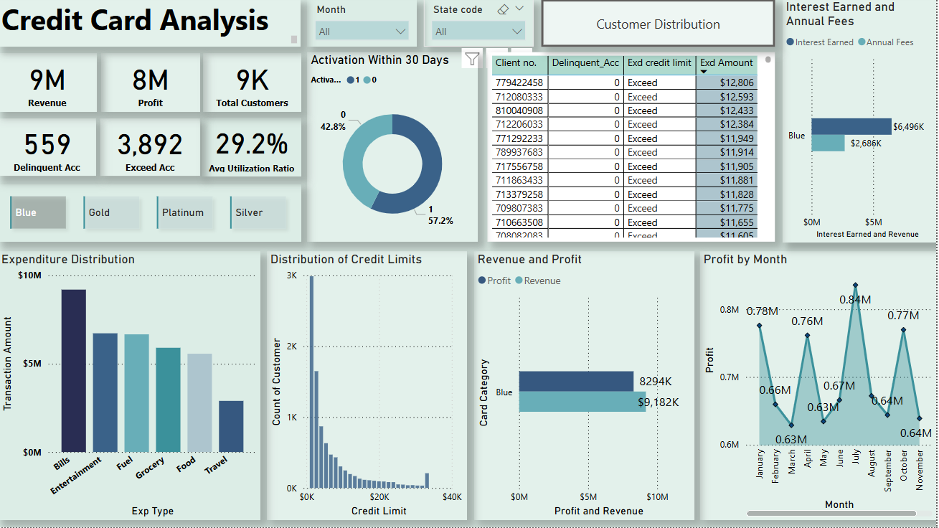

**Fig 2: Tooltip for Expenditure Distribution Fig 3: Tooltip Page**

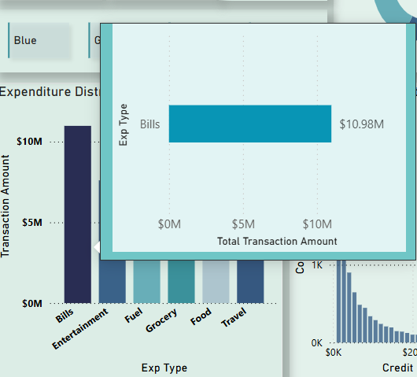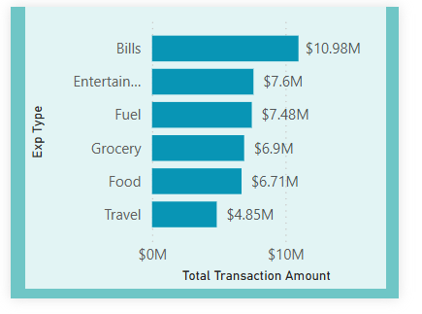

**Fig 4: Using Slicer: Month**

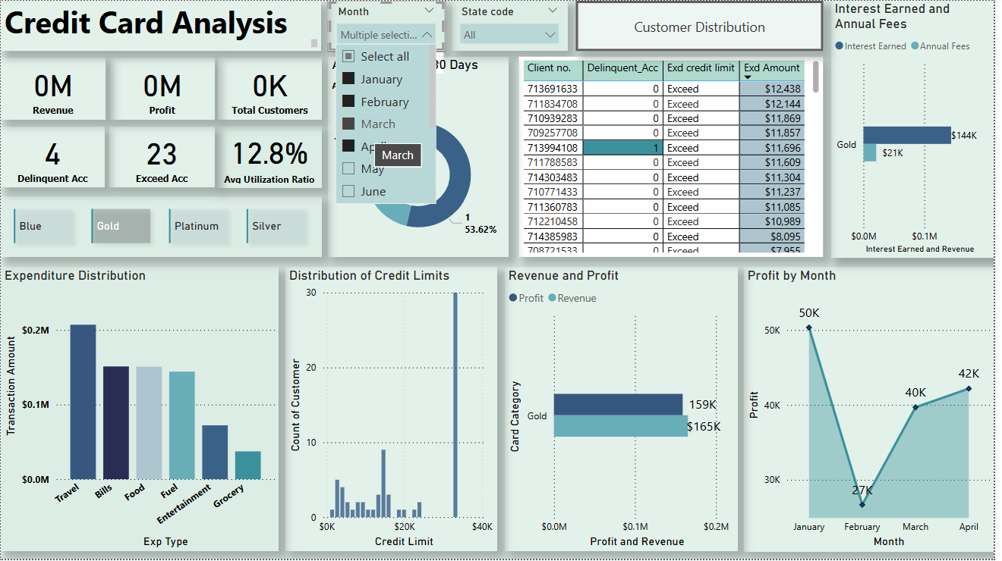

**Fig 5: Using Slicer: State code**

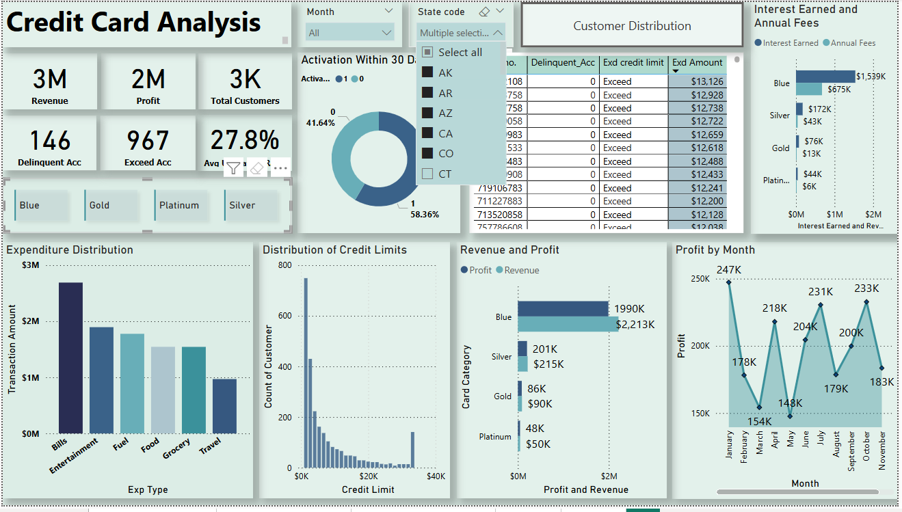

**Fig 6: Page Navigation Button**

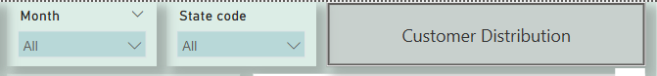

**Dashboard 2: Customer Distribution**

**Fig 1: Tooltip on map (used Dax code)**

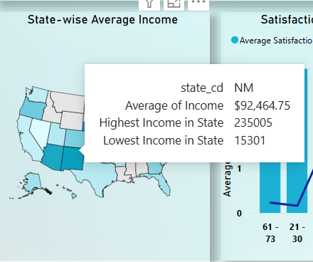

**Fig 2: Page Navigation Button**

