ASG Airlines Data Platform
Ingestion, cleaning, modelling and reporting over the ASG Airlines operational workbook
Run 20260905T205437Z-c1a716 | generated 2026-09-05

1. Problem statement and scope
The source is a single Excel workbook of four sheets - flights, bookings, payments and passengers - holding 4,059 rows of operational airline data with deliberately injected quality defects. The task is to build a pipeline that ingests it, resolves those defects defensibly, models the result for analysis, protects the personal data it carries, and reports the KPIs the business asked for.
Scope covers ingestion through to a Power BI dataset: a layered pipeline with a declarative validation rule set, a documented quarantine path, a star schema in DuckDB, PII tokenisation, and four report pages. Out of scope are streaming ingestion, a scheduler, and any production secret management beyond an environment variable, all of which are addressed as a migration path rather than implemented.
One requirement could not be met as literally stated, and that is a finding rather than a gap: the brief asks for delay analysis, and the workbook contains no scheduled-versus-actual timestamp pair from which any delay could be derived. Section 10 states what was built instead and exactly which two columns would be needed to compute true on-time performance.

2. Source dataset structure
Every figure below was measured from the workbook rather than assumed. The full profiling output is in reports/profile.md.

flights
1,020 rows x 7 columns
column | type | nulls | distinct | issues found
flight_id | str | 0 | 1004 | 1,004 unique of 1,020. 16 duplicated: 15 byte-identical, 6F250 conflicting.
airline | str | 41 | 5 | 41 null, 31 literal UNKNOWN, 4 real carriers.
source | str | 0 | 6 | 6 cities, all 30 ordered pairs present, no self-routes.
destination | str | 0 | 6 | As source.
departure_time | datetime64[us] | 0 | 981 | Spans four days, 2026-04-17 to 2026-04-20.
arrival_time | datetime64[us] | 0 | 969 | Precedes departure on SJ192 only.
duration | object | 0 | 270 | Mixed type: 1,019 datetime.time, 1 datetime.datetime (Excel negative time).

bookings
1,000 rows x 9 columns
column | type | nulls | distinct | issues found
booking_id | str | 0 | 1000 | Unique, no duplicate rows.
passenger_id | str | 0 | 636 | No orphans against passengers.
flight_id | str | 0 | 984 | No orphans against flights. 32 rows point at duplicated ids.
booking_date | datetime64[us] | 0 | 552 | 2025-04-17 to 2026-04-17, 342 distinct dates. The only usable time axis.
status | str | 45 | 4 | 45 null, 30 literal INVALID, 3 valid values.
passport_number | str | 0 | 1000 | 100% matches ^[A-Z]d{7}$. Dropped at the silver boundary.
seat_number | str | 0 | 202 | No duplicate (flight_id, seat_number) pairs.
emergency_contact_name | str | 0 | 998 | Third-party PII. Dropped at the silver boundary.
emergency_contact_phone | str | 0 | 1000 | 100% matches +91 format. Dropped at the silver boundary.

payments
1,000 rows x 4 columns
column | type | nulls | distinct | issues found
payment_id | str | 0 | 1000 | Unique.
booking_id | str | 0 | 637 | No orphans. 1,000 payments across 637 bookings.
amount | object | 48 | 922 | Three Python types: 961 float, 9 int, 30 str (all literal INVALID). 48 null.
payment_method | str | 0 | 3 | UPI 358, CARD 329, NETBANKING 313, no nulls.

passengers
1,039 rows x 9 columns
column | type | nulls | distinct | issues found
passenger_id | str | 0 | 1000 | 1,000 unique of 1,039. 36 duplicated, all conflicting, none identical.
first_name | str | 0 | 31 | Varies within 11 of 36 duplicate groups.
last_name | str | 10 | 38 | 10 null. Varies within 17 of 36 duplicate groups.
age | int64 | 0 | 89 | 1 to 89, 227 under 18. Consistent with date_of_birth in every row.
gender | str | 0 | 2 | M/F only, no nulls, never varies within a duplicate group.
email | str | 0 | 1039 | Varies within all 36 duplicate groups.
phone | str | 0 | 1039 | 100% matches +91 format. Varies within all 36 groups.
aadhaar_id | int64 | 0 | 1039 | int64 with leading zeros lost: 925 are 12 digits, 109 are 11, 5 are 10.
date_of_birth | datetime64[us] | 0 | 1011 | Varies within all 36 groups. Dropped at the silver boundary.

3. Architecture
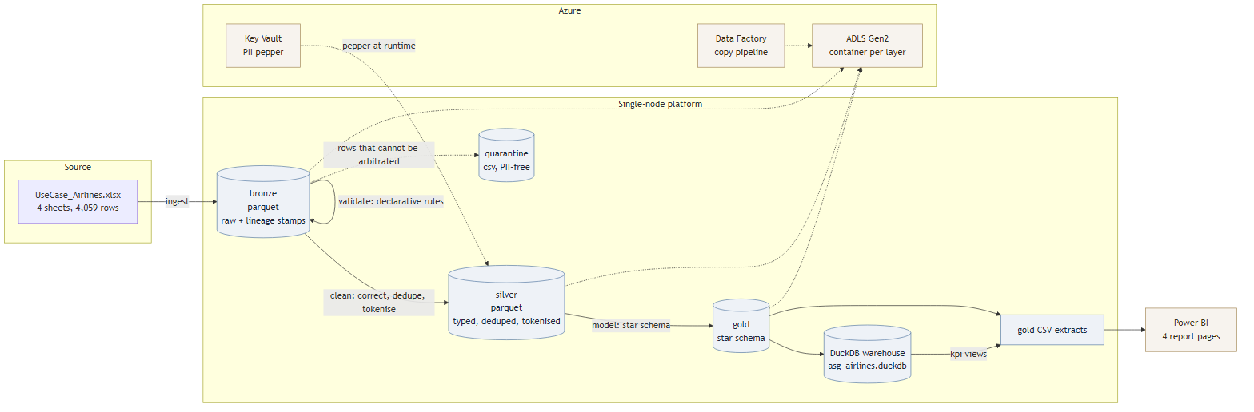
Figure 1: platform architecture
The pipeline is a medallion build. Bronze holds the source values as read, in Parquet, stamped with run_id, ingested_at, source_sheet and a row_hash. Nothing is corrected there, because the layer's job is to make the run reproducible and to give every later assertion something to be checked against. The row_hash in particular does real work later: byte-identical duplicate detection compares hashes within a key group rather than re-comparing columns.
Silver holds typed, corrected, deduplicated and tokenised data. This is where the business rules live and where the PII boundary sits: no raw identifier crosses it. Quarantine sits beside silver and holds rows that could not be arbitrated, each with the rule that rejected it and the run that rejected it.
Gold holds the star schema, written both to a DuckDB database - so the keys and the KPI logic are expressible in SQL - and to CSV extracts for Power BI. DuckDB is the warehouse rather than a served database because it is a single file, requires no server, and reads Parquet natively, which keeps the whole platform reproducible from a clean checkout.

Why not Spark or Databricks
1,020 flight records is a single-node problem. Spinning up a Spark cluster for 4,059 rows costs more in start-up than the entire transform takes; the full pipeline here runs end to end in under a second. The architecture was chosen so that this is a deployment decision rather than a design constraint: the stage boundaries in src/pipeline.py map one to one onto Databricks notebooks or Data Factory activities, so moving to Spark is a change of executor, not a rewrite.
The threshold for that move is where the flight table stops fitting comfortably in memory - on the order of tens of millions of rows - or where ingestion becomes continuous rather than batch. Section 12 sets out that path.

4. Data flow
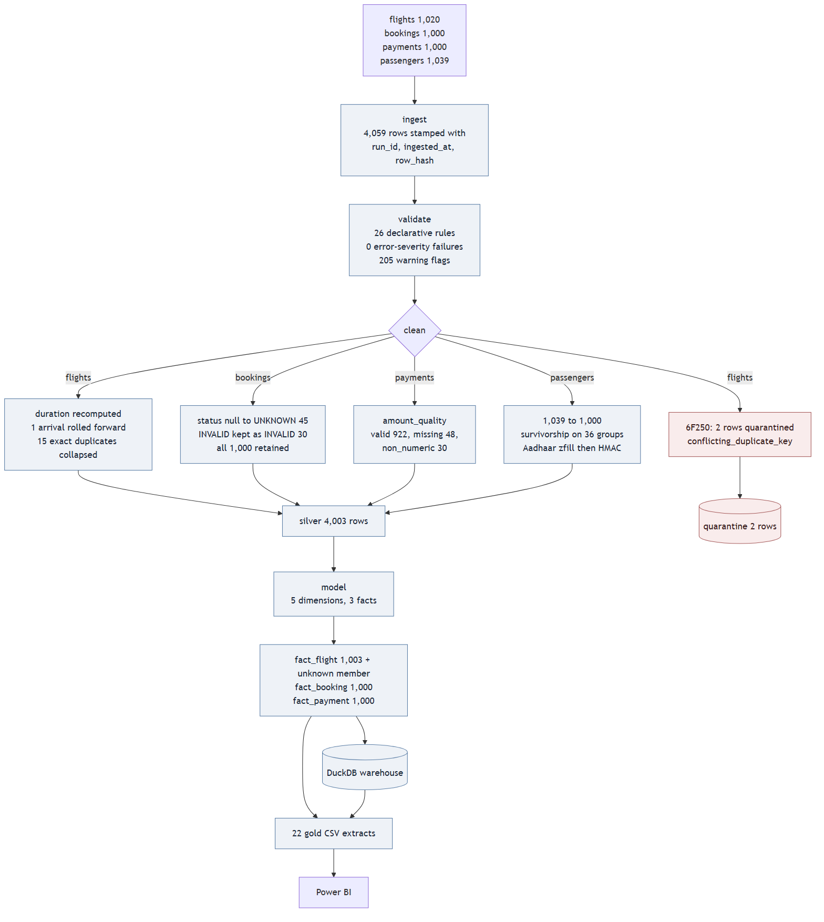
Figure 2: stage-by-stage data flow
Row counts for this run, taken from reports/run_manifest.json:
name | duration_seconds | rows_in | rows_out | rows_quarantined | status
kpi | 0.402 | 4471 | 123 | 0 | ok

Ingested 4,059 rows: flights 1,020, bookings 1,000, payments 1,000, passengers 1,039. Silver retains 4,003. The 56-row difference is 15 byte-identical flight duplicates collapsed, 39 passenger duplicates resolved by survivorship, and 2 rows quarantined. No row was dropped for being incomplete.

5. Data model
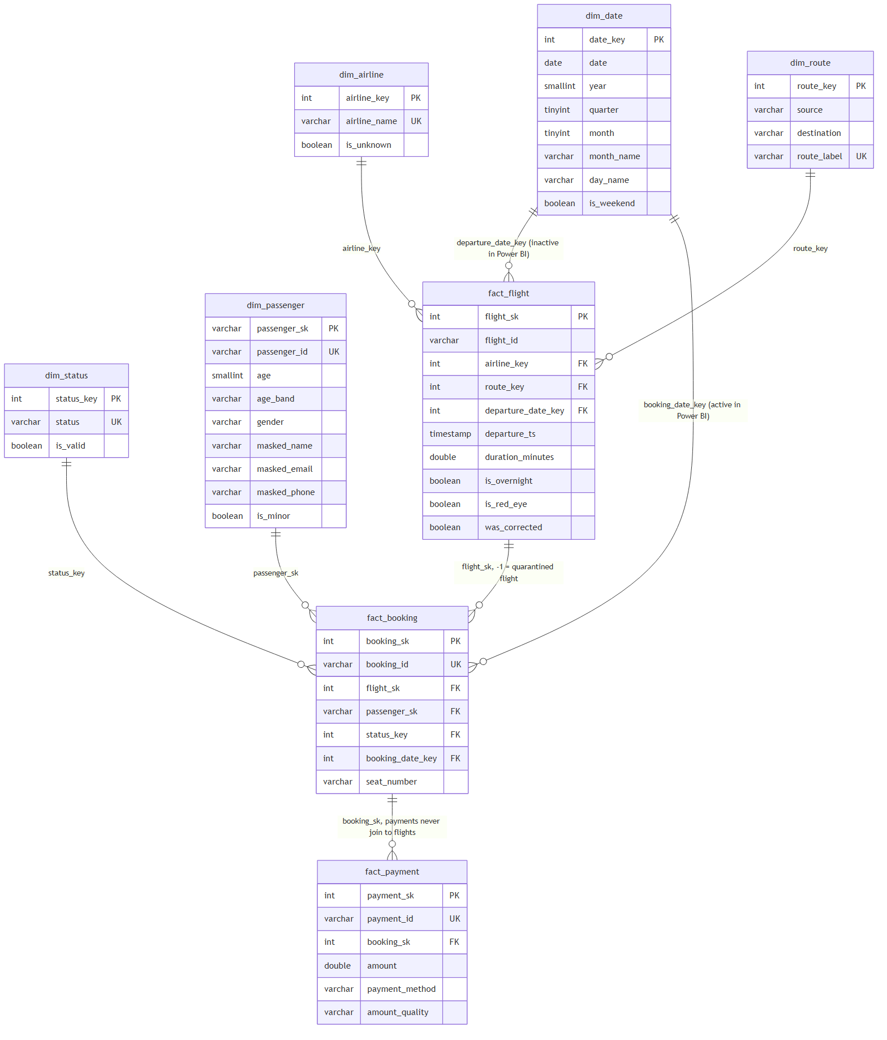
Figure 3: star schema
Five dimensions and three facts. The grain of each fact is stated here because every correctness argument in this document depends on it:
- fact_flight: one row per surviving flight_id, plus one unknown member at flight_sk = -1.
- fact_booking: one row per booking_id. 1,000 rows, always.
- fact_payment: one row per payment_id. 1,000 rows across 637 bookings.

The fan-out, and how the model prevents it
Joining bookings out to flights and payments in one query returns 1,404 rows from 1,000 bookings. Two separate fan-outs cause it: 16 flight_ids appeared twice in the source (1,000 to 1,032 rows), and 637 bookings carry 1,000 payments (1,000 to 1,363 rows). Summing amount across that join gives 7,593,758.92 against a true total of 7,385,142.98 - an inflation of 208,615.94, or 2.82%.
The model prevents this in two ways. Deduplication runs before modelling so flight_sk is unique in fact_flight - that dependency is the reason the stages are ordered as they are. And fact_payment stays at payment grain, joined to fact_booking and never to fact_flight, so a revenue measure cannot reach a flight join. Both are enforced by tests: tests/test_model.py asserts the source-level inflation figure and that the star schema does not reproduce it.

Keys and the date dimension
Primary and foreign keys are declared in sql/01_dimensions.sql and sql/02_facts.sql rather than only in pandas, so the referential contract is visible to anyone reading the warehouse. dim_date spans 2025-04-01 to 2026-05-31 because bookings cover twelve months while flights cover four days in April 2026.
In Power BI dim_date takes an active relationship to fact_booking[booking_date_key] and an inactive one to fact_flight[departure_date_key], activated per measure with USERELATIONSHIP. The alternative - two separate date tables - was rejected because it duplicates the calendar, breaks a single date slicer synced across pages, and leaves two fields that look interchangeable to a report author but are not.
Bookings whose flight was quarantined point at flight_sk = -1 rather than being dropped, so booking counts stay whole. The consequence is visible and intended: route rollups sum to 998 bookings, not 1,000.

6. Assumptions
Each assumption is stated with the evidence supporting it. The full list, including what would change each decision, is in docs/ASSUMPTIONS.md.
1. A negative duration is a midnight rollover failure, not a bad record. SJ192 gives -1,140 minutes raw. Adding one day to the arrival gives exactly 300 minutes, and the source duration column independently reads 05:00:00 for that row. Two fields agree, so this is a reconciliation rather than a guess.
2. The source duration column is a witness, not the authority. Duration is always recomputed from the timestamps. The stored column is parsed only to reconcile against, because it is mixed-type and a stored duration cannot outrank the timestamps it describes.
3. Byte-identical duplicates and conflicting duplicates need different treatments. 15 of 16 duplicated flight_ids are byte-identical and collapse to one. 6F250 disagrees on source city and both timestamps, so no survivor is justifiable and the whole group is quarantined.
4. Passenger duplicates need survivorship, not a drop. All 36 duplicate groups conflict and none is byte-identical, so drop_duplicates() would keep whichever row pandas saw first. The rule is: fewest nulls, then a full 12-digit Aadhaar, then the lowest email. It resolved 10, 5 and 21 groups respectively.
5. A null and a sentinel are different upstream failures. airline has 41 nulls and 31 UNKNOWN strings; status has 45 nulls and 30 INVALID; amount has 48 nulls and 30 INVALID. Each pair maps to one analytical bucket but is counted separately, because they point at different problems in the source system.
6. Aadhaar lost leading zeros to integer typing. 925 values are 12 digits, 109 are 11, 5 are 10, with nothing shorter. That distribution is the signature of int64 storage, not of data entry error. Values are zero-padded to 12 before hashing.
7. Nothing merely incomplete is deleted. Quarantine is reserved for rows that are structurally unusable or ambiguous. 2 rows of 4,059 are quarantined; everything else is flagged and retained.
8. Revenue has two correct answers. Gross revenue is every valid payment; confirmed revenue is the subset against CONFIRMED bookings. 306 payments sit against CANCELLED bookings, so both are always reported together.
9. booking_date is the only usable time axis. Bookings span 342 distinct dates across twelve months; flights span four days. Any trend visual sits on booking_date, and flights are profiled by departure hour instead.
10. Route duration describes the data, not a schedule. Within BOM-CCU alone durations run 33 to 293 minutes across 90 flights, so duration is reported as mean with standard deviation and never as a point estimate.

7. Data cleaning logic
Each rule below states its trigger, its action and how many rows it touched in this run. Rules are applied in this order; the ordering matters where noted.
rule | trigger | action | rows
Recompute duration | Always | duration_minutes = arrival_ts - departure_ts | 1020
Roll arrival forward | Recomputed duration < 0 | arrival_ts + 1 day, was_corrected = True | 1
Quarantine uncorrectable duration | Still negative, or > 24 hours | Quarantine, reason uncorrectable_duration | 0
Collapse exact duplicate flights | Same flight_id, identical row_hash | Keep one row | 15
Quarantine conflicting flight keys | Same flight_id, differing business columns | Quarantine all rows of the group, exclude id from fact_flight | 2
Reroute affected bookings | Booking references a quarantined flight | flight_sk = -1, booking retained | 2
Normalise airline | airline null or literal UNKNOWN | airline_clean = UNKNOWN, is_unknown = True, counted separately | 72
Normalise status | status null or literal INVALID | UNKNOWN or INVALID, is_valid = False, row retained | 75
Classify amount | amount null or non-numeric | amount_quality missing or non_numeric, amount NULL, row retained | 78
Passenger survivorship | Duplicated passenger_id | Fewest nulls, then 12-digit Aadhaar, then lowest email; all logged | 75
Keep nameless passengers | last_name null | masked_name from first_name alone, flagged | 10
Tokenise Aadhaar | Always | zfill(12) then HMAC-SHA-256, truncated, prefixed PSG_ | 1039
Drop direct identifiers | Always | date_of_birth, passport_number, emergency_contact_* removed | 2039

The dependency worth stating: deduplication has to complete before modelling, because fact_flight requires a unique flight_sk. Reversing those two stages would either produce duplicate surrogate keys or force the model to arbitrate a conflict it has no information to resolve.

Validation rules
Structural checks are declared in config/validation_rules.yaml rather than hard-coded, and interpreted by src/validate.py. Each rule names a table, a column, a type (not_null, regex, in_set, range, unique, referential), parameters and a severity: error routes a row to quarantine, warning flags and retains it. 26 rules ran in this run with 0 error-severity failures and 205 warning-severity flags, which is itself the finding - the data is structurally well-formed and its problems are all semantic.
table | ingested | flagged | quarantined | collapsed_duplicates | retained | dq_score
flights | 1020 | 68 | 2 | 15 | 1003 | 0.9314
bookings | 1000 | 75 | 0 | 0 | 1000 | 0.925
payments | 1000 | 78 | 0 | 0 | 1000 | 0.922
passengers | 1039 | 107 | 0 | 39 | 1000 | 0.897

8. Transformation logic

Duration
Duration is recomputed for every flight as arrival_ts minus departure_ts, in minutes. The stored duration column is never used as the value, for two reasons: it is a mixed-type object column that pandas cannot parse uniformly, and a stored aggregate should not outrank the fields it summarises. It is parsed separately, for every row where it is readable, purely as a reconciliation source.
Where the recomputed duration is negative, exactly one day is added to the arrival timestamp and the duration is recomputed. The row is marked was_corrected = True with correction_reason = arrival_rolled_forward_one_day. If it is still negative, or longer than 24 hours, the row is quarantined instead - the correction is applied once, not iterated until the number looks reasonable.

SJ192, worked through
SJ192 departs 2026-04-19 at 18:45:42 and arrives 2026-04-18 at 23:45:42. Recomputed naively that is -1,140 minutes. Its stored duration cell holds datetime.datetime(1899, 12, 29, 5, 0), which is how Excel represents a negative duration and which pd.to_timedelta raises on; parsed for its time component it reads 05:00:00, or 300 minutes.
Adding one day to the arrival gives 2026-04-19 23:45:42 and a recomputed duration of exactly 300 minutes - matching the stored column exactly. The correction is therefore not an assumption about what the data ought to say; it is two independent fields agreeing once the date rollover is repaired. The pipeline reports this as a reconciliation: across all 1,020 flights, exactly one row disagrees with its stored duration before the correction, by exactly 1,440 minutes, and none disagrees after.

Overnight and red-eye
is_overnight is true when the departure date differs from the arrival date. is_red_eye is true when the departure hour falls between 22:00 and 04:59. These are different measures and both are kept: 122 flights are overnight and 271 are red-eye in this run. 125 flights crossed midnight in the raw data and were already correct there; the difference is accounted for by the duplicates collapsed and by SJ192, which stops being overnight once its arrival is repaired.

Tokenisation
aadhaar_id is cast to string and zero-padded to 12 digits, then passed through HMAC-SHA-256 keyed with a pepper from the environment, truncated to 16 hex characters and prefixed PSG_ to form passenger_sk. The order matters: hashing before padding gives the same person two different surrogate keys, because 114 of 1,039 values lost leading zeros to int64 storage. That ordering is asserted by a test.

9. PII and access control
Ten source fields carry personal data. Four survive to gold in masked or tokenised form, six are dropped entirely. The full inventory, role matrix and Azure mapping are in docs/SECURITY.md; the summary follows.
field | treatment | in gold
aadhaar_id | zfill(12) then keyed HMAC-SHA-256, truncated | As passenger_sk
first_name | Masked to first name plus surname initial | masked_name
last_name | Reduced to an initial | No
email | Masked to f***l@domain | masked_email
phone | Masked to +91-XXXXXX plus last 4 | masked_phone
date_of_birth | Dropped at the silver boundary | No
passport_number | Dropped at the silver boundary | No
emergency_contact_name | Dropped at the silver boundary | No
emergency_contact_phone | Dropped at the silver boundary | No
age | Retained with age_band | Yes

The tokenisation is keyed rather than a plain hash for a specific reason. An Aadhaar number is 12 digits, a keyspace of 10^12, which a laptop enumerates in minutes: a plain SHA-256 column can be reversed by building the lookup table. HMAC with a pepper held outside the repository makes the token useless without the key while staying deterministic, so joins survive across runs.
Age is retained and date of birth is not, because age alone does not identify anyone while date of birth plus a name is a standard re-identification key. The emergency contact fields belong to third parties and no KPI needs them, so they are dropped rather than masked - the cheapest control for data you do not need is not to carry it.
The boundary is enforced by a test, not by convention: tests/test_no_pii_leak.py scans every gold and quarantine CSV for forbidden column names, raw phone and passport patterns, unmasked email addresses, Aadhaar-shaped digit strings and date-of-birth-shaped columns. It was verified against a deliberately poisoned file to confirm it fails when it should.
Known gaps, stated plainly: pepper rotation is not implemented and would invalidate every surrogate key; there is no audit log on raw access in the local build; and there is no column-level encryption at rest beyond the platform default.

10. KPI definitions
Every KPI below is defined once in sql/03_kpi_views.sql and once in powerbi/measures.dax, so the report and the warehouse can be reconciled against each other.
kpi | formula | value
Average flight duration | AVG(fact_flight.duration_minutes), unknown member excluded | 164.67 min
Duration spread | STDDEV_SAMP over the same population | 77.39 min
Route-wise traffic | COUNT(fact_booking) by route, aggregated at booking grain | 998 across 30 routes
Flights by airline | COUNT(fact_flight) by dim_airline | 4 carriers plus 67 UNKNOWN
Gross revenue | SUM(fact_payment.amount) where amount_quality = valid | 7,385,142.98
Confirmed revenue | Same, filtered to bookings with status CONFIRMED | 2,471,402.04
Cancellation rate | CANCELLED bookings / all bookings | 31.40%
Confirmation rate | CONFIRMED bookings / all bookings | 32.00%
Payment coverage | DISTINCT bookings with >= 1 payment / all bookings | 63.70%
Average ticket value per booking | Gross revenue / distinct paid bookings, not per payment | 11,593.63
Bookings per flight | Bookings / flights | 0.997
Red-eye share | Departures between 22:00 and 04:59 / all flights | 27.02%
Overnight share | Departure date != arrival date / all flights | 12.16%
Data quality score | 1 - (quarantined + flagged) / ingested, per source table | 0.9188 mean

Delay: what was built instead, and why
The brief asks for delay analysis. Operational delay is the difference between a scheduled time and an actual time, and this workbook holds exactly one departure timestamp and one arrival timestamp per flight, with no scheduled counterpart to difference them against. There is no transformation that recovers a delay from this data, and inventing one - treating a route average as a schedule, for instance - would produce a number that looks like on-time performance and means nothing.
What is computable is an anomaly rate, so an anomaly taxonomy was defined instead, with each category counted against the source table it belongs to. Adding scheduled_departure and scheduled_arrival to the source is the entire fix: with those two columns, departure delay, arrival delay and an on-time percentage at any threshold all follow immediately from the existing model.
anomaly | scope_table | count | scope_rows | rate_pct
aadhaar_length_anomaly | passengers | 114 | 1039 | 10.972
booking_on_quarantined_flight | bookings | 2 | 1000 | 0.2
booking_without_payment | bookings | 363 | 1000 | 36.3
conflicting_duplicate_key | flights | 2 | 1020 | 0.196
duplicate_passenger_id | passengers | 75 | 1039 | 7.218
exact_duplicate | flights | 15 | 1020 | 1.471
flight_without_booking | flights | 20 | 1020 | 1.961
missing_airline | flights | 41 | 1020 | 4.02
missing_amount | payments | 48 | 1000 | 4.8
missing_last_name | passengers | 10 | 1039 | 0.962
missing_status | bookings | 45 | 1000 | 4.5
negative_duration | flights | 1 | 1020 | 0.098
non_numeric_amount | payments | 30 | 1000 | 3.0
sentinel_airline | flights | 31 | 1020 | 3.039
sentinel_status | bookings | 30 | 1000 | 3.0
uncorrectable_duration | flights | 0 | 1020 | 0.0

11. Dashboard walkthrough

Executive Overview
The headline figures and the two trends that matter: bookings by month, which is the only defensible time axis in this data, and flights by airline, where the UNKNOWN bar is left visible because hiding 67 unattributed flights would overstate every carrier's share. Gross and confirmed revenue appear side by side, never one alone.
[ 01_executive_overview.png not generated yet ]
Figure: Executive Overview

Duration and Schedule
Duration by airline and by route, always with its standard deviation, plus the distribution and the departure-hour profile. There is deliberately no flights-per-day chart: flights span four days and such a chart would have four points. Overnight and red-eye are shown as separate measures because they are different questions.
[ 02_duration_schedule.png not generated yet ]
Figure: Duration and Schedule

Route and Airline Performance
The route matrix carries flights, bookings, average duration with spread, revenue and cancellation rate for all 30 routes. Bookings sum to 998 rather than 1,000 because the two bookings on the quarantined 6F250 sit on the unknown flight member and have no route - visible rather than patched.
[ 03_route_airline.png not generated yet ]
Figure: Route and Airline Performance

Data Quality and Anomalies
Anomaly counts by type against the right denominators, quality score per source table, the row-count waterfall from 4,059 ingested to 4,003 retained, the missing-versus-sentinel breakdown that keeps nulls and INVALID strings apart, and the two quarantined rows in full. Red is used on this page and nowhere else.
[ 04_data_quality.png not generated yet ]
Figure: Data Quality and Anomalies

12. Scalability
The path to 100 million rows changes the executor and the storage layout, not the shape of the pipeline. Stage boundaries stay where they are; each one becomes a Databricks notebook or a Data Factory activity.
- Partition bronze by ingest date, so a run reads only new partitions rather than the whole history.
- Swap pandas for Spark at the same stage boundaries. The transformations are already expressed as whole-table operations rather than row loops, so they translate directly.
- Push the star schema into Delta or Synapse, keeping the same keys and the same grain declarations.
- Aggregate at silver to gold rather than re-reading raw on every run; the KPI views become materialised tables refreshed on a schedule.
- Add an incremental watermark on booking_date, and switch the source from a full-file reload to change data capture.
- Move the row_hash from a per-row apply to a hash of concatenated columns computed in the engine, which is the one place the current implementation would not scale linearly.
Orchestration maps the same way. The declared stage list, its dependency order and the per-stage counters in run_manifest.json are the same information an orchestrator holds; moving to Data Factory or Dagster replaces the runner while the stage contracts, the fail-fast versus quarantine policy and the manifest stay as they are.

13. Error handling, logging and idempotency
The pipeline distinguishes two classes of failure. A schema violation - a missing sheet, a missing required column - fails the run immediately, because the pipeline can quarantine a bad row but cannot infer a column that is not there, and a silent partial load is worse than a stopped one. A row-level failure quarantines the row and the run continues, with the reason and the run_id recorded alongside it.
Every stage records its name, start and end time, duration, rows in, rows out, rows quarantined and status. Those counters are written to reports/run_manifest.json, which is diffable between runs, and the same events are logged to stdout and to reports/logs/{run_id}.log. A failed run still writes its manifest, marked failed, with the stage that broke.
The pipeline is idempotent. Surrogate keys are deterministic - passenger_sk is a keyed hash of a business value rather than a sequence - layers are overwritten by run_id, and the DDL drops and recreates the warehouse tables in dependency order. Running it twice over the same input produces byte-identical gold CSVs, which was verified by checksumming the outputs of two consecutive runs.
python -m src.pipeline runs end to end from a clean checkout with no arguments. --stage <name> runs a single stage, loading its inputs from the layer on disk. --dry-run validates the configuration and prints the plan without touching data.

14. Known limitations and next steps
- Delay is not computable from this source. Two columns - scheduled_departure and scheduled_arrival - would unlock on-time performance without any other change.
- The validation rule engine is hand-rolled. It is declarative and adequate at this scope, but Great Expectations or dbt tests would bring a maintained rule library, richer reporting and less code to defend.
- The pepper lives in an environment variable. A real deployment needs a secret store and a rotation strategy; rotating today invalidates every passenger_sk.
- Ingestion is a full-file reload. Change data capture on the source would remove the need to re-read unchanged history.
- Route averages describe this dataset rather than a schedule, because durations here are not a deterministic function of route. Any operational use would need scheduled block times.
- The unknown flight member is a single catch-all. At larger scale it would need to be typed by reason, so that quarantined and genuinely-unknown flights are distinguishable in the facts.
- Passenger survivorship keeps one row and logs the rest. A slowly changing dimension would preserve the conflicting versions with validity ranges instead of discarding them, which is what a production identity resolution would do.

