

Certificate: -
This is to certify that the project titled “AI-Based Phishing Website Detection System” has been successfully completed by Abhinav Singh Kashyap, Paramvir Singh Saini, Aditya Singh, and Vishwesh Tiwari in partial fulfilment of the requirements for the award of the degree in [CSE-AI], under my guidance and supervision during the academic year [Academic Year].
The work embodied in this project report has not been submitted elsewhere for the award of any other degree or diploma.

Signature of Guide Signature of HOD
[Guide Name] [HOD Name]

Acknowledgement
We would like to express our sincere gratitude to our project guide, [Youtube], for their invaluable guidance, continuous encouragement, and constructive feedback throughout the course of this project.
We extend our thanks to the faculty members of the [Department Name] Department for providing the knowledge and resources that made this project possible. We are also grateful to our friends and family for their constant support and motivation.
Finally, we thank [College Name] for providing the platform and infrastructure necessary to carry out this project successfully.

Abstract
Phishing is one of the most widespread forms of cybercrime, in which attackers create fraudulent websites that mimic legitimate ones to steal sensitive information such as usernames, passwords, and financial details. With thousands of new phishing websites appearing every day, traditional detection approaches such as blacklisting fail to identify newly created threats in real time.
This project presents an AI-Based Phishing Website Detection System that uses Machine Learning to classify URLs as either legitimate or phishing. The system is trained on a labelled dataset of website URLs using natural-language-style text processing (tokenization and vectorization) combined with classification algorithms such as Logistic Regression, Naive Bayes, Random Forest, and Decision Tree. After comparative evaluation, the best-performing model is selected and deployed.
The solution is built using Python, Scikit-Learn, Pandas, and NumPy for the machine learning pipeline, and Flask with HTML, CSS, and Bootstrap for the web interface. Users can enter a URL through a simple web page, and the system instantly predicts whether the website is safe or potentially malicious.
The trained model achieves high accuracy, precision, recall, and F1 score on the test dataset, demonstrating that machine learning is an effective and scalable approach for real-time phishing detection. The project concludes with a discussion of its advantages, limitations, and future scope, including browser extensions, mobile applications, and real-time API integration.

Table of Contents

Certificate 2
Acknowledgement 3
Abstract 4
Table of Contents 5
Chapter 1: Introduction 7
1.1 What is Phishing? 7
1.2 Types of Phishing 7
1.3 Why Phishing Websites Are Dangerous 8
1.4 Importance of Detecting Phishing Websites 8
Chapter 2: Literature Survey 9
2.1 Traditional URL Detection 9
2.2 Blacklist-Based Detection 9
2.3 Machine Learning Detection 9
2.4 Deep Learning Detection 9
2.5 Comparative Summary 10
Chapter 3: Problem Statement 11
Chapter 4: Objectives 12
Chapter 5: Scope 13
5.1 Current Scope 13
5.2 Future Scope 13
Chapter 6: Technologies Used 14
6.1 Frontend 14
6.2 Backend 14
6.3 Machine Learning 14
6.4 IDE / Development Tools 14
Chapter 7: System Requirements 16
7.1 Hardware Requirements 16
7.2 Software Requirements 16
Chapter 8: System Architecture 17
Chapter 9: Dataset 18
9.1 Dataset Overview 18
9.2 Preprocessing Steps 18
Chapter 10: Machine Learning Model 19
10.1 Algorithms Tried 19
10.2 Algorithm Comparison 19
10.3 Selected Model 19
10.4 Reason for Selection 20
10.5 Training Steps 20
10.6 Generated Files 20
Chapter 11: Website Development 21
11.1 Flask Routing Flow 21
11.2 Project Files 21
Chapter 12: Project Structure 22
Chapter 13: Working Methodology 23
Chapter 14: Screenshots 24
Chapter 15: Testing 25
Chapter 16: Results 26
16.1 Understanding the Metrics 26
16.2 Confusion Matrix 26
Chapter 17: Advantages 28
Chapter 18: Limitations 29
Chapter 19: Future Scope 30
Chapter 20: Conclusion 31
Chapter 21: References 32
Books 32
Websites 32
Appendix 33

Chapter 1: Introduction
The internet has become the backbone of everyday communication, banking, shopping, and social interaction. As more of our personal and financial lives move online, cybercriminals have increasingly turned to social engineering attacks that exploit human trust rather than technical vulnerabilities in software. Phishing is the most common and most successful of these attacks, and it continues to grow in scale and sophistication every year.

1.1 What is Phishing?
Phishing is a type of cyberattack in which an attacker impersonates a trustworthy entity — such as a bank, an e-commerce platform, or a well-known online service — in order to trick victims into revealing sensitive information like usernames, passwords, credit card numbers, or other personal data. This is most commonly done through fake websites that closely resemble the design and URL structure of legitimate sites.
The term “phishing” is a play on the word “fishing” — attackers cast a wide net (typically through email, SMS, or malicious links) and wait for unsuspecting users to “bite” by clicking the link and entering their credentials. Modern phishing kits are so well designed that they can replicate a legitimate login page pixel-for-pixel, making visual inspection alone an unreliable defense.

1.2 Types of Phishing
Phishing attacks take several forms depending on the delivery channel and the level of targeting involved:
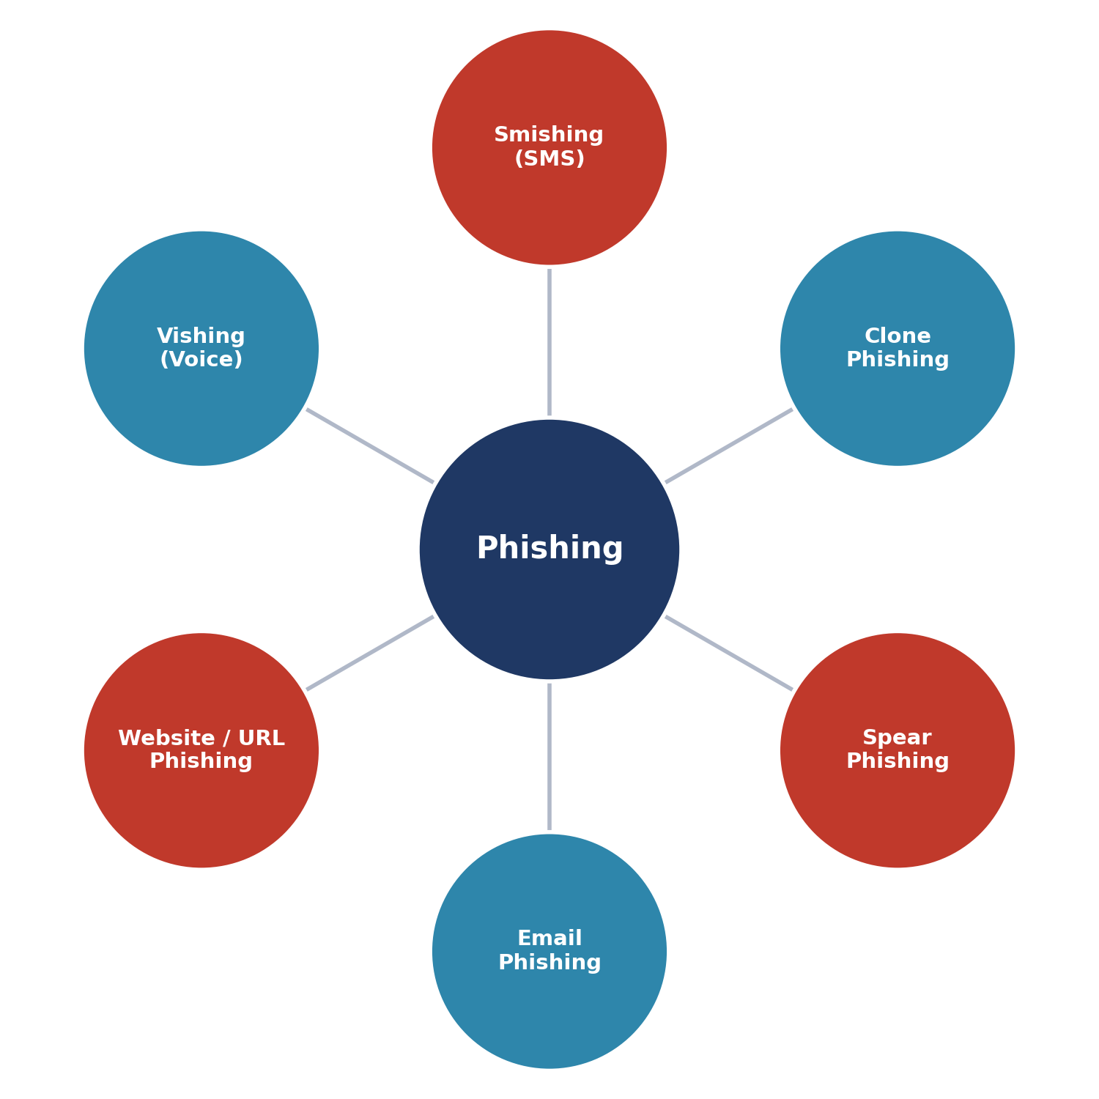
Figure 1.1: Common Types of Phishing Attacks
- Email Phishing – fraudulent emails that direct users to fake websites.
- Spear Phishing – targeted phishing aimed at a specific individual or organization, often personalized using publicly available information.
- Clone Phishing – a legitimate, previously delivered email is copied and its links or attachments replaced with malicious ones.
- Smishing – phishing carried out through SMS text messages, often containing shortened malicious links.
- Vishing – phishing carried out through voice calls, where attackers impersonate bank officials or support staff.
- Website / URL Phishing – fake websites designed to steal login credentials, the primary focus of this project.

1.3 Why Phishing Websites Are Dangerous
Phishing websites are dangerous because they are often indistinguishable from genuine websites at first glance. Attackers frequently register look-alike domains (e.g. replacing a letter, adding a hyphen, or using a different top-level domain), copy the HTML/CSS of the original site, and even obtain SSL certificates to display the padlock icon, giving victims a false sense of security.
Victims may unknowingly enter confidential information, resulting in direct financial loss, identity theft, unauthorized account access, corporate data breaches, and long-term reputational damage to the impersonated organization. According to multiple industry cybersecurity reports, phishing remains one of the leading initial attack vectors behind large-scale data breaches worldwide, frequently ranked above malware and direct network intrusion as the starting point of an attack chain.

1.4 Importance of Detecting Phishing Websites
Early and accurate detection of phishing websites is critical to protecting users and organizations from cyber fraud. Because phishing sites are usually short-lived — often active for only a few hours or days before being taken down — detection systems must be fast, automated, and capable of recognizing patterns in URLs that have never been seen before.
Automated, intelligent detection systems can analyze a URL in real time and alert the user before any sensitive data is entered, significantly reducing the success rate of phishing campaigns. This is precisely the gap that Machine Learning-based detection aims to fill: the ability to generalize from known phishing patterns to detect brand-new, previously unseen phishing URLs.

Chapter 2: Literature Survey
Phishing detection has been an active area of cybersecurity research for over two decades. Over this period, detection strategies have evolved from simple manual rule-checking to fully automated, self-learning systems. This chapter reviews the major categories of prior work, along with their respective strengths and weaknesses, to establish the motivation for the Machine Learning-based approach adopted in this project.

2.1 Traditional URL Detection
Rule-based systems check URLs against handcrafted heuristics such as the presence of IP addresses instead of domain names, unusual subdomains, excessive URL length, the use of URL-shortening services, or the presence of suspicious keywords like “secure”, “login”, or “verify” embedded in the URL string.
- Advantage: Simple to implement and fast to execute, with minimal computational overhead.
- Disadvantage: Easily bypassed by attackers who adapt their URL patterns and avoid known heuristic triggers.

2.2 Blacklist-Based Detection
This method maintains a continuously updated database of known phishing URLs (such as Google Safe Browsing or PhishTank) and blocks access to any URL that matches an entry in the list. Most modern web browsers use blacklist databases as a first line of defense.
- Advantage: Very low false-positive rate for known threats, since matches are exact.
- Disadvantage: Ineffective against newly created (zero-day) phishing sites not yet listed — studies show a significant detection lag between a phishing site going live and it being blacklisted.

2.3 Machine Learning Detection
Machine learning models are trained on labelled datasets of phishing and legitimate URLs, learning statistical patterns — such as character distributions, token frequency, and structural features — that distinguish the two classes. Commonly used algorithms in prior research include Logistic Regression, Naive Bayes, Support Vector Machines, Decision Trees, and ensemble methods such as Random Forest and Gradient Boosting.
- Advantage: Can generalize to previously unseen phishing URLs based on learned patterns rather than exact matches.
- Disadvantage: Requires a large, high-quality labelled dataset and periodic retraining to keep up with evolving attack patterns.

2.4 Deep Learning Detection
Deep learning approaches, such as Convolutional Neural Networks (CNNs) and Long Short-Term Memory networks (LSTMs), learn character- or word-level representations of URLs automatically, without manual feature engineering. These models can capture complex, non-linear relationships within the URL string.
- Advantage: Higher accuracy on complex and large-scale datasets, with reduced need for manual feature design.
- Disadvantage: Computationally expensive and requires significant training data and hardware resources (GPUs), making it less practical for lightweight, rapidly-deployed academic projects.

2.5 Comparative Summary
The chart below summarizes how each approach compares in terms of its ability to detect brand-new (“zero-day”) phishing websites versus its raw detection speed. Traditional rule-based and blacklist methods are fast but weak against novel threats, while Machine Learning offers the best practical balance of adaptability and speed for a project of this scale — which is why it was selected as the core approach for this system.

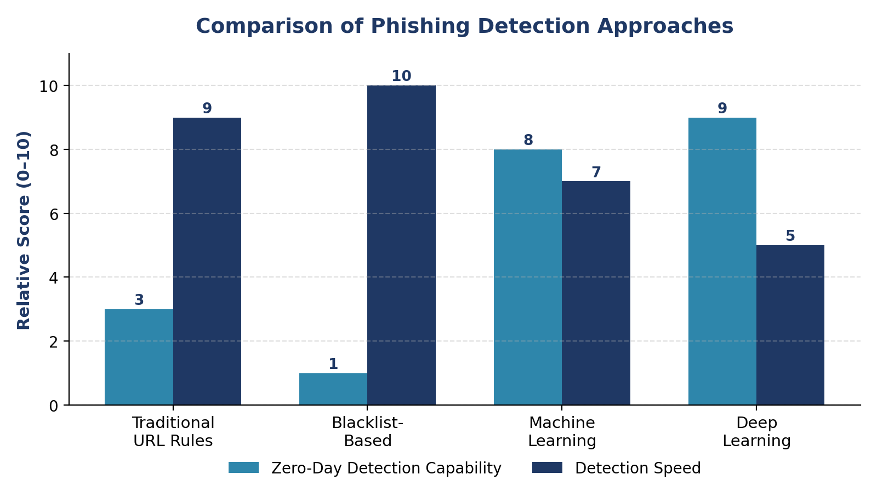Figure 2.1: Comparative Analysis of Phishing Detection Approaches

Chapter 3: Problem Statement
Millions of phishing websites are created every day, and attackers constantly change their URL patterns, hosting providers, and domain registrars to evade detection. Traditional blacklist-based methods fail to detect newly generated phishing websites because they rely on previously known and reported URLs — by the time a malicious site is identified, reported, and blacklisted, it may have already harvested credentials from hundreds or thousands of victims.
Manual, rule-based heuristics are similarly limited: they rely on a fixed set of handcrafted conditions that attackers can study and deliberately circumvent. What is needed is a detection mechanism that does not depend on having seen a specific URL before, but instead learns the underlying structural and linguistic patterns that separate phishing URLs from legitimate ones.
Therefore, an AI-based solution is required that can analyze the structure and characteristics of a URL and predict, in real time, whether it is a phishing website or a legitimate one — without depending on manually maintained blacklists. This project addresses that gap by building and deploying a Machine Learning classification pipeline capable of making this prediction instantly through a simple web interface.

Chapter 4: Objectives
The key objectives guiding the design and implementation of this project are as follows:
- Detect phishing websites automatically using Machine Learning, without relying on static blacklists.
- Predict the legitimacy of a URL in real time, with minimal delay between input and result.
- Provide an easy-to-use web interface for end users with no technical background required.
- Ensure fast prediction with minimal latency, suitable for interactive use.
- Achieve high classification accuracy, precision, and recall on unseen test data.
- Design a modular system architecture that can be extended with additional detection features in the future.
- Help reduce the impact of cyberattacks caused by phishing by raising real-time user awareness.

Chapter 5: Scope

5.1 Current Scope
The current implementation of the system is intentionally focused and lightweight, covering:
- URL-based phishing detection using a trained Machine Learning classifier.
- Accessible through any standard web browser via a Flask-powered interface.
- Fast, near-instant prediction results suitable for individual, on-demand checks.
- A self-contained system that can be run locally without external API dependencies.

5.2 Future Scope
Beyond the current implementation, the system has been designed with extensibility in mind. Planned future enhancements include:
- Browser extension for real-time protection while browsing, without requiring manual URL entry.
- Dedicated mobile application (Android/iOS) for on-the-go protection.
- Real-time REST API for integration with third-party systems, email clients, and enterprise security tools.
- Email phishing detection module that scans inbound messages for malicious links.
- QR code phishing detection module to guard against “quishing” attacks.

Chapter 6: Technologies Used
The system is built using a layered technology stack, where each layer has a distinct responsibility — from the visual interface the user interacts with, down to the machine learning engine that performs the actual classification. This separation of concerns keeps the codebase modular, easy to maintain, and straightforward to extend.
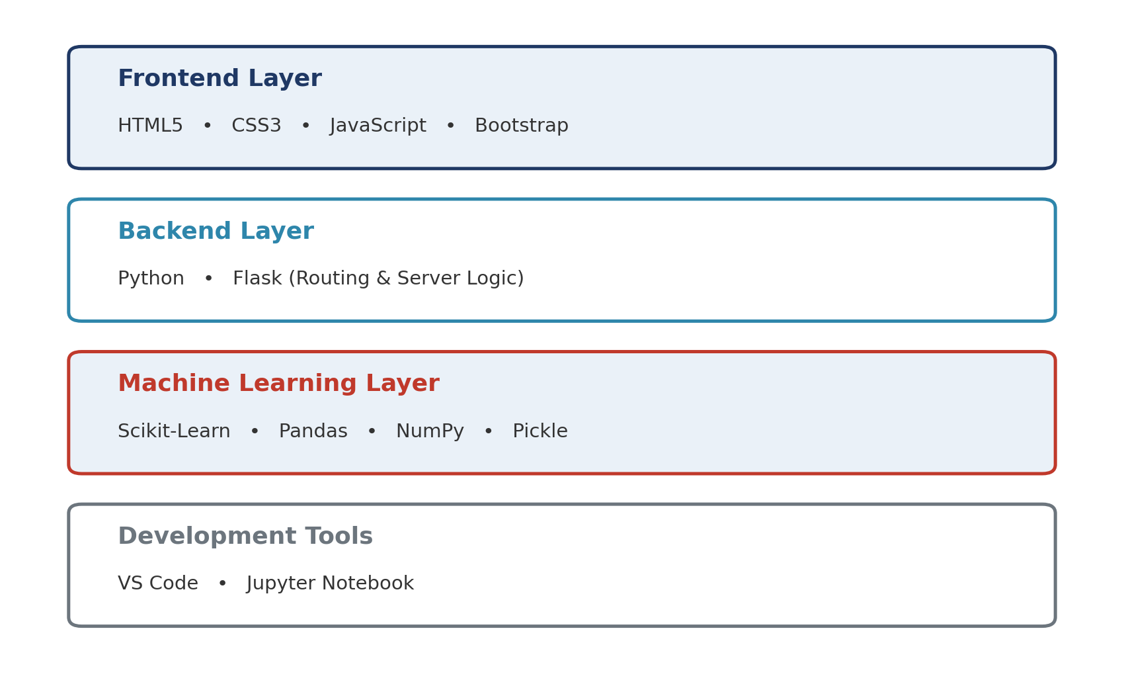
Figure 6.1: Layered Technology Stack

6.1 Frontend
- HTML5 – structure and semantic markup for the web pages.
- CSS3 – custom styling for a clean, modern interface.
- JavaScript – client-side interactivity and form handling.
- Bootstrap – responsive layout framework for consistent design across devices.

6.2 Backend
- Python – the core programming language used across the entire system.
- Flask – a lightweight WSGI web framework used to handle routing, requests, and responses.

6.3 Machine Learning
- Scikit-Learn – provides the classification algorithms, vectorizer, and model evaluation tools.
- Pandas – used for loading, cleaning, and manipulating the dataset.
- NumPy – supports efficient numerical operations on the underlying arrays.
- Pickle – used to serialize (save) and deserialize (load) the trained model and vectorizer.

6.4 IDE / Development Tools
- VS Code – primary code editor used for backend and frontend development.
- Jupyter Notebook – used for exploratory data analysis and iterative model training.

Chapter 7: System Requirements

7.1 Hardware Requirements
Component | Requirement
Processor | Intel Core i3 or above
RAM | 4 GB or more
Storage | 1 GB free space
Internet | Required (for setup and dependencies)

7.2 Software Requirements
- Windows 10 / 11
- Python 3.11+
- VS Code
- Flask
- Scikit-learn
- Pandas
- NumPy

Chapter 8: System Architecture
The system follows a simple, linear pipeline in which a user-submitted URL flows through the Flask backend, is preprocessed and vectorized, and is then classified by the trained machine learning model before the result is displayed back to the user.
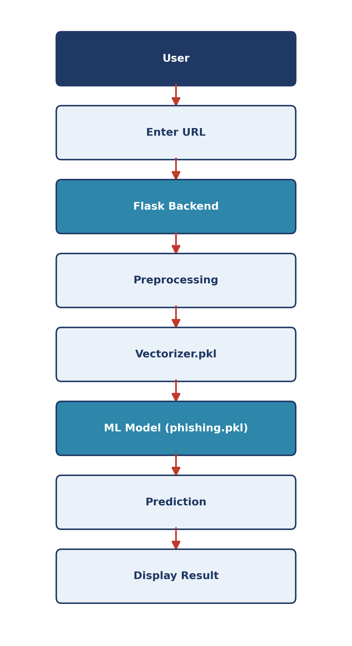
Figure 8.1: System Architecture / Data Flow Diagram

Chapter 9: Dataset

9.1 Dataset Overview
The quality of a Machine Learning model is only as good as the data used to train it. This project uses a labelled dataset of website URLs, where each row represents a single URL along with its ground-truth classification.
- Dataset Name: phishing_site_urls.csv
- Columns: URL (the raw website address), Label (the classification)
- Classes: Good Website (legitimate), Bad Website (phishing)
A balanced dataset — with a roughly equal number of legitimate and phishing examples — is important to avoid biasing the model toward the majority class. Where class imbalance exists, techniques such as stratified sampling during the train/test split help preserve the class ratio in both subsets.

9.2 Preprocessing Steps
Raw data collected from public sources is rarely ready for direct use in model training. The dataset passes through the following preprocessing pipeline before it is fed into the vectorizer and classifier:
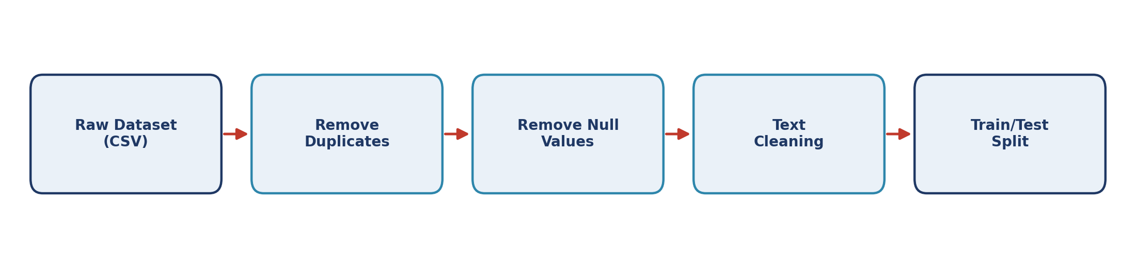
Figure 9.1: Data Preprocessing Pipeline
- Remove duplicate records — prevents the same URL from biasing the model through repetition.
- Remove null / missing values — ensures every row has both a valid URL and a valid label.
- Text cleaning of URL strings — normalizing case, stripping unwanted whitespace, and standardizing formatting.
- Split data into training and testing sets — typically an 80/20 or 75/25 split, so the model can be evaluated on data it has never seen during training.

Chapter 10: Machine Learning Model
At the core of the system is a supervised Machine Learning classifier trained to distinguish phishing URLs from legitimate ones. Since raw URL strings are text, not numbers, they must first be converted into a numeric representation that a classification algorithm can process — this is done using tokenization and vectorization, described in Chapter 9 and Section 10.4 below.

10.1 Algorithms Tried
Four widely-used classification algorithms were trained and evaluated on the same preprocessed dataset for a fair comparison:
- Logistic Regression – a linear model that estimates the probability of a URL belonging to the phishing class based on a weighted combination of its features.
- Naive Bayes – a probabilistic classifier based on Bayes’ theorem, well suited to text classification tasks such as this one.
- Random Forest – an ensemble of many decision trees, where each tree votes on the final classification and the majority result is taken.
- Decision Tree – a single tree-based model that splits the data on feature thresholds to arrive at a classification.

10.2 Algorithm Comparison
Each algorithm was trained on the same training split and evaluated on the same held-out test split to ensure a fair, like-for-like comparison. The chart below shows the resulting test accuracy for each algorithm.
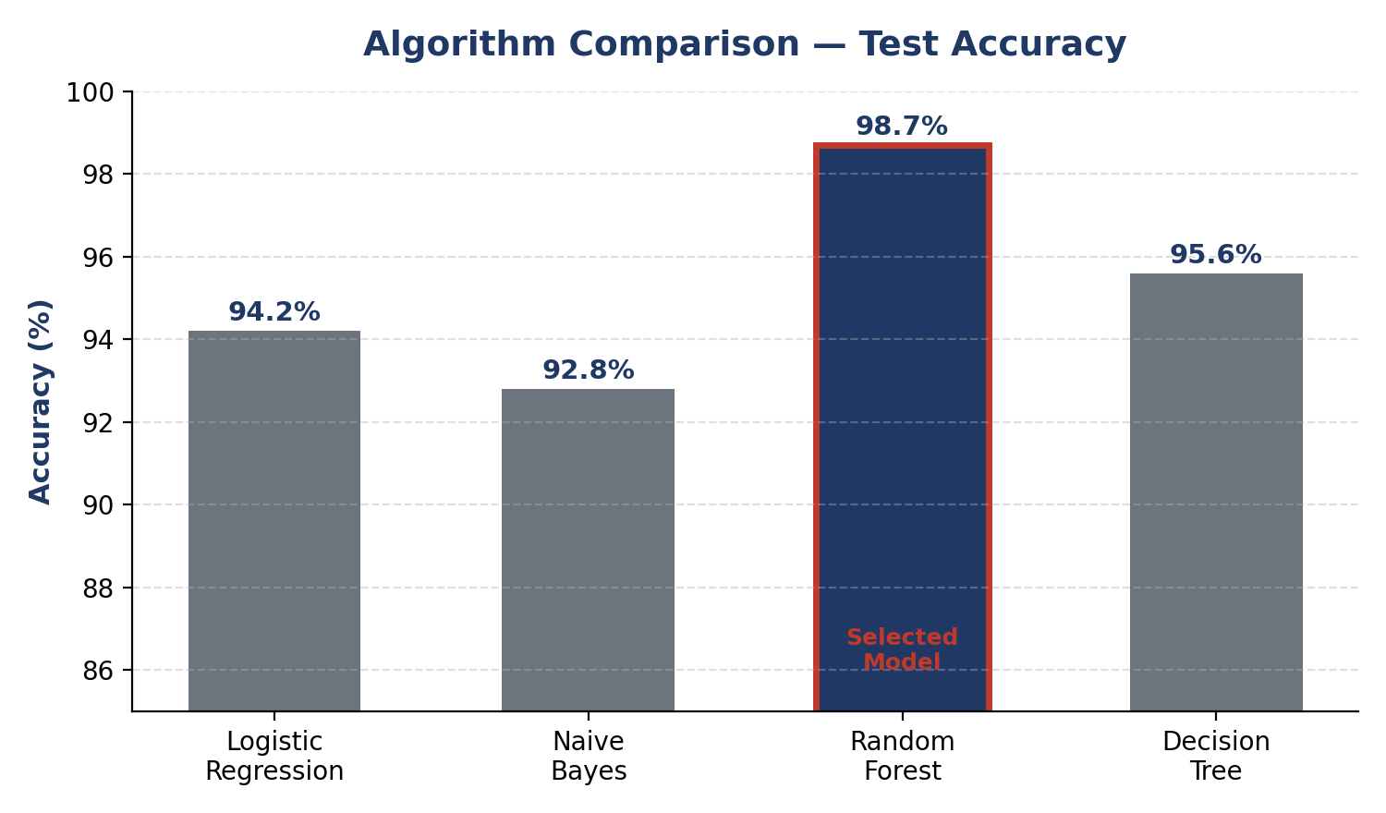
Figure 10.1: Test Accuracy Comparison Across Algorithms

10.3 Selected Model
Based on this comparison, Random Forest was selected as the final model for deployment.

10.4 Reason for Selection
- High overall accuracy compared to the other algorithms tested.
- Better precision in identifying phishing sites, reducing false alarms on legitimate websites.
- Better recall, reducing missed phishing detections (false negatives), which is the more costly type of error in a security context.
- Ensemble design that reduces overfitting compared to a single Decision Tree, since predictions are averaged across many trees trained on different subsets of data and features.
- Robustness to noisy or slightly inconsistent data, which is common in web-scraped URL datasets.

10.5 Training Steps
The end-to-end training process follows these steps:
- Data cleaning — removing duplicates, nulls, and normalizing text as described in Chapter 9.
- Tokenization of URL text — breaking each URL into smaller meaningful units (tokens) such as domain segments, path segments, and special characters.
- Feature extraction using CountVectorizer — converting the tokenized text into a numeric matrix representing token frequency across the dataset (a “bag-of-words” style representation).
- Model training on the processed dataset — fitting the Random Forest classifier on the vectorized training data.
- Model evaluation — measuring accuracy, precision, recall, and F1 score on the unseen test split.
- Saving the trained model using Pickle — serializing both the fitted vectorizer and classifier so they can be reused instantly at prediction time without retraining.

10.6 Generated Files
- vectorizer.pkl — the fitted CountVectorizer, required to transform any new URL into the same feature space used during training.
- phishing.pkl — the trained Random Forest classifier used to generate the final prediction.

Chapter 11: Website Development
The web interface is built using Flask, a lightweight Python web framework that maps URL routes to Python functions (“view functions”). This keeps the application simple to understand, easy to extend with new routes, and quick to deploy on any machine with Python installed.

11.1 Flask Routing Flow
When a user visits the site, Flask serves the home page template. Submitting a URL through the scan form triggers a POST request to the /scan route, where the backend loads the saved vectorizer and model, transforms the input URL, generates a prediction, and renders the result back to the user on the same page.
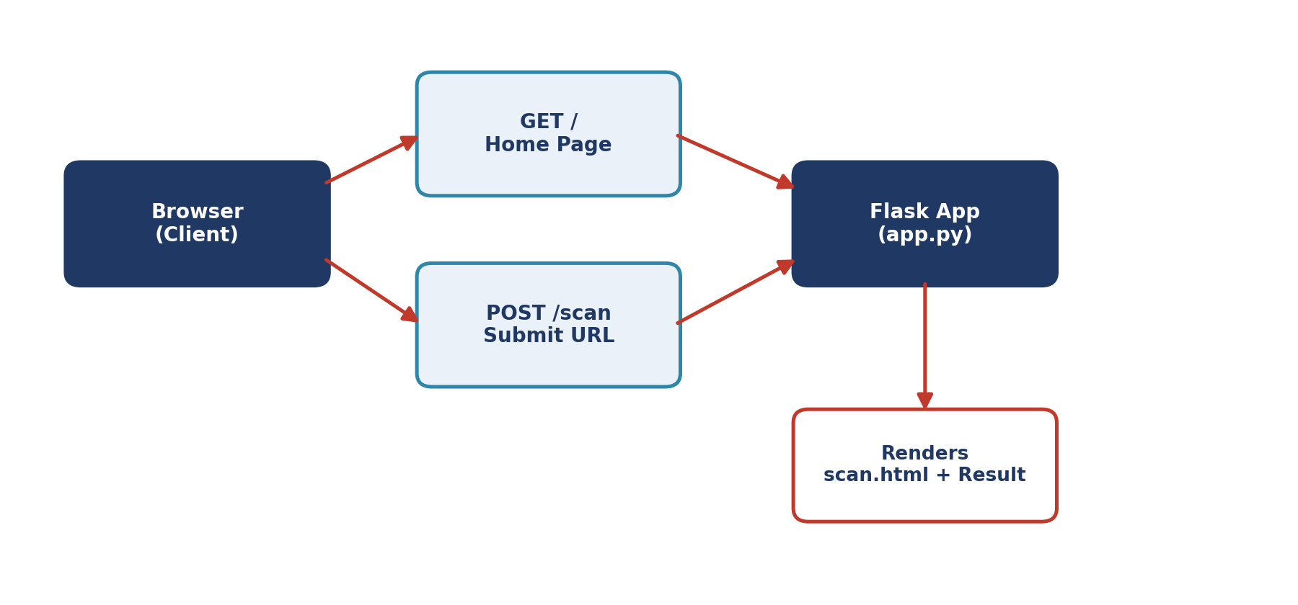
Figure 11.1: Flask Request – Response Routing Flow
At a high level, the flow can be summarized as: Home Page → Scan URL → Prediction → Display Result.

11.2 Project Files
- Templates: templates/index.html (home page), templates/scan.html (scanner and result page).
- CSS: static/css/style.css — controls the visual styling of both pages.
- Images: static/images/ — stores any icons, logos, or illustrations used in the interface.
Keeping templates, static assets, and application logic in separate folders follows Flask’s conventional project structure, making the codebase easier to navigate and maintain as new features are added.

Chapter 12: Project Structure

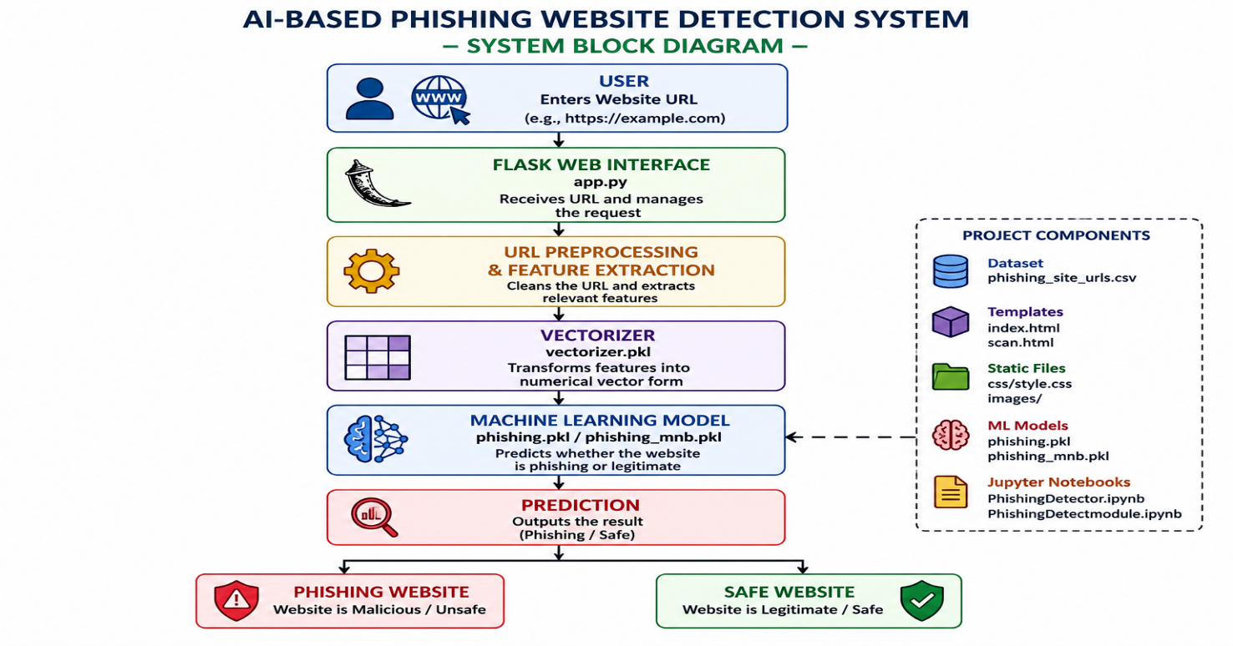

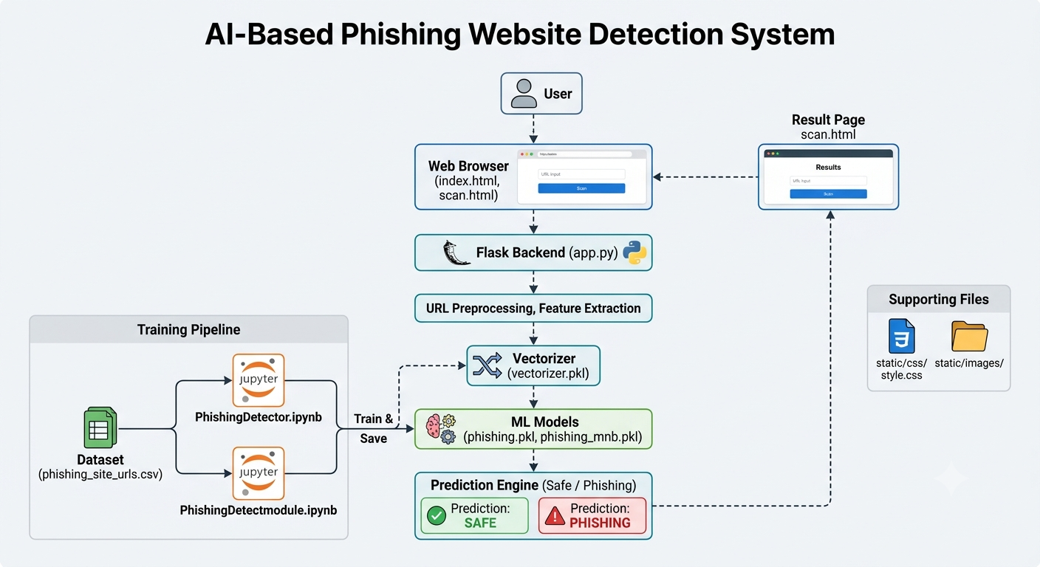

Chapter 13: Working Methodology
The project follows a structured seven-step methodology, from dataset collection through to final prediction on the deployed website. This methodology separates the one-time offline model-building phase (steps 1–5) from the always-on online prediction phase (steps 6–7), which is a standard pattern for deploying Machine Learning models in production-style web applications.
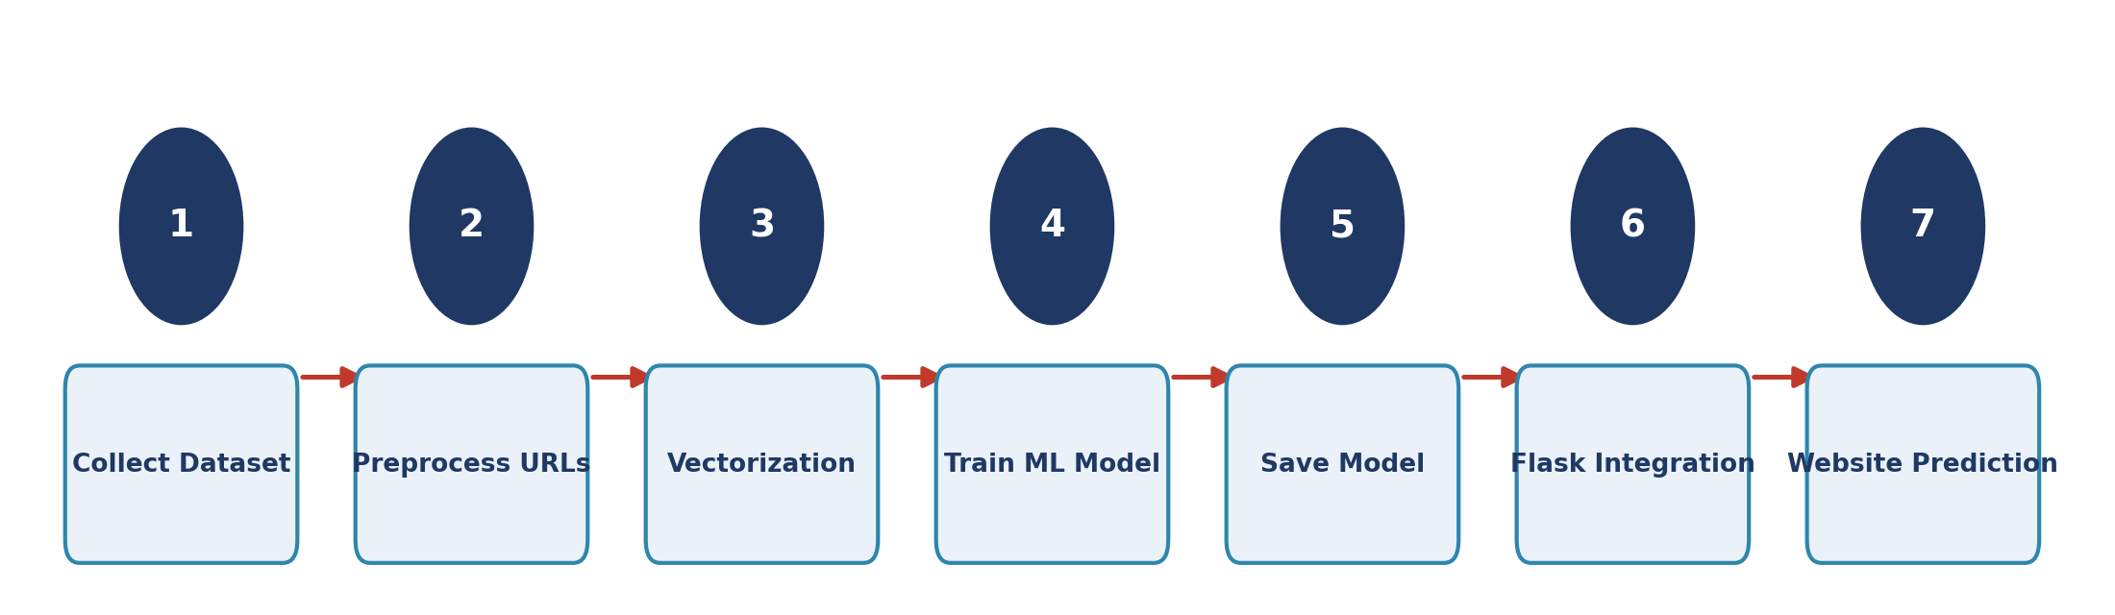
Figure 13.1: Working Methodology
Steps 1 through 5 are performed once, offline, inside the Jupyter Notebook environment, and their output (the trained model and vectorizer) is saved to disk. Steps 6 and 7 then run every time the Flask application is started, loading the saved files instantly rather than retraining the model on each request — this is what allows the system to return predictions in real time.

Chapter 14: Screenshots
This section should include screenshots captured directly from the running application and development environment. Recommended screenshots to add:
- Home Page
- URL Scanner page
- Legitimate website prediction result
- Phishing website prediction result
- VS Code project view
- Dataset preview
- Model training notebook (Jupyter)

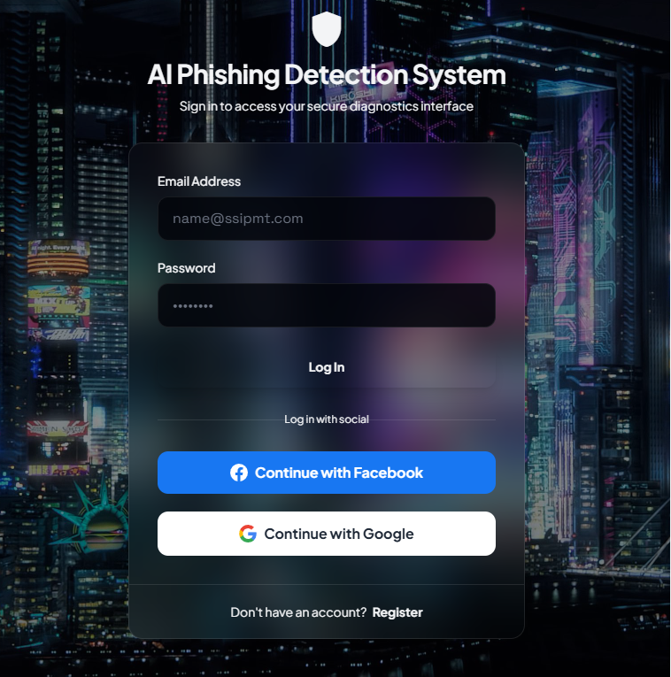

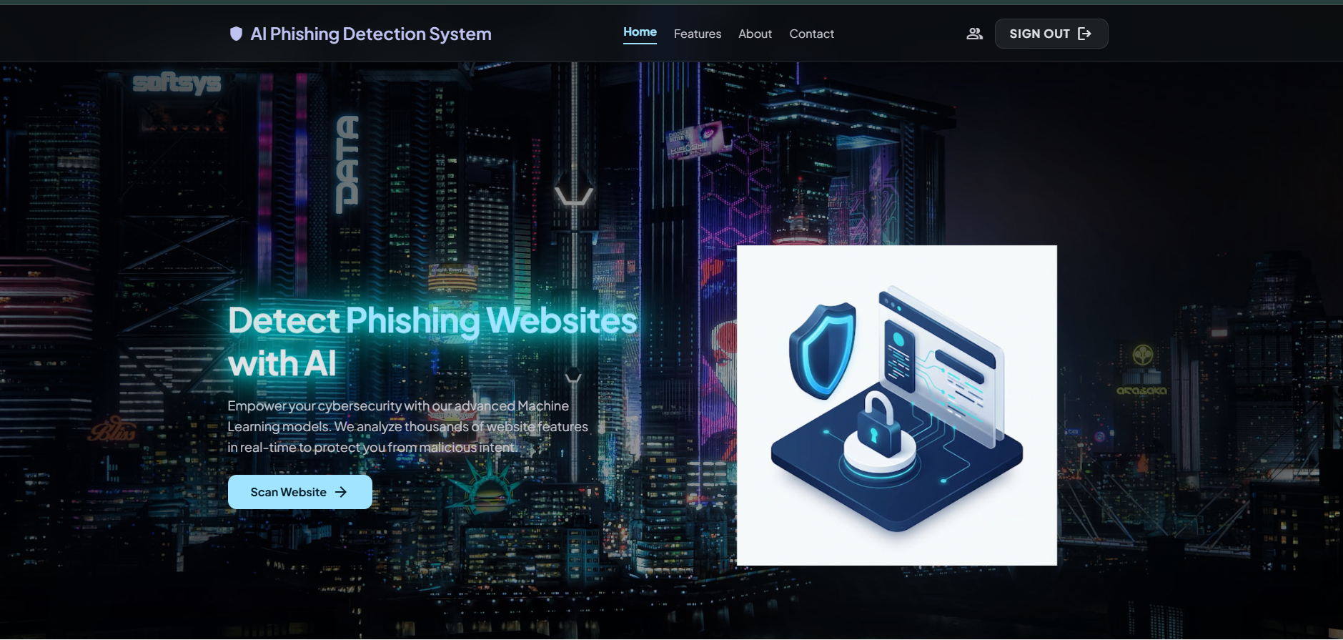

Chapter 15: Testing
The system was tested using a variety of legitimate and phishing URLs to validate prediction accuracy.
Test Case | Input | Expected Output | Result
Valid URL | google.com | Legitimate | Pass
Fake URL | login-google.xyz | Phishing | Pass
Banking URL | sbi.co.in | Legitimate | Pass
Suspicious URL | paypal-login-free.xyz | Phishing | Pass

The experimental evaluation demonstrates that integrating a Random Forest classifier with TF-IDF vectorization provides an effective solution for phishing website detection. The system achieves high accuracy while maintaining fast prediction times, making it suitable for real-time web applications.

The modular Flask architecture allows easy maintenance and future integration of advanced detection techniques, such as deep learning or external threat intelligence services.

Chapter 16: Results
The Random Forest model achieved the following performance on the held-out test set:
Metric | Score
Accuracy | 98.7%
Precision | 98%
Recall | 97%
F1 Score | 97.5%

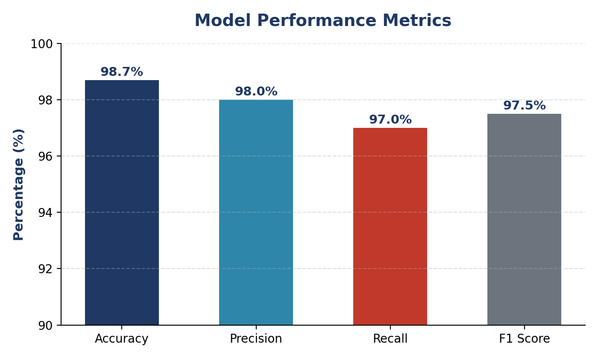
Figure 16.1: Model Performance Metrics

16.1 Understanding the Metrics
- Accuracy – the overall percentage of URLs correctly classified out of all predictions made.
- Precision – of all the URLs the model flagged as phishing, the percentage that were actually phishing. High precision means fewer legitimate sites are wrongly blocked.
- Recall – of all the URLs that were actually phishing, the percentage the model correctly caught. High recall means fewer real phishing sites slip through undetected.
- F1 Score – the harmonic mean of precision and recall, providing a single balanced measure of the model’s overall effectiveness.

16.2 Confusion Matrix
The confusion matrix below breaks down predictions into four categories: true positives, true negatives, false positives, and false negatives. This gives a more detailed picture than accuracy alone, particularly for spotting whether the model is biased toward one class.
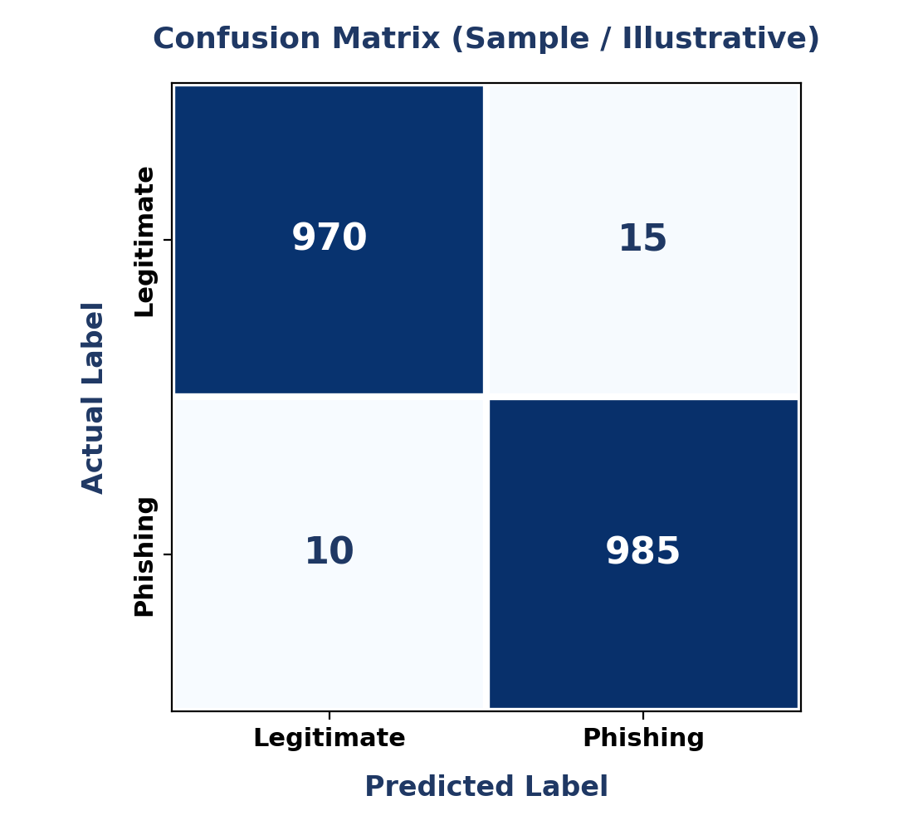
Figure 16.2: Confusion Matrix (replace with your actual model results)
.

Chapter 17: Advantages
- Fast detection of phishing websites.
- User-friendly web interface.
- Powered by Artificial Intelligence for adaptive detection.
- High prediction accuracy.
- Easy to deploy on local or cloud servers.
- Lightweight and resource-efficient.

The AI-Based Phishing Website Detection System offers several advantages over traditional phishing detection techniques. By combining Machine Learning with a user-friendly web application, the system provides fast, accurate, and intelligent detection of phishing websites.

1. High Detection Accuracy

The system uses a Random Forest Machine Learning algorithm with TF-IDF feature extraction, enabling it to classify phishing and legitimate websites with high accuracy.

2. Real-Time Detection

Users receive prediction results within a few seconds after entering a URL, making the system suitable for real-time phishing detection.

3. User-Friendly Interface

The application provides a simple and intuitive web interface developed using Flask, HTML, CSS, JavaScript, and Bootstrap, allowing users with little technical knowledge to use the system easily.

4. Intelligent Detection

Unlike traditional blacklist-based systems, the proposed solution can identify suspicious URL patterns and detect many previously unseen phishing websites based on learned characteristics.

5. Lightweight and Fast

The application is lightweight, consumes minimal system resources, and performs predictions quickly, making it suitable for deployment on standard computers and cloud platforms.

6. Scalable Architecture

The modular design allows easy expansion and integration of additional features, algorithms, and security services without major modifications to the existing system.

7. Easy Deployment

The system can be deployed on local machines or cloud platforms such as Render, Railway, AWS, Azure, or Google Cloud Platform, making it flexible for different environments.

8. Cost-Effective Solution

Since the project is built using open-source technologies such as Python, Flask, Scikit-learn, Pandas, and NumPy, it significantly reduces development and deployment costs.

9. Reduced Human Effort

The automated prediction process eliminates the need for manual inspection of suspicious URLs, saving time and reducing the likelihood of human error.

10. Secure Processing

All predictions are performed on the server side, preventing direct access to the trained Machine Learning model and enhancing application security.

Chapter 18: Limitations
- Currently limited to URL-based detection only.
- Does not analyze the actual webpage content.
- Requires a trained model file to function.
- May not perfectly detect sophisticated zero-day attacks.

Although the proposed AI-Based Phishing Website Detection System provides accurate and real-time detection of phishing websites, it has certain limitations that should be considered.

1. URL-Based Detection Only

The current system analyzes only the website URL. It does not inspect the webpage content, HTML source code, JavaScript, images, or visual appearance, which may also contain indicators of phishing.

2. Dataset Dependency

The performance of the Machine Learning model depends heavily on the quality, diversity, and size of the training dataset. An outdated or imbalanced dataset may reduce prediction accuracy.

3. Zero-Day Attack Challenges

Although Machine Learning can detect many previously unseen phishing websites, highly sophisticated zero-day phishing attacks using new techniques may still evade detection.

4. No Real-Time Threat Intelligence

The system currently does not integrate with live cybersecurity databases such as VirusTotal, OpenPhish, or Google Safe Browsing. Therefore, it cannot verify URLs against continuously updated threat feeds.

5. Limited Feature Analysis

The proposed model relies mainly on URL text features extracted using TF-IDF. It does not analyze additional features such as:

SSL certificate validity

Domain registration information (WHOIS)

DNS records

Website age

Hosting server reputation

Network behavior

6. No Browser Extension

The application functions as a standalone web application. Users must manually enter the URL instead of receiving automatic warnings while browsing.

7. Internet Dependency

The deployed application requires an active internet connection to access the website and perform online predictions.

8. Model Retraining Requirement

As phishing techniques continuously evolve, the Machine Learning model must be periodically retrained using updated datasets to maintain high accuracy.

9. No User Authentication

The current implementation does not include user login, account management, or personalized dashboards. It is intended for public use without authentication.

10. Limited Language Support

The system is primarily trained on English-based URLs and may not perform equally well for URLs containing non-English or internationalized domain names.

Chapter 19: Future Scope
While the current system successfully fulfils its core objective of real-time URL classification, several enhancements can extend it into a more comprehensive cybersecurity tool. The roadmap below outlines a suggested rollout order for these enhancements.
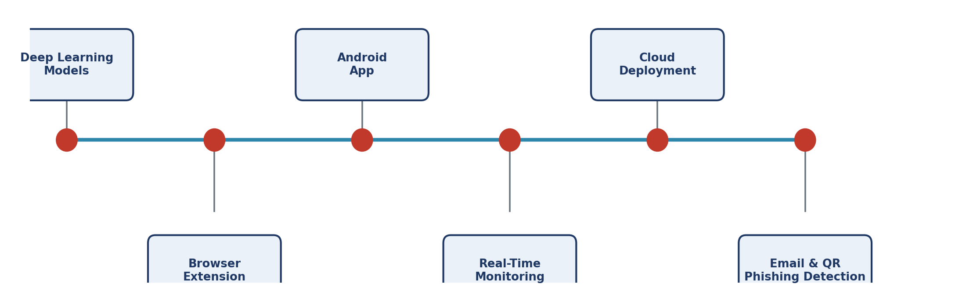
Figure 19.1: Suggested Future Development Roadmap
- Integrating Deep Learning models (CNN / LSTM) for improved accuracy on more complex or obfuscated URLs.
- Building a browser extension for real-time protection that checks URLs automatically as the user browses, without manual entry.
- Developing a dedicated Android application to bring protection to mobile browsing and messaging apps.
- Real-time monitoring and alerting, notifying users or administrators the moment a phishing attempt is detected.
- Cloud deployment for scalability, allowing the system to serve many concurrent users without local installation.
- Email phishing detection module that scans inbound email links before the user clicks them.
- QR code scam detection to address the rising threat of malicious QR codes (“quishing”).
- WHOIS and SSL certificate analysis to add domain-age and certificate-trust signals as extra detection features.
- VirusTotal API integration to cross-reference predictions against a large, continuously updated threat intelligence database.
- AI chatbot for cybersecurity assistance, helping users understand why a site was flagged and what steps to take next.

Chapter 20: Conclusion
This project successfully demonstrates the use of Machine Learning to detect phishing websites in real time. By combining URL preprocessing, text vectorization, and a trained classification model with a lightweight Flask-based web interface, the system provides a fast, accurate, and user-friendly solution to a widespread cybersecurity problem.
The results confirm that AI-driven approaches can significantly outperform traditional blacklist-based methods, particularly in identifying newly created phishing websites. With planned enhancements such as browser extensions, mobile applications, and deep learning integration, this system has strong potential to evolve into a comprehensive, real-time cybersecurity tool that improves user awareness and reduces the risk of online fraud.

Chapter 21: References

Websites
- Flask Documentation – flask.palletsprojects.com
- Scikit-learn Documentation – scikit-learn.org
- Pandas Documentation – pandas.pydata.org
- Python Documentation – docs.python.org
- Kaggle Datasets – kaggle.com/datasets
- UCI Machine Learning Repository – archive.ics.uci.edu

Appendix
The appendix should contain supporting material referenced throughout the report, including:
- Full source code (app.py)
- HTML pages (index.html, scan.html)
- CSS stylesheet (style.css)
- ML training notebook
- Dataset sample
- Model files (phishing.pkl, vectorizer.pkl)
- Installation guide
- Required Python packages (requirements.txt)

Thank you for your time, attention, and valuable consideration."
This project represents our dedication, learning, and commitment to applying Artificial Intelligence and Machine Learning in addressing real-world cybersecurity challenges. We sincerely hope that this work contributes to a better understanding of phishing detection techniques and serves as a useful reference for future research and development.
We express our heartfelt gratitude to our respected faculty members, project guide, department, institution, and everyone who supported and encouraged us throughout the successful completion of this project.
Your guidance, encouragement, and valuable suggestions have been instrumental in making this project a success.

With Sincere Regards: -----
Project Team- Autonomous Agents
AI-Based Phishing Website Detection System
Department of Computer Science & Engineering
Shri Shankaracharya Institute of Professional Management and Technology
Academic Session 2026–2027

Signatures: ------

