Business Requirement Document – NIRI, MoSPI

Introduction
The NIRI platform serves as a unified digital ecosystem to collect, validate, approve, visualize, report and rank infrastructure readiness data across States, UTs, and Ministries in India. The system enables transparent performance monitoring through a robust multi-tier workflow for data submission and approval, enriched with real-time dashboards and analytical tools.

Objectives
- Provide a seamless workflow for data collection, validation, approval, and scoring.
- Enable real-time tracking of infrastructure performance across 4 main categories.
- Ensure compliance through version control, audit trails, and data integrity checks.
- Support decision-making with dynamic dashboards, KPIs, and reports.
- Enable transparency and efficiency in inter-ministerial and federal data handling.

Stakeholders
User Role | Description | Key Responsibilities
Nodal Officer | Enters data into predefined forms at State/UTs/ Ministry level. | - Logs in, enter data accurately, perform initial checks, and submit forms to Approver.  - Resubmits data in case of receiving it back from the Approver.  - Reviews dashboard to ensure minimum pendencies at their end.
MoSPI Reviewer | Conducts a thorough review of the submitted data from the approvers of States/UTs and Ministries.  Final data validation and sends to MoSPI Approver with any action propositions/feedback. | - Reviews data received from Approver of States/UTs/Ministries.  - Has only view rights, along with adding comments/feedback.  - Sends the forms along with comments further to MoSPI Approver.
MoSPI Approver | Review the feedback/propositions submitted by the MoSPI Reviewer.  Review data submitted by the Approver from States/UTs/Ministries and take action. | - Approve or reject data received from the States/UTs/Ministries.  - In case of rejection provide mandatory feedback while sending back the data for revision to States/UTs/Ministries.  - Ensure compliance from all users and monitor Dashboards to keep the pendencies to the minimum.

Business Process Workflow – Data Entry, Validation & Approval
Step 1: Nodal Officer (State/UTs/Ministries)
- Actor: Nodal Officer
- Action: Fills in the required data fields in the forms
- Next Step: Submits to Approver (States/UTs/Ministries)
Step 2: MOSPI Review
- Actor: MOSPI Reviewer
- Actions:
  - Review: Reviews data submitted by the Nodal Officer (State/UTs/Ministries)
  - Add feedback/propositions before sending it to the MoSPI Approver.
Step 4: MOSPI Approver
- Actor: MOSPI Approver
- Actions:
  - Review
→ Review the data submitted by the MoSPI Reviewer.
  - Approve
→ Data is accepted into the system
→ Score is updated as per business logic
→ Process ends
  - Send Back to Nodal Officer
→ Reason/comment for rejection is attached

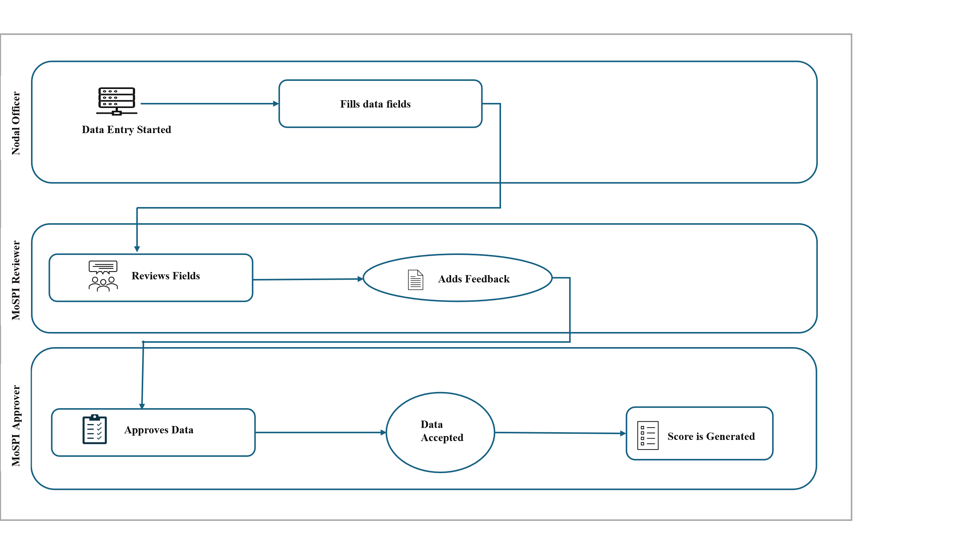
NIRI Workflow

User Journey
User: Nodal officer
Step 1: Log in to the system and opens the assigned Indicator/form.
Step 2: Fill in all required fields as per the specified format and validation rules.
Step 3: Ensure all mandatory fields are completed and data is logically consistent.
Step 4: Review the form for accuracy and completeness.
Step 5: Submit the completed form for review.
Next Step: The form is submitted to the Approver (States/UTs/Ministry) for validation.
User: MoSPI Review
Step 1: Open the submission received from the Nodal Officer (State/UTs/Ministry)
Step 2: Review the data for:
  - Compliance with business rules.
  - Alignment with project goals and standards.
  - Completeness and correctness of information.
Step 3: Takes the following actions:
  - Add comments:
    - Add comments/Feedback
Next Step: Sends the submission to MoSPI Approver
User: MoSPI Approver
Step 1: Reviews information submitted by the MoSPI Reviewer
Step 2: Take the following actions:
  - Accept the Submission
    - Data is reflected in the system and score is generated/updated as per the business logic.

Functional Requirements

FR ID | Functional Area | Requirement Category | Detailed Functional Requirement
FR001 | User Management | Role-Based Access Control (RBAC) | Implement role-based authentication for Nodal Officer, MoSPI Reviewer, MoSPI Approver, and Admin. Each role will have restricted access to modules and actions based on their level in the workflow.
FR002 | User Management | Authentication & Access | System must support secure login via Single Sign-On (SSO) using government domains (‘@nic.in’, ‘@gov.in’). Unauthorized domains must be blocked.
FR003 | Data Entry (Nodal Officer) | Form Access & Data Input | Nodal Officer can log in, open assigned indicators/forms, and enter data as per the predefined format. Field-level validations (type, range, mandatory checks) must be applied.
FR004 | Data Entry (Nodal Officer) | Data Review & Submission | The Nodal Officer must review all entries for completeness and logical consistency before final submission. Upon submission, the form status changes from Draft → Submitted and is routed to the MoSPI Reviewer.
FR005 | Review Management (MoSPI Reviewer) | Submission Access & Validation | MoSPI Reviewer can view submissions received from Nodal Officers. The system shall enable validation against business rules, completeness, and project alignment.
FR006 | Review Management (MoSPI Reviewer) | Feedback & Commenting | MoSPI Reviewer can add comments or feedback for corrections. Comments are stored at field and section levels with timestamps and reviewer IDs. Once reviewed, the submission is sent to the MoSPI Approver.
FR007 | Approval Management (MoSPI Approver) | Review & Decision | MoSPI Approver can open reviewed submissions, verify details, and perform one of the following actions: Accept or Reject. All actions must be logged with user ID and timestamp.
FR008 | Approval Management (MoSPI Approver) | Approval Workflow Logic | On Accept, the data is finalized and reflected in the system; the scoring process is auto triggered based on business logic. On Reject, the form is routed back to the respective Nodal Officer with mandatory comments. Status transitions: Reviewed → Approved → Scored / Rejected → Returned.
FR009 | Scoring & Ranking | Score Calculation & Update | Once the submission is approved, the system auto-generates scores as per predefined formulas and weightages from the ranking table. Scores update dynamically in dashboards.
FR010 | Scoring & Ranking | Ranking Table Integration | The scoring framework must include the four key NIRI categories — Infrastructure Financing (250 marks), Infrastructure Development (250 marks), PPP Development (250 marks), and Infrastructure Enablers (250 marks). Each category contains pre-defined indicators and weightages for automated ranking generation.
FR011 | Dashboard & Reporting | Role-Based Dashboard Views | Dashboards should display submission status, approvals, rejections, and final scores based on user role. MoSPI Approver sees consolidated national-level data; Nodal Officers see their respective state/UT submissions.
FR012 | System Logging | Audit & Version Tracking | The system must maintain a complete audit trail of actions (submit, review, approve, reject) with timestamps and user IDs. Each resubmission creates a new version while preserving historical records.

Non-Functional Requirements:
Category | Requirement
Security | - Role-based access  - HTTPS encryption
Availability | - 99.9% uptime  - Load balancing  - Concurrent support > 1000 users
Usability | - WCAG 2.1 compliant  - Responsive UI  - English language support

Business Rules/Logics
Rule Type | Rule Description
Submission | Submission requires all mandatory fields and documents.
Approval | Rejection requires mandatory comments.
Verification | Only verified/Approved by MoSPI data is scored.
Dashboard | Data visibility restricted to role; real-time data must reflect latest status.

Note: A detailed calculation matrix for scoring is attached in Annexure I.

Acceptance Criteria
- All attachments can be submitted with document upload and validation.
- Multi-level approval and scoring flow functions with business logics/rules validations.
- Dashboard displays real-time performance data accurately.
- Reports and exports work across formats.
- All actions are traceable via audit logs.
- Notifications are triggered as per events.
****************

Annexure I
Parameter | Indicator Name | A1 | A2 | Formula / Method | Full Marks | Remarks
1.1 | % of Capex (Budgetary Capital Allocation) to GSDP | User fill value | User fill value | 10 marks for every 1% | 50 | A1: Budgetary Capital AllocationA2: GSDP
1.2 | % Capex Utilization | User fill value | User fill value | 1 mark for every 2% | 50 | A1: Capital Expenditure  A2: Budgetary Capex
1.3 | % of Credit Rated ULBs | User fill value | User fill value | 1 mark for every 2% | 50 | A1: Credit Rated ULBs  A2: Total ULBs
1.4 | % of ULBs issuing Bonds | User fill value | User fill value | 2 marks for every 1% | 50 | A1: ULBs issuing bondA2: Total ULBs
1.5 | Functional financial intermediary for infra dev | User fill value |  | Yes/No | 50
2.1 | Availability of Infrastructure Act/Policy | User fill value |  | Yes/No | 50 | A1: Number of sectors covered (if no = 0 marks)
2.2 | Availability of specialized entity for infra dev | User fill value |  | Yes/No | 50
2.3 | Availability of Sector Infra Development Plan | User fill value |  | 10 marks for each sector | 50 | A1: Number of sectors covered
2.4 | Availability of Investment Ready project pipeline | User fill value |  | Yes/No | 50
2.5 | Availability of Asset Monetization pipeline | User fill value |  | Yes/No | 50
3.1 | Availability of PPP Act/Policy | User fill value |  | Yes/No | 50
3.2 | Functional State/UT PPP Cell/Unit | User fill value |  | Yes/No | 50
3.3 | Proposals submitted under VGF/IIPDF | User fill value |  | 5 marks for each project | 50 | A1: Number of proposals submitted
3.4 | Proportion of TPC of PPP or Bankable projects | User fill value | User fill value | 2 marks for every 1% | 100 | A1: sum (PPP or Bankable); A2: TPC; P: A1/A2
4.1 | Are all eligible Infra projects on PMG portal | User fill value |  | Yes/No | 50
4.2 | Availability and use of State/UT PMG portal | User fill value |  | Yes/No | 30
4.3 | Adoption of PM GatiShakti NMP | User fill value |  | 5 marks for each project planned via PMGS | 20 | A1: Number of projects
4.4 | Adoption of Alternate Dispute Resolution (ADR) | User fill value |  | Yes/No | 50
4.5 | Any Innovative Practice for Infra Dev | User fill value |  | 10 marks for each practice | 50 | Portal/conference etc.
4.6 | Capacity building - officer participation | User fill value |  | 1 mark for each officer participation | 50 | A1: Number of participants

