1. Building Docker image

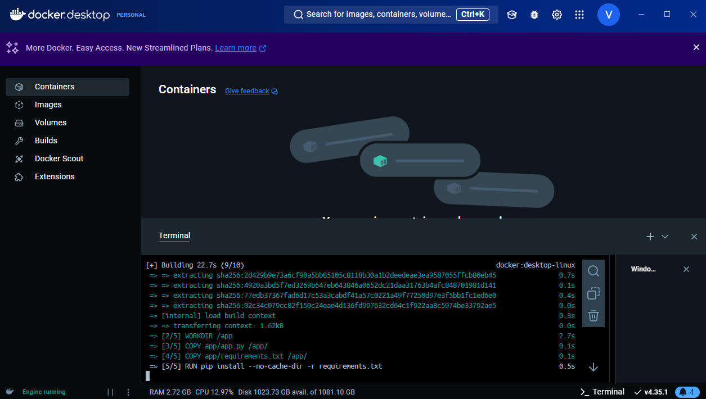

1. MongoDB Server

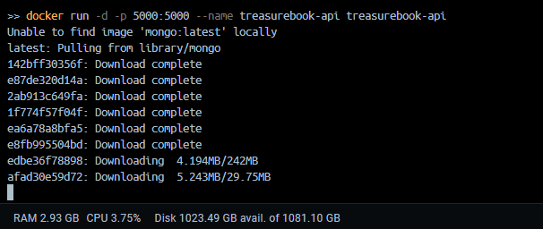

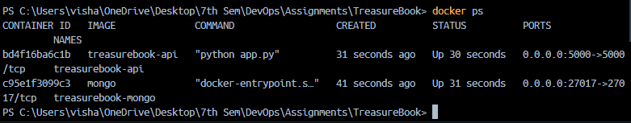

1. Checking the status of the application.

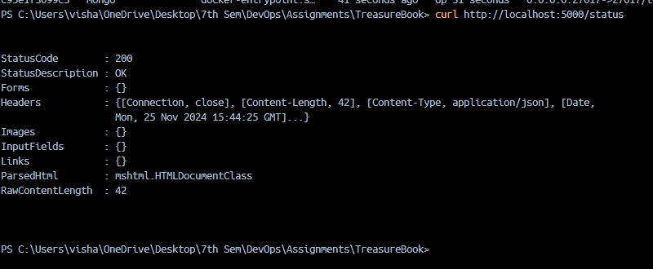

1. Deploy Kubernetes Resources

Apply MongoDB Deployment and Service

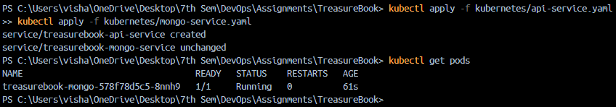

Verify Deployments and Services:

