# GreenSense: The Complete IoT Solution for Plant Growth and Care Using Machine Vision and AI-Powered Disease Detection

***Project Reference No.:*** *48S_BE_3562*

College : B.M.S. College of Engineering

Branch : Department of Information Science and Engineering

Guide(s) : Dr. Anitha H M

Student(s) : Vishal S

Sanat K

Shreesha Bhat

Keywords:

IoT, Machine Vision, Plant Disease Detection, Smart Agriculture, Automated Irrigation, Solar-Powered System, Urban Gardening, Environmental Monitoring, Blynk App, ESP32

**Introduction:**

Urban gardening faces time, knowledge, and monitoring challenges. GreenSense offers a modular, affordable IoT system with sensors, smart irrigation, and AI-based disease detection to automate care, support sustainability, and scale to small farms.

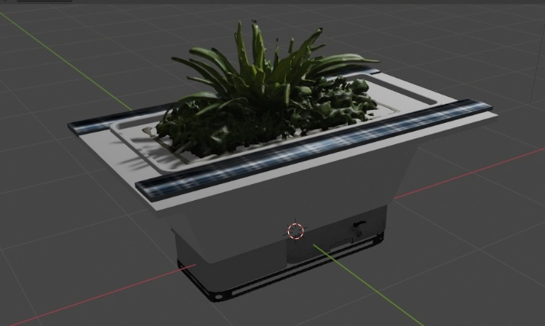

Figure 1: A 3D Render of the envisioned product.

Objectives:

1. Enable water-efficient urban gardening with minimal manual input.
2. Detect plant diseases early using machine vision and AI.
3. Design a scalable system adaptable for agricultural use.
4. Utilize solar power for energy sustainability.

Methodology:

* Hardware: ESP32 with sensors, camera, solar panel, and Li-ion batteries.
* Monitoring: Real-time data via Wi-Fi and Blynk app.
* Machine Vision: CNN model for early disease detection.
* Irrigation: Moisture-based pump control with low-water alerts.
* Fertilizer: Data-driven dosage suggestions.

The project:

GreenSense is a solar-powered, modular system that provides real-time plant monitoring and care. It automates irrigation based on soil conditions, detects diseases using AI, and offers actionable insights for plant health. Designed for urban gardening, it supports future scaling to agriculture, combining sustainability, affordability, and ease of use.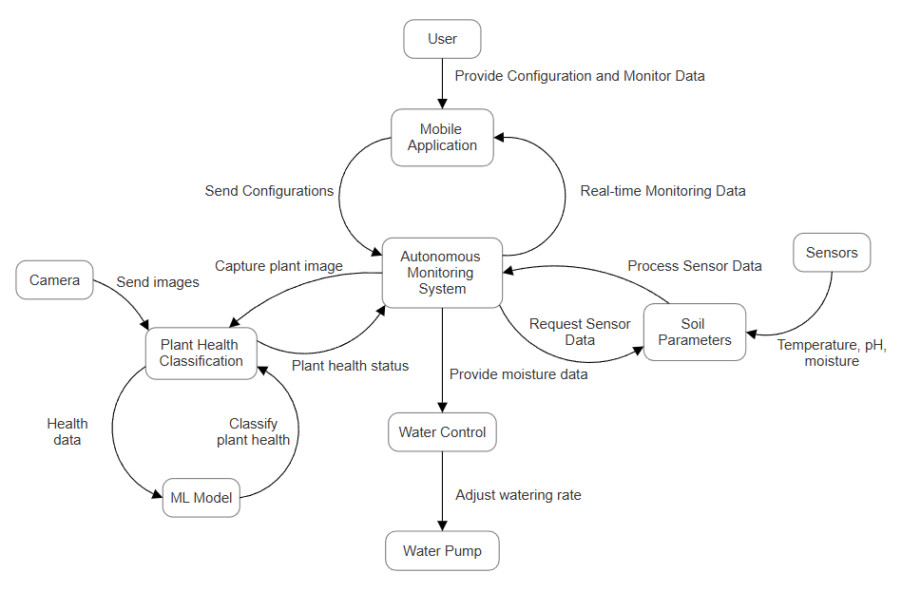

Figure 2: System flow chart

Result and ****Conclusion****:

GreenSense monitors plant health in real time, automates irrigation, detects diseases early with AI, and suggests fertilizers. Solar-powered and scalable, it’s a smart, eco-friendly solution for urban and small-scale farming.

Project Outcome & Industry Relevance:

Gained expertise in IoT, sensing, and AI for plant health. Built a prototype with real-time monitoring, irrigation, and disease detection. The project supports future research and offers a scalable solution for urban and small-scale farming.

Working Model vs. Simulation/Study:

Working Model: Integrated DHT11, soil moisture, and pH sensors with ESP32 for real-time monitoring via Blynk. Trained a CNN for plant disease detection, with integration planned. Demonstrated modular sensor support and automated irrigation based on moisture levels.

Simulation/Study: Planned to integrate DHT11, soil moisture, pH, and NPK sensors (NPK omitted due to cost). Designed a dual-compartment pot for sensors and irrigation, with a side port for pH sensor access. Proposed an AI model to give plant-specific care recommendations based on sensor data.

Project Outcomes and Learnings:

Outcomes: Demonstrated real-time monitoring of plant health and automated irrigation to optimize growth and water use. Used AI for early disease detection and insights. Powered by solar energy, the modular system supports sustainable urban and scalable agricultural applications.

Learnings: Gained practical skills in hardware integration, IoT (Blynk), and machine learning (CNN). Learned sustainable design using renewable energy and explored modular systems for future expansion.

Future Scope:

The future scope of this project includes:

1. Expand sensor capabilities to include additional environmental parameters such as nutrient levels (NPK).
2. Integrate rainwater harvesting systems for sustainable water management.
3. Enhance machine learning models for more accurate disease detection and predictive analysis.
4. Extend the modular system for large-scale agricultural applications, supporting small-scale farmers.