IFC PS Screening Connector
Specification for an EMC-hosted MCP server, Step 3
Environmental Management Centre (EMC), Mumbai. Draft 1.0, October 2026. Internal and for prospective development partners.

1. Purpose and position
The connector is the third and EMC-controlled layer of the IFC PS screening toolset. It gives Claude, in Claude Desktop, claude.ai, the mobile apps or Cowork, live access to an EMC-hosted server that holds the IFC Performance Standards, Guidance Notes and related documents in a paragraph-level index, together with EMC’s screening rules, national law comparisons and regional red flags. Claude does the reasoning and the conversation; the server supplies authoritative text and EMC’s method, so outputs cite exact paragraphs and apply rules consistently.
Layer | Who gets it | What it contains | Control
HTML checklist | Free take-away for participants | 33 questions, trigger logic, actions | Fully distributed
Claude Project and Skill (Steps 1 and 2) | Masterclass participants | Instructions, method, references; participants load IFC documents themselves | Distributed under terms of use
Connector (this specification) | Funds and lenders under licence; participants on time-limited access; EMC consultants | Indexed IFC corpus, rules engine, India law and flags, fund customisation | Hosted by EMC; access switched on and off per user and per fund

What stays with EMC: the curated corpus and its paragraph mapping, the full rule set and its test suite, fund-specific configurations and the usage record. This matches EMC’s intent to demonstrate the AI tool in the course while offering customised deployments to funds.

2. Users and use cases
User | Typical use
Fund deal team (PE, infrastructure) | Pre-investment triage: paste an information memorandum summary, get a screening against PS and the fund’s own exclusion list and risk appetite, and a list of questions for the promoter
Fund E&S officer | Investment committee memo; draft ESAP for term sheet; gap check of a portfolio company’s ESMS
Lender or DFI analyst | Category check; paragraph-level citations for a credit note
Developer or borrower | Investment readiness: which plans and documents a lender will ask for
EMC consultant | Faster ESDD scoping and proposal preparation, with consistent method
Masterclass participant | Practice screenings with exact citations during a time-limited access period

3. Architecture
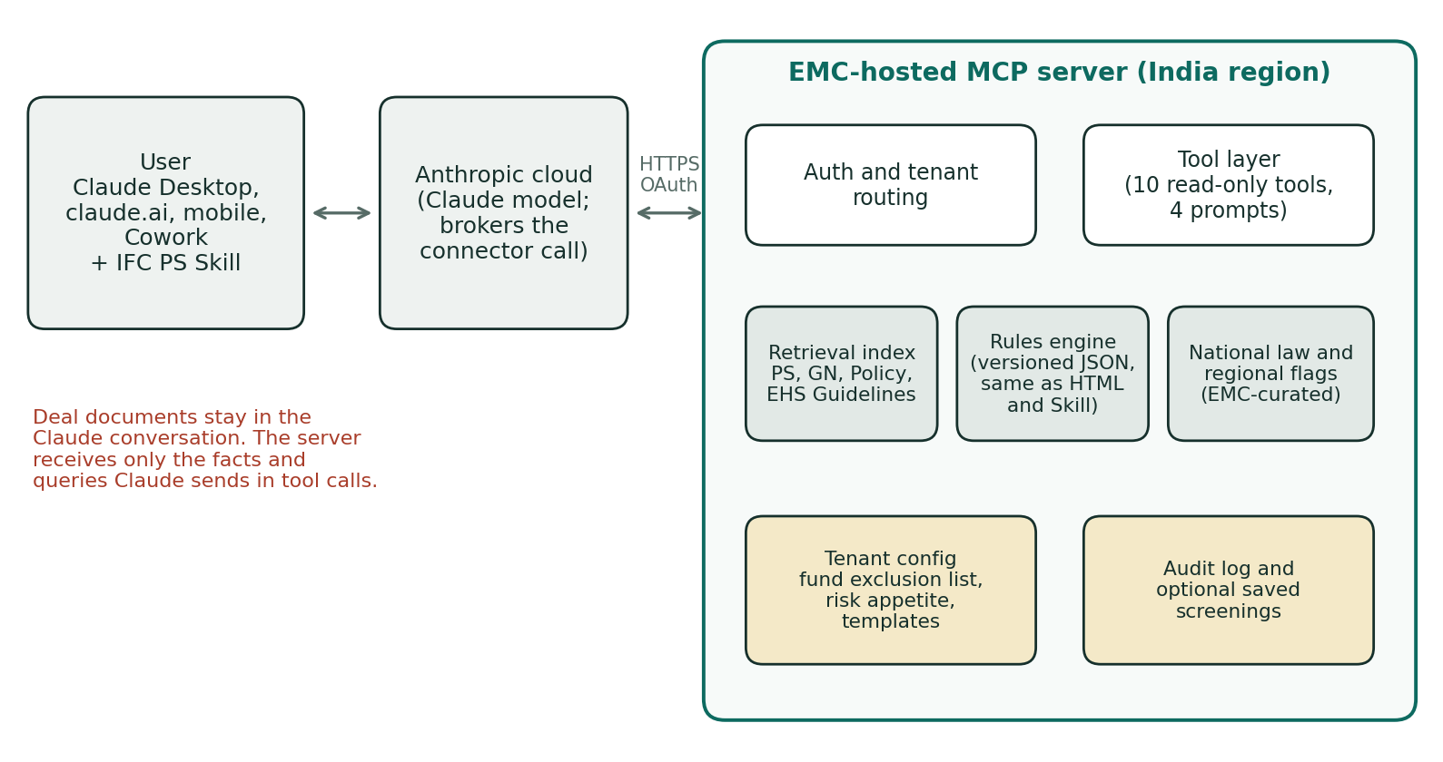
Claude connects to the server as a custom connector using a remote MCP server URL. The connection to the server comes from Anthropic’s cloud, not from the user’s computer, so the server must be reachable on the public internet over HTTPS. Custom connectors are available on Free, Pro, Max, Team and Enterprise plans (Free users are limited to one custom connector). On Team and Enterprise plans, an organisation Owner adds the connector once and members then connect individually.

Components
- Transport and auth. MCP over Streamable HTTP. OAuth 2.1 authorisation per the MCP specification, with EMC as the authorisation server (or a managed identity provider). Each token carries user, tenant (fund) and access tier.
- Tool layer. Ten tools (section 4), all read-only except the optional save_screening. Four MCP prompts give one-click workflows: quick screen, screening memo, ESAP draft, gap check.
- Retrieval index. Paragraph-level chunks of the IFC corpus with metadata (document, PS, section, paragraph number, version). Hybrid search: keyword plus vector embeddings, with exact lookup by paragraph number.
- Rules engine. The trigger, categorisation and conformance rules as a versioned JSON rule set: the same rules that drive the HTML checklist and the Skill, so all three layers agree.
- National law and regional flags. EMC-authored tables with a last-reviewed date on every row; India first, other countries added as EMC builds them.
- Tenant configuration. Per-fund exclusion list, sector policies, escalation thresholds, required output templates.
- Audit log. Who called which tool, when, with which rule-set and corpus version; no deal content stored by default.

4. Tools
Tool | Purpose | Main inputs | Returns
search_standards | Find the passages that answer a question | query; optional PS list; document types (PS, GN, Policy, IN-FI, EHS); top_k | Passages with document, PS, section, paragraph number, text excerpt, version, source link
get_paragraph | Return exact text for citation | document; PS; paragraph number | Paragraph text, neighbouring paragraphs, version
list_sections | Table of contents of a standard or Guidance Note | PS; document | Section headings with paragraph ranges
screen_project | Deterministic first-pass screening | Intake facts (schema in Appendix A) and/or answers to the 33 checklist questions; tenant | Verdict per PS with triggering facts, open facts with owners, provisional category, A-signals, rule-set version
get_conformance_requirements | Requirements, documents and ESAP actions for triggered standards | PS list with triggers; category; sector | Requirements with citations, documents expected, ESAP actions with timing conventions
requirements_checklist | Checklist for gap-checking a document | Document type (ESIA, ESMP, ESMS manual, SEP, RAP, LRP, BAP, IPP, HR policy); PS list | Requirement rows with citations for Claude to compare against the uploaded document
national_law_comparison | Domestic equivalent and gap for each PS | Country; state; sector; PS list | Rows: instrument, what it requires, what PS adds, last-reviewed date
regional_risk_flags | Location and sector red flags | Country; state; district; sector | Flags with type (species, Scheduled Area, water, labour), basis and what to check
check_exclusion_list | Screen against IFC and fund exclusion lists | Activity description; tenant | Possible matches with list source and wording
save_screening (optional) | Keep a record for audit and portfolio view | Screening result; deal reference; tenant | Record ID and timestamp

Design rules for the tools
- Return structured data with citations, not prose. Claude writes the narrative; the server guarantees the facts.
- Every response states the corpus version and rule-set version, so a screening can be reproduced later.
- screen_project is deterministic: the same inputs give the same verdicts. Where facts are missing it returns NEEDS REVIEW with the missing fact, never a guess.
- Excerpts returned from IFC documents are short and always carry the source link (see section 5 on terms of use).
- No tool takes actions outside the server. This keeps tool approval simple for users and limits prompt-injection risk.

Prompts and resources
MCP prompts: quick-screen, screening-memo, esap-draft, gap-check, each pre-wiring the right sequence of tool calls and the EMC output template. MCP resources: methodology note, version notes, and the intake schema, so Claude and users can read how the screening works.

5. Content corpus
Document | Version | Indexing notes
IFC Performance Standards on Environmental and Social Sustainability | 2012 (in force) | Paragraph-level; footnotes linked to their paragraph
Guidance Notes | 2012 edition, updated 14 June 2021 | Map each GN paragraph to the PS paragraph it explains; PS text in the GN (bold italics) tagged as requirement
IFC Policy on Environmental and Social Sustainability | 2012 | Paragraphs 19, 30–44 and 49–53 tagged (Exclusion List, categories, FIs, sector disclosure)
Guidance Note on Financial Intermediaries (29 September 2023, replaces the Interpretation Note) | Current IFC version | For FI screening
World Bank Group EHS Guidelines | General plus sector guidelines, each with own date | Index tables of performance levels separately for exact lookup
IFC Exclusion List | Current IFC version | Item-level
Selected IFC good practice handbooks | As chosen by EMC | Tagged as guidance, never as requirement
EMC national law tables and regional flags | EMC-authored, quarterly review | Every row dated
Revised IFC Sustainability Framework | Phase I dialogue to December 2026; draft proposals for consultation from January 2027; nothing approved, no effective date | Indexed as a separate version, off by default; switch when it takes effect

Versioning
Every chunk carries a version tag. Screens run against the version in force by default; a tenant can opt to see draft-framework comparisons. When IFC adopts the revised framework, EMC switches the default and keeps 2012 available for legacy portfolio questions.

Terms of use for IFC material
The IFC documents are freely published. Before launch, EMC should confirm IFC’s terms of use for hosting them in a retrieval service and returning excerpts, and if needed ask IFC for permission. The design already limits exposure: short excerpts with links rather than full documents.

6. Rules engine
- Single source. One JSON rule set generates the HTML checklist logic, the Skill’s trigger reference and the server’s screen_project. Changes are made once.
- Contents. Questions and their mapping to PS, trigger and A-signal flags, sector risk classes, category logic, conformance actions, open-fact wording and owners.
- Test suite. Reference cases with expected verdicts and categories: the three worked examples and the further reference cases in test_cases.json (20 in rule set 1.2.0), plus 20 to 30 anonymised cases from EMC’s ESDD record across sectors. Every rule change must pass the suite.
- Change control. Rule changes approved by an EMC E&S lead; version number increments; release notes published as an MCP resource.

7. Fund customisation
Setting | Example
Exclusion list | IFC list plus fund additions such as thermal coal, tobacco, gambling
Sector policies | Hydropower above a size threshold needs E&S committee review; no projects in critical habitat
Escalation rules | Any PS7 NEEDS REVIEW goes to the E&S officer; Category A requires external ESDD
Output templates | Fund’s investment committee memo format; ESAP format used in term sheets
Reference frameworks | Equator Principles, a DFI co-investor’s safeguard policy, the fund’s ESG policy
Language and terminology | Fund’s own category labels or risk ratings

Customisation is set up during onboarding with training for the fund team, and links to EMC’s follow-on support: when a screening flags exposure, the deal team can request a scoped ESDD, ESIA or ESMS proposal from EMC.

8. Security, privacy and confidentiality
- Deal documents stay with Claude. Users upload documents into the Claude conversation; the server receives only the facts and queries Claude sends in tool calls. Say this clearly to funds, because confidentiality will be their first question.
- No content storage by default. Tool inputs are not kept beyond the audit metadata unless the tenant enables save_screening.
- Tenant isolation. Fund configurations and saved screenings are separated by tenant at the database level.
- Data protection. Host in an India region; design to the Digital Personal Data Protection Act 2023, and to GDPR where EU users are served. Minimise personal data: user identity and usage only.
- Prompt-injection hygiene. Tools are read-only, inputs are validated against schemas, and corpus text is returned as data. Users should be told to approve tool calls and to connect only to the EMC server URL.
- Operations. Rate limits per user and tenant; access revocable instantly; logs retained for an agreed period.

9. Access tiers
Tier | Access | Notes
Masterclass participant | Time-limited (for example three months), core tools, no customisation | Converts participants into users; demonstrates value to their institutions
Fund or lender licence | All tools, tenant customisation, saved screenings, training | Annual licence; onboarding and customisation priced separately
EMC internal | All tools plus draft-framework comparisons | Used in ESDD scoping and proposals
Demo | Read-only demo tenant with sample cases | For the masterclass demonstration and sales meetings

10. Technology choices
- Server. Python with the official MCP Python SDK (FastMCP), or TypeScript with the official MCP TypeScript SDK. Python suits the document-processing and rules work.
- Hosting. Managed containers in an India cloud region (for example AWS Mumbai or Azure Central India) behind HTTPS.
- Search. PostgreSQL with pgvector, or a managed search service; hybrid keyword and vector search. Embeddings from a hosted embedding model; Anthropic does not provide embeddings, and its documentation points to providers such as Voyage AI.
- Ingestion. PDF parsing that keeps paragraph numbers, footnotes and tables; manual QA of the paragraph mapping for PS and GN, since citation accuracy is the product.
- Auth. OAuth 2.1 with dynamic client registration as expected by Claude’s connector flow; a managed identity provider reduces build effort.

11. Build plan
Phase | Indicative time | Scope and exit test
0. Content and rules | 2 to 3 weeks | Index PS, GN and Policy at paragraph level; QA paragraph mapping; export rule set to JSON. Exit: 100% of sampled citations match source
1. Demo MVP | 3 to 4 weeks | search_standards, get_paragraph, list_sections, screen_project; single demo tenant; simple token auth. Exit: reference cases pass; usable for live demonstration
2. Pilot | 6 to 8 weeks | OAuth, tenants, conformance, national law, flags, exclusion list, checklist and prompts; pilot with one fund. Exit: fund team completes ten live screenings with acceptable quality
3. Product | Ongoing | save_screening, portfolio view, interactive checklist inside Claude as an interactive connector, more countries, draft-framework version

Timing note for the masterclass (20–21 November 2026). About three weeks remain. A full Phase 1 is unlikely by then. Practical options: demonstrate the Step 1 Project and Step 2 Skill live, which already show cited screening, and present the connector as the next release with this architecture; or build a narrow demo with only search_standards and get_paragraph over PS and GN, hosted for the demo tenant.

12. Acceptance criteria
- Citation accuracy: every paragraph number returned matches the source text (sampled QA of at least 200 citations before launch).
- Consistency: on the reference suite, screen_project gives the same verdicts as the HTML checklist for the same answers.
- Coverage: each PS returns relevant passages for a standard set of 50 test queries written by EMC specialists.
- Performance: retrieval responses within about two seconds; screening within about three seconds.
- Security: penetration test before the fund pilot; tenant isolation verified.

13. Decisions for EMC
- Build in-house, with the PCCOE student team under supervision, or with a development partner.
- Hosting provider and region; who operates the service day to day.
- Confirmation of IFC terms of use for hosting the corpus.
- Which 20 to 30 past ESDD cases to anonymise for the test suite.
- Pricing and term for fund licences and participant access.
- Masterclass approach: demonstrate Steps 1 and 2 with the connector as a roadmap, or build the narrow demo.

Appendix A. Intake schema for screen_project
{
"project_name": "string",
"sector": "solar | wind | hydro | td | thermal | transport | ports | oilgas |
mining | heavy | light | agri | forestry | realestate | water |
social | services | fi",
"stage": "greenfield | expansion | existing | acquisition",
"location": { "country": "IN", "state": "string", "district": "string" },
"financing_route": "ifc_dfi | equator_bank | fund | other",
"answers": {
"p2_workers": "yes | no | unsure",
"p5_users": "yes | no | unsure",
"...": "one key per checklist question (33 in total)"
},
"free_text_facts": ["string"],
"tenant": "set from the OAuth token, not by the caller"
}

Appendix B. Example screen_project response (abridged)
{
"rule_set_version": "1.2.0",
"corpus_version": "PS2012-GN2021",
"category": { "value": "B", "provisional": true,
"could_change_to": "A",
"if": "species check confirms Great Indian Bustard use of line route" },
"standards": [
{ "ps": 5, "verdict": "TRIGGERED",
"because": ["Allotted revenue land is grazed (p5_users = yes)"],
"cite": [{ "doc": "PS5", "section": "Economic Displacement",
"para": "verified", "link": "https://www.ifc.org/..." }] },
{ "ps": 6, "verdict": "NEEDS_REVIEW",
"open_fact": "Species presence along plant and line",
"owner": "specialist ecologist",
"flags": ["GIB priority or potential habitat: Jaisalmer"] }
],
"india_law_gate": "Solar PV and transmission outside EIA Notification 2006"
}

