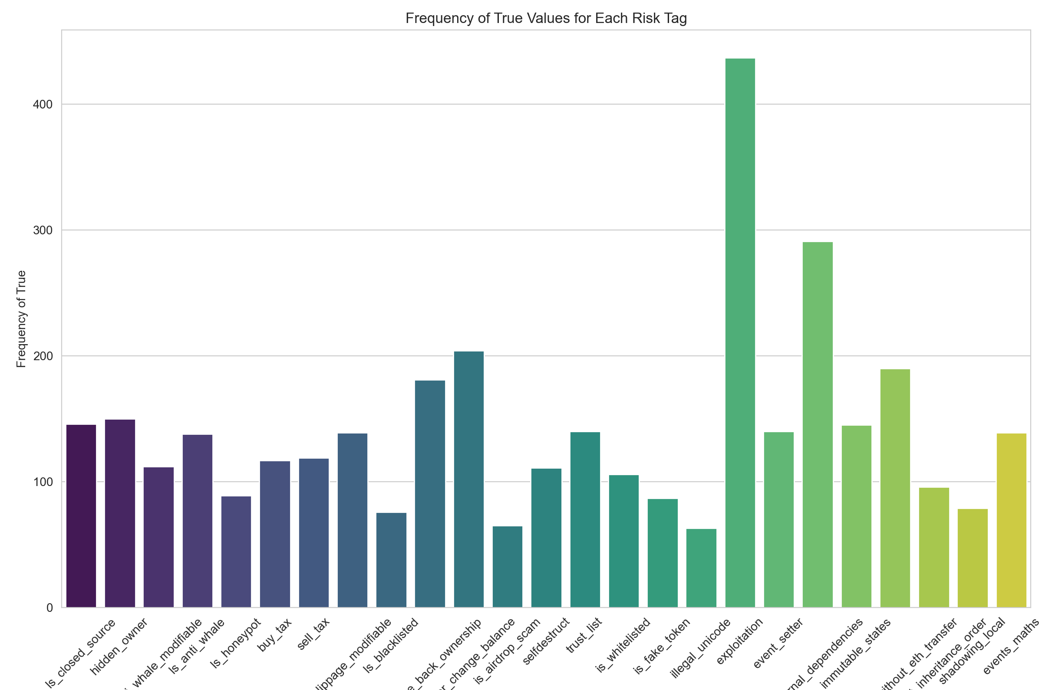

The frequency of exploitation aka the risk in smart contract is too high

