**Tutorial No.4**

1. **Write a Servlet program that takes parameter using POST method**

**Code:**

**Parameter_Webform.html**

<HTML>

<BODY>

<form action="webform" method="post">

Name:<input type="text" name="userName"/><br/>

<input type="submit" value="go"/>

</form>

</BODY>

</HTML>

**web.xml**

<?xml version=*"1.0"* encoding=*"UTF-8"*?>

<display-name>ServletJspApplication</display-name>

<welcome-file-list>

<welcome-file>index.html</welcome-file>

<welcome-file>index.htm</welcome-file>

<welcome-file>index.jsp</welcome-file>

<welcome-file>default.html</welcome-file>

<welcome-file>default.htm</welcome-file>

<welcome-file>default.jsp</welcome-file>

</welcome-file-list>

<servlet>

<servlet-name>S2</servlet-name>

<servlet-class>Parameter_WebForm</servlet-class>

</servlet>

<servlet-mapping>

<servlet-name>S2</servlet-name>

<url-pattern>/webform</url-pattern>

</servlet-mapping>

</web-app>

**Parameter_Webform.java**

import java.io.*;

import javax.servlet.*;

import javax.servlet.http.*;

public class Parameter_WebForm extends HttpServlet {

protected void doGet(HttpServletRequest request, HttpServletResponse response) throws ServletException, IOException {

doPost(request,response);

}

protected void doPost(HttpServletRequest request, HttpServletResponse response) throws ServletException, IOException {

response.setContentType("text/html");

PrintWriter out = response.getWriter();

String n=request.getParameter("userName");

out.println("<HTML>");

out.println("<BODY>");

out.print("Welcome "+n);

out.println("</BODY>");

out.println("</HTML>");

}

}

**Output:**

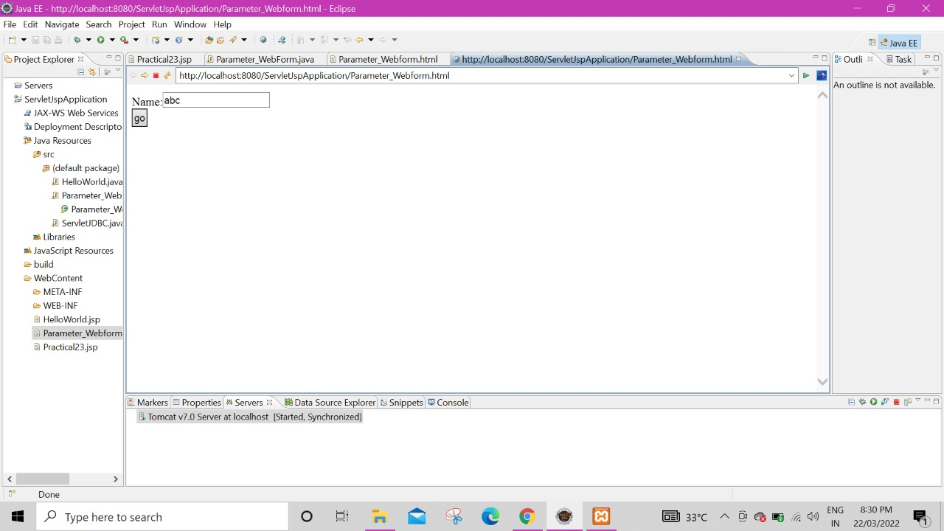

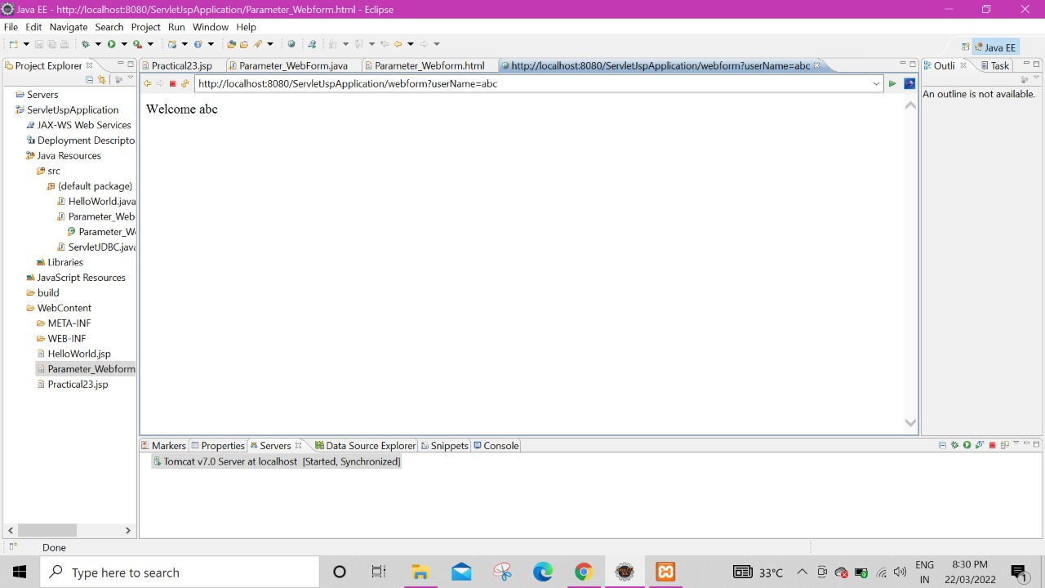

1. **Write a Servlet to read & display parameters using doGET method.**

**Code:**

**Parameter_Webform.html**

<HTML>

<BODY>

<form action="webform" method="get">

Name:<input type="text" name="userName"/><br/>

<input type="submit" value="go"/>

</form>

</BODY>

</HTML>

**web.xml**

<?xml version=*"1.0"* encoding=*"UTF-8"*?>

<display-name>ServletJspApplication</display-name>

<welcome-file-list>

<welcome-file>index.html</welcome-file>

<welcome-file>index.htm</welcome-file>

<welcome-file>index.jsp</welcome-file>

<welcome-file>default.html</welcome-file>

<welcome-file>default.htm</welcome-file>

<welcome-file>default.jsp</welcome-file>

</welcome-file-list>

<servlet>

<servlet-name>S2</servlet-name>

<servlet-class>Parameter_WebForm</servlet-class>

</servlet>

<servlet-mapping>

<servlet-name>S2</servlet-name>

<url-pattern>/webform</url-pattern>

</servlet-mapping>

</web-app>

**Parameter_Webform.java**

import java.io.*;

import javax.servlet.*;

import javax.servlet.http.*;

public class Parameter_WebForm extends HttpServlet {

protected void doGet(HttpServletRequest request, HttpServletResponse response) throws ServletException, IOException {

doPost(request,response);

}

protected void doPost(HttpServletRequest request, HttpServletResponse response) throws ServletException, IOException {

response.setContentType("text/html");

PrintWriter out = response.getWriter();

String n=request.getParameter("userName");

out.println("<HTML>");

out.println("<BODY>");

out.print("Welcome "+n);

out.println("</BODY>");

out.println("</HTML>");

}

}

**Output:**

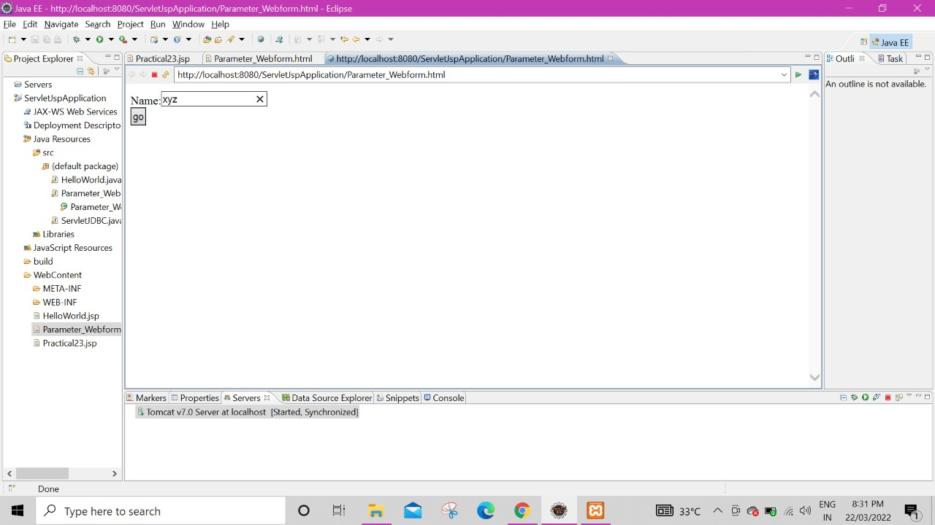

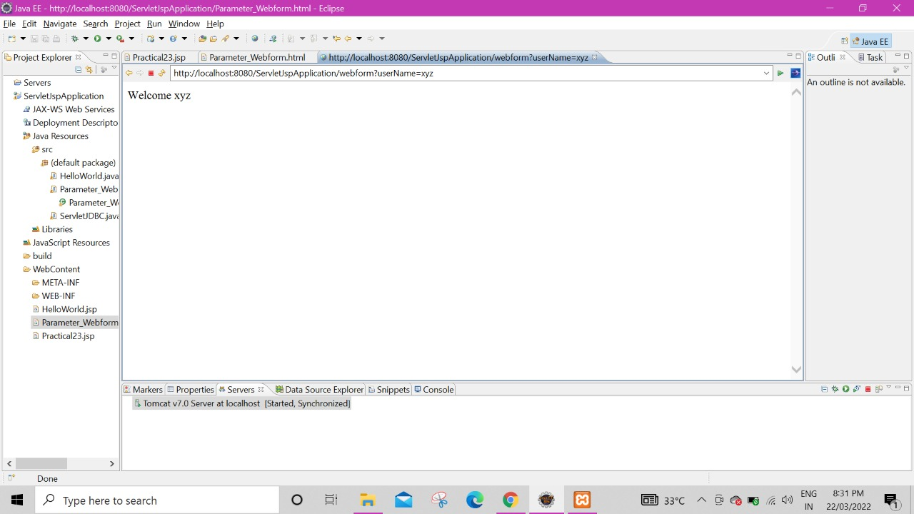

1. **Write a program using servlets to reading database and displaying them.**

**Code:**

**web.xml**

<?xml version=*"1.0"* encoding=*"UTF-8"*?>

<display-name>ServletJspApplication</display-name>

<welcome-file-list>

<welcome-file>index.html</welcome-file>

<welcome-file>index.htm</welcome-file>

<welcome-file>index.jsp</welcome-file>

<welcome-file>default.html</welcome-file>

<welcome-file>default.htm</welcome-file>

<welcome-file>default.jsp</welcome-file>

</welcome-file-list>

<servlet>

<servlet-name>ServletJDBC</servlet-name>

<servlet-class>ServletJDBC</servlet-class>

</servlet>

<servlet-mapping>

<servlet-name>ServletJDBC</servlet-name>

<url-pattern>/ServletJDBC</url-pattern>

</servlet-mapping>

</web-app>

**ServletJDBC.java**

**import** java.io.*;

**import** java.sql.*;

**import** javax.servlet.*;

**import** javax.servlet.http.*;

**public** **class** ServletJDBC **extends** HttpServlet {

Connection con=**null**;

Statement stmt=**null**;

ResultSet rs=**null**;

**public** **void** init() **throws** ServletException {

// **TODO** Auto-generated method stub

**try**

{

Class.*forName*("com.mysql.jdbc.Driver"); con=DriverManager.*getConnection*("jdbc:mysql://localhost:3306/student_info","root","");

System.*out*.println("connection successfull");

stmt = con.createStatement();

}

**catch**(ClassNotFoundException e)

{

System.*out*.println(e);

}

**catch**(SQLException e)

{

System.*out*.println(e);

}

}

**protected** **void** doGet(HttpServletRequest request, HttpServletResponse response) **throws** ServletException, IOException {

// **TODO** Auto-generated method stub

doPost(request,response);

}

**protected** **void** doPost(HttpServletRequest request, HttpServletResponse response) **throws** ServletException, IOException {

// **TODO** Auto-generated method stub

response.setContentType("text/html");

PrintWriter out = response.getWriter();

out.println("<HTML>");

out.println("<BODY>");

**try**

{

System.*out*.println("Reading from table...");

String sql = "select * from student_details";

rs = stmt.executeQuery(sql);

**while**(rs.next())

{

out.println("Id : "+rs.getInt(1)+" Name : "+ rs.getString(2)+" Age : "+rs.getString(3)+"\n");

}

}

**catch**(SQLException e)

{

System.*out*.println(e);

}

out.println("</BODY>");

out.println("</HTML>");

}

**public** **void** destroy() {

// **TODO** Auto-generated method stub

**try**

{

**if**(rs!= **null**)

rs.close();

**if**(stmt!=**null**)

stmt.close();

**if**(con!=**null**)

con.close();

}

**catch**(SQLException e)

{

System.*out*.println(e);

}

}

}

**Output:**

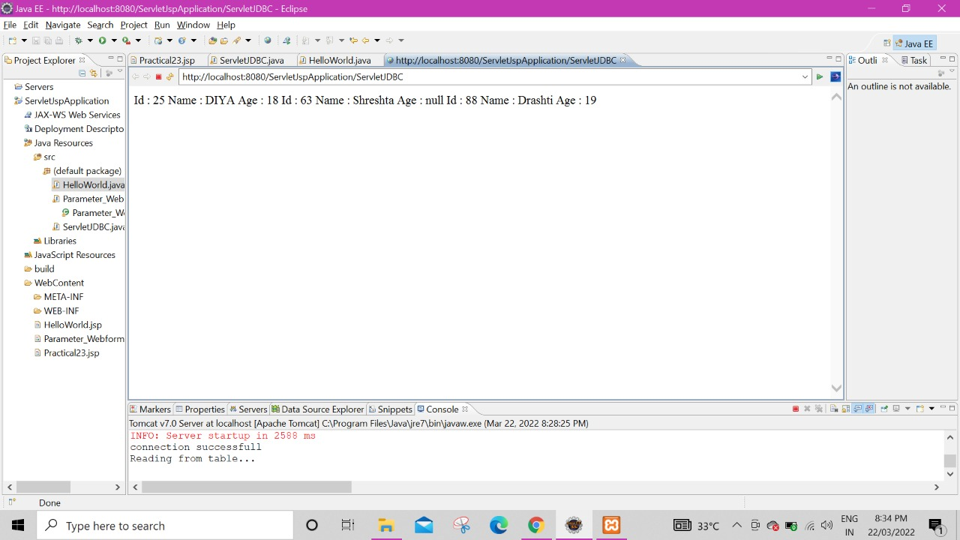

1. **Write the Simple JSP program to print “hello”.**

**Code:**

**HelloWorld.jsp**

<%@ page language=*"java"* contentType=*"text/html; charset=ISO-8859-1"*

pageEncoding=*"ISO-8859-1"*%>

<html>

<body>

Hello World

</body>

</html>

**Output:**

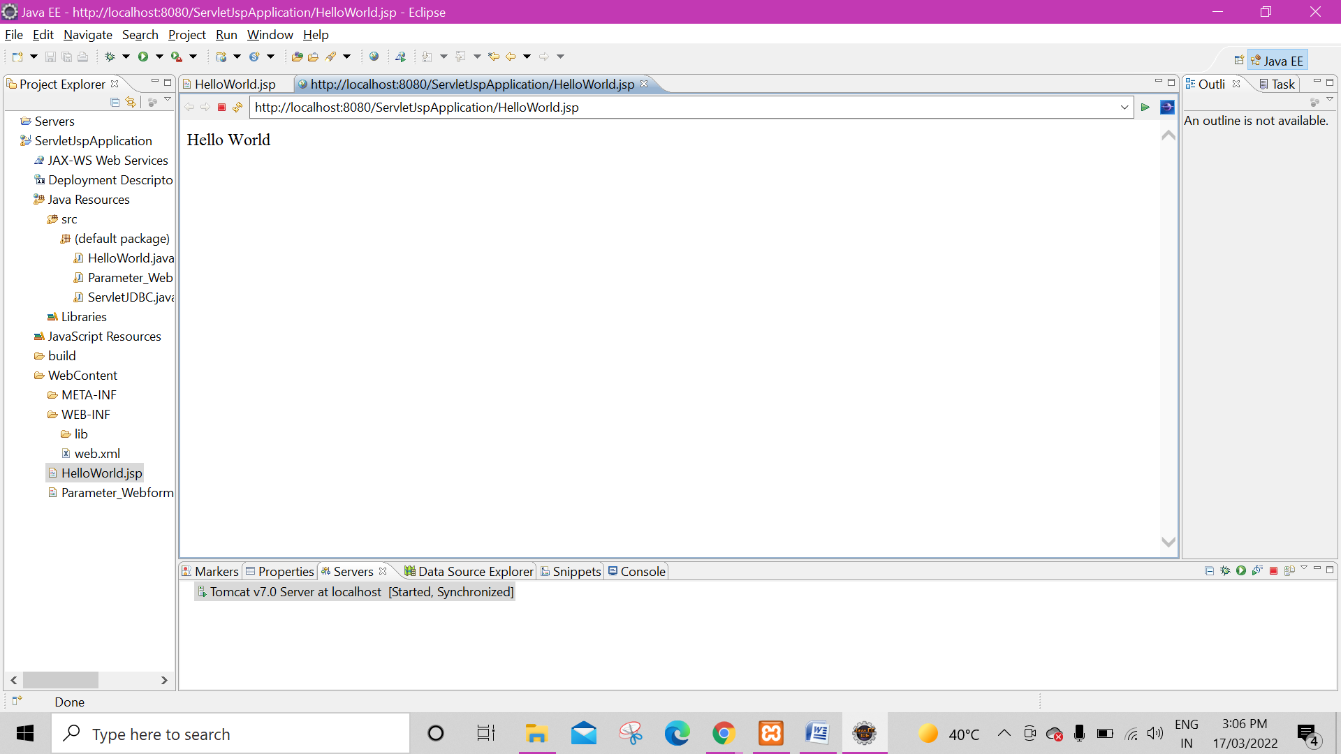

1. **Develop a JSP application to insert record in MySQL database. (Assume suitable database)**

**Code:**

**Practical23.jsp**

<%@ page language=*"java"* contentType=*"text/html; charset=ISO-8859-1"*

pageEncoding=*"ISO-8859-1"*%>

<html>

<body>

<FORM action = *"Practical23.jsp"* method = *"POST"*>

<TABLE>

<TR>

<TD>

UserName :

<INPUT type= *"text"* name=*"uname"*>

</TD>

</TR>

<TR>

<TD>

Password :

<INPUT type= *"text"* name=*"pswd"*>

</TD>

</TR>

<TR>

<TD>

<INPUT type=*"submit"* value=*"SUBMIT"*>

</TD>

</TR>

</TABLE>

</FORM>

<%@ page import=*"java.sql.*"* %>

<%

**if**(request.getParameter("uname") != **null**)

{

Connection con = **null**;

Statement s=**null**;

ResultSet rs=**null**;

String url= "jdbc:mysql://localhost:3306/login";

String id= "root";

String pass = "";

String count = "0";

**try**

{

Class.forName("com.mysql.jdbc.Driver");

con = DriverManager.getConnection(url, id, pass);

String sql = "select count(*) from login_details where username = '"+request.getParameter("uname")+"' and password ='"+request.getParameter("pswd") + "'";

s = con.createStatement();

rs = s.executeQuery(sql);

**while**( rs.next() ){

count = rs.getString(1);

}

**if**(count.equals("1"))

{

%>

<H1>Dear <%= request.getParameter("uname")%> , Login successfully done </H1>

<%

}

**else**

{

%>

<H1> Incorrect credentials...</H1>

<%

}

}

**catch**(Exception e)

{

e.printStackTrace();

}

**finally**

{

**if**(rs!=**null**) rs.close();

**if**(s!=**null**) s.close();

**if**(con!=**null**) con.close();

}

}

%>

</body>

</html>

**Output:**

