

**University Institute of Information Technology,**

**PMAS-Arid Agriculture University,**

**Rawalpindi Pakistan**

**VisionForBlinds**

***By***

**Anum Areej 19-ARID-785**

**Muhammad Komail Abbas Khan 19-ARID-832**

**Muhammad Rakib Nadeem 19-ARID-835**

***Supervisor*Mr. Suleman Khurram**

***Bachelor of Science in Computer Science (2019-2023)***

**The candidate confirms that the work submitted is their own and appropriate  
 credit has been given where reference has been made to the work of others**.

**DECLARATION**

We hereby declare that this software, neither whole nor as a part has been copied out from any source. It is further declared that we have developed this software documentation and accompanied report entirely on the basis of our personal efforts. If any part of this project is proved to be copied out from any source or found to be reproduction of some other. We will stand by the consequences. No Portion of the work presented has been submitted of any application for any other degree or qualification of this or any other university or institute of learning.

Anum Areej Muhammad Komail Abbas Khan Muhammad Rakib Nadeem

(19-ARID-785) (19-ARID-832) (19-ARID-835)

--------------------------- --------------------------- ---------------------------

**CERTIFICATE OF APPROVAL**

It is to certify that the final year project of **BS (CS)** **“VisionForBlinds”** was developed by **“Anum Areej (19-ARID-785)”**, **“Muhammad Komail Abbas Khan (19-ARID-832)”** and **“Muhammad Rakib Nadeem (19-ARID-835)”** under the supervision of **“Mr. Suleman Khurram”** and that in their opinion; it is fully adequate, in scope and quality for the degree of Bachelors of Science in Computer Science.

---------------------------------------

**(Mr. Suleman Khurram)**

**Supervisor**

---------------------------------------

**External Examiner**

---------------------------------------

**Administrator UIIT**

**Executive Summary**

People see their surroundings through the beautiful sense of sight that is gifted to them. But some people have lost this sense either because of any ailment or due to any other reasons. It becomes difficult for them to live their rest of lives with this disability. They cannot enjoy their lives and perform their daily life activities on their own. They need someone else’s aid to guide them in certain activities and tasks. Due to advancements in technology, the lives of such people have now been eased to some extent. These people can use their smartphones and perform various daily life activities and tasks easily. To create more ease for people having any kind of visual impairment, we have built a mobile application that has various utilities and modules. This mobile application titled **“VisionForBlinds”** will guide its visual impaired users in the best possible way.

Our mobile application **VisionForBlinds** is an Artificial Intelligence based project that would assist its blind and visual impaired users in various ways. Our application has used the technology of **React Native** for developing UI for mobile. Since it is an AI based mobile application, we have used various techniques of Artificial Intelligence, mostly Deep Learning techniques like **Convolutional Neural Networks (CNN)** and **Optical Character Recognition (OCR)** for its utilities and modules. Our mobile application has three important modules including **Image Captioning** and **OCR Detection**, **Currency Detection** and **Color Detection**. If the user wants to use these utilities, they will have to grant camera access to its mobile phone. The proposed solution has used various datasets for training and to predict the best possible outcomes for its users. Since we have developed this application for visually impaired people, we have incorporated the feature of **text-to-speech** with all the working modules.

**Acknowledgement**

All praise is to Almighty Allah who bestowed upon us a minute portion of His boundless knowledge by virtue of which we were able to accomplish this challenging task.

We are greatly indebted to our project supervisor **“Mr. Suleman Khurram”** for personal supervision, advice, valuable guidance and completion of this project. We are deeply indebted to him for encouragement and continual help during this work.

And we are also thankful to our parents and family who have been a constant source of encouragement for us and brought us the values of honesty & hard work.

Anum Areej Muhammad Komail Abbas Khan Muhammad Rakib Nadeem

(19-ARID-785) (19-ARID-832) (19-ARID-835)

--------------------------- --------------------------- ---------------------------

**Abbreviations**

|  |  |
| --- | --- |
| **FYP** | Final Year Project |
| **CNN** | Convolutional Neural Networks |
| **OCR** | Optical Character Recognition |
|  |  |
|  |  |

**Table of Contents**

**Introduction 1**

1.1 Brief 1

1.2 Relevance to Course Modules 2

1.3 Project Background 3

1.4 Literature Review 4

1.5 Analysis from Literature Review 6

1.6 Methodology and Software Life Cycle 6

1.6.1 Rationale behind Selected Methodology 7

**Problem Definition**

2.1 Problem Statement

2.2 Deliverables and Development Requirements

2.3 Current Systems

**Requirement Analysis**

3.1 Functional Requirments

3.2 Non – Functional Requirments

3.2.1 Usability

3.2.2 Reliability

3.2.3 Performance

3.2.4 Supportability

3.2.5 Design Constraints

3.3 Use cases

3.3.1 Use Case Diagram

3.3.2 Use Case and Actors Description

**The Design**

4.1 UML Structural Diagrams

4.1.1 Component Diagram

4.1.2 Package Diagram

4.1.3 Deployment Diagram

4.2 UML Behavioral Diagrams

4.2.1 Activity Diagrams

4.2.2 State Machine Diagrams

4.3 UML Interaction Diagrams

4.3.1 Sequence Diagrams

4.4 Node Structure

4.5 Communication Design Protocol

**Implementation**

5.1 Communication Protocol Implementation

5.2 PC Application Implementation

5.3 Embedded Application Implementation

5.4 Wireless Sensor Application Implementation

**Testing and Evaluation**

6.1 Verification

6.1.1 Functional Testing

6.1.2 Static Testing

6.2 Validation

6.3 Usability Testing

6.4 Unit Testing

* 1. Integration Testing

6.6 System Testing

**GUI**

**Future Work**

**References**

**List of Figures**

Fig 1.4.1 ColorBlindPal 4

Fig 1.4.2 Cash Reader 5

Fig 1.4.3 KNFB Reader 5

Fig 1.6.1 Agile Methodology Process Diagram 7

Fig 1.6.2 Agile Values 8

**List of Tables**

Table 1.1 Data Table

# Chapter 1: Introduction

Vision is one of those blessings that have no alternatives in one’s lives. People enjoy all the beautiful things in their lives because of this sense. But for some people, it is still a dream to see and enjoy all the activities that are going on in their lives and their surroundings. Some people lack this beautiful sense that is called “Vision”. They are either blind, visually impaired or partially visually impaired. They need someone’s support and aid to do their daily activities properly. As technology is advancing day by day, there are many new advancements that are helping those visually impaired people in their lives. So, we have worked on a project that would propose a solution to the problems that are mostly faced by visually impaired people. Our mobile application is developed having multiple utilities for blinds including Image Captioning and Optical Character Recognition (OCR) Detection, Currency Detection and Color Detection. The user must have to provide camera access to its mobile phone to use these utilities. All of these modules will use various techniques of Artificial Intelligence, mostly Deep Learning techniques like Convolutional Neural Networks (CNN) and Optical Character Recognition (OCR). For this purpose, several datasets will firstly be trained and then they will predict the best possible outcomes. Along with Artificial Intelligence, our proposed solution will use the technology of React Native for developing UI for mobile application. There are various mobile applications that have also been developed for assisting visually impaired people. Our application has surely been their re-implementation but removing certain limitations that are in already existing systems.

In this chapter, we will discuss about the brief introduction of our project including outcome of our work, tools and methodologies used. We will also discuss the relevance of our courses that we have studied in our degree with our project and the idea behind developing this project. Moreover, we will also provide an analysis of all the existing systems that are relevant to our proposed solution. We will end this chapter by discussing which software methodology and SDLC model is selected for this project.

# Brief

Sense of vision plays a very important role in any person’s life. This sense makes one’s life meaningful and beautiful. But there are some people who are deprived of this beautiful sense and are unable to live and enjoy their lives to the fullest because they have totally become dependent on other people in performing their various activities and tasks. They need someone’s guidance and assistance so that they could do their certain activities. But now a days, technology has played a very important and supportive role in their lives. The modern use of technology has somehow eased their way of living and helped them in many ways.

To overcome the gap between people having any kind of visual impairment and their surroundings, we have worked on a project that would guide and assist those people in many ways. We have developed a very user-friendly mobile application that would be very easy for blind people to navigate. The interface is very lucid and user-friendly with very few buttons that are larger in size. The user interface for our mobile application has been developed through technology of React Native. Our mobile application is purely based on different techniques of Artificial Intelligence like CNN and OCR Detection. The user will have to grant camera access in order to operate our mobile application. The user can use different modules and utilities like Image Captioning and OCR Detection, Currency Detection and Color Detection. All these modules have been developed by applying different techniques of Artificial Intelligence, mostly of Deep Learning and Machine Learning. At first, different datasets were trained to capture inputs from its desired users and then the model appropriately predicted the suitable and best possible results. Since our application is specifically designed to guide and assist blind people in their lives, we have incorporated the feature of Text-To-Speech along with all the working modules, so that the mobile application will speak out the output instead of just displaying on the screen.

The development of our mobile application involved the use of various technologies like React Native for building user interfaces for mobile and various useful libraries of Python like Keras and TensorFlow for different models. Moreover, we have also used the platform of Google Colab for training our different datasets. We have also used TensorFlow Lite (tFLite) for deploying various Machine Learning to edge devices like Android and iOS. We have used the Agile model for our software development because of its iterative and incremental approach.

In the next chapters of this report, we will discuss about problem definition and problem solution. We will also highlight the most important phase of SDLC that is Requirement Analysis through which we gathered user’s requirements. Then in further chapters, we will discuss about System Design and Architecture, Implementation, Testing and Evaluation. Lastly, we will highlight the conclusion of our proposed solution and will also discuss about future work that can be further carried on to improve the already existing systems and our proposed solution.

# Relevance to Course Modules

The main aim for developing a Final Year Project (FYP) by any student is to demonstrate all those skills that he/she has learnt throughout their entire degree. They have to show which skills and how much knowledge they have acquired in their entire educational time period in university. A student mostly integrates and applies various areas or courses that they have learnt in their curriculum. They use different tools, technologies and methodologies to apply on a real-world scenario in development of their FYP. This development also serves as a way of learning new topics and curriculum and enhancing the already learnt knowledge and skills.

There are various courses that have helped us in the development of our FYP that we have studied in our curriculum. But there are also some knowledge gaps that we have faced during the development of our proposed solution. To overcome those gaps, we have to gather knowledge from some other sources like Online Courses, YouTube and some websites.

Courses that have helped us in developing our project are listed below:

1. Technical and Business Writing.
2. Software Engineering.
3. Artificial Intelligence.
4. Mobile Application Development.

The course of **Technical and Business Writing** has helped us in the preparation of Proposal and Final Report of our Final Year Project.

The course of **Software Engineering** has helped us in choosing appropriate Software Methodologies and SDLC models for our project. This course has also facilitated us in requirement analysis for gathering user requirements. This course has helped us a lot in designing various diagrams like UML diagrams for the purpose of visual representation of all the actors, roles, actions or classes. This course gave us knowledge about choosing appropriate system architecture and system design for our proposed solution.

The course of **Artificial Intelligence** gave us knowledge about various techniques that we have used in our project like Convolutional Neural Networks (CNN) and how to train different models.

The course of **Mobile Application and Development** has helped us in development phase for creating User Interfaces for our mobile application. This course helped us in making familiar with the development tool Android Studio. Although the technology we used for developing UI for our project was React Native, but we were taught Java as a language for development in this course. We learnt React Native through other sources like Online Courses and YouTube.

# Project Background

Sense of vision helps people in many ways: It can help people in seeing and examining their surroundings and their routine life daily activities. People having sense of vision are independent in their lives in context that they can perform their daily activities and tasks on their own without any other person’s assistance and guide. They can view their surroundings and experience it. But there are some people, who are deprived of this basic sense of vision. They may be either completely blind, partially visually impaired or completely visually impaired because of several reasons. These reasons can be some ailment, abnormality or anything. But the most drastic effect in their lives because of this visual impairment is that they become dependent on other people’s guide and assistance to perform their several activities and tasks.

The main idea behind developing a mobile application for visually impaired people was to facilitate its blind users in various ways. The idea was to develop any application that would ease the lives of these people to the best possible way. Our mobile application was developed with different useful utilities and modules for visually impaired people including Image Captioning and OCR Detection, Currency Detection and Color Detection. Our proposed solution was developed to help its users in various activities e.g., to grasp knowledge about an image containing any text on it, any sign board having any text written on it or any book cover having a title. This could help its users to get knowledge about any scenario depicted in an image. Similarly, blind people suffer very much while dealing with money or currency notes. The user can know about the amount of currency note that would be scanned in our application. The user can scan PKR 10,20,50,100,500 and 1000 currency notes. Lastly, the user can also know about various colors that would be inside any image. Since we have developed this mobile application for visually impaired people, we have incorporated the feature of Text-To-Speech along with all the modules of our application, so that the user can listen to whatever is detected as a result of their input.

Our project is purely based on different techniques of Artificial Intelligence, mostly Deep Learning and Machine Learning like Convolutional Neural Networks (CNN) and Optical Character Recognition (OCR). These techniques work in a complex manner. Firstly, appropriate datasets were trained according to our requirement. As a result of training models, our mobile application was able to predict the most closely related outputs. OCR was used in our application to extract any kind of text from any image. Similarly, CNN was used as a model in all the utilities to predict the best possible outcome of the input. Since our project was a mobile application, we developed it through the technology of React Native for building user-friendly and lucid User Interfaces (UI). The UI was built in the simplest possible way so that it become easy for blind people to navigate in the application.

# Literature Review

In the past, a number of mobile applications have been developed to assist and guide the people having any kind of visual impairment. The development of our proposed solution is surely a re-implementation of its existing systems but reducing the limitations to the best possible way. Some of existing systems described below:

In [1], Color Blind Palis a mobile application that is to facilitate its color-blind users in detecting various colors. The main aim of this application is to notify its users about different colors that they are unable to perceive. It is available for all users having Android, iOS and MAC. This mobile application is very simple to use for its visually impaired users, you just have to point your device camera towards any image and it will detect the color inside that image. In [2], Cash Readeris also a mobile application for its blind users in detecting amount of currency notes. It has two versions, the free version allowing you to identify the two lowest denominations of each currency, while the upgraded version allowing identifications of all denominations. The free version restricts its users for detecting a few numbers of currency notes while premium version allows detection of number of currency notes, thereby, forcing its users to buy its subscription. In [3], KNFB Reader is a mobile application to guide its blind, low vision, dyslexic or other print- disabled users that converts text-to-speech or text-to-braille. This mobile application reads any print aloud. You just have to take any photo and the app reads the text aloud or publishes it in Braille. This mobile application basically recognizes any printed text fluently and accurately.

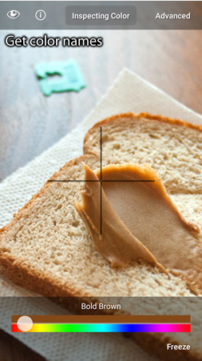

**Figure 1.4.1: ColorBlindPal**

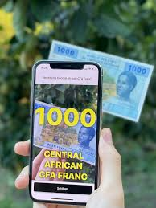

**Figure 1.4.2: Cash Reader**

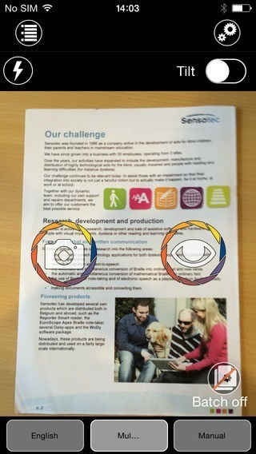

**Figure 1.4.3: KNFB Reader**

# Analysis from Literature Review

As our proposed solution is a re-implementation of already existing systems, our main aim is to remove the limitations that are present in the existing systems for the purpose of improvement in the future. Our mobile application has been developed with three different utilities or modules specially designed for people having any kind of visual impairment.

The first and foremost purpose for developing our mobile application with three different modules is to provide facility to handle three different utilities at one platform. As the existing systems that have been mentioned in the literature review comprise of only a specific utility in their application. On the other hand, we are providing three different modules at a single platform to reduce switching between different applications for a single user.

Moreover, there are certain limitations in the existing systems. We have tried to reduce those limitations to the best possible way. As mentioned in the literature review, the application [1] Color Blind Pal, does not support the feature of Text-To-Speech, it only displays the output in text form. While we have incorporated the feature of Text-To-Speech as we have designed and developed this system specifically to assist and guide the visually impaired people.

The next application, [2] Cash Reader, has two versions; the free version and the paid version. The free version only allows the scanning of limited currency notes. In order to scan every currency, note, you have to buy its subscription which is not feasible for all of its users. So, we have worked on scanning of currency notes of PKR 10,20,50,100,500 and 1000 with no subscription. The scanning of all the above-mentioned currency notes will be available free of cost without any subscription to make it easy for all of its users.

Lastly, the application, [3] KNFB Reader, is also available in two versions; the free version and the paid version. It is also not feasible for all of its users to access its services free of cost. This subscription has created a barrier between its users restricting them due to its cost, hence the users are unable to fully enjoy the services. We have also tried to reduce this barrier of cost between the application and the user by providing them with utility of Image Captioning and OCR Detection free of cost. This can somehow provide ease to its intended users.

# Methodology and Software Lifecycle for This Project

Image Captioning and OCR Detection firstly capture image and then predict the possible outcome. This involves analysis of input data with already trained datasets and recognition of images that will follow some algorithms to extract text from images in case of OCR Detection.

The methodology that we used in realization of our project was Agile Methodology. The main purpose for using Agile methodology was that it is incremental and evolutionary rather than revolutionary process. It is a flexible and adaptive methodology that is suitable for short projects in high-risk situations.

* + 1. Rationale behind Selected Methodology

We used Agile methodology for our proposed solution. The main rationale behind using this methodology was that it is based on iterative and incremental development, that promotes project management process which encourages inspection and adaptation, hence to get feedback from the customers. It delivers value to its customers faster. Agile team works in small increments. All the phases of development are continuously monitored so that it becomes easy to respond to changes quickly. Agile model provides flexibility and adaptability that allow its team members to keep on adding new functionalities later on according to the needs of the customers.

The Agile Methodology is suitable for our proposed solution in various other ways described below:

* Incremental and iterative approach in SDLC.
* Considered as unstructured, flexible and adaptable model.
* Feedback-based approach having sprints that lead to short build updates.
* At the end of each sprint, user acceptance is necessary to proceed to further development.
* Documentation has less priority as compared to software development.

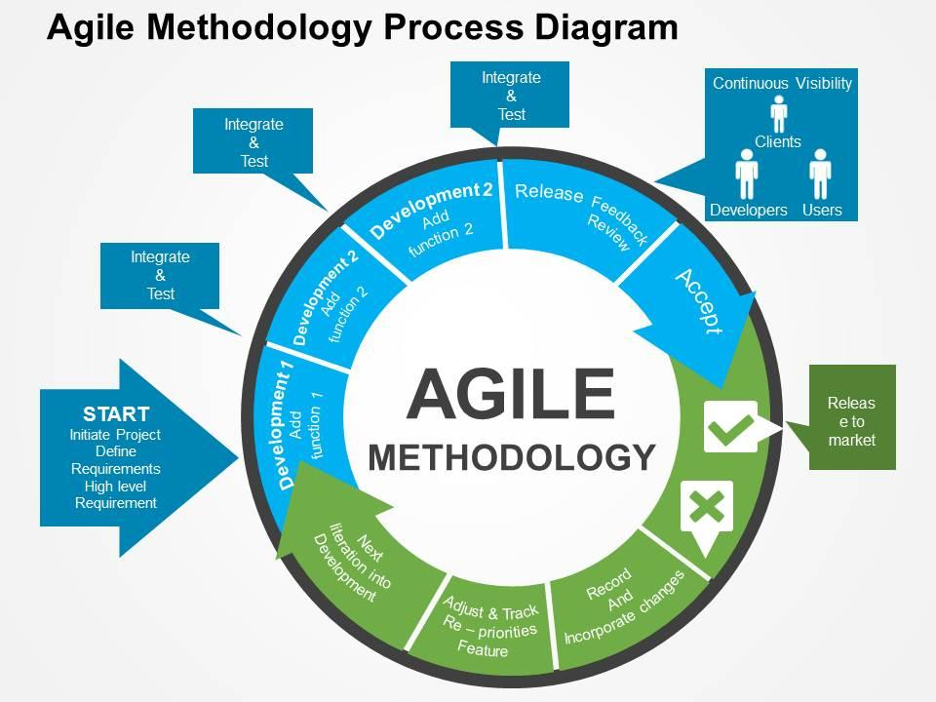

**Figure 1.6.1: Agile Methodology Process Diagram**

The Agile software model emphasizes on four important core values:

1. Individuals and team interactions over processes and tools.
2. Working software instead of comprehensive documentation.
3. Customer collaboration over contract negotiation.
4. Responding to change over following a particular plan.

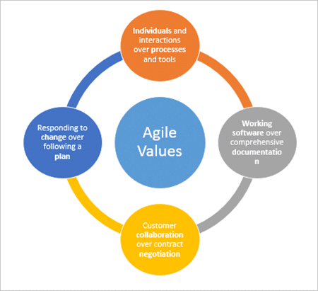

**Figure 1.6.2: Agile Values**