1)
EPOCHS = 100
LEARNING_RATE = 0.001
BATCH_SIZE = 50
Dropout_Rate = 0.5
Normalisation = ON

EPOCH 10 ...
Training loss = 0.464
Training accuracy = 0.857
EPOCH 10 ...
Validation loss = 0.534
Validation accuracy = 0.838

EPOCH 25 ...
Training loss = 0.389
Training accuracy = 0.884
EPOCH 25 ...
Validation loss = 0.477
Validation accuracy = 0.856

EPOCH 50 ...
Training loss = 0.364
Training accuracy = 0.890
EPOCH 50 ...
Validation loss = 0.498
Validation accuracy = 0.862

EPOCH 75 ...
Training loss = 0.309
Training accuracy = 0.908
EPOCH 75 ...
Validation loss = 0.448
Validation accuracy = 0.870

EPOCH 100 ...
Training loss = 0.317
Training accuracy = 0.904
EPOCH 100 ...
Validation loss = 0.487
Validation accuracy = 0.867

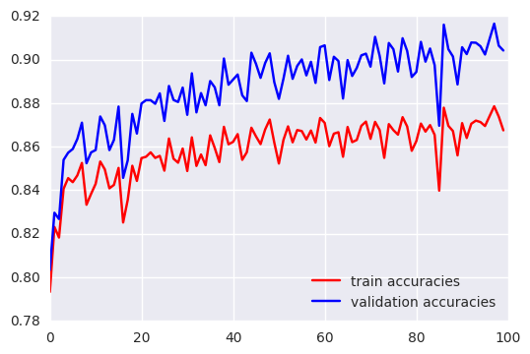
2)
EPOCHS = 25
LEARNING_RATE = 0.0005
BATCH_SIZE = 50
Dropout_Rate = 0.5
Normalisation = ON

EPOCH 10 ...
Training loss = 0.441
Training accuracy = 0.865
EPOCH 10 ...
Validation loss = 0.514
Validation accuracy = 0.845

EPOCH 25 ...
Training loss = 0.363
Training accuracy = 0.888
EPOCH 25 ...
Validation loss = 0.466
Validation accuracy = 0.861

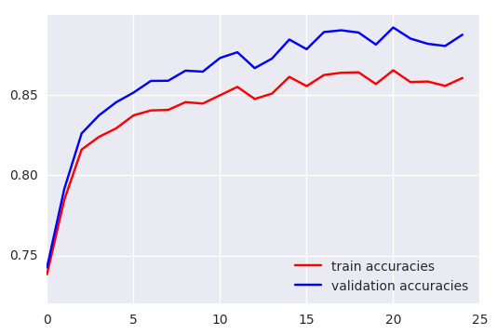
3)
EPOCHS = 25
LEARNING_RATE = 0.0002
BATCH_SIZE = 50
Dropout_Rate = 0.5
Normalisation = ON

EPOCH 10 ...
Training loss = 0.363
Training accuracy = 0.887
EPOCH 10 ...
Validation loss = 0.443
Validation accuracy = 0.866

EPOCH 25 ...
Training loss = 0.265
Training accuracy = 0.919
EPOCH 25 ...
Validation loss = 0.402
Validation accuracy = 0.883

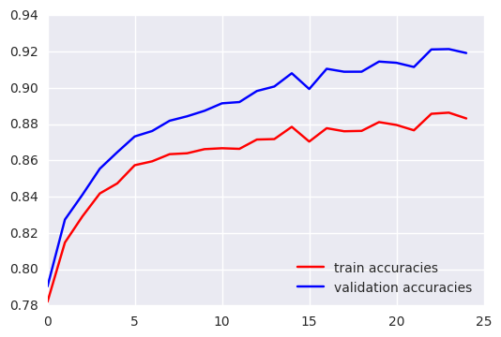
4)
EPOCHS = 25
LEARNING_RATE = 0.0002 (was best of 3 – the lower the better)
BATCH_SIZE = 25
Dropout_Rate = 0.5
Normalisation = ON

Training loss = 0.284
Training accuracy = 0.913
EPOCH 10 ...
Validation loss = 0.377
Validation accuracy = 0.890

EPOCH 25 ...
Training loss = 0.168
Training accuracy = 0.951
EPOCH 25 ...
Validation loss = 0.328
Validation accuracy = 0.912

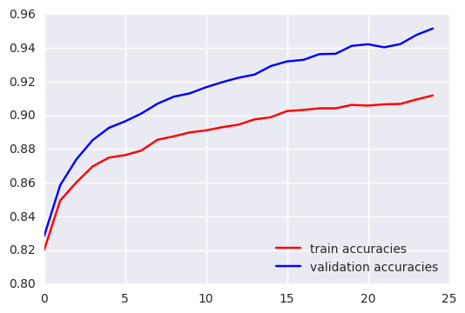
5)
EPOCHS = 25
LEARNING_RATE = 0.0002 (was best of 3 – the lower the better)
BATCH_SIZE = 75
Dropout_Rate = 0.5
Normalisation = ON

Training loss = 0.326
Training accuracy = 0.904
EPOCH 10 ...
Validation loss = 0.391
Validation accuracy = 0.883

EPOCH 25 ...
Training loss = 0.225
Training accuracy = 0.934
EPOCH 25 ...
Validation loss = 0.357
Validation accuracy = 0.898

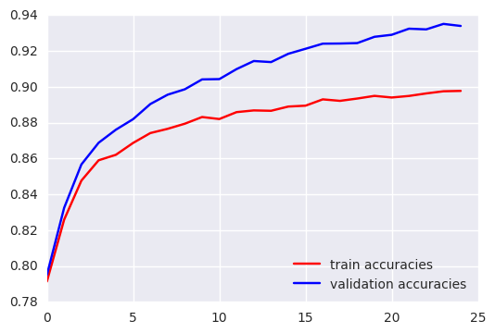
6)
EPOCHS = 25
LEARNING_RATE = 0.0002 (was best of 3 – the lower the better)
BATCH_SIZE = 25 (was best of 3 – the lower the better)
Dropout_Rate = 0.25
Normalisation = ON

EPOCH 10 ...
Training loss = 0.492
Training accuracy = 0.850
EPOCH 10 ...
Validation loss = 0.528
Validation accuracy = 0.840

EPOCH 25 ...
Training loss = 0.433
Training accuracy = 0.867
EPOCH 25 ...
Validation loss = 0.490
Validation accuracy = 0.853

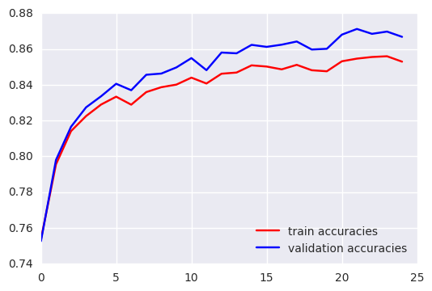

7)
EPOCHS = 25
LEARNING_RATE = 0.0002 (was best of 3 – the lower the better)
BATCH_SIZE = 25
Dropout_Rate = 0.75
Normalisation = ON

EPOCH 10 ...
Training loss = 0.260
Training accuracy = 0.922
EPOCH 10 ...
Validation loss = 0.378
Validation accuracy = 0.888

EPOCH 25 ...
Training loss = 0.136
Training accuracy = 0.960
EPOCH 25 ...
Validation loss = 0.369
Validation accuracy = 0.906

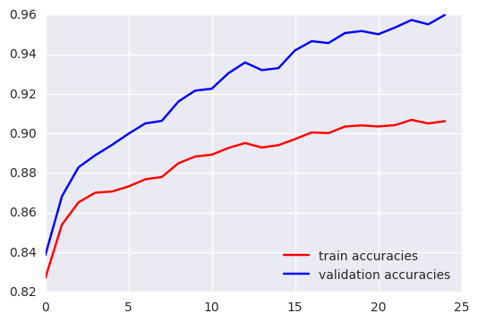

8)
EPOCHS = 25
LEARNING_RATE = 0.0002 (was best of 3 – the lower the better)
BATCH_SIZE = 25
Dropout_Rate = 0.50
Normalisation = OFF

EPOCH 10 ...
Training loss = 0.392
Training accuracy = 0.886
EPOCH 10 ...
Validation loss = 0.477
Validation accuracy = 0.867

EPOCH 25 ...
Training loss = 0.261
Training accuracy = 0.924
EPOCH 25 ...
Validation loss = 0.409
Validation accuracy = 0.890

