**Assignment 1.4 | Typescript**

**Aaron Wilson**

**July 13, 2019**

**Figure 1 | Typescript CLI transpile**

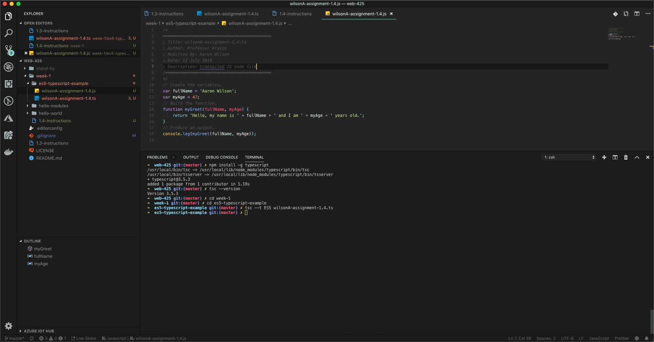

**Figure 2 | Output.**

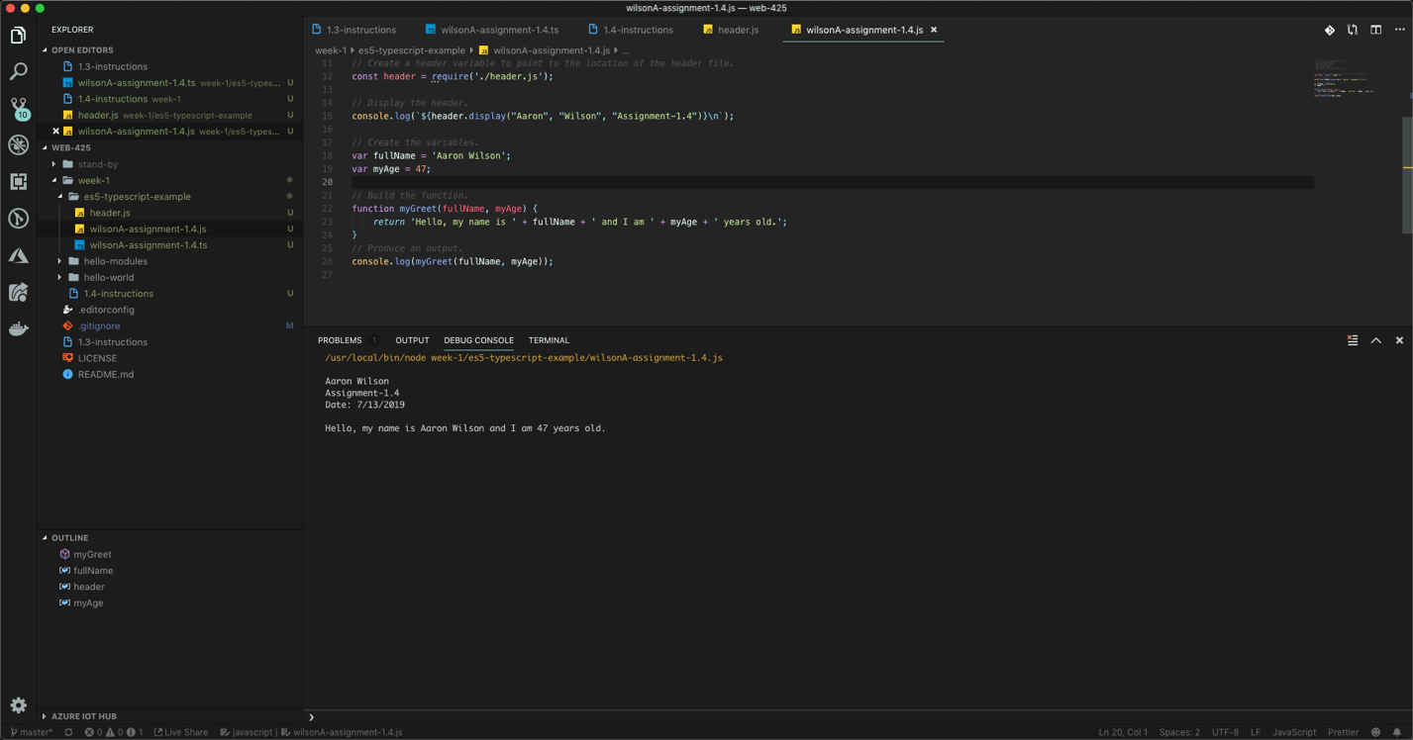

**Figure 3 | Folder Structure.**

