**Exercise 2.3 | Two-Way Binding**

**Aaron Wilson**

**July 21, 2019**

**Figure 1 | Output.**

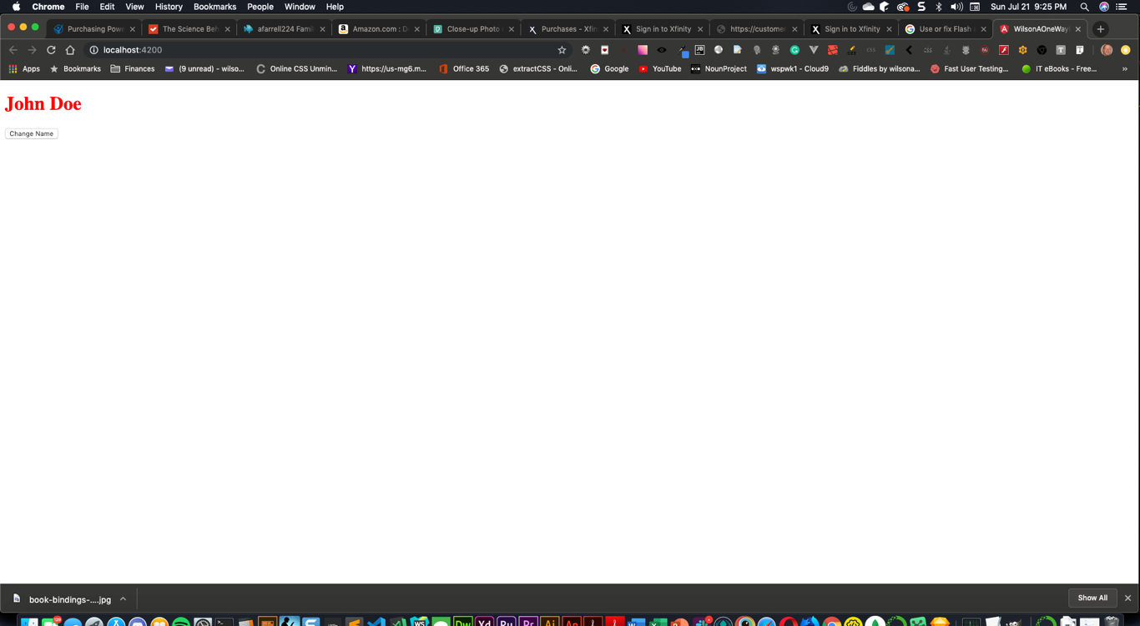

**Figure 2 | Output After change.**

