**Exercise 4.2 | Dependency Injection**

**Aaron Wilson**

**August 04, 2019**

**Figure 1 | Browser Output.**

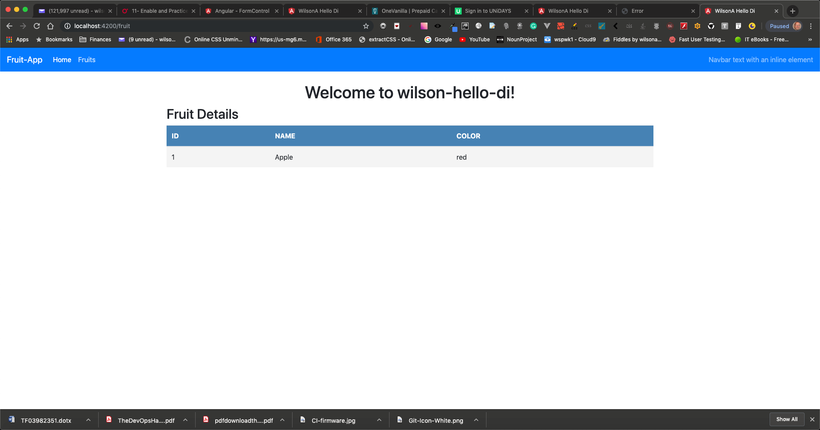

**Figure 2 | VSCode folders.**

