**Assignment 5.4 | Material Design Layout**

**Aaron Wilson**

**August 09, 2019**

**Figure 1 | Browser Output.**

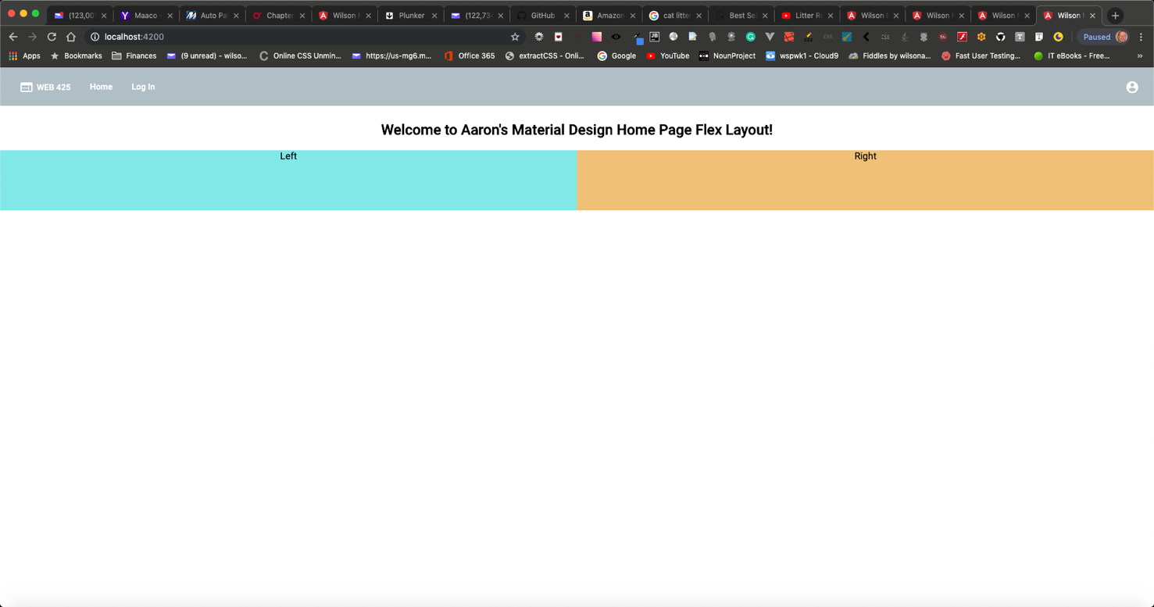

**Figure 4 | Browser Output 1.**

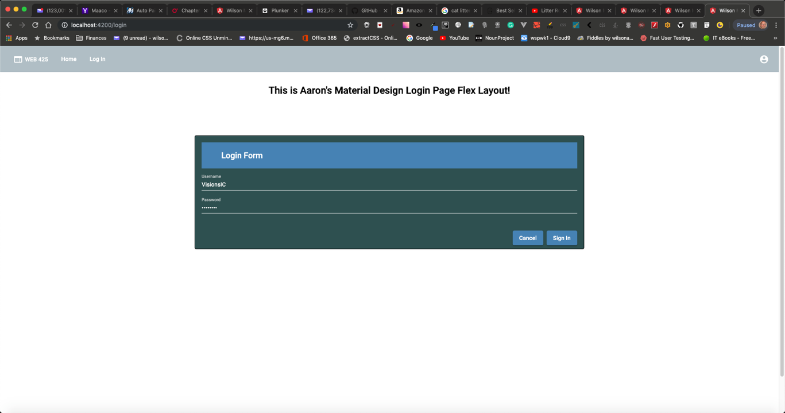

**Figure 3 | Browser Output 3.**

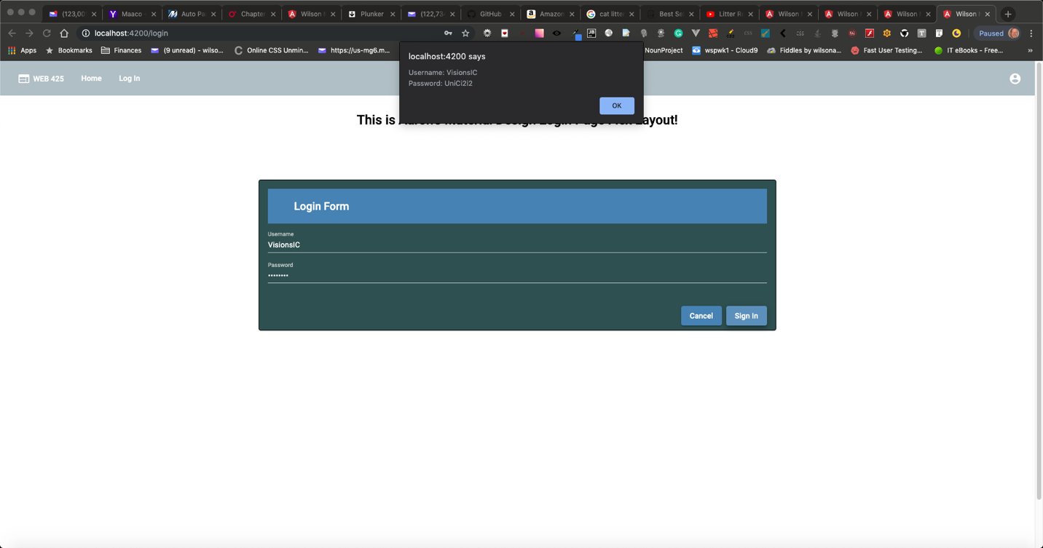

**Figure 4 | VSCode folders.**

