**Exercise 5.3 | Material Design Login**

**Aaron Wilson**

**August 09, 2019**

**Figure 1 | Browser Output.**

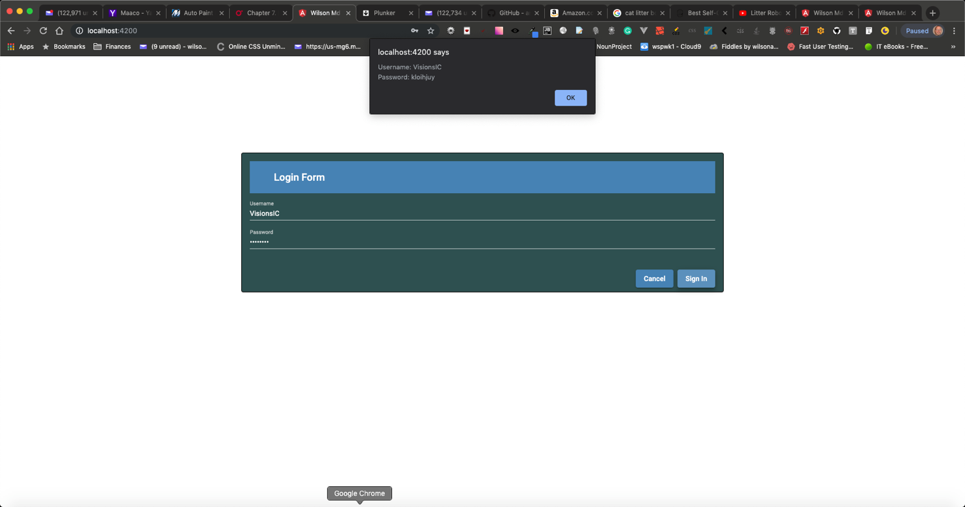

**Figure 2 | VSCode folders.**

