**Exercise 8.2 | Server-Side Communications with Node.js and Express**

**Aaron Wilson**

**September 01, 2019**

**Figure 1 | Browser Output.**

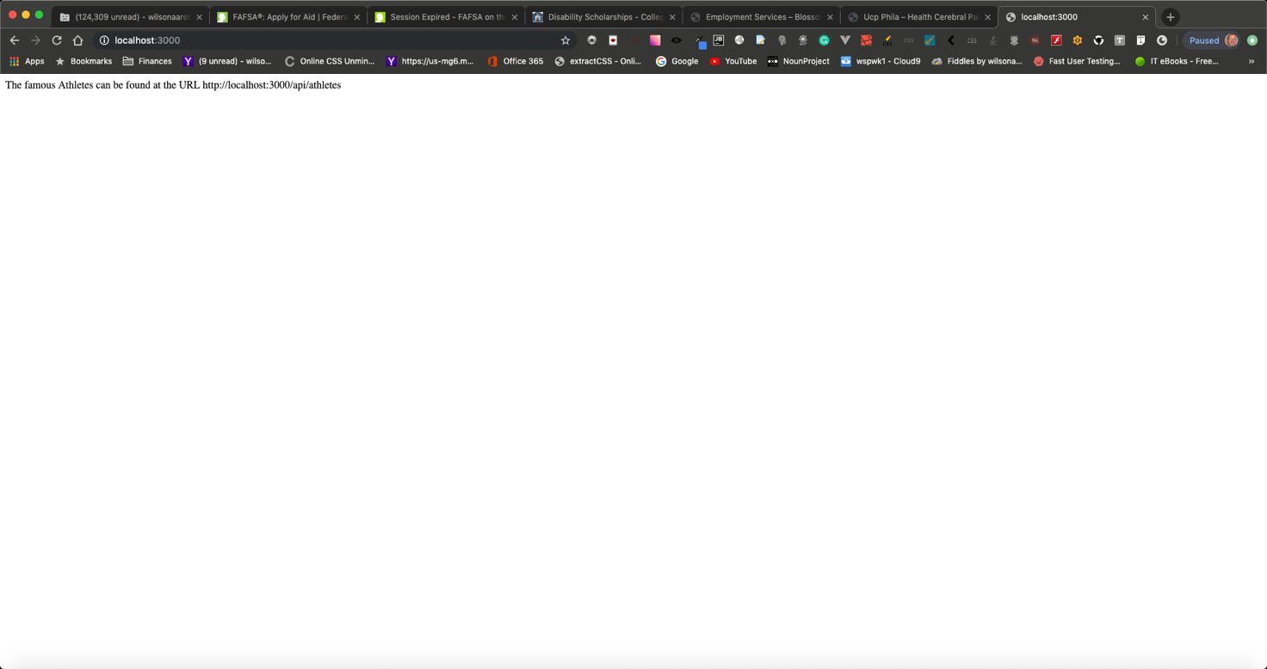

**Figure 2 | Browser Output 2.**

**Figure 3 | Browser Output 3.**

**Figure 4 | VSCode folders.**

