Price Recommendation using Data/ AI /ML

Contents

Key Requirements: 1

Design Approach: 2

Deliverables: 3

Potential Solution/ Architecture 3

Factors Impacting Car Sales Price: 3

Related Information/ Data 4

Your Proposal/ Next Steps: 6

Test Approach: 7

# Key Requirements:

I am developing a car marketplace where sellers register their vehicles to sell and we help them find buyers through offering online negotiation method. For more information, you can see <http://my.RoboNegotiator.com> -

As part of the offering we would get seller’s data, seller’s vehicle data (VIN#, etc.) and other details. As part of normal operations, we would also get counter offers from buyers who are negotiating for this car and if we matched a buyer with a seller, we would also get final “negotiated” (closed deal) price too in our own database.

As part of this solution, we also want to provide AI / Scientific/ Statistical Models by which can suggest an ideal sales price range like shown in image below.

It will be shown like our AI suggested price. Every listing has VIN# so we know make, model, trim, year and we also have ZIP code of a car and seller’s email address along with other details.

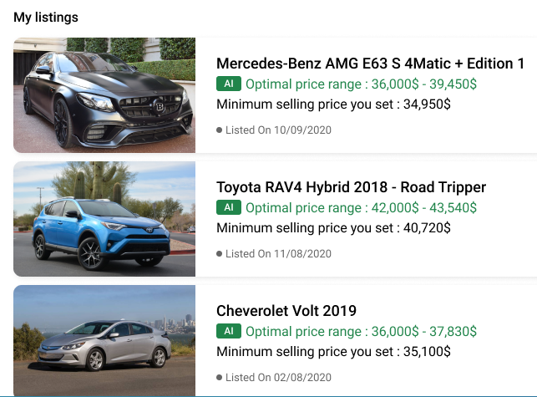

# Design Approach:

AI/ML/ BI or Data Driven Decision Making is not my technical strengths but from my common sense and past education/ experience I can say that this kind of system will have three components

1. **Data Sources** – We must have data to suggest or learn from – In my mind, we need to have our own data where we know about a car, sell price in our own inventory and other things. We might need to scrap. We need to connect to third party API providers in this space. We may need to buy data from others (DMV in USA – do they sell data for all sales price by VIN#)? KBB.Com, NADA, Edmunds, DMV, Inventory on hand, Car2Db, VINAudit, Competition/ Scrapper Data, Our own historic data (like eBay uses past data to suggest price for your listing) - all can chime in in my mind.
2. **Intelligence** – We cannot have just any kind of data. We need to understand what data will play a role in decision making/ intelligence. This will also drive the requirements if we need to buy data, partner with some companies (API providers), use our own data or collect more and/or scrap data from relevant sites. **You need to show me a proof in your proposal that you can think some dependencies/ factors which should be fed into AI/Decision Making. Like Competition Data is one source. What other factors should influence the range? I have list of 8 sources as I think – I want to see how you think here.**
3. **Model/ Algorithm** – Once we have 1) and 2), we need efficient AI/ML/Data Science Modeling and Algorithms which will do the magic (HOW part) of bringing Data Sources and Intelligence to gather.

Prove you have ability to think through a solution covering all 3 points above. Don’t sell me your AI/BI/ML algorithm skills alone. Similarly, don’t sell me web scraper solution alone. Show me your experience, rough idea about how you would go after this project, what do you need from me, etc. so I can select you.

Deliverables:  
  
We will have paid projects for 3 levels and before that you need to prove you can think or work through all 3 levels I mentioned above.

**Phase 1** – You do design/ technical specs before we start development – It will be detailed. You would have given enough proofs about your capabilities, thought process, technical source, past experiences to get this level.

**Phase 2** – You do a quick **prototype of** the solution – Demo’able so we can decide to go forward and finish the remaining development, fix bugs, add more data sources to make it complete/ more accurate, etc. Purpose of prototype is to check feasibility (practical) and demonstrate that it can be developed. We can get trial data, manufacture dummy data, get limited scrapper in place (instead of 5 sites – it could get data from 2 sources for example).

**Phase 3 – Full Solution** – We integrate with API Providers, We collect all data sources, We purchase data as needed and then we have proper intelligence/ model/ decision making logic along with all APIs and DB support so we can serve the business. Purchasing data and business dealing with API providers will be my responsibility while you will integrate and do all technical work.

# Potential Solution/ Architecture

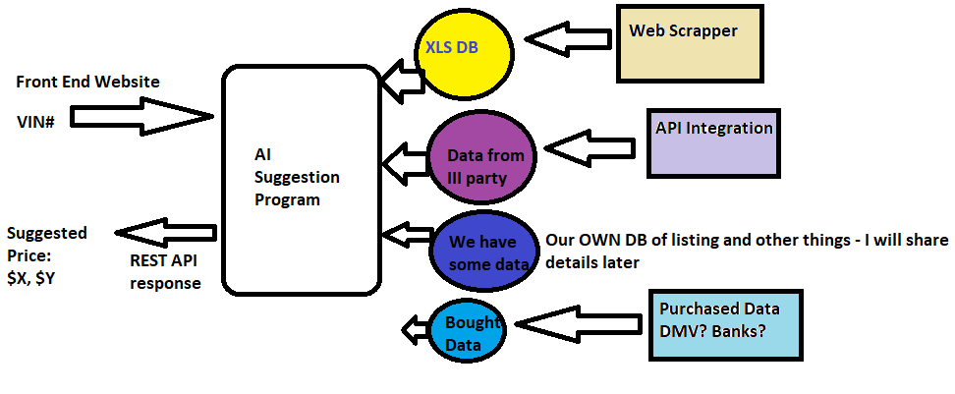

Factors Impacting Car Sales Price:  
From the common sense and from pure human psychology/ behavior/ intelligence perspective, I have been able to think of 11 factors below which should influence seller’s seller price. I am sure we can debate, add few more and remove some but this is an initial list which can help us refine how/ where/ what data sources we need.

1. **Supply & Inventory of a similar model/ products/ car in the marketplace** - if we have more inventory of this / similar car in the market, sellers have a problem of more supplies and hence selling price will be squeezed and will be lower - 91362
2. **Age of Listing/Inventory** – If an item/ product/ vehicle is on the market (for sale) for long, there is a pressure to reduce the prize. Longer the product is on market, lower it will fetch.
3. **Competitive Pressure/ Research** – Seller needs to make sure listing price, sale price for similar product/car from their competitors. If competition has listed same car to sell at $15,000, you will not be able to get $17,000 in most cases for example. More or less, you will get similar price when you try to sell the car/ product.
4. **Past Sales History from our own database** – Assuming we have our own database of all sales prices for similar car/product happening on our site (all negotiation matching), we can use that data to influence the recommended sales price for this product/ car.
5. **Market Data/ III party Market data for similar car (Conservative Price)** – Kelly Blue Book, Edmunds and other sources give APIs to get market data/ price for same cars. There is trade in calculators which give prices of same car in wholesale/ trade in market. This data should also give some idea how we can sell this car
6. **Type of product/ Vehicle** – Is it an electric/ latest technology vehicle? Gives great MPG?, Rare/ Limited Editions? these factors also give additional items/ data points to decide sales price. For example, Volvo is considered the safest car in the world. It carries some weight. Tesla or full electric cars are considered new trends/ technology so they will fetch more $$
7. **Actual Sales Data** – If we are able to get data from DMV (Motor Vehicle Department or III party) where we can get actual sales prices of various cars, models, years, vehicles – that data will go long way in deciding recommended sales price. Last research shows DMV doesn’t provide this listing ☹
8. **Our product/ Offer Statistics** – We have our own ways to capture counteroffers from buyers on a given vehicle. # of offers, Counteroffers could influence sales price so we should factor that in. It is assumed that if listed price is not attractive, that car will not get more offers.
9. **Google Analytics/ Views/ Clicks** – It is similar to above item - I am sure, we can get data how a specific price of a product/ car influences buyers to click further down (car details page) so we know if $35000 listed price got more attention or $34500 and that should help us in some ways
10. **Urgency to sell** – Sometimes sellers want to sell a car/ product sooner. Urgency of selling also dictate the price of a product/ car. Sooner the seller wants to sell, we will have to settle for lower price of the car/ product.
11. **Depreciation** – If we start tracking original dealer invoice price or current sales price for current car models (2021 for example) and if we are scrapping data every month or so, we would know how a typical car depreciates. If we can track all these changes, we can predict how the car sale price would be at a given time.
12. Please think what else we can capture, collect, purchase so we have complete 360 degree solution for price recommendation.

# Related Information/ Data

Here are relevant articles/links/potential data sources for this exercise. This is just a primary list. I am hoping our chosen freelancer(s) will be able to find more accurate ones or relevant ones.

<https://www.edmunds.com/appraisal/>

<https://www.nadaguides.com/Cars>

<https://www.kbb.com/used-cars/>

<https://invoice-pricing.com/>

<https://www.carpricetracker.com/>

**It is hard to get a Kelley Blue Book price.** Even in private party transactions. With other car evaluation companies like Edmunds, NADA, and Black Book (which often lists lower prices than KBB), it will be hard to convince someone to pay that much–especially if you cannot accurately judge car quality and market pricing yourself.

1. Go to [AutoTrader](https://www.autotrader.co.uk/), [PistonHeads](https://www.pistonheads.com/classifieds/used-cars) or [Cars2Buy](https://www.cars2buy.co.uk/) set your search criteria, and view the results.
2. Copy the page URL from the search results page and [submit it to us](https://www.carpricetracker.com/search/create).
3. Once a day, we visit the page you submitted and record the prices of the cars that match the search results.
4. If the best price has changed, we'll send you an email.
5. Over time we build up a price graph showing you how that car is depreciating over time.

<https://archive.ics.uci.edu/ml/datasets/Automobile>

<http://www.indianbluebook.com/used-car-valuation>

How IndianBlueBook gives you the precise Used Car Valuation?

Buying and selling used car is a tricky task. The most important part of the transaction (buying as well as selling) is making sure the price is fair. At IBB we believe in, never undersell or overbuy philosophy. The transaction that happens at this price is the precise price or in the simple term the right price of any used car. Price of a used car depends on the following factors

* The price of the car when it was new.
* Age of the car and number of previous owners.
* The usage, kilometer the car has run.
* The condition of the car.
* Are you selling or trading? When you trade (with a dealer) you get less value for your car.
* Region and landscapes- Some cars are favorites in some states/ cities and they command better resale. Also a car registered in one state or city gets comparatively lesser price if sold in a different state or city.
* Manufacturer- Cars manufactured by companies like Maruti, Hyundai, Honda and Toyota commands better resale value in India. And in general Japanese cars get better resale than the European, American and Asian cars in India.
* Segment- The depreciation is much higher in the higher segments. A premium luxury sedan depreciates much faster than an economy hatchback.
* The urgency factor of seller and buyer. The rule is simple, more you are desperate to close the deal, and you lose money

Do your homework well before putting a price tag on the car you want to sell or offer a price for a used car you intend to buy? Here comes the role of IBB, we at IBB has done the research for you and the precise price for each and every model in India is just a few clicks away.

IndianBlueBook and the science of precise pricing, helps you to arrive at that fair price for the car you are considering to buy.

<https://towardsdatascience.com/predicting-used-car-prices-with-machine-learning-techniques-8a9d8313952>

<https://www.kaggle.com/avikasliwal/used-cars-price-prediction>

# Your Proposal/ Next Steps:

This will be long term project which will be delivered in 3 phases for now and we will keep adding more factors in extended phases.   
  
Your proposal quality (content, approach, Technical Suggestions, timeline, your thought process, your AI/ML/ Data Science Background, Cost and many factors will decide the outcome).

We will not be able to address all factors.   
We need to start somewhere with a goal/ focus to keep making our AI/ML based Price Suggestion better and better over period of time.   
We have to use many sources as possible to make sure we are not relying on just few sources which may be inaccurate.   
We need to find out which data sources we can buy/purchase or which APIs we can integrate with?

Proposal which handles most comprehensive way of predicting a Car Price for a given vehicle (VIN# being the identify of the car) will win this project.

## Test Approach:

I have 3 cars I own, and I will use those 3 VIN#/ Car Models as a seller to see how your solution recommends the sales price today as well as after 30 days (assuming depreciation or listing/ aging factor kicks in). If that price range is acceptable, we will go to next phase.