SRN : PES1UG24AM325
Name : Vismay H S
Section : F
Subject : SE Lab1

FR and Non FR requirements table :
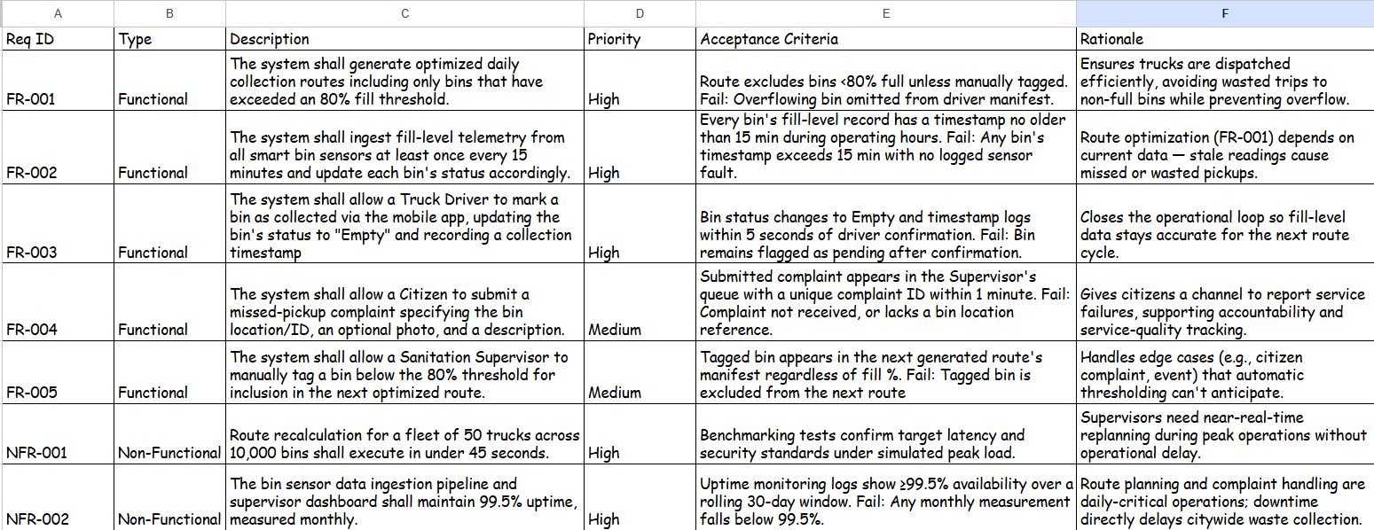

Use-Case Flow Specification :

Use Case: Generate Optimized Collection Route
Primary Actor: Sanitation Supervisor
Supporting Actors: Truck Driver (receives the route), Smart Bin Sensor (provides the fill-level data used to build the route)

Preconditions:
- Supervisor is logged into the sanitation portal.
- Bin fill-level data from the sensors is not older than 15 minutes.
- The list of trucks and drivers available for the day is already entered in the system.

Postconditions:
- One or more collection routes are created and assigned to trucks.
- Truck drivers can see their route manifest on the app.
- Any bins that were left out of the route are recorded by the system.

Main Success Scenario:
1. Supervisor logs in and selects "Generate Routes."
2. System pulls the latest fill-level readings for all bins.
3. System checks each bin and keeps only the ones that are above 80% full.
4. Supervisor selects the date and picks which trucks are available that day.
5. System works out the best route for each truck based on bin location and truck capacity.
6. System shows the supervisor a preview of the routes, along with the number of bins and estimated time.
7. Supervisor checks the preview and confirms it.
8. System assigns each route to a truck driver and publishes the manifest.
9. Truck driver gets the route on the mobile app.
10. Use case ends.

Alternate Flow – 3a: Supervisor Manually Tags a Bin
- 3a1. While the bins are being checked in step 3, the supervisor notices a bin that is below 80% full but still needs to be picked up (for example, a complaint was filed about it).
- 3a2. Supervisor manually tags this bin for collection.
- 3a3. The system adds the tagged bin to the list along with the bins above 80%, and the flow continues from step 4.

