Vismaya E

Apache Kafka - Internship
Assignment

Document Version: 1.0 | Duration: 2-3 weeks | Difficulty: Intermediate

PHASE 1: FOUNDATIONS

TASK 1.1 :

Explaining topic, partition, offset, broker, replication factor, ISR, producer, consumer, consumer group, and Kraft.

Apache Kafka Overview
Apache Kafka is a distributed event streaming platform used to publish, store, and process real-time data streams. It enables communication between different applications through events or messages. Kafka is widely used for microservices communication, log aggregation, real-time analytics, and data pipelines.

Concepts of Kafka
- Topic : A topic is a logical channel or category where messages are stored. Producers send messages to a topic, and consumers read messages from it.
Example: orders, payment etc. If an order is created, the event can be published to the orders topic.

- Partition : A partition is a subdivision of a topic. Kafka distributes messages across partitions to improve scalability and allow parallel processing. More partitions allow more consumers to process messages simultaneously.
Ex : Partition-0, Partition-1, Partition-2 for topic order.

- Offset : An offset is a unique sequential number assigned to each message within a partition. Consumers use offsets to keep track of which messages have already been read and processed.
Ex : offset 0, offset 1, offset 2.
- Broker : A broker is a Kafka server responsible for storing messages and handling requests from producers and consumers. A Kafka cluster can contain one or more brokers.
Ex: broker-1, broker-2, broker-3.
- Replication Factor : The replication factor determines how many copies of a partition are maintained across brokers. Replication improves fault tolerance because data remains available even if a broker fails.
Ex: Replication Factor = 3 (leader, replica copy, replica copy)
- ISR (In-Sync-Replicas) : ISR are replica partitions that are fully synchronized with the leader partition. Kafka uses ISR to ensure data consistency and reliability. Only replicas that are up to date with the leader are considered part of the ISR.

- Producer : A producer is an application that sends messages to Kafka topics. The producer publishes events such as order creation, payment completion, or user registration.

Ex: Order Service Producer Kafka Topic

- Consumer : A consumer is an application that reads messages from Kafka topics and processes them. Consumers can perform actions such as sending notifications, updating databases, or generating reports.
Ex : Kafka Topic Consumer
- Consumer Group : A consumer group is a collection of consumers working together to process messages from a topic. Kafka distributes partitions among consumers in the same group, allowing parallel processing and load balancing.

Ex : Consumer Group
Partition 1 Consumer 1
Partition 2 Consumer 2
Partition 3 Consumer 3

- Kraft (Kafka Raft Metadata Mode) : KRaft is the modern architecture used by Kafka to manage cluster metadata without relying on ZooKeeper. t handles broker coordination, leader election, and configuration management, making Kafka simpler to deploy, easier to maintain, and more scalable.

TASK 1.2

Start a single-node (or Docker Compose) Kafka cluster. Capture screenshots or terminal output showing: broker started, topic created, message produced, message consumed.

TERMINAL OUTPUT :
- Broker Started
Command used : docker logs kafka | select-string “started”
This command list out only the line from the logs of the docker where it has the word “started” in it .
Here kafka is the container name.
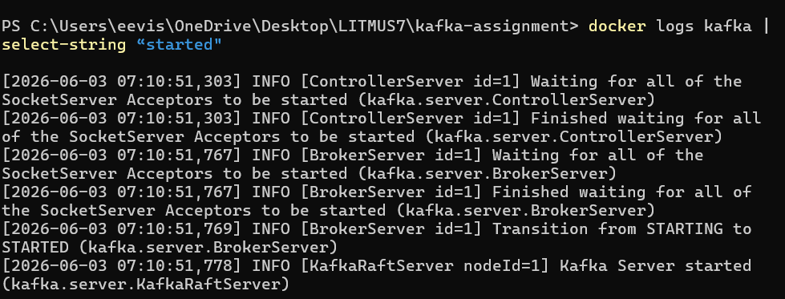
- Topic Created
Command used : docker exec -it kafka /opt/kafka/bin/kafka-topics.sh --create --topic order --bootstrap-server localhost:9092--partitions 3 --replication-factor 1
- Message Produced
Command used : docker exec -it kafka /opt/kafka/bin/kafka-console-producer.sh --bootstrap-server localhost:9092 --topic order
This opens an interactive producer prompt (type the message and enter).
>Order 101 created.
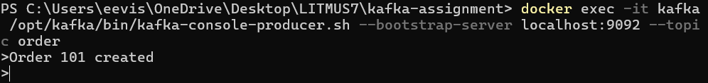

- Message Consumed
Command used : docker exec -it kafka /opt/kafka/bin/kafka-console-consumer.sh --bootstrap-server localhost:9092 --topic order --from-beginning
From the starting means it will show all the message from 1st message till the latest.

TASK 1.3
Create a topic orders with 3 partitions and replication factor 1 (local). Produce at least 10 messages with different keys. Consume from partition 0 only and document what you observe.
Created a topic ‘orders’ with partition 3 and replication factor 1
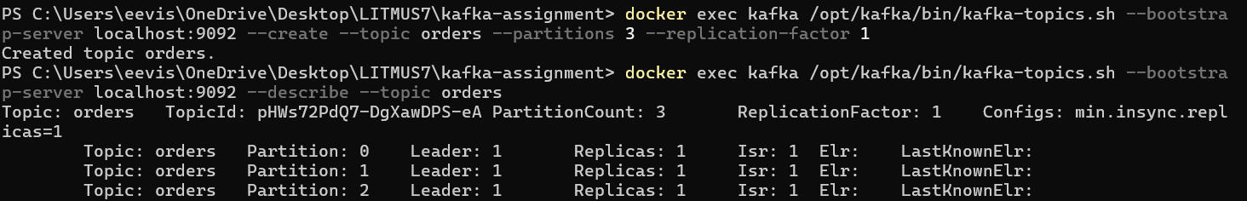
Adding 10 message from producer to kafka
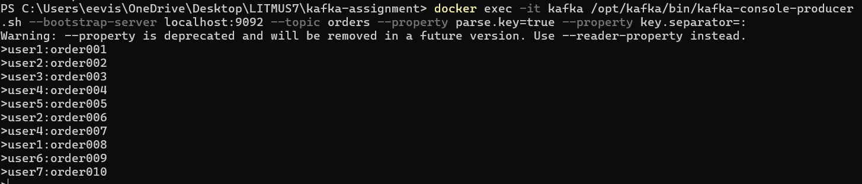
Then read from kafka by consumer, it list out all the message from the kafka with respect to partitions and key-value.
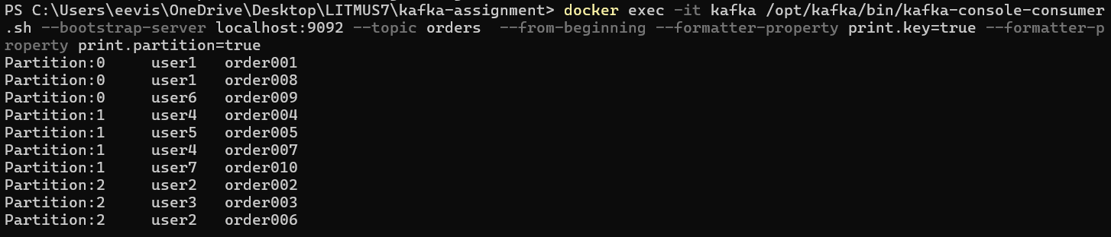

The question was to list out all the message from the partition 0 :

