**DAY 6 – FUNCTION RECAP**

Find the culprit

fix.html

<!DOCTYPE html>

<html>

<body>

<script>

alert( “I’m JavaScript!’);

</script>

Whats the error in this ?

</body>

</html>

**OUTPUT:**

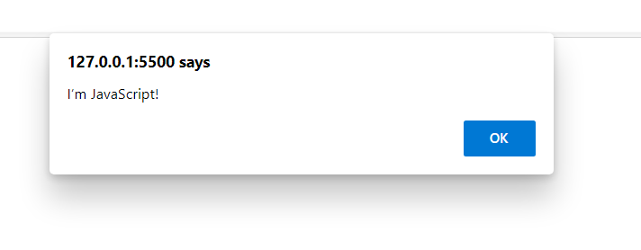

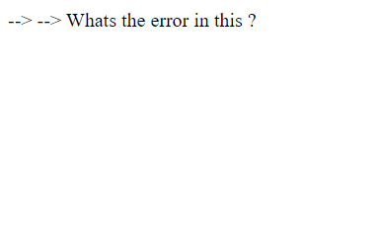

**fix.html**

<!DOCTYPE html>

<html>

<body>

<script src=”script.js”></script>

</body>

</html>

scripts.js

alert(“I’m invoked!”);

**OUTPUT:**

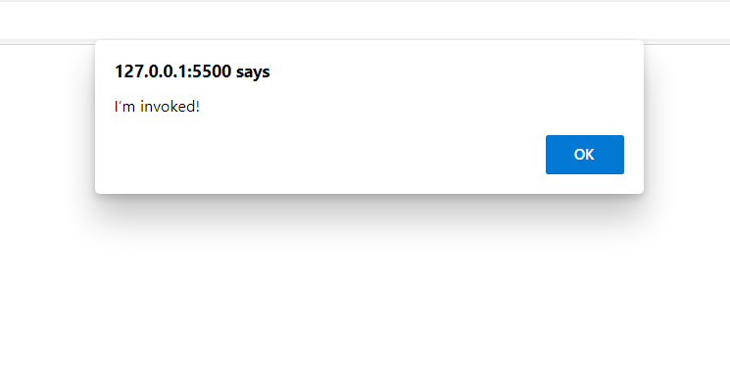

**Explain the below how it works**

**explain.html**

<!DOCTYPE html>

<html>

<body>

<script src=”script.js”></script>

</body>

</html>

script.js

alert("I'm JavaScript!");

alert('Hello') // this line is not having semicolon

alert(`Wor

ld`)

alert(3 +

1

+ 2); // this is multiple line code and its working

**OUTPUT:**

It firs invoke ("I'm JavaScript!"); then Hello then World Id then 6.

**Fix the below to alert Guvi geek**

**OUTPUT:**

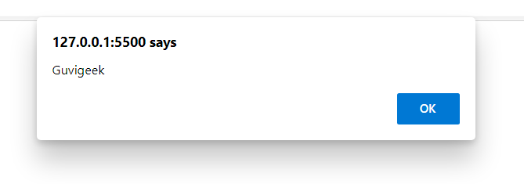

**Fix the below to alert hello Guvi geek**

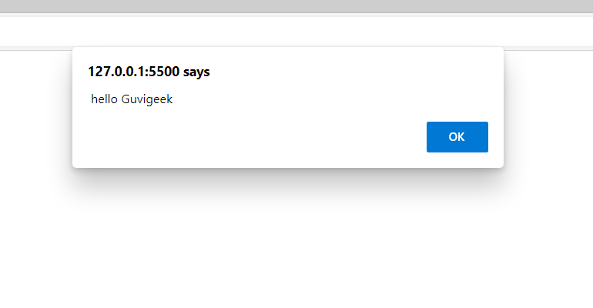

**Fix the below to alert sum of two numbers**

fix.html

<!DOCTYPE html>

<html>

<body>

<script src=”script.js”></script>

</body>

</html>

script.js

let a = prompt("First number?");

let b = prompt("Second number?");

alert(a + b);

**CODE:**

**let a = prompt("First number?");**

**let b = prompt("Second number?");**

**alert(parseInt(a) +parseInt(b));**

**OUTPUT:**

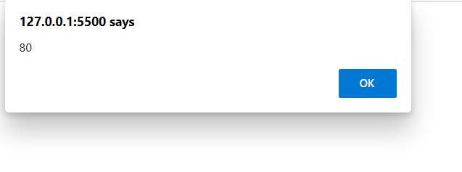

**If you run the below scritpt you will get “Code is Blasted”**

**Explain Why the Code is blasted and how to diffuse it and get “Diffused”.**

var a = "2" > "12";

// a value is true so Code is blasted will be the outpt

//if we pass !a it will o/p diffused

if (!a) {

console.log("Code is Blasted")

}

else

{

console.log("Diffused")

}

**OUTPUT:**



**How to get the success in console.**

let a = prompt("Enter a number?");

//Don't modify any code below this

if (a) {

console.log( 'OMG it works for any number inc 0' );

}

else

{

console.log( "Success" );

}

**OUTPUT:**



**How to get the correct score in console.**

let value = prompt('How many runs you scored in this ball');

if (value === 4) {

console.log("You hit a Four");

} else if (value === 6) {

console.log("You hit a Six");

} else {

console.log("I couldn't figure out");

}

**CODE:**

let value = prompt('How many runs you scored in this ball');

if (value == "4") {

console.log("You hit a Four");

} else if (value == "6") {

console.log("You hit a Six");

} else {

console.log("I couldn't figure out",typeof value);

}

**OUTPUT:**





**Fix the code to welcome the Employee**

let login = 'Employee';

let message = (login == 'Employee') ? :

(login == 'Director') ? 'Greetings' :

(login == '') ? 'No login' :

'';

console.log(message);

**CODE:**

let login = 'Employee';

let message = (login == 'Employee') ?

'Greetings' :

'No login' ;

console.log(message);

**OUTPUT:**



**Fix the code to welcome the boss**

let message;

if (null || 2 || undefined )

{

message = "welcome boss";

}

else

{

message = "Go away";

}

console.log(message)

**OUTPUT:**



**Fix the code to welcome the boss**

let message;

let lock = 2;

//Dont change any code below this

if (null || lock || undefined )

{

message = "Go away";

}

else

{

message = "welcome";

}

console.log(message);

**CODE:**

let message = " WELCOME BOSS";

let lock = 0;

//Dont change any code below this

if (null || lock || undefined )

{

message = "Go away";

}

else

{

message = "welcome";

}

console.log(message);

**OUTPUT:**



let message;

let lock = 2;

//Dont change any code below this

if (lock && " " || undefined )

{

message = "Go away";

}

else

{

message = "welcome";

}

console.log(message);

**CODE:**

let message ="hello";

let lock = 0;

//Dont change any code below this

if (lock && " " || undefined )

{

message = "Go away";

}

else

{

message = "welcome";

}

console.log(message);

**OUTPUT:**



**Change the code to print**

**//You can change only 2 characters**

let i = 3;

while (i) {

console.log( --i );

}

**CODE:**

let i = 3;

while (i) {

//i-- 3,2,1

//--i 2,1,0

console.log( i-- );

}

**OUTPUT:**

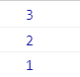

//Change the code to print 1 to 10 in 4 lines

let num = 1

console.log(num)

num += 1

console.log(num)

num += 1

console.log(num)

num += 1

console.log(num)

num += 1

console.log(num)

num += 1

console.log(num)

num += 1

console.log(num)

num += 1

console.log(num)

num += 1

console.log(num)

num += 1

console.log(num)

**CODE:**

for(let i = 1; i<= 10; i++){

console.log(i);

}

**OUTPUT:**

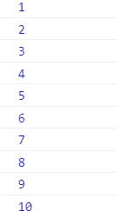

**Change the code to print even numbers**

//You are allowed to modify only one character

for (let num = 2; num <= 20; num += 1) {

console.log(num)

}

**CODE**

for (let num = 2; num <= 20; num += 1) {

if(num % 2 === 0){

console.log(num);

}

}

**OUTPUT:**

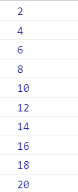

**//Change the code to print all the gifts**

let gifts = ["teddy bear", "drone", "doll"];

for (let i = 0; i < gifts.length; i++) {

console.log(`Wrapped ${gifts[i]} and added a bow!`);

}

**OUTPUT:**



**Whats the msg printed and why?**

var lemein = "0";

var lemeout = 0;

var msg = " ";

if (lemein) {

msg += "hi";

}

//It is (0 is false condition)falsy

if (lemeout) {

msg += "Hello";

}

console.log(msg);

**OUTPUT:**

**Hi is printed its truthy condition other part wont work as it is falsy condition.**