**DAY 6 – FUNCTION RECAP**

Find the culprit

fix.html

<!DOCTYPE html>

<html>

<body>

<script>

alert( “I’m JavaScript!’);

</script>

Whats the error in this ?

</body>

</html>

**OUTPUT:**

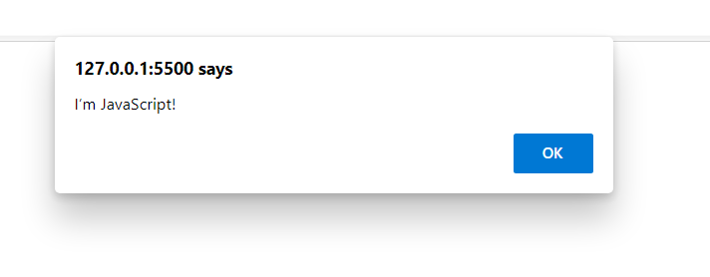

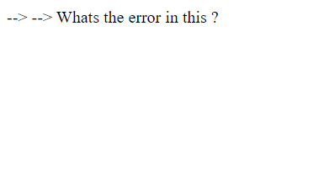

**fix.html**

<!DOCTYPE html>

<html>

<body>

<script src=”script.js”></script>

</body>

</html>

scripts.js

alert(“I’m invoked!”);

**OUTPUT:**

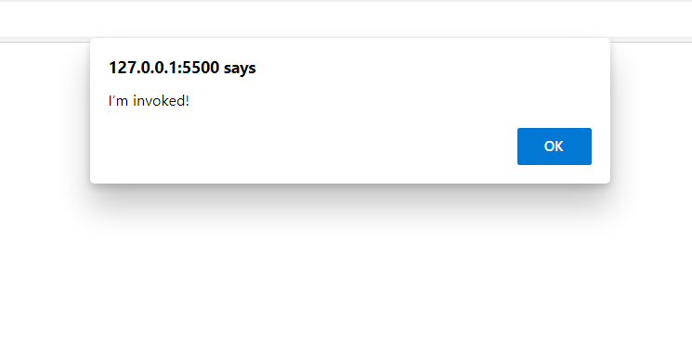

**Explain the below how it works**

**explain.html**

<!DOCTYPE html>

<html>

<body>

<script src=”script.js”></script>

</body>

</html>

script.js

alert("I'm JavaScript!");

alert('Hello') // this line is not having semicolon

alert(`Wor

ld`)

alert(3 +

1

+ 2); // this is multiple line code and its working

**OUTPUT:**

It firs invoke ("I'm JavaScript!"); then Hello then World Id then 6.

**Fix the below to alert Guvi geek**

**OUTPUT:**

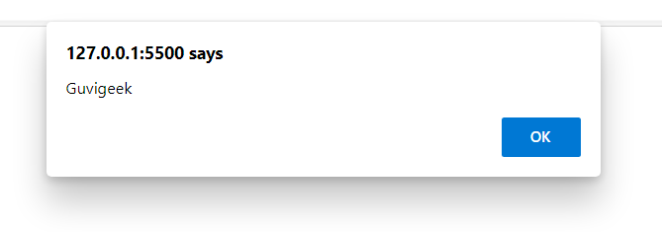

**Fix the below to alert hello Guvi geek**

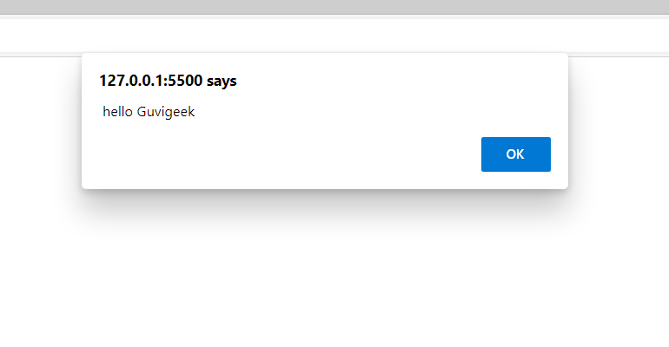

**Fix the below to alert sum of two numbers**

fix.html

<!DOCTYPE html>

<html>

<body>

<script src=”script.js”></script>

</body>

</html>

script.js

let a = prompt("First number?");

let b = prompt("Second number?");

alert(a + b);

**CODE:**

**let a = prompt("First number?");**

**let b = prompt("Second number?");**

**alert(parseInt(a) +parseInt(b));**

**OUTPUT:**

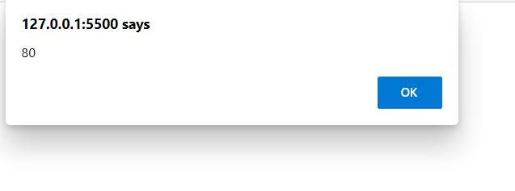

**If you run the below scritpt you will get “Code is Blasted”**

**Explain Why the Code is blasted and how to diffuse it and get “Diffused”.**

var a = "2" > "12";

// a value is true so Code is blasted will be the outpt

//if we pass !a it will o/p diffused

if (!a) {

console.log("Code is Blasted")

}

else

{

console.log("Diffused")

}

**OUTPUT:**



**How to get the success in console.**

let a = prompt("Enter a number?");

//Don't modify any code below this

if (a) {

console.log( 'OMG it works for any number inc 0' );

}

else

{

console.log( "Success" );

}

**OUTPUT:**



**How to get the correct score in console.**

let value = prompt('How many runs you scored in this ball');

if (value === 4) {

console.log("You hit a Four");

} else if (value === 6) {

console.log("You hit a Six");

} else {

console.log("I couldn't figure out");

}

**CODE:**

let value = prompt('How many runs you scored in this ball');

if (value == "4") {

console.log("You hit a Four");

} else if (value == "6") {

console.log("You hit a Six");

} else {

console.log("I couldn't figure out",typeof value);

}

**OUTPUT:**





**Fix the code to welcome the Employee**

let login = 'Employee';

let message = (login == 'Employee') ? :

(login == 'Director') ? 'Greetings' :

(login == '') ? 'No login' :

'';

console.log(message);

**CODE:**

let login = 'Employee';

let message = (login == 'Employee') ?

'Greetings' :

'No login' ;

console.log(message);

**OUTPUT:**



**Fix the code to welcome the boss**

let message;

if (null || 2 || undefined )

{

message = "welcome boss";

}

else

{

message = "Go away";

}

console.log(message)

**OUTPUT:**



**Fix the code to welcome the boss**

let message;

let lock = 2;

//Dont change any code below this

if (null || lock || undefined )

{

message = "Go away";

}

else

{

message = "welcome";

}

console.log(message);

**CODE:**

let message = " WELCOME BOSS";

let lock = 0;

//Dont change any code below this

if (null || lock || undefined )

{

message = "Go away";

}

else

{

message = "welcome";

}

console.log(message);

**OUTPUT:**



let message;

let lock = 2;

//Dont change any code below this

if (lock && " " || undefined )

{

message = "Go away";

}

else

{

message = "welcome";

}

console.log(message);

**CODE:**

let message ="hello";

let lock = 0;

//Dont change any code below this

if (lock && " " || undefined )

{

message = "Go away";

}

else

{

message = "welcome";

}

console.log(message);

**OUTPUT:**



**Change the code to print**

**//You can change only 2 characters**

let i = 3;

while (i) {

console.log( --i );

}

**CODE:**

let i = 3;

while (i) {

//i-- 3,2,1

//--i 2,1,0

console.log( i-- );

}

**OUTPUT:**

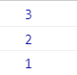

//Change the code to print 1 to 10 in 4 lines

let num = 1

console.log(num)

num += 1

console.log(num)

num += 1

console.log(num)

num += 1

console.log(num)

num += 1

console.log(num)

num += 1

console.log(num)

num += 1

console.log(num)

num += 1

console.log(num)

num += 1

console.log(num)

num += 1

console.log(num)

**CODE:**

for(let i = 1; i<= 10; i++){

console.log(i);

}

**OUTPUT:**

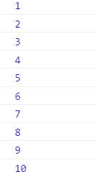

**Change the code to print even numbers**

//You are allowed to modify only one character

for (let num = 2; num <= 20; num += 1) {

console.log(num)

}

**CODE**

for (let num = 2; num <= 20; num += 1) {

if(num % 2 === 0){

console.log(num);

}

}

**OUTPUT:**

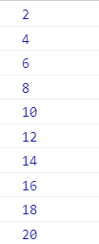

**//Change the code to print all the gifts**

let gifts = ["teddy bear", "drone", "doll"];

for (let i = 0; i < gifts.length; i++) {

console.log(`Wrapped ${gifts[i]} and added a bow!`);

}

**OUTPUT:**



**Whats the msg printed and why?**

var lemein = "0";

var lemeout = 0;

var msg = " ";

if (lemein) {

msg += "hi";

}

//It is (0 is false condition)falsy

if (lemeout) {

msg += "Hello";

}

console.log(msg);

**OUTPUT:**

**Hi is printed its truthy condition other part wont work as it is falsy condition.**

**Fix the code to get the largest of three.**

aa = (f,s,t) => {

console.log(f,s,t);

if(f>s &&f>t){

console.log(f)}

else if(s>f && s>t){

console.log(s)}

else{

console.log("OUTPUT",t)}

}

**aa(1,2,3);**

**OUTPUT:**



**/ Fix the code to Sum of the digits present in the number**

**// Code:**

let n = [1,2,3];

console.log(add(n));

function add(n)

{

let sum = 0;

for(var i=0;i<n.length;i++){

sum+=n[i]

}

return sum;

}

**OUTPUT:**



**// Fix the code to Sum of the digits present in the number**

**// Code:**

const arr = [9,8,5,6,4,3,2,1];

(function() {

let sum = 0;

for (var i = 0; i < arr.length; i++){

sum += arr[i];

}

console.log(sum);

return sum;

})();

**OUTPUT:**



**// Fix the code to Sum of the digits present in the number**

**// Code:**

const newArray=[1,3,2,5,10];

const myPrime=newArray.filter(num=>{

for(let i=2;i< num;i++){

if(num % i === 0) return false;

}

return true;

});

console.log(myPrime);

**OUTPUT:**



**// Fix the code to sum the number in that array**

**// Code:**

const num = [10, 20, 30, 40,50,60,70,80,90,100]

const sum = (a, b) =>{

return a + b;

}

const total = num.reduce(sum)

console.log("total",total);

**OUTPUT:**



**//Fix the code to gen Title caps.**

**//Code:**

var arr = ["guvi", "geek", "zen", "fullstack"];

var ano = function(arr) {

for (var i = 0; i < arr.length; i++) {

console.log(arr[i][0].toUpperCase() + arr[i].substr(1));

}

}

ano(arr);

**OUTPUT:**

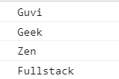

**print all odd numbers in an array using IIFE function**

**Code:**

var arr = [1, 2, 3, 5, 7, 79, 7, 2, 6, 9, 4];

(function() {

for (var i = 0; i < arr.length; i++) {

if (arr[i] % 2 !== 0) {

console.log(arr[i]);

}}

})();

**OUTPUT:**

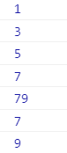

**Fix the code to reverse.**

**Code:**

(function(str){

str1 = str.split("").reverse().join("");

console.log(str1);

})("abcd");

**OUTPUT:**



**//////////////////////////////////////////////////////////////////////////////////////////////////////////////////////**

**/1) Write a code to print the numbers in the array**

**// Output: 1234567891011**

var numsArr = [1, 2, 3, 4, 5, 6, 7, 8, 9, 10, 11];

var new_string = "";

for (var i = 0; i < 11; i++) {

new_string += numsArr[i];

}

console.log("OUTPUT 1", new_string);

**//2)Write a code to print the numbers in the array**

**//Output: 1,2,3,4,5,6,7,8,9,10,11**

var numsArr = [1, 2, 3, 4, 5, 6, 7, 8, 9, 10, 11];

var new_string = "";

for (var i = 0; i < 11; i++) {

new_string += numsArr[i] + ",";

}

console.log("OUTPUT 2", new_string);

**//3)Write a code to print from last to first with spaces (Make sure there is no space after the last element 1)**

**//Output: 11 10 9 8 7 6 5 4 3 2 1**

var new_string = "";

for (var i = 10; i >= 0; i--) {

new_string += numsArr[i] + " ";

}

console.log("OUTPUT 3", new_string.trim());

// Write a code to replace the array value — If the number is even, replace it with ‘even’.

// Output:[ 1, “even”, 3, “even”, 5, “even”, 7, “even”, 9, “even”, … ]

var numsArr = [1, 2, 3, 4, 5, 6, 7, 8, 9, 10, 11];

for (var i = 0; i < numsArr.length; i++) {

if (numsArr[i] % 2 == 0) {

numsArr[i] = "even";

}

}

console.log("OUTPUT 4", numsArr);

// Write a code to replace the array value — If the index is even, replace it with ‘even’.

// Output: [ “even”, 2, “even”, 4, “even”, 6, “even”, 8, “even”, 10, … ]

var numsArr = [1, 2, 3, 4, 5, 6, 7, 8, 9, 10, 11];

for (var i = 0; i < numsArr.length; i++) {

if (i % 2 == 0) {

numsArr[i] = "even";

}

}

console.log("OUTPUT 5" + numsArr);

**// Write a code to add all the numbers in the array**

**// Output: 66**

var numsArr = [1, 2, 3, 4, 5, 6, 7, 8, 9, 10, 11];

var sum = 0;

for (var i = 0; i < numsArr.length; i++) {

sum += numsArr[i];

}

console.log("OUTPUT 6", sum);

**// Write a code to add the even numbers only**

**// Output: 30**

var numsArr = [1, 2, 3, 4, 5, 6, 7, 8, 9, 10, 11];

var sum = 0;

for (var i = 0; i < numsArr.length; i++) {

if (numsArr[i] % 2 === 0) {

sum += numsArr[i];

}

}

console.log("OUTPUT 7", sum);

**// Write a code to add the even numbers and subract the odd numbers**

**// Output: 94**

var numsArr = [1, 2, 3, 4, 5, 6, 7, 8, 9, 10, 11];

var sum = 100;

for (var i = 0; i < numsArr.length; i++) {

if (numsArr[i] % 2 === 0) {

sum += numsArr[i];

} else {

sum -= numsArr[i];

}

}

console.log("OUTPUT 8", sum);

**OUTPUT:**

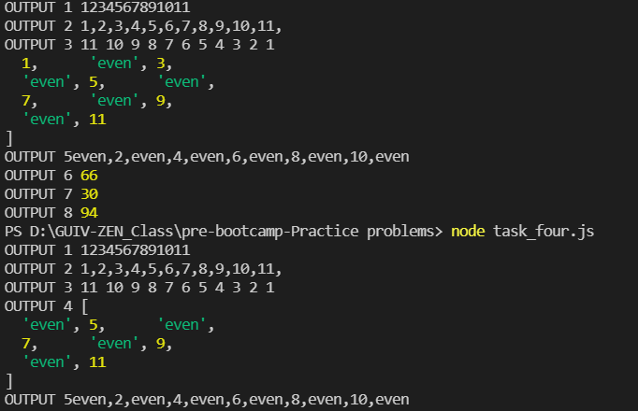

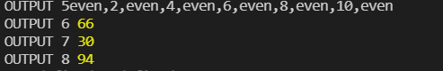

**// Write a code to print inner arrays**

**// Output:**

**// Array(5) [ 1, 2, 3, 4, 5 ]**

**// Array(6) [ 6, 7, 8, 9, 10, 11 ]**

var numsArr = [

[1, 2, 3, 4, 5],

[6, 7, 8, 9, 10, 11]

];

for (var i = 0; i < numsArr.length; i++) {

console.log("OUTPUT 9 ", numsArr[i]);

}

**OUTPUT:**



**// Write a code to print elements in the inner arrays**

**// Output: 1234567891011**

var numsArr = [

[1, 2, 3, 4, 5],

[6, 7, 8, 9, 10, 11],

];

var str_all = "";

for (var i = 0; i < numsArr.length; i++) {

for (var j = 0; j < numsArr[i].length; j++) str_all += numsArr[i][j];

}

console.log("OUTPUT 10", str_all);

**OUTPUT:**



**// Write a code to print elements in the inner arrays**

**// Output: 1234567891011**

var numsArr = [

[1, 2, 3, 4, 5],

[6, 7, 8, 9, 10, 11],

];

var str_all = "";

for (var i = 0; i < numsArr.length; i++) {

for (var j = 0; j < numsArr[i].length; j++) str_all += numsArr[i][j];

}

console.log("OUTPUT 10", str_all);

**// Write a code to replace the array value — If the index is even, replace it with ‘even’.**

**// Output: [ [“even”, 2, “even”, 4, “even”], [6, “even”, 8, “even”, 10, …] ]**

var numsArr = [

[1, 2, 3, 4, 5],

[6, 7, 8, 9, 10, 11],

];

var str_all = 0;

for (var i = 0; i < numsArr.length; i++) {

for (var j = 0; j < numsArr[i].length; j++)

if (numsArr[i][j] % 2 == 0) {

numsArr[i][j] = "even";

}

}

console.log("OUTPUT 11", numsArr);

**OUTPUT:**



**// Write a code to print elements in the inner arrays in reverse**

**// Output: 11 10 9 8 7 6 5 4 3 2 1**

var numsArr = [[1, 2, 3, 4, 5],[ 6, 7, 8, 9, 10, 11]];

var str_all=" ";

let numArray = [];

for (var i = 0; i < numsArr.length; i++) {

var inner_array = numsArr[i];

for(var j = 0; j < numsArr[i].length ;j++ )

str_all +=numsArr[i][j]+" ";

}

console.log("OUTPUT 12",str_all.split(" ").reverse().join(" "));

**OUTPUT:**



**// Write a code to add elements in the inner arrays based on odd or even values**

**// Output:**

**// 36**

**//30**

var numsArr = [[1, 2, 3, 4, 5],[ 6, 7, 8, 9, 10, 11]];

var sum_odd=0;

var sum_even=0;

for (var i = 0; i < numsArr.length; i++) {

for(var j = 0 ; j < numsArr[i].length;j++ ){

if(numsArr[i][j] % 2 !== 0)

{

sum_odd += numsArr[i][j];

}

else

{

sum_even += numsArr[i][j];

}

}

}

console.log("Sum of ODD", sum_odd);

console.log("Sum of Even", sum_even);

**OUTPUT:**

