**Day - 1 : Introduction to Browser & web**

1. **Write a blog on Difference between HTTP1.1 vs HTTP2**

In HTTP1.1 to load a webpage it takes time also page load is also slow, only single request is processed at time.

In HTTP 2, page load speed improved hence webpage load faster, multiple requests can be sent over a TCP connection. Convert text in to binary format before transferring over a network. Compression of request headers and payload is possible. Able to download web files asynchronously from web server.

1. **Write a blog about objects and its internal representation in Javascript**

**Object** is the most important datatype in JS .Unlike primitive data types it can hold multiple values

**Objects** are written in key value pairs. Key and value separated by colon.

Objects are created with figured brackets { }

**Eg )creating objects via Object literal**

let obj = {

name:”Sherly”,

place:”Valkulamb”year”1992”.

}

**Accessing Object Properties:**

***objectName.propertyName -*** dot notation

***objectName[“propertyName”] -***  bracket notation

**Object constructor using new keyword :**

Another way to create objects in JS

const person = new Object();

person.name = “Vismaya”;

person.location= “Palakkad:

persin.age = 40;

}

If we want to create multiple objects of same kind the above 2 way is not recommended.

**Alternative Way : Constructor function**

Create an instance of the object with new keyword

Function Person(name,age){

this.name= name;

this.age = age;

}

//assigning new keyword before the function make it as a constriuctor

Let person1 =new Person(“Vismaya”,30);

Let person2 = new Person(“Wilson”,50);

**JS Objects are mutable**

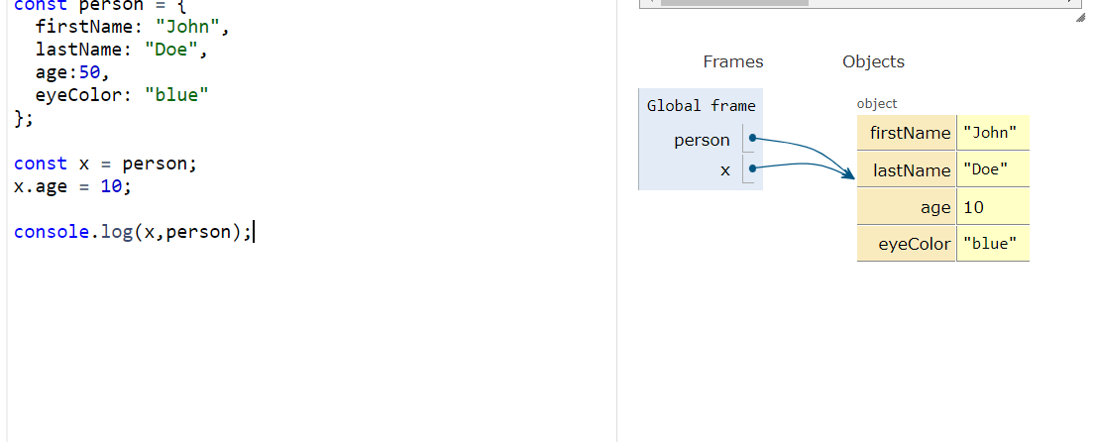

Objects are referenced by address not by value .changes to x will also change person

**Prototype**

If we need to add new prototype to object constructors we can use prototype

function Person(age,name){

this.age =age;

this.name = name;

}

Person.prototype.nationality = “India”;