**//DAY-7 OOPS- CLASS**

**//1)https://github.com/rvsp/typescript-oops/blob/master/Practice/Movie.md**

//A class become useful when we create object of the class

/*

1. **Write a constructor for the class Movie, which takes a String representing the title of the movie, a String representing the studio, and a String representing the rating as its arguments, and sets the respective class properties to these values.**

**b) The constructor for the class Movie will set the class property rating to "PG" as default when no rating is provided**

.*/

class Movie {

//a,b constructor of the class to hold the values passed while Object creation

constructor(title, rating = "PG", studio) {

//assign those values to this keyword so that it can be available to entire class

this.title = title;

this.rating = rating;

this.studio = studio;

}

**/*c) Write a method getPG, which takes an array of base type Movie as its argument, and returns a new array of only those movies in the input array with a rating of "PG".You may assume the input array is full of Movie instances. The returned array need not be full.*/**

getPG(movies) {

//filter the array

let newData = movies.filter((data) => {

// return the details which have rating = PG

return data.rating === "PG";

});

return newData;

}

}

// creating instance of the class

let movie1 = new Movie("Priest", "R", "KEM");

let movie3 = new Movie("War & Love");

let movie4 = new Movie("Drishyam2");

**//d)creates an instance of the class Movie with the title “Casino Royale”, the studio “Eon Productions”, and the rating “PG­13”**

let movie2 = new Movie("Casino Royale", "PG­13", "Eon Productions");

console.log(“Object with given Details”, movie2);

**OUTPUT:**

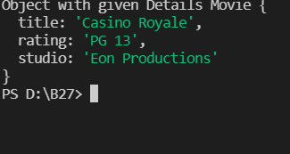

//create array and push all the objects

let objCollection = [];

objCollection.push(movie3, movie2, movie1, movie4);

// console.log("getPG()---->",movie1.getPG(objCollection));

**OUTPUT:**

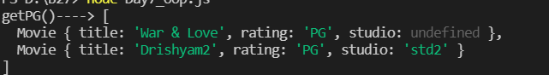

**//2)https://github.com/rvsp/typescript-oops/blob/master/Practice/class-circle.md**

//create a class with name Circle

class Circle {

//create constructor with properties radius and color

constructor(radius, color) {

//assign proerties to this keyword so that the values will be available to the entire class

this.radius = radius;

this.color = color;

}

//getRadius() retuens the radius which is set via setRadius

getRadius() {

return this.radius;

}

//setRadius() sets the radius which is passed as a parameter

setRadius(radius) {

this.radius = radius;

}

//getColor() retuens the radius which is set via setColor

getColor() {

return this.color;

}

//setColor() sets the color which is passed as a parameter

setColor(color) {

this.color = color;

}

//toSrinng returns radius and color in the form of String

toString() {

return this.radius.toString() + " "+this.color.toString();

}

//returns the area of the circle (3.14 * r * r)

getArea() {

return this.radius * this.radius * 3.14;

}

//returns the area of the circumference (3.14 * r * 2)

getCirumference() {

return 2 * this.radius * 3.14;

}

}

let objCircle2 = new Circle();

let objCircle1 = new Circle(10);

let objCircle = new Circle(1, "red");

console.log(objCircle,objCircle1, objCircle2,objCircle1.getCirumference(),

objCircle1.getArea(),objCircle.setColor("YELLOW"),

objCircle.getColor(),objCircle1.setRadius("30"),objCircle1.getRadius(),objCircle.toString()

);



**//3Write a “person” class to hold all the details rating**

//typeof a class is function

class Person {

// pass parameters to the constructor to accomadate the values in the Object.

constructor(lastName,firstName,age,experience,salary,qualification,occupation) {

// initalize value to this keyword which is available over the class

this.lastName = lastName;

this.firstName = firstName;

this.age = age;

this.experience = experience;

this.salary = salary;

this.qualification = qualification;

this.occupation = occupation;

}

}

//Object Creation

let emp1 = new Person("Wilson","Vismaya",21,6,"30k","Btech","Software Engineer");

let emp2 = new Person("Wilson", "Susmitha", 29, 1, "90k", "BSC", "Nurse");

console.log(emp1);

console.log(emp2);

**OUTPUT:**

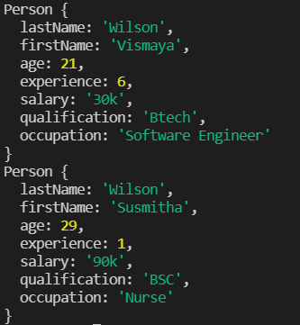

**//4 write a class to calculate uber price.**

class PriceCalculator {

constructor(kmTravelled, amount) {

//value initialized to this keyword

this.km = kmTravelled;

this.amt = amount;

}

//function to calculate UberPrice

calculateUberPrice() {

//multiply km travelled with price

return this.km * this.amt;

}

}

//Object creation and passed value to constructor

let obj = new PriceCalculator(5, 10);

console.log(`UberPrice ${obj.calculateUberPrice()}`);

**OUTPUT :**

