/*

**DAY - 8 MRF(Map,reduce,filter) Array methods**

**Solving problems using array functions on rest countries data.**

**1)Get all the countries from Asia continent /region using Filter function**

**2)Get all the countries with a population of less than 2 lakhs using Filter function**

**3)Print the following details name, capital, flag using forEach function**

**4)Print the total population of countries using reduce function**

**5)Print the country which uses US Dollars as currency.**

*/

/* xhr implementation*/

let xhr = new XMLHttpRequest();

let responseData;

let url = "https://restcountries.eu/rest/v2/all";

//passing the url to open() to fetch the all details

xhr.open("GET", url);

//Onload listner to process completed request

xhr.onload = function () {

//check if the status is ok and data is processed

if (xhr.status === 200 && xhr.readyState == 4)

//response will be in form of string JSON.parse will convert that in to Object

responseData = JSON.parse(this.response);

**/*1) Get all the countries from Asia continent /region using Filter function */**

const getAsianCountries = responseData.filter((data) => {

//filter the array and return array of Obj by fetching region from data

return data.region === "Asia";

});

console.log("check_Asian_Countries", getAsianCountries);

**OUTPUT :**

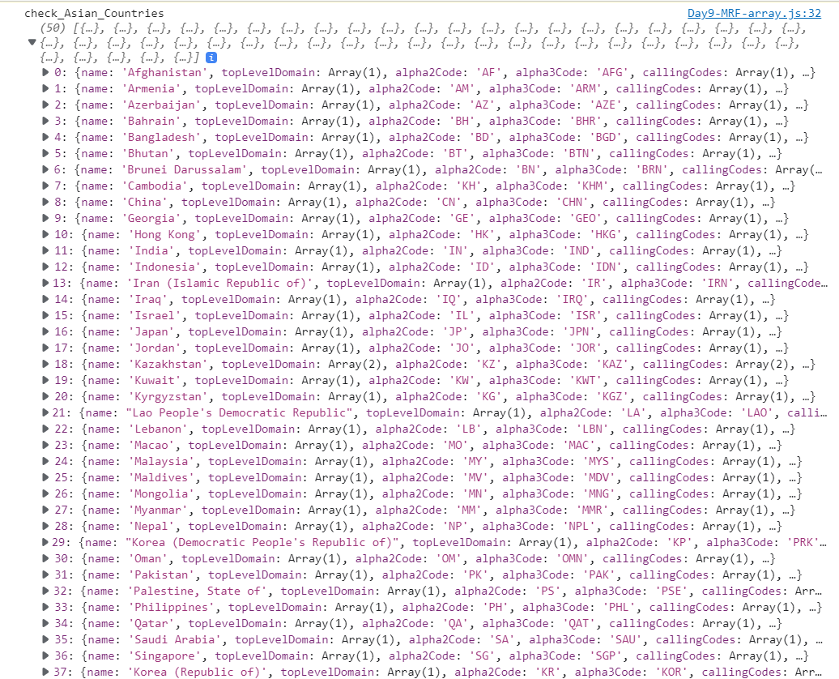

**/*2)Get all the countries with a population of less than 2 lakhs using Filter function */**

const getPopulation = responseData.filter((data) => {

//filter the array and return array of Obj by checking condition that data.population < 2Lakh

return data.population <= 200000;

});

console.log("getPopulationLessThan 2 Lakh", getPopulation);

**OUTPUT :**

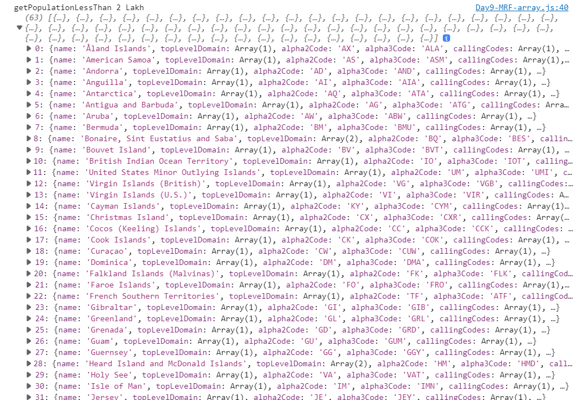

**/*3)Print the following details name, capital, flag using forEach function */**

const getDetails = responseData.forEach((data) => {

// take respective values and assign it to a object

let details = { name: data.name, capital: data.capital, flag: data.flag };

console.log(details);

});

**OUTPUT:**

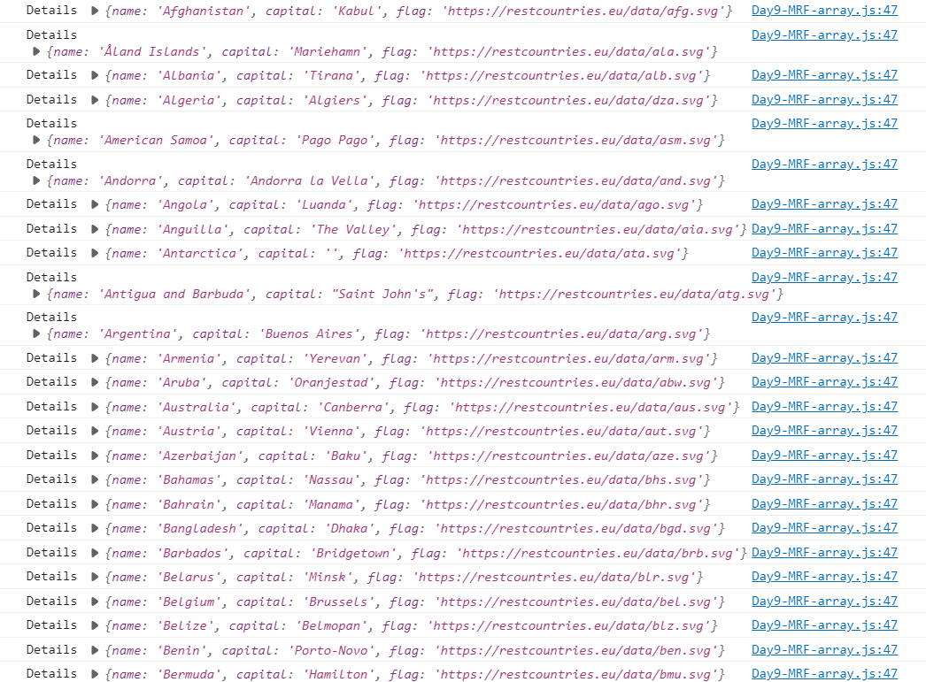

**/* 4)Print the total population of countries using reduce function */**

//using map take the population and using reduce find the sum of all numbers

const totalPopulation = responseData

.map((data) => {

//using map take all the population details

return data.population;

})

//ussing reduce add all the elements in the array

.reduce((prev, current) => {

return prev + current;

});

console.log("totalPopulation", totalPopulation);

**OUTPUT:**



**/*5)Print the country which uses US Dollars as currency. */**

let countryNames = [];

const currency = responseData

.map((data) => {

//take currency details from the array of Objects using map

let currencyList = data.currencies;

return currencyList;

})

.filter((data) => {

//filter the code which is USD

return data.filter((data) => {

if (data.code === "USD") {

//push the country name to the array

countryNames.push(data.name);

}

return countryNames;

});

});

console.log("COUNTRY NAMES", countryNames);

**OUTPUT:**

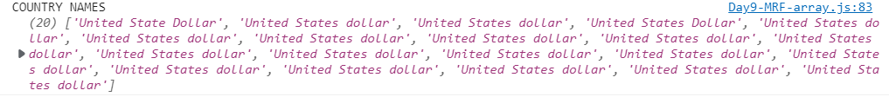

xhr.onerror = function () {

console.log("Error", this.statusText);

};

};

//Send data to server

xhr.send();