**Day4-XML-HTTP-REQUEST**

**//Javascript - Day -4 : What is XMLHTTPRequest? & scope**

**//2 Use the rest countries API url -> https://restcountries.eu/rest/v2/all and display all the country flags in console**

**//3 Use the same rest countries and print all countries name, region, sub region and population**

**//1) How to compare two JSON have the same properties without order?**

var obj1 = { name: "Person 1", age: 5 };

var obj2 = { age: 5, name: "Person 1" };

// we are passing 2 objects to compareObject method

let compareObject = (obj1, obj2) => {

//key1 will have array of keys of obj 1 eg [name, age]

key1 = Object.keys(obj1);

//key2 will have array of keys of obj 2 eg [name, age]

key2 = Object.keys(obj2);

// we are checking both keys length are same or not if same and keys value are same in both objects if both are true we will return true

return (

key1.length === key2.length &&

Object.keys(obj1).every((key) => obj1[key] === obj2[key])

);

};

console.log(compareObject(obj1, obj2));

**OUTPUT:**



//Xml http request are used to interact with servers

**//Create XMLHttpRequest()**

var xhr = new XMLHttpRequest();

let url = "https://restcountries.eu/rest/v2/all";

xhr.open("GET", url);

//Onoad listner to process completed request

xhr.onload = function () {

if(xhr.status === 200 && xhr.readyState == 4)

var responseData = JSON.parse(this.response);

console.log(responseData);

let nameArray= [];

let regionArray = [];

let subregionArray = [];

let flagArray = [];

let populationArray = [];

for(let data of responseData){

flagArray.push(data.flag);

nameArray.push(data.name);

regionArray.push(data.region);

subregionArray.push(data.subregion);

populationArray.push(data.population);

}

console.log(“FLAGS”,flagArray);

**OUTPUT:**

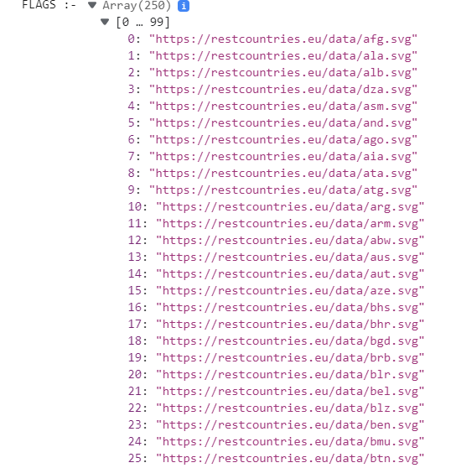

console.log('Names : ' +nameArray + "\n ",

'Region : '+regionArray + "\n ",

'Sub-region : '+subregionArray + "\n ",

'Population : '+populationArray + "\n ");

};

**OUTPUT:-** 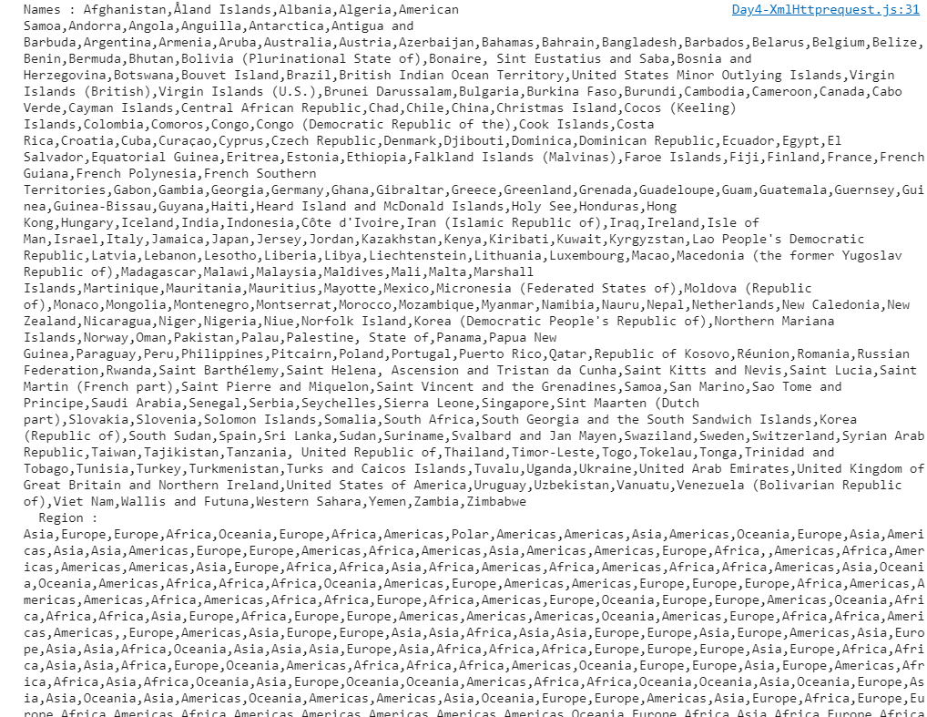

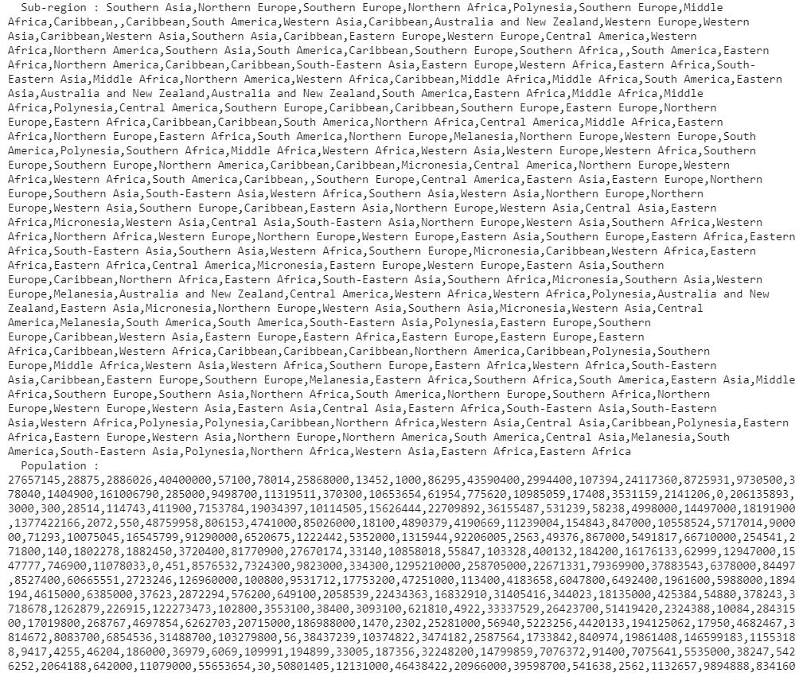

xhr.onerror = function () {

console.log("Error", this.statusText);

};

//Send request to the server

xhr.send();

**4)**[**https://medium.com/@reach2arunprakash/www-guvi-io-zen-d395deec1373**](https://medium.com/@reach2arunprakash/www-guvi-io-zen-d395deec1373)

**Task 1: Simple Programs todo for variables**

1. Declare four variables without assigning values and print them in console

let first_Name;

let last_Name;

let id;

let sex;

console.log(first_Name, last_Name, id, sex);

console.log({ first_Name, last_Name, id, sex });

**OUTPUT:**

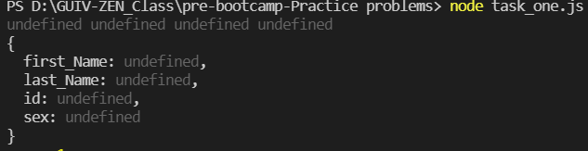

**2)** How to get value of the variable myvar as output

**OUTPUT:**



**3. Declare variables to store your first name, last name, marital status, country and age in multiple lines**

**4. Declare variables to store your first name, last name, marital status, country and age in a single line**

**5. Declare variables and assign string, boolean, undefined and null data types**

//3

let firstName;

let lastName;

let maritalStatus;

let country;

let age;

//4

let firstName_, lastName_, maritalStatus_, country_, age_;

console.log({ firstName_, lastName_, maritalStatus_, country_, age_ });

**OUTPUT:**

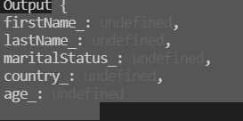

**//5. Declare variables and assign string, boolean, undefined and null data types**

let name_f = "vismaya";

let married = true;

let allergic;

let phNumber = null;

console.log("Print", typeof (name_f),

typeof (married),

typeof (allergic),

typeof (phNumber));

**OUTPUT:**



//6.Convert the string to integer

let strToCheck = "123456789";

let str1 = parseInt(strToCheck);

let str2 = Number(strToCheck);

let str3 = +strToCheck;

console.log('Convert String to Integer ' + str1, str2, str3);

**OUTPUT:**



**//7. Write 6 statement which provide truthy & falsey values.**

//null undefined NAN false "" 0

let today;

let quote = "";

let number = 0;

let emptyobj = {};

let emptyArray = [];

let negativeNum = -5;

if (!today && !quote && number === 0) {

console.log("No value for today", quote, today, number);

} else {

console.log("See the values in today" + today);

}

//truthy empty {},[] -no

if (emptyArray || emptyobj || negativeNum) {

console.log("Truthy", emptyobj, emptyArray, negativeNum)

} else {

console.log("Falsy..");

}

**OUTPUT:**



**Task 2: Simple Programs todo for Operators**

**Square of a number**

function squareOfNumber(a){

let square = a * a;

console.log('Square : '+square);

return square;

}

squareOfNumber(6);

squareOfNumber(9);

**OUTPUT:**



**Swapping 2 numbers**

let a = 2;

let b = 4; let c;

console.log(' Before Swapping a : ', a + ' b: ',b);

c = a;// c = 2

a = b;// a= 4

b = c;// b = 2

**console.log(' After Swapping a : ' ,a + ' b: ',b);**

**OUTPUT:**



**Addition of 3 numbers**

let num1 = 10, num2 = 20, num3 = 30;

let sum = num1 + num2 + num3;

console.log("Final Sum : " +sum);

**OUTPUT:**



**Celsius to Fahrenheit conversion**

// (0°C × 9/5) + 32 = 32°F

function cToF(c){

let farenhiet = (c * (9/5)) + 32;

console.log('Farenhiet : '+farenhiet);

return farenhiet;

}

cToF(1);

cToF(5);

cToF(32);

**OUTPUT:**

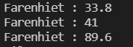

**Meter to miles**

function meterToMiles(m){

//i meter = 0.000621371 miles

let miles = 0.000621371 * m;

console.log('Miles : '+miles);

return miles;

}

meterToMiles(10);

meterToMiles(7);

**OUTPUT:**



**Pounds to kg**

function poundToKg(pound){

//1 pound = .45kg

let kg = pound * 0.45;

console.log('Pound : '+kg);

return kg;

}

poundToKg(4);

**OUTPUT:**



**Calculate Batting Average**

**Calculate five test scores and print their average**

function Average(){

let n = 5 ,n1 =50,n2= 49,n3 =50, n4 =49,n5 = 50;

//sum of all numbers divide by total numbers

let total = (n1 + n2 + n3 + n4 + n5)/n;

console.log('Total : '+total);

}

**Average();**

**OUTPUT:**



**Power of any number x ^ y.**

function exponent(x,y){

let power = Math.pow(x,y);

console.log('Power : ',power);

}

exponent(2,2);

exponent(10,3);

exponent(6,7);

exponent(-1,2);

**OUTPUT:**

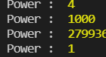

**Calculate Simple Interest**

/SI = (P * T * R) / 100

let p = 7500 , t = 5 , r = 10;

let simpleIntrest = (p * t * r)/100;

console.log("Simple Intrest : "+simpleIntrest);

**OUTPUT:**



**Calculate area of an equilateral triangle**

function equilateralArea(a){

//area = .43 * a * a

let findSquare = (0.43 *a * a);

console.log("equilateralArea : "+findSquare);

return findSquare;

}

equilateralArea(5);

equilateralArea(3);

**OUTPUT:**



**Area Of Isosceles Triangle**

function isocelesTriangleArea(b,h){

//area = .5 * b * h

let isoceles = 0.5 * b * h;

console.log('Isoceles Area : '+isoceles);

return isoceles ;

}

isocelesTriangleArea(5,10);

**OUTPUT:**



**Volume Of Sphere**

function volumeOfSphere(rad){

//Volume = 4/3 * 3.13 * R * R *R

let sphereVol =(4.0/3.0) * Math.PI * Math.pow(rad,3);

console.log('Sphere VOlume : '+sphereVol);

return sphereVol;

}

volumeOfSphere(3);

**OUTPUT**



**Volume Of Prism**

function volumeOfPrisml(l,b,h){

let volume = (l * b * h) / 2;

console.log("Volume of Prism : "+volume);

return volume;

}

volumeOfPrisml(4,5,6);

**OUTPUT:**



**Find area of a triangle.**

function triangleArea(s){

let side1 =10 ,side2 = 15,side3 = 20;

const areaValue = Math.sqrt(

s * (s - side1) * (s - side2) * (s - side3)

);

console.log('Area : '+areaValue);

};

triangleArea(100);

**OUTPUT:**



**Give the Actual cost and Sold cost, Calculate Discount Of Product**

function discountProduct(actual,sold){

let discount = actual - sold;

console.log("Discount : "+discount);

return discount;

}

discountProduct(100,90);

**OUTPUT**



**Given their radius of a circle and find its diameter, circumference and area.**

function circle(radius){

//Apply the equations

//2 * radius

let diameter = 2 * radius;

//2 * 3.14 * radius

let circumference = Math.PI * 2 * radius;

//3.14 * radius * radius

let area = Math.PI * (radius * radius);

let Final = {diameter , circumference ,area};

console.log('FINAL : '+JSON.stringify(Final));

return Final;

}

circle(2);

**OUTPUT:**



**Given two numbers and perform all arithmetic operations.**

function arithmeticOperations(a,b){

//add

let sum = a + b;

//minus

let sub = a - b;

let mul = a * b;

let division = a / b;

let result = { sum , sub, mul ,division};

//convert object object to string form to see the output

console.log("Result : "+JSON.stringify(result));

return result;

}

arithmeticOperations(34,5);

**Display the asterisk pattern as shown below(No loop needed):**

**\*\*\*\*\***

**\*\*\*\*\***

**\*\*\*\*\***

*****

*****

let n = 5;

let starPattern = '*'.repeat(n);

console.log( starPattern +"\n" +"\n",starPattern +"\n" +"\n",starPattern +"\n" +"\n",starPattern +"\n" +"\n",starPattern +"\n" +"\n");

**OUTPUT:**



**Calculate electricity bill?**

**For example, a consumer consumes 100 watts per hour daily for one month. Calculate the total energy bill of that consumer if per unit rate is 10?**

function calculateElectercityBill(watts,rate){

let totalKiloWatt = watts * 30 * 24;

let totalConsumption = totalKiloWatt / 1000 ;

let eBill = totalConsumption * rate;

console.log("Electercity Bill : " +eBill);

return eBill;

}

calculateElectercityBill(100,10);

**OUTPUT:**



**Program To Calculate CGPA**

function cgpaCalcutator(s1,s2,s3,s4,s5,n){

let sum = s1+s2+s3+s4+s5;

let total = sum / n;

console.log("Total : "+total * 9.5);

}

cgpaCalcutator(9,9,9,9,8,5);

**OUTPUT:**

