**DAY -9 HTML**

1. **Fix the bugs in below snippet**

<html lang="en">

<head>

<title>Document guvi

</title>

</head>

<body>

<div>

Lorem ipsum dolor sit amet consectetur adipisicing elit.

<div>

<div>

Guvi Geek Network

</div>

</body>

</html>

**OUTPUT:**

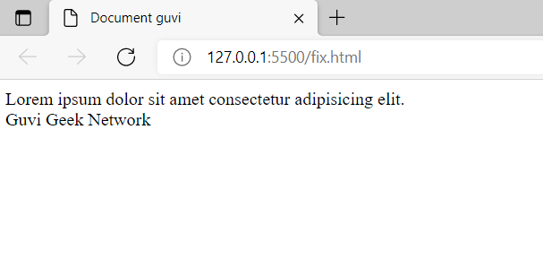

**//2.Try the below one**

<html lang="en">

<head>

<title>Document guvi</title>

</head>

<body>

<div>

Lorem ipsum dolor sit amet consectetur adipisicing elit.

<div>

<div>

Guvi Geek Network

</div>

</body>

</html>

**OUTPUT:**

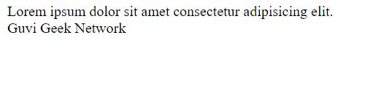

**3)Design a contact us form with all fields as required.**

**CODE:**

<div style="border:2px solid black;text-align:center;">

<h1><i>Contact Us</i></h1>

<p><i>Please fill all the mandatory fields</i></p>

<div>

<form>

<label>Full Name</label><br>

<input type = "text" class = "txtPost" placeholder = "name" required /><br>

<label>Email</label><br>

<input type = "text" placeholder = "email" required /><br>

<label>Message</label><br>

<textarea type="text" placeholder= "message" required></textarea><br><br>

<button class = "btnPost btnBlue">Post</button>

</form>

</div>

</div>

**OUTPUT:**



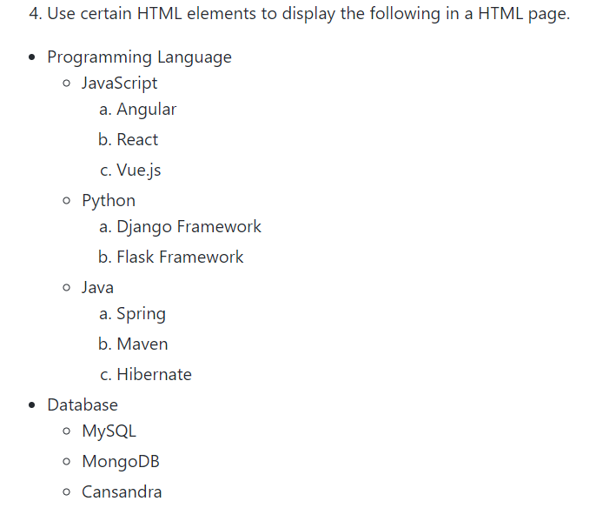

**OUTPUT:**

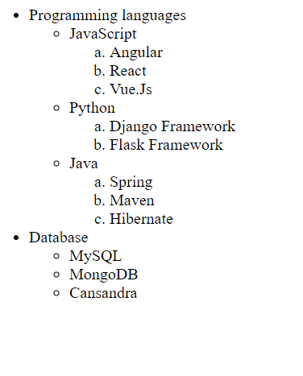

1. **Create an element that helps you to open the**[**https://google.com**](https://google.com/)**in separate new tab.**

<html lang="en">

<head>

<title>Document guvi</title>

</head>

<body>

<a href="http://www.google.com" target="_blank"> Click Here to Open Google</a>

</body>

</html>

**OUTPUT:**



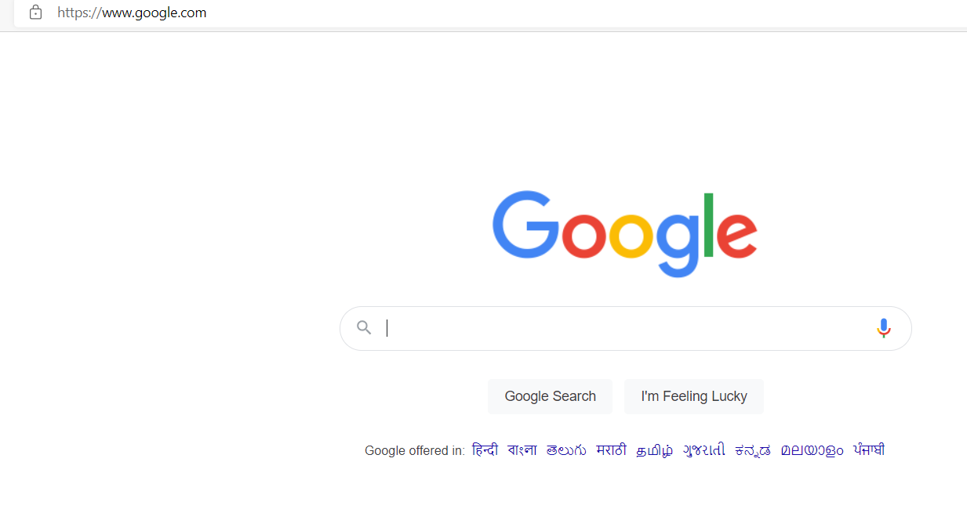

**6)In the form, add two radio buttons with grouping them for employee type(Salaried and own business)**

**CODE:**

<form>

<p>Employee Type</p>

<input type="radio" name="salaried"/>

<label for="salaried">Salaried</label>

<input type="radio" name="salaried"/>

<label for="business">Own Business</label>

</form>

**OUTPUT:**

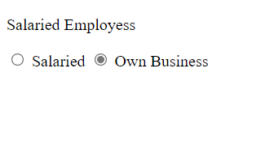

**7)Design form shown in the link (**[**http://evc-cit.info/cit040/formguide/card_0.png**](http://evc-cit.info/cit040/formguide/card_0.png)**)**

**CODE:**

<!DOCTYPE html>

<html lang="en">

<head>

<meta charset="UTF-8">

<meta http-equiv="X-UA-Compatible" content="IE=edge">

<meta name="viewport" content="width=device-width, initial-scale=1.0">

<title>Document</title>

</head>

<style>

table {

border: 2px solid black;

}

hr {

margin-top: -15px;

border: 0;

border-bottom: 3px solid black;

}

#elem {

margin-top: -10px;

}

#details {

text-align: center;

}

</style>

<body>

<table>

<tr style="background-color: red">

<th colspan="3" style="color: white;">Yes ! I want to subscribe to Mag-O-Zine</th>

</tr>

<tr>

<td>

<p id="details"> <i><strong>Joe</strong></i></p>

<hr style="color:black;border-width:2px">

<p id="elem">First Name</p>

</td>

<td>

<p id="details"> <i><strong>Schemmeggige</strong></i></p>

<hr style="color:black;">

<p id="elem">Last Name</p>

</td>

</tr>

<tr>

<td colspan="3">

<p id="details"> <i><strong>1001 Washington Street</strong></i></p>

<hr style="color:black;">

<span id="elem">Address</span>

</td>

</tr>

<tr>

<td>

<p id="details"> <i><strong>ArmFlour</strong></i></p>

<hr style="color:black;">

<span id="elem">City</span>

</td>

<td>

<p id="details"> <i><strong>CA</strong></i></p>

<hr style="color:black;">

<span id="elem">State</span>

</td>

<td>

<p id="details"> <i><strong>99999</strong></i></p>

<hr style="color:black;">

<span id="elem">Zip</span>

</td>

</tr>

<tr>

<td><b>Subscribe for : </b></td>

<td> <input type="checkbox" name="check"><b> 1 year ($19.95)</b></td>

<td> <input type="checkbox" name="check"><b> 2 years ($35.00) </b></td>

</tr>

<tr>

<th>Send me more information about:</th>

</tr>

<tr>

<td><input type="checkbox" name="check">Computer-Zine</td>

</tr>

<tr>

<td><input type="checkbox" name="check">Fishing-Zine</td>

</tr>

<tr>

<td><input type="checkbox" name="check">Cat-O-Zine</td>

</tr>

</table>

</body>

</html>

**OUTPUT:**

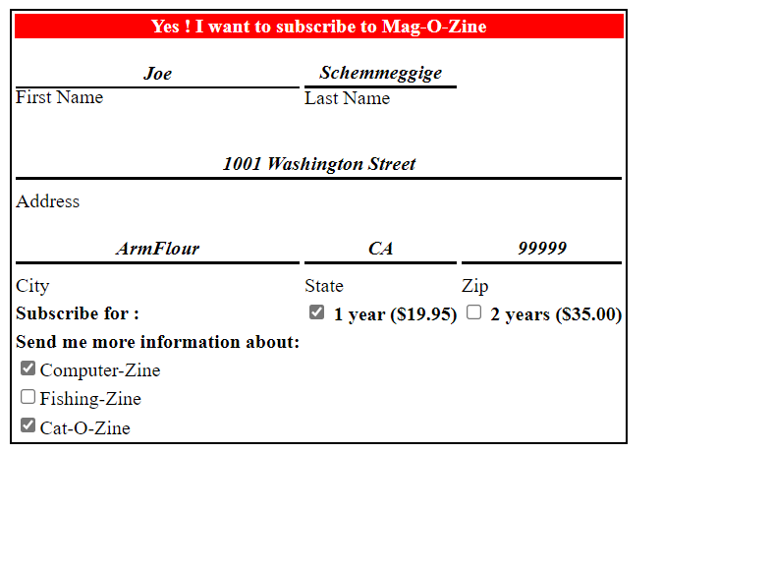

**8:** Use the table tag to design given image [Click here](https://www.bapugraphics.com/assets/img/port_upload_dir/table-4.jpg).

**CODE:**

<!DOCTYPE html>

<html lang="en">

<head>

<meta charset="UTF-8">

<meta http-equiv="X-UA-Compatible" content="IE=edge">

<meta name="viewport" content="width=device-width, initial-scale=1.0">

<title>Document</title>

<style>

table, th, td {

border: 1px solid black;

border-collapse: collapse;

}

td{

text-align: center;

}

</style>

</head>

<body>

<table cellpadding="12">

<caption>Health Chart</caption>

<tr>

<th rowspan="2">State of Health</th>

<th colspan="2">Fasting Value</th>

<th>After Eating</th>

</tr>

<tr>

<th>Minimum</th>

<th>Maximum</th>

<th> 2 hours after eating</th>

</tr>

<tr>

<th>Health</th>

<td>70</td>

<td>100</td>

<td>Less than 140</td>

</tr>

<tr>

<th>Pre-Diabetes</th>

<td>101</td>

<td>126</td>

<td>140 - 200</td>

</tr>

<tr>

<th>Diabetes</th>

<td>More than 126</td>

<td>N/A</td>

<td>More than 200</td>

</tr>

</table>

</body>

</html>

**OUTPUT:**

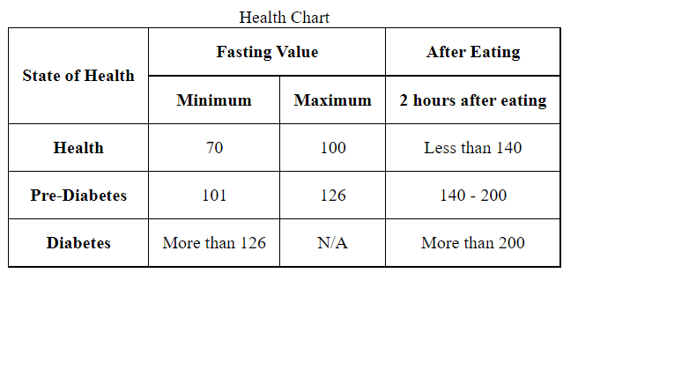

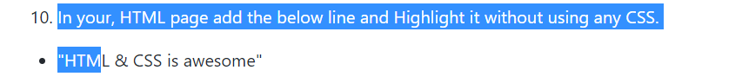

<ul>

<li>

<p>

<mark>"HTML & CSS is awesome"</mark>

</p>

</li>

</ul>

**OUTPUT:**

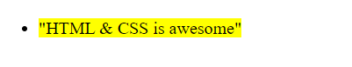

**11)** **Create an HTML page, which should contain all types of input elements.**

**CODE:**

<!DOCTYPE html>

<html lang="en">

<head>

<meta charset="UTF-8">

<meta http-equiv="X-UA-Compatible" content="IE=edge">

<meta name="viewport" content="width=device-width, initial-scale=1.0">

<title>Document</title>

</head>

<style>

p {

padding-left: 185px;

}

body {

background-color: rgb(218, 19, 19);

color: white;

}

h2 {

text-align: center;

color: black;

}

#img1 {

float: right;

}

</style>

<body>

<h2>Registration Form</h2>

<input type="image" src="assets/nature.jpg" width="800px" height="600px" id="img1" />

<form>

<table>

<tr>

<td>First Name </td>

<td></td>

<td><input type="text" name="first" placeholder="First Name" required autofocus></td>

</tr>

<tr>

<td>Last Name </td>

<td></td>

<td><input type="text" name="last" placeholder="Last Name" required /></td>

</tr>

<tr>

<td>Phone Number </td>

<td></td>

<td><input type="number" name="phone" placeholder="Phone Number" required /></td>

</tr>

<tr>

<td>Alternate Number </td>

<td></td>

<td><input type="tel" name="alternatephone" placeholder="Alternate Number" required /></td>

</tr>

<tr>

<td>Sex </td>

<td></td>

<td><input type="radio" name="sex"><span>Male</span></td>

<td><input type="radio" name="sex"><span>Female</span><br></td>

</tr>

<tr>

<td>Email </td>

<td></td>

<td> <input type="email"></td>

</tr>

<tr>

<td>Time </td>

<td></td>

<td> <input type="time"></td>

</tr>

<tr>

<td>Date </td>

<td></td>

<td> <input type="date"></td>

</tr>

<tr>

<td>Date of Birth </td>

<td></td>

<td> <input type="month" name="month"></td>

</tr>

<tr>

<td>Password </td>

<td></td>

<td> <input type="password"></td>

</tr>

<tr>

<td>Select Current Day</td>

<td></td>

<td><input type="week" name="week" /></td>

</tr>

<tr>

<td>Select your favourite color</td>

<td></td>

<td> <input type="color"><br></td>

</tr>

</table>

<table>

<div>

<span>Known Languages</span>

<p><input type="checkbox" name="html" />HTML</p>

<p><input type="checkbox" name="Css" />CSS</p>

<p><input type="checkbox" name="JS" />Javascript</p>

<p><input type="checkbox" name="Java" />Java</p>

<p><input type="checkbox" name="Python" />Python</p>

<p><input type="checkbox" name="React" />React</p>

<p><input type="checkbox" name="Angular" />Angular</p>

</div>

<tr>

<td>Knowledge Level</td>

<td></td>

<td> <input type="range" min="1" max="100"></td>

</tr>

<tr>

<td>Upload your Resume</td>

<td></td>

<td><input type="file" name="myResume" /></td>

<!--The hidden field is not shown to the user, but the data is sent when the form is submitted.-->

<td><input type="hidden" name="hiddenValue" value="1234" /></td>

</tr>

<tr>

<td>Enter the URL</td>

<td></td>

<td> <input type="url" id="homepage" name="homepage" placeholder="https://www.google.com"></td>

</tr>

<tr>

<td>Search Google</td>

<td></td>

<td> <input type="search" id="gsearch" name="gsearch"></td>

</tr>

<tr>

<td> <input type="reset"><br></td>

<td> <input type="submit"><br></td>

<td> <input type="button" value="Close"><br></td>

</tr>

</table>

</form>

</body>

</html>

**OUTPUT:**



