

Fabric Inspection Report
Date | 2025-01-28
Vendor | tanu
PO Number | 9999
Order Quantity | 400
Offer Quantity | 40
Style | nbgv
Colour | Beige

Defect Details
Type of Major Defect | mmm
Count of Major Defect | 76
Type of Minor Defect | bbb
Count of Minor Defect | 32
Inspection Result | Pass
QA Remarks | nn

Inspection Images
Bulk vs PP  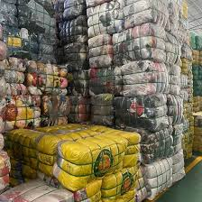 | Barcode Tag & Washcare  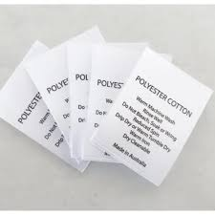
Bulk vs HLP/GPT Report  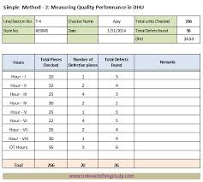 | Measurement Chart  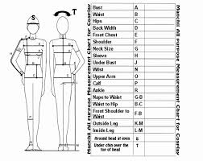
Bulk Carton/Carton Opening/Carton Marking   | Defect Picture  