## Sudo apt-get install wireshark

## Capturing HTTP Traffic in Wireshark

Now that you’ve installed Wireshark on your computer, we can move on to capturing http traffic. Here are the steps to do it:

1. Open your browser – You can use any browser.
2. Clear cache – Before capturing the traffic, you need to clear your browser’s cache. You can do this if you go to your browser’s settings.  
   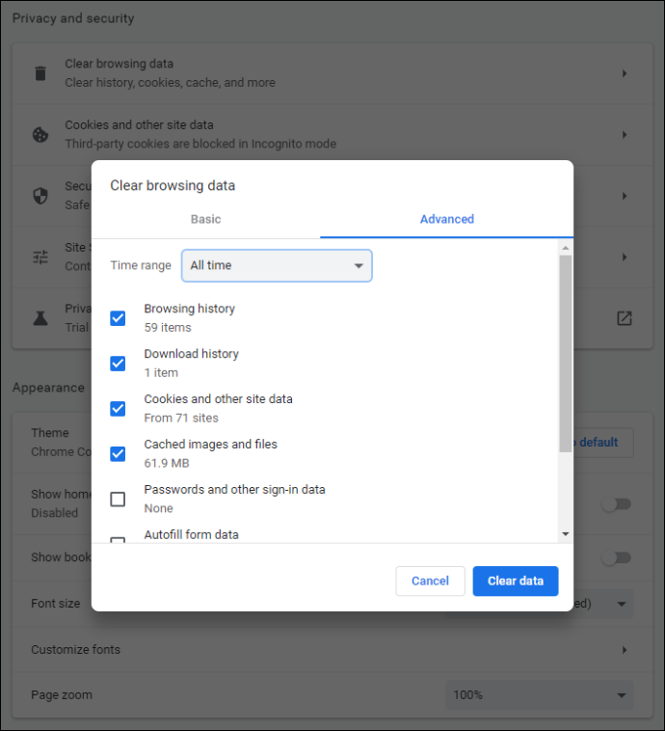

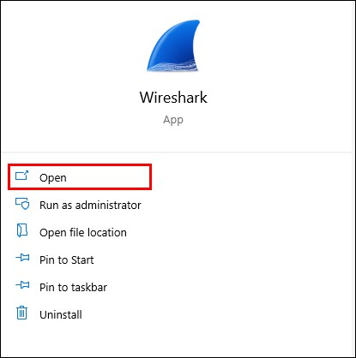Open Wireshark.

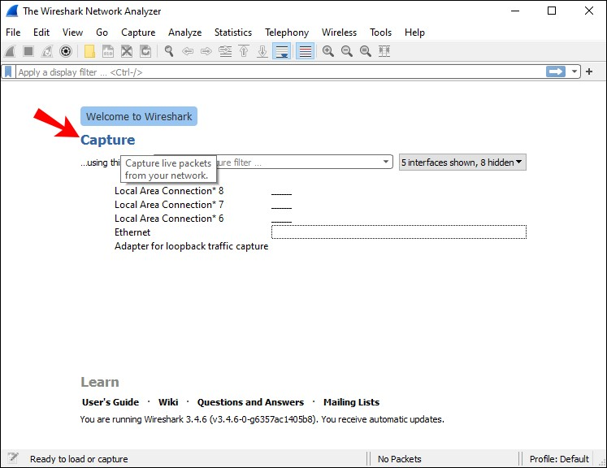4 Tap “Capture.”

5 Tap “Interfaces.” You will now see a pop-up window on your screen.

6 Choose the interface. You probably want to analyze the traffic going through your ethernet driver.

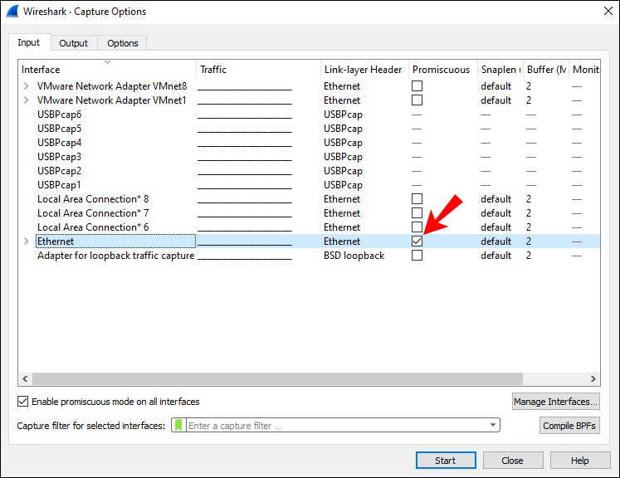

8 Now go back to your browser and visit the URL you want to capture traffic from.



9 Once you’re done, stop capturing traffic. Go back to Wireshark and tap “Ctrl + E.”

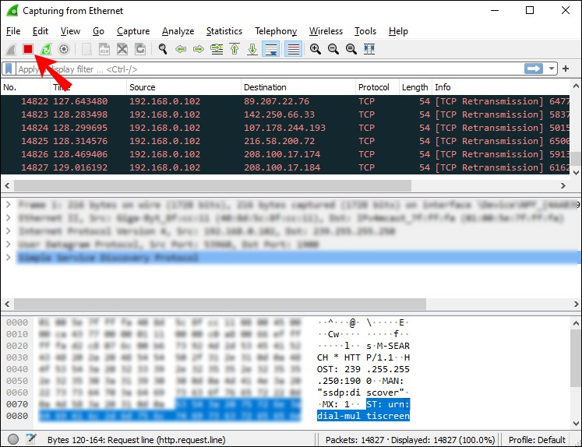

10. Save the captured traffic. If you have network issues and want to send the captured traffic to support, save it into a *.pcap format file.

