Symbiosis Institute of Technology, Nagpur
Bachelor of Technology
in
Computer Science and Engineering
“Demand Forecasting for Supply Chain Optimization Using Historical Sales Data”
Submitted by
VISMAYAA RAJAN
PRN: 23070521169
Semester: VII
Section: C
Course : Predictive Analytics
Guide
Prof. Deepak S Asudani
Academic Year: 2026

Symbiosis International (Deemed University),
Pune


DECLARATION
I, hereby declare that the project report submitted herein, titled “Demand Forecasting for Supply Chain Optimization Using Historical Sales Data”, has been carried out by me as part of the Predictive Analytics course towards the partial fulfillment of the requirements for the award of the Degree of Bachelor of Technology in Computer Science and Engineering. The work is original and has not been submitted earlier, in whole or in part, for the award of any degree or diploma at this or any other Institution / University.
I hereby assign all copyright rights in this work, including any revised or expanded derivative works, to Symbiosis Institute of Technology, Nagpur. Any content sourced from references, manuals, datasets, or other external materials has been duly acknowledged and appropriately cited.
Name of Student:
Vismayaa Rajan (PRN: 23070521169)
Place: Nagpur
Date: 9th October 2026

ACKNOWLEDGEMENT
I would like to express my sincere gratitude to Symbiosis Institute of Technology, Nagpur for providing me with the opportunity to undertake this project as part of the Predictive Analytics course. Working on demand forecasting for supply chain optimization has been a valuable learning experience, helping me develop practical skills in data preparation, feature engineering, machine learning and model evaluation.
I am deeply thankful to my course mentor, Prof. Deepak S Asudani, for the guidance, valuable suggestions and feedback provided throughout the project. This support played an important role in improving my understanding of predictive analytics and the KDD methodology and their practical application.
I am also grateful to the faculty members of the Department of Computer Science and Engineering for their support and encouragement throughout the course, and to the Kaggle community for making the Store Item Demand Forecasting and Rossmann Store Sales datasets publicly available.
Lastly, I would like to acknowledge my family and friends for their encouragement and support during the completion of this project.

ABSTRACT
This project investigates how machine learning regression models can forecast daily retail sales and support inventory and supply chain planning. Two public Kaggle datasets are analysed as separate forecasting experiments: the Store Item Demand Forecasting training data (913,000 records, four columns) and the Rossmann Store Sales training data (1,017,209 records, nine columns). The work follows the six-step Knowledge Discovery in Databases (KDD) methodology: selection, data cleaning, transformation, data mining, interpretation and evaluation, and knowledge presentation.
Both datasets were checked for missing values and duplicate rows, and none were found. Records were aggregated into total daily sales, enriched with calendar features (year, month, day, day of week, day of year) and lagged sales features (1, 7 and 14 days), and split chronologically into 80% training and 20% validation periods. Five regressors were trained on each dataset: Linear Regression, Decision Tree, Random Forest, Gradient Boosting and Extra Trees. They were compared using MAE, RMSE, WAPE and R-squared on the held-out validation period.
Extra Trees achieved the lowest MAE, RMSE and WAPE and the highest R-squared on both datasets: MAE 540.58, WAPE 1.83% and R-squared 0.9808 for Store Item Demand, and MAE 724,881, WAPE 10.95% and R-squared 0.8281 for Rossmann. The results show that tree-based ensembles built on simple calendar and lag features can forecast aggregate daily demand well, while also exposing limitations of the evaluation design, which are discussed in the report.

CONTENTS
1 Introduction 1
1.1 Background of Retail Demand Forecasting 1
1.2 Problem Statement 1
1.3 Motivation and Significance 1
1.4 Aim and Objectives 1
1.5 Research Questions 1
1.6 Predictive Analytics and the KDD Methodology 2
1.7 Overview of the Datasets and Modelling Approach 2
1.8 Scope and Limitations 2
1.9 Organisation of the Report 2
2 Literature Review 3
2.1 Predictive Analytics and the KDD Process 3
2.2 Retail Sales and Demand Forecasting 3
2.3 Time-Series Forecasting and Machine Learning Regression 3
2.4 Tree-Based Ensemble Models 4
2.5 Model Evaluation for Regression Forecasting 4
2.6 Predictive Analytics in Inventory and Supply Chain Management 4
2.7 Motivation for the Present Study 5
3 Workflow and Predictive Modelling Process 6
3.1 Overall Workflow 6
3.2 Step 1: Selection 6
3.3 Step 2: Data Cleaning 7
3.4 Step 3: Transformation 7
3.5 Step 4: Data Mining 8
3.6 Step 5: Interpretation and Evaluation 9
3.7 Step 6: Knowledge Presentation 9
4 Results and Discussion 10
4.1 Experimental Results Overview 10
4.2 Dataset 1: Store Item Demand Forecasting 10
4.3 Dataset 2: Rossmann Store Sales 11
4.4 Interpretation of the Metrics 12
4.5 Why Extra Trees Performed Best Among the Models Tested 12
4.6 Differences in Forecasting Difficulty Between the Datasets 13
4.7 Practical Implications for Demand and Inventory Planning 13
4.8 Limitations and Evaluation Caveats 13
5 Conclusion 14
6 References 15

LIST OF FIGURES
Figure 3.1: Six-step KDD workflow applied to both datasets 6
Figure 3.2: Chronological 80/20 training and validation split for each dataset 8
Figure 4.1: Validation MAE of the five models on Store Item Demand 10
Figure 4.2: Actual and predicted daily sales for the best model (Extra Trees) on Store Item Demand, validation period (notebook output) 11
Figure 4.3: Validation MAE of the five models on Rossmann 11
Figure 4.4: Actual and predicted daily sales for the best model (Extra Trees) on Rossmann, validation period (notebook output) 12

LIST OF TABLES
Table 2.1: Summary of reviewed literature and its relevance to this project 5
Table 3.1: Mapping of project activities to the six KDD steps 6
Table 3.2: Structure of the two training datasets 7
Table 3.3: Summary statistics of the sales field before aggregation 7
Table 3.4: Regression models and settings used in the notebook 8
Table 4.1: Validation results for all models on both datasets (sorted by MAE) 10
Table 4.2: Margin of Extra Trees over the runner-up and the Linear Regression baseline 12

1. INTRODUCTION

1.1 Background of Retail Demand Forecasting
Retail supply chains operate under a basic tension: stock must be available when customers want it, yet every unit held in a store or warehouse ties up capital, space and handling effort. Demand forecasting, the estimation of how much of each product will be sold in future periods, is the information that resolves this tension. Forecasts drive replenishment orders, safety-stock levels, labour schedules and transport planning, so their quality has a direct effect on service levels and on inventory cost (Chopra & Meindl, 2019).
Retail demand is difficult to forecast because it combines several overlapping patterns: weekly shopping cycles, annual seasonality, holidays and promotions, and a large number of related time series at store and product level (Fildes et al., 2022). Traditional statistical methods model these patterns explicitly, whereas machine learning regressors learn them from engineered input features such as calendar variables and previous sales values. The availability of public retail datasets on Kaggle makes it possible to compare such approaches on realistic sales histories.

1.2 Problem Statement
Inaccurate demand forecasts produce two opposite failures. Under-forecasting leads to stock-outs, lost sales and dissatisfied customers; over-forecasting leads to excess inventory, higher holding costs and, for perishable goods, waste. The problem addressed in this project is to forecast daily sales from historical sales records, and to determine which of several commonly used regression models produces the most accurate forecasts on two different retail datasets, so that the resulting forecasts could inform inventory and supply chain planning.

1.3 Motivation and Significance
The project is motivated by the practical value of accurate short-term forecasts and by the need to compare modelling choices fairly rather than assume that one model is best. Using two datasets with different scales and structure tests whether conclusions hold beyond a single data source. The significance lies in showing, with a transparent and reproducible workflow, how an undergraduate predictive analytics project can move from raw sales records to a quantified model comparison that links directly to inventory decisions.

1.4 Aim and Objectives
The aim of the project is to analyse historical retail sales, develop and compare machine learning regression models for daily demand forecasting, and evaluate their performance to support inventory management and supply chain planning. The specific objectives are:
- To select two retail sales datasets and define the forecasting target for each.
- To inspect and clean the data and verify its quality before modelling.
- To transform transaction-level records into daily series with calendar and lag features, and to split them chronologically into training and validation periods.
- To train five regression models on each dataset and compare them using MAE, RMSE, WAPE and R-squared.
- To identify the best-performing model on each dataset and discuss the practical implications and limitations of the findings.

1.5 Research Questions
The experiments are designed to answer three questions. RQ1: Which of the five regression models achieves the lowest validation error on the Store Item Demand data? RQ2: Which model achieves the lowest validation error on the Rossmann data, and is the ranking the same as for RQ1? RQ3: How do the errors, expressed as scale-free measures, differ between the two datasets, and what does this suggest about their relative forecasting difficulty?

1.6 Predictive Analytics and the KDD Methodology
Predictive analytics uses historical data and statistical or machine learning models to estimate unknown or future outcomes. In this project the outcome is the total sales of a day, and the models are supervised regressors trained on past observations. The project is organised according to the Knowledge Discovery in Databases (KDD) process, which describes data mining as one step in a larger sequence that begins with selecting relevant data and ends with presenting the discovered knowledge (Fayyad et al., 1996). The six steps used here are selection, data cleaning, transformation, data mining, interpretation and evaluation, and knowledge presentation. Exploratory data analysis and feature engineering are carried out inside the relevant steps rather than as a separate methodology.

1.7 Overview of the Datasets and Modelling Approach
Two public retail datasets are used. Store Item Demand Forecasting contains 913,000 daily item-level sales records across stores and items, and Rossmann Store Sales contains 1,017,209 daily store-level sales records with customer, promotion and holiday fields. Each dataset is aggregated into total daily sales, enriched with calendar and lag features, split chronologically into 80% training and 20% validation data, and modelled separately. Five regression models of increasing flexibility, Linear Regression, Decision Tree, Random Forest, Gradient Boosting and Extra Trees, are trained on each dataset and compared using MAE, RMSE, WAPE and R-squared. The datasets are never merged into a single training set.

1.8 Scope and Limitations
The scope is limited to forecasting total daily sales for each dataset, using eight features derived from the date and from previous daily totals. The two datasets are processed and modelled separately, and their raw errors are not compared as if they shared a scale. The main limitations are as follows. Item-level and store-level detail is aggregated away. Evaluation uses a single chronological validation split of the labelled training data, not the official Kaggle test labels. Hyperparameters were set by hand and not tuned, and no seasonal baseline or statistical time-series model was included. These points are revisited in Chapters 4 and 5.

1.9 Organisation of the Report
The report contains six chapters. Chapter 1 introduces the problem, objectives and scope. Chapter 2 reviews the literature on predictive analytics, retail demand forecasting, machine learning forecasting, tree-based ensembles, evaluation measures and supply chain applications. Chapter 3 describes the workflow and predictive modelling process through the six KDD steps, including the datasets, cleaning, feature engineering, the five models and the evaluation measures. Chapter 4 presents and discusses the results for both datasets, including the justification for selecting Extra Trees, the practical implications and the limitations. Chapter 5 concludes the report and outlines future improvements, and Chapter 6 lists the references.

2. LITERATURE REVIEW

2.1 Predictive Analytics and the KDD Process
Predictive analytics applies statistical and machine learning models to historical data in order to estimate unknown or future outcomes, and it is usually carried out as a sequence of data preparation, modelling and evaluation activities rather than as a single modelling step. The Knowledge Discovery in Databases (KDD) process of Fayyad et al. (1996) defines knowledge discovery as the non-trivial process of identifying valid, novel, potentially useful and ultimately understandable patterns in data, and treats data mining as only one stage in a larger process that also includes selecting the data, preprocessing it, transforming it and interpreting and evaluating the discovered patterns. This project follows the six-step formulation required by the course, which separates data cleaning as its own step and adds an explicit knowledge presentation step to the sequence of selection, transformation, data mining and interpretation and evaluation. The framework is used as an organising structure for the experimental work reported in Chapter 3.

2.2 Retail Sales and Demand Forecasting
Retail forecasting has a long research tradition, and its practical challenges are well documented. Fildes et al. (2022) review research and practice in retail forecasting and describe features that distinguish it from many other settings: very large numbers of products and locations, strong calendar effects, promotions and price changes, and decisions that must be made at several levels of aggregation. They also note that forecast usefulness depends on the decision it supports, which is why accuracy has to be judged against inventory and replenishment needs and not only against statistical criteria.
From the operations side, Chopra and Meindl (2019) explain that forecasts are the basis of supply chain planning, and that errors propagate into safety inventory, capacity and service-level decisions. Hyndman and Athanasopoulos (2021) provide the standard introduction to forecasting practice, covering trend and seasonal structure, the use of calendar predictors and lagged values, and the principle that forecasts must be evaluated on data not used to fit the model. These ideas motivate the calendar and lag features and the held-out validation period used in this project.

2.3 Time-Series Forecasting and Machine Learning Regression
Time-series forecasting methods are commonly divided into statistical models, which describe the series through trend, seasonality and autocorrelation, and machine learning models, which treat forecasting as a supervised regression problem on engineered features. Makridakis et al. (2018) compared popular machine learning methods with classical statistical methods on a large set of monthly series and found that the machine learning methods they tested were less accurate and more computationally demanding, which led them to call for more careful, evidence-based comparisons. Their result is a caution against assuming that machine learning always wins, and it is one reason this project reports a linear baseline alongside four non-linear models.
Applied work on supply chains has reported more favourable results for learning methods. Carbonneau et al. (2008) compared neural networks, recurrent neural networks and support vector machines with simpler benchmarks such as naive forecasts, moving averages, trend and linear regression, using simulated demand and real supply chain data, and found that recurrent networks and support vector machines gave the best accuracy in their experiments. Together, the two studies show that the relative merit of methods depends on the data and the evaluation design, so a project of this kind should compare several models under one protocol on each dataset.
How the validation data are chosen matters as much as which model is used. Bergmeir and Benítez (2012) examined cross-validation for time series predictors and discussed when it is and is not valid, and Cerqueira et al. (2020) compared performance estimation methods empirically and found that out-of-sample evaluation that respects temporal order is generally the safer choice when series are non-stationary. This supports the chronological 80/20 split used here, in which the most recent observations are held out and no future information can enter training.
Feature construction is the other half of the machine learning approach. Calendar variables and lagged values of the target convert a time series into a table of predictors and responses, so that any regression algorithm can be applied (Hyndman & Athanasopoulos, 2021). One property of tree-based regressors is relevant here: because each leaf predicts an average of training responses, a tree ensemble cannot predict values outside the range seen in training, and so it may follow a long-run trend less well than a model that extrapolates explicitly (Hastie et al., 2009). The year feature and the lag features used in this project give the models some access to level shifts, but the limitation should be kept in mind when interpreting the results.

2.4 Tree-Based Ensemble Models
A decision tree partitions the feature space with a sequence of threshold tests and predicts a constant value in each region, which allows it to capture non-linear relationships and interactions without a prespecified functional form (Hastie et al., 2009). Single trees have high variance, so ensemble methods combine many trees. Random Forest, introduced by Breiman (2001), grows each tree on a bootstrap sample and considers a random subset of features at each split, then averages the predictions, which reduces variance relative to a single tree.
Extremely Randomized Trees, proposed by Geurts et al. (2006), push randomisation further: split thresholds are drawn at random for candidate features and the best of these random splits is chosen, instead of searching for the optimal threshold. The authors report that this reduces variance further and lowers computational cost. Gradient boosting, formulated by Friedman (2001), builds the ensemble sequentially, fitting each new tree to the remaining errors of the current model so that the prediction is improved stage by stage. The scikit-learn library provides implementations of all these regressors with documented defaults (Pedregosa et al., 2011), which are used in this project.
The choice among such models is a matter of the bias-variance trade-off. Flexible models can fit complex patterns but are sensitive to the particular training sample, while simple models are stable but may miss structure; ensemble averaging is one way to keep flexibility while reducing variance, and no single method is best for every problem (Hastie et al., 2009). For this reason the project does not assume a winner in advance but evaluates all five models under identical conditions on each dataset.

2.5 Model Evaluation for Regression Forecasting
Hyndman and Koehler (2006) review measures of forecast accuracy and classify them into scale-dependent measures such as MAE and RMSE, percentage-error measures, and scaled-error measures. Scale-dependent measures are easy to interpret but cannot be compared across series measured in different units or magnitudes, which is directly relevant to this project because the two datasets differ greatly in sales magnitude. Percentage errors are problematic when actual values are zero or near zero, which can occur in daily retail data.
Kolassa and Schütz (2007) discuss the ratio of the mean absolute deviation to the mean of the actuals as an alternative to the mean absolute percentage error. Their ratio, the sum of absolute errors divided by the sum of actual values, is what this report calls WAPE; it is scale-free, remains defined when individual days have low sales, and weights errors by sales volume. R-squared is added as a complementary measure of how much of the variation in the validation target the model explains. Using all four measures gives a more complete view than any one alone.
A further point concerns benchmarks. Hyndman and Athanasopoulos (2021) recommend comparing any proposed method with simple reference forecasts, such as a seasonal naive forecast that repeats the value from the same period of the previous cycle, because a high R-squared can be obtained on strongly seasonal data by almost any reasonable model. The linear baseline in this project serves as a reference for the non-linear models, but a seasonal naive benchmark was not included, and this is listed as a limitation and a direction for future work in Chapters 4 and 5.

2.6 Predictive Analytics in Inventory and Supply Chain Management
The reviewed literature links forecasting accuracy to inventory outcomes through safety stock, replenishment frequency and service level (Chopra & Meindl, 2019), and shows that learning-based forecasting has been applied to supply chain demand with encouraging results (Carbonneau et al., 2008). The KDD process of Fayyad et al. (1996) provides the organising structure for turning such data into usable knowledge. The present project does not measure inventory costs; it evaluates forecast accuracy, which is the input to those decisions.
The link between forecast error and inventory is quantitative in standard supply chain models. In the usual safety-inventory calculation, the safety stock required to reach a target service level grows with the standard deviation of the forecast error over the replenishment lead time (Chopra & Meindl, 2019). A forecasting method that reduces error therefore allows a lower safety stock for the same service level, which is the mechanism through which the accuracy gains measured in this project could translate into lower inventory cost. The magnitude of that effect depends on lead times, service targets and costs that are outside the data used here.

2.7 Motivation for the Present Study
Table 2.1 summarises the reviewed work and its relevance to this project. Based on the literature, the project adopts four design decisions. First, several models of increasing flexibility are compared, starting with a linear baseline, because the superiority of learning methods is not guaranteed (Makridakis et al., 2018). Second, tree-based ensembles are included because they handle non-linear calendar and lag effects and are available with documented defaults (Breiman, 2001; Geurts et al., 2006; Friedman, 2001; Pedregosa et al., 2011). Third, evaluation is chronological, so that validation data lie in the future of the training data (Cerqueira et al., 2020). Fourth, both scale-dependent and scale-free metrics are reported (Hyndman & Koehler, 2006; Kolassa & Schütz, 2007). The results in Chapter 4 are the author's own experimental observations and are kept distinct from the established findings reviewed above.
Source | Focus | Relevance to this project
Fildes et al. (2022) | Retail forecasting research and practice | Frames the challenges of retail demand and decision-oriented evaluation
Makridakis et al. (2018) | Statistical versus machine learning forecasting | Motivates a linear baseline and cautious conclusions
Carbonneau et al. (2008) | Machine learning for supply chain demand | Supports learning-based regressors for demand forecasting
Bergmeir & Benítez (2012); Cerqueira et al. (2020) | Validation of time series predictors | Support the chronological hold-out split
Breiman (2001); Geurts et al. (2006); Friedman (2001) | Random Forest, Extra Trees, gradient boosting | Define the tree ensembles compared
Hyndman & Koehler (2006); Kolassa & Schütz (2007) | Forecast accuracy measures | Justify MAE, RMSE, WAPE and scale-free comparison
Table 2.1: Summary of reviewed literature and its relevance to this project

3. WORKFLOW AND PREDICTIVE MODELLING PROCESS

3.1 Overall Workflow
The project follows the six-step KDD process shown in Figure 3.1. The two datasets travel through the same sequence independently: each is selected, cleaned, transformed, modelled and evaluated on its own, and only the final results are placed side by side for discussion. All work was carried out in a Python notebook in a Google Colab environment, using pandas and NumPy for data handling, scikit-learn for modelling and metrics, and Matplotlib for the validation plots. Table 3.1 maps the project activities to the KDD steps.
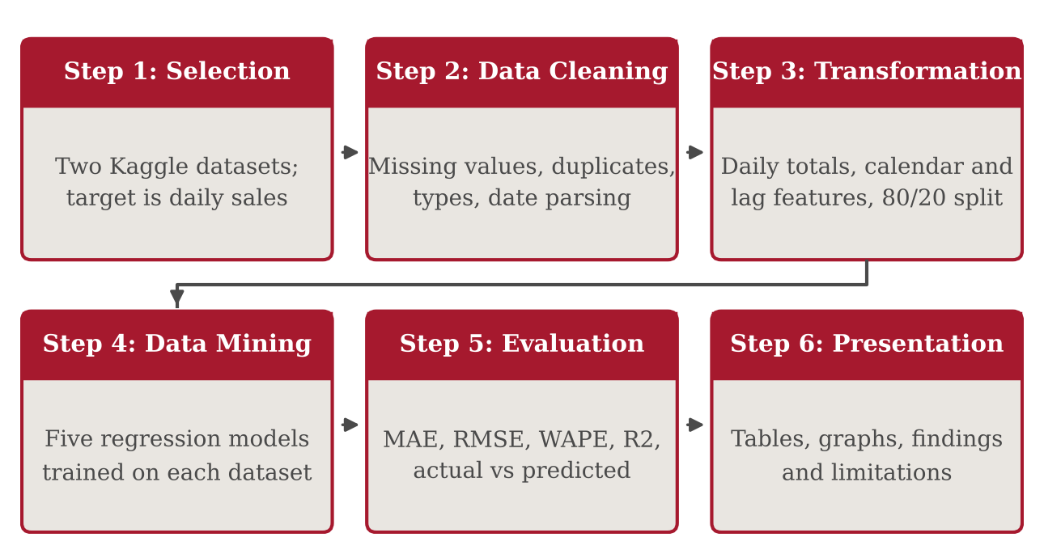
Figure 3.1: Six-step KDD workflow applied to both datasets
Step | KDD stage | Activities carried out in this project
1 | Selection | Chose the Store Item Demand and Rossmann training files; identified date and sales fields; defined daily total sales as the target.
2 | Data cleaning | Checked missing values, duplicate rows, data types and sales summaries; converted dates to datetime; kept sales numeric.
3 | Transformation | Aggregated to daily totals; created calendar and lag features; dropped rows without full lag history; split chronologically 80/20.
4 | Data mining | Trained Linear Regression, Decision Tree, Random Forest, Gradient Boosting and Extra Trees on each training set.
5 | Interpretation and evaluation | Computed MAE, RMSE, WAPE and R-squared on validation data; plotted actual against predicted sales; selected the best model.
6 | Knowledge presentation | Presented comparison tables, charts and graphs, and drew conclusions about forecasting and inventory planning.
Table 3.1: Mapping of project activities to the six KDD steps

3.2 Step 1: Selection
Two datasets were selected so that the conclusions are not tied to a single data source. Store Item Demand Forecasting is the training data of a Kaggle forecasting challenge in which each record gives the units sold of one item in one store on one date (Kaggle, n.d.-a). Rossmann Store Sales is the training data of a Kaggle competition in which each record gives the sales of one store on one date together with customer counts and promotion, holiday and opening indicators (Kaggle, n.d.-b). Table 3.2 summarises the structure of the two files as loaded in the notebook.
Property | Store Item Demand | Rossmann Store Sales
Source | Kaggle Store Item Demand Forecasting Challenge | Kaggle Rossmann Store Sales
Rows and columns | 913,000 rows, 4 columns | 1,017,209 rows, 9 columns
Columns | date, store, item, sales | Store, DayOfWeek, Date, Sales, Customers, Open, Promo, StateHoliday, SchoolHoliday
Target variable | sales (units sold) | Sales
Modelling unit | Total daily sales across stores and items | Total daily sales across stores
Table 3.2: Structure of the two training datasets
The forecasting task is therefore to predict the total sales of a day from information available before that day. Only the date columns and the sales column are used for modelling; the other Rossmann columns (Customers, Open, Promo, StateHoliday, SchoolHoliday) were inspected but not used as features.

3.3 Step 2: Data Cleaning
Data cleaning targeted problems that could distort the models. Both datasets were checked for missing values, duplicate rows, data types and the distribution of sales values. No missing values were found in any column of either dataset, and no duplicate rows were found. The date columns were stored as text and were converted to datetime format, and the sales columns were converted with a numeric cast, which left both as integers. The cleaned datasets therefore kept their full size of 913,000 and 1,017,209 rows. No further cleaning operations were applied.
Summary statistics, shown in Table 3.3, served as the exploratory data analysis of the sales fields. Both datasets contain zero-sales observations (minimum 0), and these were deliberately retained instead of being removed automatically, because a zero can be a genuine demand outcome or a closed day and deleting it would hide real behaviour from the models. Rossmann sales per record are larger than Store Item Demand sales by roughly two orders of magnitude, which is why the two datasets are modelled separately and compared through scale-free measures.
Statistic | Store Item Demand (sales) | Rossmann (Sales)
Count | 913,000 | 1,017,209
Mean | 52.25 | 5,773.82
Standard deviation | 28.80 | 3,849.93
Minimum | 0 | 0
25th percentile | 30 | 3,727
Median | 47 | 5,744
75th percentile | 70 | 7,856
Maximum | 231 | 41,551
Table 3.3: Summary statistics of the sales field before aggregation

3.4 Step 3: Transformation
Daily aggregation. Each dataset was grouped by date and its sales summed, giving one total-sales value per day. This turns transaction-level records into a single time series per dataset, which is the quantity a planner needs for aggregate replenishment and capacity decisions. The cost is that differences between individual stores and items are no longer visible to the models.
Calendar features. Five features were derived from the date: year, month, day of month, day of week and day of year. Day of week captures the weekly shopping cycle, while month and day of year allow the models to represent annual seasonality and the year feature allows a long-run level shift.
Lag features. Three lagged versions of the target were added, using the sales of the same series 1, 7 and 14 days earlier, as defined in Equation 3.1. The one-day lag carries recent momentum, and the seven- and fourteen-day lags carry the weekly pattern. The first 14 days of each series have no complete lag history, so these rows were dropped, leaving 1,812 daily records for Store Item Demand and 928 for Rossmann, both starting on 15 January 2013.
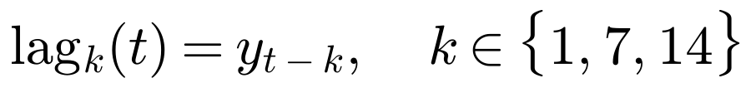 (3.1)
Chronological split and leakage. The daily records were sorted by date and divided without shuffling: the earliest 80% were used for training and the latest 20% for validation (Figure 3.2). Temporal order matters because information leaks if the model is trained on observations that lie after the observations it is tested on. Random shuffling would, for example, allow a model to learn from sales on the days immediately before and after a validation day, which is information that would not exist in real forecasting, and would make the measured error unrealistically optimistic. The chronological split gave 1,449 training and 363 validation days for Store Item Demand (validation ending on 31 December 2017) and 742 training and 186 validation days for Rossmann (validation ending on 31 July 2015).
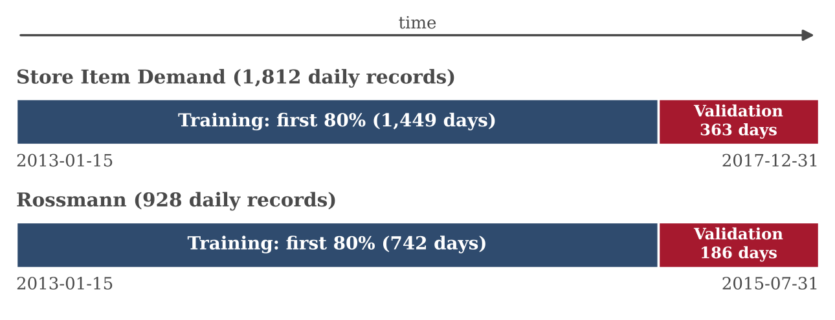
Figure 3.2: Chronological 80/20 training and validation split for each dataset

3.5 Step 4: Data Mining
Five regression algorithms were trained independently on each dataset's training period, using the same eight features: year, month, day, day of week, day of year, lag_1, lag_7 and lag_14. Each fitted model then predicted the validation period. The models were chosen to span increasing flexibility, so that the benefit of each additional modelling idea can be seen in the results. Table 3.4 gives the settings used.
Model | Family | Settings
Linear Regression | Linear baseline | scikit-learn defaults
Decision Tree | Single tree | max_depth = 10, random_state = 42
Random Forest | Bagged tree ensemble | n_estimators = 100, max_depth = 12, random_state = 42
Gradient Boosting | Sequential tree ensemble | scikit-learn defaults, random_state = 42
Extra Trees | Randomised tree ensemble | n_estimators = 100, max_depth = 12, random_state = 42
Table 3.4: Regression models and settings used in the notebook
Linear Regression models sales as a weighted sum of the features, as in Equation 3.2, with weights estimated by least squares. It is fast, transparent and a useful baseline, since any more complex model should beat it to justify its complexity. Its limitation is that it cannot represent non-linear effects, such as a weekly pattern that is not proportional to the day-of-week number.
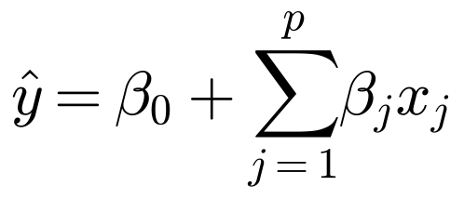 (3.2)

Decision Tree Regressor repeatedly splits the data on feature thresholds so that the squared error within the resulting groups is reduced, and predicts the mean sales of the training days in each final group. It captures non-linearity and interactions, such as the combination of a weekday and a high lag value, but a single deep tree is unstable and can overfit, so its depth was limited to 10.
Random Forest Regressor and Extra Trees Regressor both average the predictions of many trees, as in Equation 3.3, where B is the number of trees (100 here) and T_{b} is the b-th tree. Random Forest trains each tree on a bootstrap sample of the training days and searches for the best split among a random subset of features. Extra Trees draws split thresholds at random and keeps the best of these random candidates, which adds more randomisation and further reduces the variance of the averaged prediction. The depth of both ensembles was limited to 12.
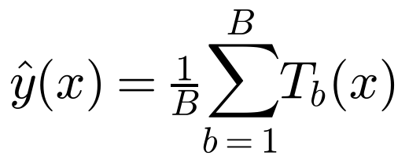 (3.3)
Gradient Boosting Regressor builds its model sequentially. Starting from a simple initial prediction, each new small tree h_{m} is fitted to the residual errors of the current model F_{m-1} and added with a learning rate ν, as shown in Equation 3.4. This lets the ensemble correct its own mistakes stage by stage and often gives high accuracy, but it is more sensitive to settings and noise than averaging methods, and the library defaults were used here.
 (3.4)

3.6 Step 5: Interpretation and Evaluation
Models were evaluated on the validation period using four measures, where y_{i} is the actual sales on day i, ŷ_{i} the predicted sales, ȳ the mean of the actual validation sales and n the number of validation days. Mean absolute error (Equation 3.5) is the average size of the prediction error in sales units. Root mean squared error (Equation 3.6) squares errors before averaging and therefore penalises large misses more heavily. Weighted absolute percentage error (Equation 3.7) divides the total absolute error by the total actual sales and expresses the result as a percentage, which makes it comparable across datasets of different scale. The coefficient of determination R-squared (Equation 3.8) is the share of the variation in validation sales that the model explains. Lower is better for MAE, RMSE and WAPE, and higher is better for R-squared.
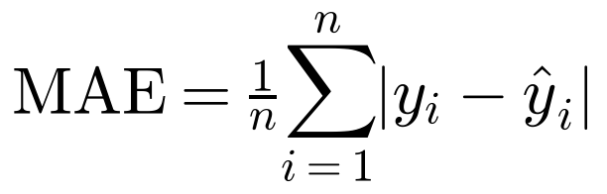 (3.5)
 (3.6)
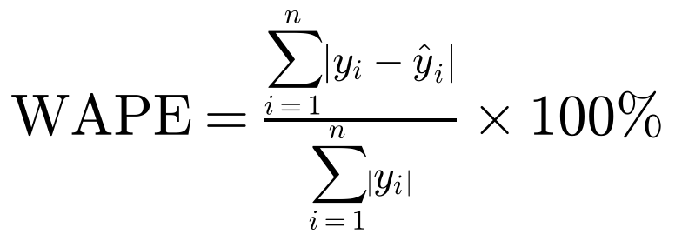 (3.7)
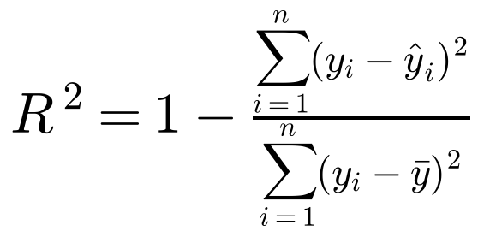 (3.8)
The best model for each dataset was selected as the one with the lowest validation MAE, and the other three measures were examined to see whether they agreed. Actual and predicted validation sales were plotted for the selected model to inspect how the errors are distributed over time. Because the lag features are computed from the full daily series before the split, the validation predictions use the actual observed sales of the previous days. The evaluation is therefore a one-step-ahead evaluation, discussed further in Section 4.8.

3.7 Step 6: Knowledge Presentation
The final step of the KDD process is Knowledge Presentation, in which the knowledge obtained from data analysis, predictive modelling, and evaluation is communicated in a clear, structured, and meaningful manner. The main objective of this step is to transform the experimental results into information that can be understood and used for practical decision-making in demand forecasting and supply chain optimization.
In this project, the findings obtained from the five regression models—Linear Regression, Decision Tree Regressor, Random Forest Regressor, Gradient Boosting Regressor, and Extra Trees Regressor—are presented through evaluation tables, graphical visualizations, and comparative analysis. The experiments are conducted separately on the Store Item Demand Forecasting Challenge dataset and the Rossmann Store Sales dataset. Presenting the results independently allows the performance of each model to be evaluated within the context of its respective dataset, without directly comparing error values that may differ because of variations in sales scale and data characteristics.
A combined evaluation table is used to summarize the performance of all five models on both datasets. The table includes Mean Absolute Error (MAE), Root Mean Squared Error (RMSE), Weighted Absolute Percentage Error (WAPE), and the coefficient of determination (\(R^2\)). These evaluation metrics provide different perspectives on model performance. MAE indicates the average magnitude of prediction errors, while RMSE gives greater weight to larger errors. WAPE expresses the total absolute prediction error relative to the total actual sales, making it useful for understanding the relative scale of forecasting errors. The \(R^2\) score indicates how well the model explains the variation in the target variable. Considering these metrics together provides a more balanced assessment than relying on a single evaluation measure.
In addition to the numerical evaluation, MAE comparison charts are used to visualize the differences in forecasting performance among the five models. These charts make it easier to identify which models produce lower prediction errors and how the models compare with one another on each dataset. Actual-versus-predicted graphs are also presented for the best-performing model on each dataset. These visualizations help examine how closely the predicted sales values follow the actual sales pattern and highlight periods where the model may overestimate or underestimate demand.
Based on the experimental results obtained in this project, the Extra Trees Regressor achieved the best overall performance among the five tested models on both datasets. For the Store Item Demand Forecasting Challenge dataset, it recorded an MAE of 540.58, an RMSE of 898.45, a WAPE of 1.8349%, and an \(R^2\) score of 0.980755. For the Rossmann Store Sales dataset, it recorded an MAE of 724,880.89, an RMSE of 1,332,483, a WAPE of 10.9455%, and an \(R^2\) score of 0.828052. These results indicate that Extra Trees was the strongest model among those evaluated under the experimental setup used in this project. However, the absolute error values of the two datasets should not be compared directly because their target sales values and scales are different.
The findings are discussed in relation to their potential applications in inventory management and supply chain planning. Demand forecasts can support decisions regarding stock replenishment, inventory allocation, purchasing schedules, and the planning of resources required to meet expected demand. More reliable forecasts may help reduce the risk of overstocking and stockouts, although the actual operational benefits would need to be evaluated in a real supply chain environment.

4. RESULTS AND DISCUSSION

4.1 Experimental Results Overview
Each of the five models was trained on the training period and evaluated on the validation period of each dataset, as described in Chapter 3. All figures reported here come from the notebook's validation output, which uses the chronological split of the labelled training data and not the official Kaggle test labels. Table 4.1 presents the complete results, sorted by MAE within each dataset.
Dataset | Model | MAE | RMSE | WAPE (%) | R-squared
Store Item Demand | Extra Trees | 540.58 | 898.45 | 1.8349 | 0.9808
 | Gradient Boosting | 599.70 | 929.09 | 2.0356 | 0.9794
 | Random Forest | 606.68 | 1,033.40 | 2.0593 | 0.9745
 | Decision Tree | 833.34 | 1,416.52 | 2.8286 | 0.9522
 | Linear Regression | 1,075.59 | 1,675.99 | 3.6509 | 0.9330
Rossmann | Extra Trees | 724,881 | 1,332,483 | 10.9455 | 0.8281
 | Random Forest | 751,936 | 1,434,824 | 11.3540 | 0.8006
 | Gradient Boosting | 816,629 | 1,463,634 | 12.3309 | 0.7925
 | Decision Tree | 911,149 | 1,779,977 | 13.7581 | 0.6932
 | Linear Regression | 1,402,377 | 2,041,933 | 21.1755 | 0.5962
Table 4.1: Validation results for all models on both datasets (sorted by MAE)

4.2 Dataset 1: Store Item Demand Forecasting
On Store Item Demand, Extra Trees gave the lowest MAE (540.58), RMSE (898.45) and WAPE (1.83%) and the highest R-squared (0.9808), followed by Gradient Boosting and Random Forest, with the Decision Tree and the Linear Regression baseline last. Figure 4.1 shows the MAE ranking. The three ensemble models are close to one another, whereas the single tree is about 54% worse than Extra Trees in MAE and the linear baseline is roughly twice as large, so non-linear structure in the calendar and lag features is clearly useful.
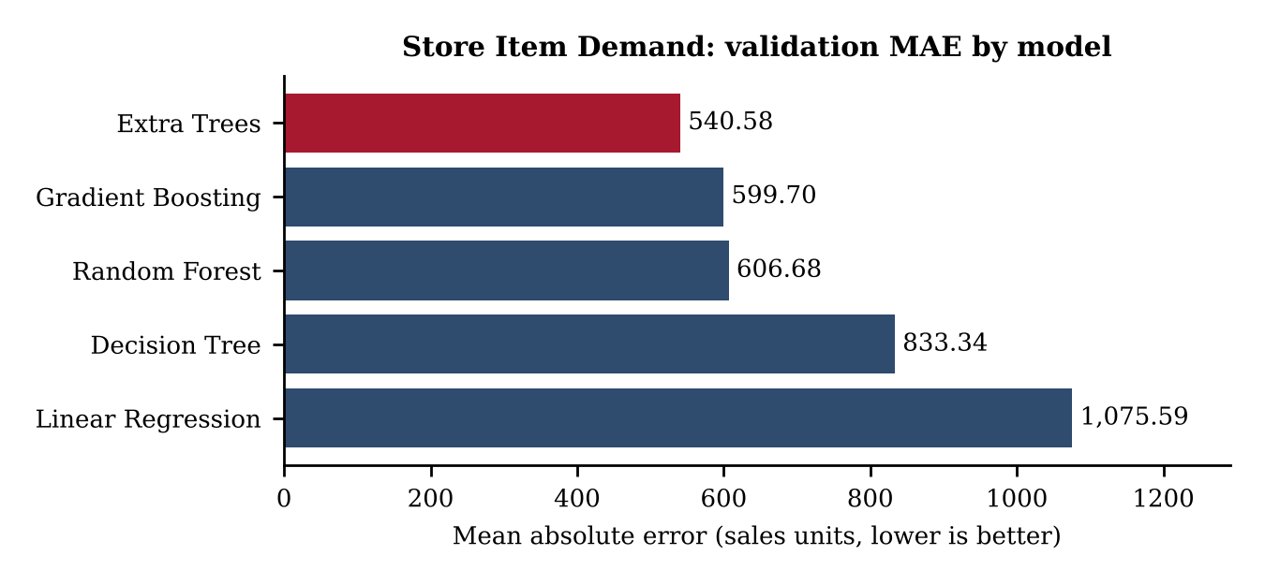
Figure 4.1: Validation MAE of the five models on Store Item Demand
Figure 4.2 compares actual and predicted daily sales over the validation period (2017). Daily sales show a strong repeating weekly pattern with a higher level in the summer months, peaking near 45,000 units in July and falling in late autumn. The Extra Trees prediction follows both the weekly oscillation and the seasonal rise and fall closely, and the visible gaps are mainly at some sharp weekly peaks, which the model tends to under-predict slightly. A WAPE of 1.83% means that total absolute error is under 2% of total actual sales over the period.
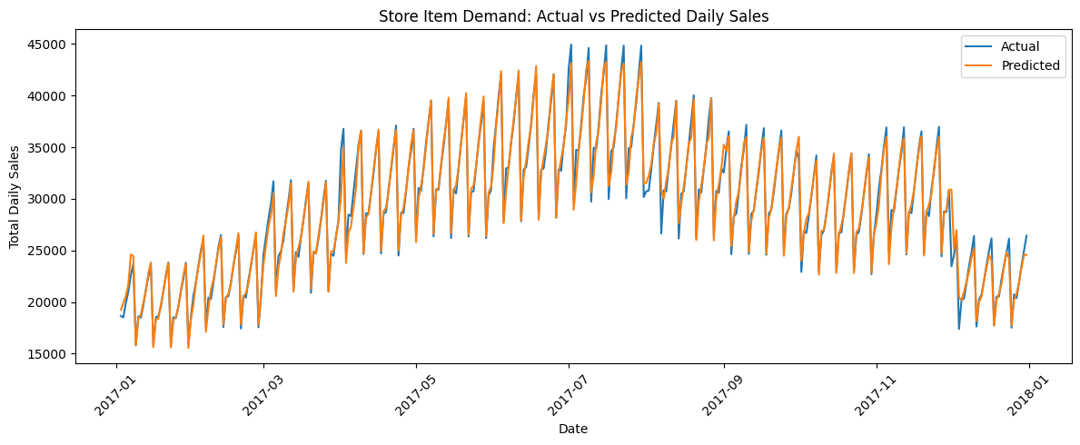
Figure 4.2: Actual and predicted daily sales for the best model (Extra Trees) on Store Item Demand, validation period (notebook output)

4.3 Dataset 2: Rossmann Store Sales
On Rossmann, the model ranking at the top and bottom was the same: Extra Trees was best on all four measures (MAE 724,881; RMSE 1,332,483; WAPE 10.95%; R-squared 0.8281) and Linear Regression was worst. The middle places differ, with Random Forest second and Gradient Boosting third, whereas on Store Item Demand Gradient Boosting was second. Figure 4.3 shows the MAE comparison. The gaps between models are larger in relative terms than for Dataset 1: the linear baseline has an MAE almost twice that of Extra Trees, and its R-squared is 0.5962.
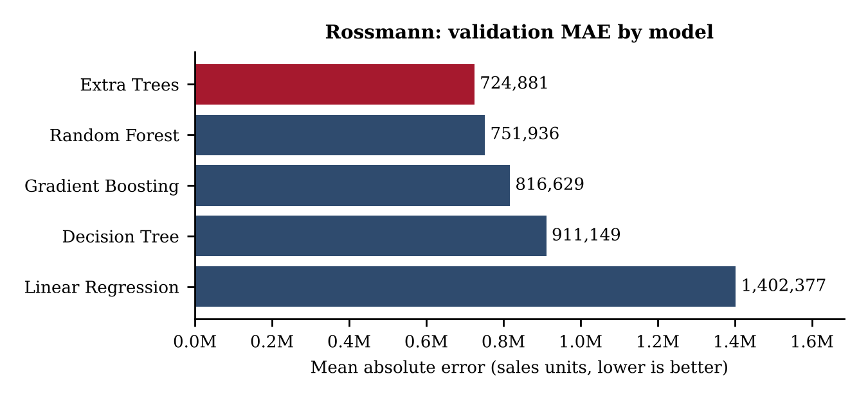
Figure 4.3: Validation MAE of the five models on Rossmann
Figure 4.4 shows the Extra Trees predictions against actual sales from late January to July 2015. Actual daily totals fall to near zero at regular intervals, consistent with closed days, and the model reproduces this recurring pattern and the general level of sales. It is less accurate at the heights of some peaks and at isolated days with unexpected zero or very low sales, which matches the higher WAPE of 10.95%. The Open and Promo fields were not used as features, so the model cannot anticipate events that those fields describe.
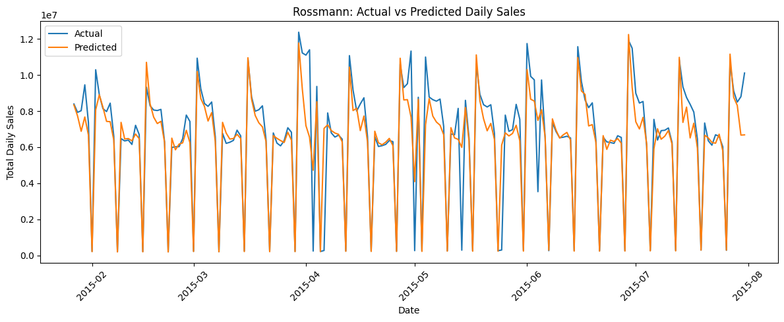
Figure 4.4: Actual and predicted daily sales for the best model (Extra Trees) on Rossmann, validation period (notebook output)

4.4 Interpretation of the Metrics
The four measures agree on the best and worst models in both experiments, but they are not four independent pieces of evidence. Within one dataset, WAPE equals the MAE divided by the mean actual validation sales (as a percentage), so it necessarily ranks the models in the same order as MAE. The independent confirmation comes from RMSE and R-squared, which also rank Extra Trees first and Linear Regression last on both datasets. Dividing the Extra Trees MAE by its WAPE gives an implied mean validation sales of about 29,460 units per day for Store Item Demand and about 6.62 million per day for Rossmann, which places the MAE of 540.58 units and 724,881 in context as roughly 1.8% and 10.9% of typical daily sales.
RMSE is larger than MAE for every model, as expected because squaring gives large misses more weight. For Extra Trees the RMSE-to-MAE ratio is about 1.66 on Store Item Demand and 1.84 on Rossmann, so Rossmann errors are somewhat more concentrated in large misses. Table 4.2 quantifies the margin of Extra Trees over the runner-up and over the Linear Regression baseline, using the values in Table 4.1.
Measure | Store Item vs Gradient Boosting | Rossmann vs Random Forest | Store Item vs Linear Regression | Rossmann vs Linear Regression
MAE reduction (%) | 9.9 | 3.6 | 49.7 | 48.3
RMSE reduction (%) | 3.3 | 7.1 | 46.4 | 34.7
WAPE reduction (points) | 0.20 | 0.41 | 1.82 | 10.23
R-squared gain | 0.0013 | 0.0274 | 0.0477 | 0.2318
Table 4.2: Margin of Extra Trees over the runner-up and the Linear Regression baseline
The margin over the runner-up is small on Store Item Demand, with an R-squared gain of only 0.0013, and larger on Rossmann, particularly in RMSE (7.1% lower), whereas the margin over the linear baseline is large on both datasets. Because a single validation window was used for each dataset, small margins such as 0.0013 in R-squared should not be over-interpreted, while the large and consistent advantage of the tree ensembles over the linear baseline is much more convincing.

4.5 Why Extra Trees Performed Best Among the Models Tested
The experiments establish that Extra Trees had the lowest error on both validation sets; they do not isolate the cause. Plausible explanations, consistent with the literature, are as follows. The target is a noisy daily total with strong weekly and seasonal structure, and averaging 100 trees with random split thresholds smooths out day-to-day noise and limits overfitting (Geurts et al., 2006). The calendar and lag features interact non-linearly, which a linear model cannot represent. Depth limits and the modest number of daily observations (1,449 and 742 training days) favour variance-reducing methods over a single tree. These explanations were not tested, for example by tuning the models or running ablations, and the result should not be read as showing that Extra Trees is generally superior.

4.6 Differences in Forecasting Difficulty Between the Datasets
Raw MAE values must not be compared between the datasets, because Store Item Demand daily totals are in the tens of thousands of units and Rossmann daily totals are in the millions. The scale-free measures show that Rossmann was harder to forecast: the best WAPE was 10.95% against 1.83%, and the best R-squared 0.8281 against 0.9808. Contributing factors visible in the data and plots are the recurring near-zero days and isolated irregular days in Rossmann, and the absence of the Open and Promo indicators from the features. Store Item Demand, by contrast, shows a smooth and regular weekly and seasonal profile. Other differences between the two sources, such as the length of the validation window (363 against 186 days), mean that the comparison is indicative and not exact.

4.7 Practical Implications for Demand and Inventory Planning
A WAPE under 2% on aggregate daily demand suggests that calendar and lag features alone give a dependable short-term demand signal in a regular setting such as Store Item Demand, which could support replenishment planning and safety-stock calculations at the aggregate level. The roughly 11% WAPE on Rossmann indicates a useful but less precise forecast, and a planner would want additional drivers such as promotions and opening days, or would need to hold more safety stock against the larger errors. No inventory cost or service-level outcome was measured in this project, so no financial benefit is claimed.

4.8 Limitations and Evaluation Caveats
Several caveats apply. First, the lag features use the actual sales of the preceding days, as would be available when forecasting one day ahead after each day closes. A forecast several days ahead would not have newly observed actual sales for the lags, and would need either recursive prediction using the model's own earlier forecasts or direct multi-step models; its errors would be larger, and this was not evaluated. Second, aggregating store and item records into daily totals hides local variation and means that the results describe total demand, not the demand at any particular shelf. Third, evaluation used one chronological validation window per dataset, so the results may be sensitive to the period chosen, and rolling-origin evaluation was not performed. Fourth, hyperparameters were set by hand, and no seasonal-naive or statistical time-series baseline was included. Fifth, the metrics come from the validation split of the labelled training data and not from the official Kaggle test labels. Finally, no statistical test of the differences between models was run.

5. CONCLUSION
This project applied the six-step KDD methodology to the problem of forecasting daily retail sales from historical data. Two Kaggle datasets, Store Item Demand Forecasting (913,000 records) and Rossmann Store Sales (1,017,209 records), were selected and treated as separate experiments. Data cleaning found no missing values or duplicate rows, converted date fields to datetime and retained zero-sales observations. The transformation step produced daily total sales series of 1,812 and 928 days, with calendar and lag features and a chronological 80/20 split that prevents future information from entering training.
Five regression models, Linear Regression, Decision Tree, Random Forest, Gradient Boosting and Extra Trees, were trained and compared using MAE, RMSE, WAPE and R-squared. Extra Trees was selected for both datasets because it achieved the lowest MAE, RMSE and WAPE and the highest R-squared among the five models tested. On Store Item Demand it reached an MAE of 540.58, a WAPE of 1.83% and an R-squared of 0.9808, and on Rossmann an MAE of 724,881, a WAPE of 10.95% and an R-squared of 0.8281. These results answer the research questions: the same model was best on both datasets, the ranking of the best and worst models was identical, and Rossmann proved considerably harder to forecast according to the scale-free measures.
The results indicate that machine learning regressors built on simple calendar and lag features can forecast aggregate daily retail demand well, and that tree-based ensembles clearly outperformed the linear baseline in these experiments. The findings do not show that Extra Trees is universally best, and no deployment or real-world business saving was measured.
The main limitations are the aggregation of store and item detail, the single chronological validation window, hand-set hyperparameters, the use of actual previous sales in the lag features (a one-step-ahead evaluation), the absence of seasonal or statistical baselines, and the use of a validation split instead of official test labels. Realistic future improvements include adding seasonal-naive and statistical time-series baselines, richer feature engineering such as promotion, holiday, opening-day and rolling-average features, hyperparameter tuning, rolling-origin validation, multi-step forecasting without observed lags, and store-level and item-level forecasting. Such work would show how far the results carry into the decisions that inventory and supply chain planners actually make.

6. REFERENCES
Bergmeir, C., & Benítez, J. M. (2012). On the use of cross-validation for time series predictor evaluation. Information Sciences, 191, 192-213.
Breiman, L. (2001). Random forests. Machine Learning, 45(1), 5-32.
Carbonneau, R., Laframboise, K., & Vahidov, R. (2008). Application of machine learning techniques for supply chain demand forecasting. European Journal of Operational Research, 184(3), 1140-1154.
Cerqueira, V., Torgo, L., & Mozetič, I. (2020). Evaluating time series forecasting models: An empirical study on performance estimation methods. Machine Learning, 109, 1997-2028.
Chopra, S., & Meindl, P. (2019). Supply chain management: Strategy, planning, and operation (7th ed.). Pearson.
Fayyad, U., Piatetsky-Shapiro, G., & Smyth, P. (1996). From data mining to knowledge discovery in databases. AI Magazine, 17(3), 37-54.
Fildes, R., Ma, S., & Kolassa, S. (2022). Retail forecasting: Research and practice. International Journal of Forecasting, 38(4), 1283-1318.
Friedman, J. H. (2001). Greedy function approximation: A gradient boosting machine. The Annals of Statistics, 29(5), 1189-1232.
Geurts, P., Ernst, D., & Wehenkel, L. (2006). Extremely randomized trees. Machine Learning, 63(1), 3-42.
Hastie, T., Tibshirani, R., & Friedman, J. (2009). The elements of statistical learning: Data mining, inference, and prediction (2nd ed.). Springer.
Hyndman, R. J., & Athanasopoulos, G. (2021). Forecasting: Principles and practice (3rd ed.). OTexts. https://otexts.com/fpp3/
Hyndman, R. J., & Koehler, A. B. (2006). Another look at measures of forecast accuracy. International Journal of Forecasting, 22(4), 679-688.
Kaggle. (n.d.-a). Store item demand forecasting challenge [Competition dataset]. https://www.kaggle.com/c/demand-forecasting-kernels-only
Kaggle. (n.d.-b). Rossmann store sales [Competition dataset]. https://www.kaggle.com/c/rossmann-store-sales
Kolassa, S., & Schütz, W. (2007). Advantages of the MAD/MEAN ratio over the MAPE. Foresight: The International Journal of Applied Forecasting, 6, 40-43.
Makridakis, S., Spiliotis, E., & Assimakopoulos, V. (2018). Statistical and machine learning forecasting methods: Concerns and ways forward. PLoS ONE, 13(3), e0194889. https://doi.org/10.1371/journal.pone.0194889
Pedregosa, F., Varoquaux, G., Gramfort, A., Michel, V., Thirion, B., Grisel, O., Blondel, M., Prettenhofer, P., Weiss, R., Dubourg, V., Vanderplas, J., Passos, A., Cournapeau, D., Brucher, M., Perrot, M., & Duchesnay, É. (2011). Scikit-learn: Machine learning in Python. Journal of Machine Learning Research, 12, 2825-2830.

