Symbiosis Institute of Technology, Nagpur
Bachelor of Technology
in
Computer Science and Engineering
“Demand Forecasting for Supply Chain Optimization Using Historical Sales Data”
Submitted by
VISMAYAA RAJAN
PRN: 23070521169
Semester: VII
Section: C
Course : Predictive Analytics
Guide
Prof. Deepak S Asudani
Academic Year: 2026

Symbiosis International (Deemed University),
Pune


DECLARATION
I, hereby declare that the project report submitted herein, titled “Demand Forecasting for Supply Chain Optimization Using Historical Sales Data”, has been carried out by me as part of the Predictive Analytics course towards the partial fulfillment of the requirements for the award of the Degree of Bachelor of Technology in Computer Science and Engineering. The work is original and has not been submitted earlier, in whole or in part, for the award of any degree or diploma at this or any other Institution / University.
I hereby assign all copyright rights in this work, including any revised or expanded derivative works, to Symbiosis Institute of Technology, Nagpur. Any content sourced from references, manuals, datasets, or other external materials has been duly acknowledged and appropriately cited.
Name of Student:
Vismayaa Rajan (PRN: 23070521169)
Place: Nagpur
Date: 9th October 2026

ACKNOWLEDGEMENT
I would like to express my sincere gratitude to Symbiosis Institute of Technology, Nagpur for providing me with the opportunity to undertake this project as part of the Predictive Analytics course. Working on demand forecasting for supply chain optimization has been a valuable learning experience, helping me develop practical skills in data preparation, feature engineering, machine learning and model evaluation.
I am deeply thankful to my course mentor, Prof. Deepak S Asudani, for the guidance, valuable suggestions and feedback provided throughout the project. This support played an important role in improving my understanding of predictive analytics and the KDD methodology and their practical application.
I am also grateful to the faculty members of the Department of Computer Science and Engineering for their support and encouragement throughout the course, and to the Kaggle community for making the Store Item Demand Forecasting and Rossmann Store Sales datasets publicly available.
Lastly, I would like to acknowledge my family and friends for their encouragement and support during the completion of this project.

ABSTRACT
This project investigates how machine learning regression models can forecast daily retail demand at the level where supply chain decisions are actually made, namely the individual store and item. Two public Kaggle datasets are treated as separate forecasting experiments: the Store Item Demand Forecasting training data (913,000 records, 4 columns, 10 stores and 50 items, giving 500 series) and the Rossmann Store Sales training data (1,017,209 records, 9 columns, 1,115 stores) enriched with the accompanying store information file. The work follows the six-step Knowledge Discovery in Databases (KDD) methodology: selection, data cleaning, transformation, data mining, interpretation and evaluation, and knowledge presentation.
Both sales files were checked for missing values and duplicate rows and none were found. Forecasting was carried out per series: lagged sales (up to 364 days for Store Item Demand and up to 28 days for Rossmann), rolling means, calendar variables, a training-only series mean and, for Rossmann, promotion, holiday, store type, assortment and competition fields were computed within each series, giving 16 and 22 model inputs respectively. The data were split chronologically, with the last 90 days (45,000 records) held out for Store Item Demand and the last 42 days (40,282 open store-days) held out for Rossmann. Linear Regression, Decision Tree, Random Forest, Gradient Boosting and LightGBM were compared using MAE, MSE, RMSE, WAPE and R-squared.
LightGBM achieved the lowest error on both datasets: MAE 5.874 units (WAPE 10.75%, R-squared 0.928) for Store Item Demand and MAE 551.714 (WAPE 7.91%, R-squared 0.931) for Rossmann. Feature importance analysis showed that features derived from past sales account for 97.5% and 85.9% of total importance respectively. The results show that gradient-boosted trees built on lag and rolling features forecast store-level and item-level demand accurately, while the limitations of the one-day-ahead evaluation design are discussed in the report.

CONTENTS
1 Introduction 1
1.1 Background of Retail Demand Forecasting 1
1.2 Problem Statement 1
1.3 Motivation and Significance 1
1.4 Aim and Objectives 1
1.5 Research Questions 2
1.6 Predictive Analytics and the KDD Methodology 2
1.7 Overview of the Datasets and Modelling Approach 2
1.8 Scope and Limitations 2
1.9 Organisation of the Report 2
2 Literature Review 3
2.1 Predictive Analytics and the KDD Process 3
2.2 Retail Sales and Demand Forecasting 3
2.3 Time-Series Forecasting and Machine Learning Regression 3
2.4 Tree-Based and Boosted Models 4
2.5 Model Evaluation for Regression Forecasting 4
2.6 Predictive Analytics in Inventory and Supply Chain Management 5
2.7 Motivation for the Present Study 5
3 Workflow and Predictive Modelling Process 6
3.1 Overall Workflow 6
3.2 Step 1: Selection 6
3.3 Step 2: Data Cleaning 7
3.4 Step 3: Transformation 8
3.5 Step 4: Data Mining 9
3.6 Step 5: Interpretation and Evaluation 9
3.7 Step 6: Knowledge Presentation 10
4 Results and Discussion 10
4.1 Experimental Results Overview 10
4.2 Dataset 1: Store Item Demand Forecasting 11
4.3 Dataset 2: Rossmann Store Sales 11
4.4 Feature Importance and Patterns in the Data 12
4.5 Interpretation of the Metrics and Model Differences 12
4.6 Practical Implications for Demand and Inventory Planning 13
4.7 Limitations and Evaluation Caveats 13
5 Conclusion 13
6 References 14

LIST OF FIGURES
Figure 3.1: Six-step KDD workflow applied to both datasets 6
Figure 3.2: Chronological hold-out split for each dataset (schematic, not to scale) 9
Figure 4.1: Validation MAE of the five models on both datasets (notebook output) 11
Figure 4.2: Actual and predicted daily sales for the best model (LightGBM) on Store Item Demand, 90-day validation window (notebook output) 11
Figure 4.3: Actual and predicted daily sales for the best model (LightGBM) on Rossmann, 42-day validation window (notebook output) 12
Figure 4.4: Top ten LightGBM features by gain importance for each dataset (notebook output; red bars are features derived from past sales) 12

LIST OF TABLES
Table 2.1: Summary of reviewed literature and its relevance to this project 5
Table 3.1: Mapping of project activities to the six KDD steps 6
Table 3.2: Structure of the two datasets 7
Table 3.3: Summary statistics of the sales field 7
Table 3.4: Feature sets used for the two datasets 8
Table 3.5: Regression models and settings used in the notebook 9
Table 4.1: Validation results on Store Item Demand (sorted by MAE; 45,000 records) 10
Table 4.2: Validation results on Rossmann (sorted by MAE; 40,282 open store-days) 11
Table 4.3: Margin of LightGBM over Gradient Boosting and over Linear Regression 13

1. INTRODUCTION

1.1 Background of Retail Demand Forecasting
Retail supply chains operate under a basic tension: stock must be available when customers want it, yet every unit held in a store or warehouse ties up capital, space and handling effort. Demand forecasting, the estimation of how much of each product will be sold in future periods, is the information that resolves this tension. Forecasts drive replenishment orders, safety-stock levels, labour schedules and transport planning, so their quality has a direct effect on service levels and on inventory cost (Chopra & Meindl, 2019).
Retail demand is difficult to forecast because it combines several overlapping patterns: weekly shopping cycles, annual seasonality, holidays and promotions, and a large number of related time series at store and product level (Fildes et al., 2022). Traditional statistical methods model these patterns explicitly, whereas machine learning regressors learn them from engineered input features such as calendar variables and previous sales values. The availability of public retail datasets on Kaggle makes it possible to compare such approaches on realistic sales histories.

1.2 Problem Statement
Inaccurate demand forecasts produce two opposite failures. Under-forecasting leads to stock-outs, lost sales and dissatisfied customers; over-forecasting leads to excess inventory, higher holding costs and, for perishable goods, waste. Replenishment decisions are taken for a particular item in a particular store, so a forecast that is accurate only for the chain-wide total is of limited use. The problem addressed in this project is to forecast daily sales for each store and item (and for each store in the second dataset) from historical sales records, and to determine which of several commonly used regression models produces the most accurate forecasts, so that the resulting forecasts could inform inventory and supply chain planning.

1.3 Motivation and Significance
The project is motivated by the practical value of accurate short-term forecasts at the level of individual series and by the need to compare modelling choices fairly rather than assume that one model is best. Using two datasets with different scales and structure tests whether conclusions hold beyond a single data source. The significance lies in showing, with a transparent and reproducible workflow, how an undergraduate predictive analytics project can move from raw sales records to a quantified model comparison, and to an explanation of which input features drive the forecasts, that links directly to inventory decisions.

1.4 Aim and Objectives
The aim of the project is to analyse historical retail sales, develop and compare machine learning regression models for daily demand forecasting at store and store-item level, and evaluate their performance to support inventory management and supply chain planning. The specific objectives are:
- To select two retail sales datasets and define the forecasting target and the forecasting level (series) for each.
- To inspect and clean the data and verify its quality before modelling.
- To engineer lag, rolling-mean and calendar features within each series, and to split the data chronologically into training and validation periods.
- To train five regression models on each dataset and compare them using MAE, MSE, RMSE, WAPE and R-squared.
- To identify the best-performing model on each dataset, examine which features drive its predictions, and discuss the practical implications and limitations of the findings.

1.5 Research Questions
The experiments are designed to answer three questions. RQ1: Which of the five regression models achieves the lowest validation error on each dataset, and is the ranking the same for both? RQ2: Which patterns and input features, such as recent sales, weekly and yearly seasonality and promotions, contribute most to the accuracy of the best model? RQ3: How large are the forecast errors relative to typical sales volume, and what does this imply for supporting inventory decisions?

1.6 Predictive Analytics and the KDD Methodology
Predictive analytics uses historical data and statistical or machine learning models to estimate unknown or future outcomes. In this project the outcome is the number of units (or the sales value) sold in a day for a given series, and the models are supervised regressors trained on past observations. The project is organised according to the Knowledge Discovery in Databases (KDD) process, which describes data mining as one step in a larger sequence that begins with selecting relevant data and ends with presenting the discovered knowledge (Fayyad et al., 1996). The six steps used here are selection, data cleaning, transformation, data mining, interpretation and evaluation, and knowledge presentation. Exploratory data analysis and feature engineering are carried out inside the relevant steps rather than as a separate methodology.

1.7 Overview of the Datasets and Modelling Approach
Two public retail datasets are used. Store Item Demand Forecasting contains 913,000 daily item-level sales records (10 stores and 50 items, so 500 store-item series over five years), and Rossmann Store Sales contains 1,017,209 daily store-level sales records for 1,115 stores, with customer, promotion and holiday fields and a separate store information file. Each dataset is modelled separately and at its natural forecasting level: per store-item for the first and per store for the second. Lagged sales, rolling means and calendar features are computed within each series, the data are split chronologically into training and validation periods, and five regression models of increasing flexibility, Linear Regression, Decision Tree, Random Forest, Gradient Boosting and LightGBM, are compared. The datasets are never merged into a single training set.

1.8 Scope and Limitations
The scope is limited to one-day-ahead forecasting of daily sales for each series, using 16 features for Store Item Demand and 22 for Rossmann. The two datasets are processed and modelled separately, and their raw errors are not compared as if they shared a scale. The main limitations are as follows. Each validation prediction uses the actual sales of the preceding days, so the evaluation is not a multi-week forecast. Evaluation uses a single chronological hold-out window per dataset, of different lengths (90 and 42 days), and not the official Kaggle test labels. Hyperparameters were set by hand and not tuned. These points are revisited in Chapters 4 and 5.

1.9 Organisation of the Report
The report contains six chapters. Chapter 1 introduces the problem, objectives and scope. Chapter 2 reviews the literature on predictive analytics, retail demand forecasting, machine learning forecasting, tree-based and boosted models, evaluation measures and supply chain applications. Chapter 3 describes the workflow and predictive modelling process through the six KDD steps, including the datasets, cleaning, feature engineering, the five models and the evaluation measures. Chapter 4 presents and discusses the results for both datasets, including the feature importance analysis, the practical implications and the limitations. Chapter 5 concludes the report and outlines future improvements, and Chapter 6 lists the references.

2. LITERATURE REVIEW

2.1 Predictive Analytics and the KDD Process
Predictive analytics applies statistical and machine learning models to historical data in order to estimate unknown or future outcomes, and it is usually carried out as a sequence of data preparation, modelling and evaluation activities rather than as a single modelling step. The Knowledge Discovery in Databases (KDD) process of Fayyad et al. (1996) defines knowledge discovery as the non-trivial process of identifying valid, novel, potentially useful and ultimately understandable patterns in data, and treats data mining as only one stage in a larger process that also includes selecting the data, preprocessing it, transforming it and interpreting and evaluating the discovered patterns. This project follows the six-step formulation required by the course, which separates data cleaning as its own step and adds an explicit knowledge presentation step to the sequence of selection, transformation, data mining and interpretation and evaluation. The framework is used as an organising structure for the experimental work reported in Chapter 3.

2.2 Retail Sales and Demand Forecasting
Retail forecasting has a long research tradition, and its practical challenges are well documented. Fildes et al. (2022) review research and practice in retail forecasting and describe features that distinguish it from many other settings: very large numbers of products and locations, strong calendar effects, promotions and price changes, and decisions that must be made at several levels of aggregation. They also note that forecast usefulness depends on the decision it supports, which is why accuracy has to be judged against inventory and replenishment needs and not only against statistical criteria. This is the reason the present project forecasts at store and item level instead of aggregating to chain-wide totals.
From the operations side, Chopra and Meindl (2019) explain that forecasts are the basis of supply chain planning, and that errors propagate into safety inventory, capacity and service-level decisions. Hyndman and Athanasopoulos (2021) provide the standard introduction to forecasting practice, covering trend and seasonal structure, the use of calendar predictors and lagged values, and the principle that forecasts must be evaluated on data not used to fit the model. These ideas motivate the calendar and lag features and the held-out validation period used in this project.

2.3 Time-Series Forecasting and Machine Learning Regression
Time-series forecasting methods are commonly divided into statistical models, which describe the series through trend, seasonality and autocorrelation, and machine learning models, which treat forecasting as a supervised regression problem on engineered features. Makridakis et al. (2018) compared popular machine learning methods with classical statistical methods on a large set of monthly series and found that the machine learning methods they tested were less accurate and more computationally demanding, which led them to call for more careful, evidence-based comparisons. Their result is a caution against assuming that machine learning always wins, and it is one reason this project reports a linear baseline alongside four non-linear models.
Applied work on supply chains has reported more favourable results for learning methods. Carbonneau et al. (2008) compared neural networks, recurrent neural networks and support vector machines with simpler benchmarks such as naive forecasts, moving averages, trend and linear regression, using simulated demand and real supply chain data, and found that recurrent networks and support vector machines gave the best accuracy in their experiments. Together, the two studies show that the relative merit of methods depends on the data and the evaluation design, so a project of this kind should compare several models under one protocol on each dataset.
How the validation data are chosen matters as much as which model is used. Bergmeir and Benítez (2012) examined cross-validation for time series predictors and discussed when it is and is not valid, and Cerqueira et al. (2020) compared performance estimation methods empirically and found that out-of-sample evaluation that respects temporal order is generally the safer choice when series are non-stationary. This supports the chronological hold-out split used here, in which the most recent observations of every series are held out and no future information can enter training.
Feature construction is the other half of the machine learning approach. Calendar variables and lagged values of the target convert a time series into a table of predictors and responses, so that any regression algorithm can be applied (Hyndman & Athanasopoulos, 2021). One property of tree-based regressors is relevant here: because each leaf predicts an average of training responses, a tree model cannot predict values outside the range seen in training, and so it may follow a long-run trend less well than a model that extrapolates explicitly (Hastie et al., 2009). Lag features that carry the recent level of each series, such as the 364-day lag used for Store Item Demand, give the models access to level shifts, but the limitation should be kept in mind when interpreting the results.

2.4 Tree-Based and Boosted Models
A decision tree partitions the feature space with a sequence of threshold tests and predicts a constant value in each region, which allows it to capture non-linear relationships and interactions without a prespecified functional form (Hastie et al., 2009). Single trees have high variance, so ensemble methods combine many trees. Random Forest, introduced by Breiman (2001), grows each tree on a bootstrap sample and considers a random subset of features at each split, then averages the predictions, which reduces variance relative to a single tree. Gradient boosting, formulated by Friedman (2001), builds the ensemble sequentially, fitting each new tree to the remaining errors of the current model so that the prediction is improved stage by stage.
LightGBM, proposed by Ke et al. (2017), is a gradient boosting decision tree implementation designed for efficiency on large datasets. It uses histogram-based split finding and two additional techniques, gradient-based one-side sampling and exclusive feature bundling, to reduce training time with little loss of accuracy. The scikit-learn library provides the other regressors used here, including a histogram-based gradient boosting regressor (Pedregosa et al., 2011). Both boosting implementations suit tables with several hundred thousand rows and a few dozen numeric features, which is the shape of the data in this project.
The choice among such models is a matter of the bias-variance trade-off. Flexible models can fit complex patterns but are sensitive to the particular training sample, while simple models are stable but may miss structure; ensembles are one way to keep flexibility while controlling variance, and no single method is best for every problem (Hastie et al., 2009). For this reason the project does not assume a winner in advance but evaluates all five models under identical conditions on each dataset.

2.5 Model Evaluation for Regression Forecasting
Hyndman and Koehler (2006) review measures of forecast accuracy and classify them into scale-dependent measures such as MAE and RMSE, percentage-error measures, and scaled-error measures. Scale-dependent measures are easy to interpret but cannot be compared across series measured in different units or magnitudes, which is directly relevant to this project because the two datasets differ greatly in sales magnitude. Percentage errors are problematic when actual values are zero or near zero, which occurs in daily item-level retail data.
Kolassa and Schütz (2007) discuss the ratio of the mean absolute deviation to the mean of the actuals as an alternative to the mean absolute percentage error. Their ratio, the sum of absolute errors divided by the sum of actual values, is what this report calls WAPE; it is scale-free, remains defined when individual days have low sales, and weights errors by sales volume. R-squared is added as a complementary measure of how much of the variation in the validation target the model explains, and MSE is reported as the quantity whose square root is RMSE. Using all five measures gives a more complete view than any one alone.
A further point concerns benchmarks. Hyndman and Athanasopoulos (2021) recommend comparing any proposed method with simple reference forecasts, such as a seasonal naive forecast that repeats the value from the same period of the previous cycle, because a high R-squared can be obtained on strongly seasonal data by almost any reasonable model. The linear baseline in this project serves as a reference for the non-linear models, but a seasonal naive benchmark was not included, and this is listed as a limitation and a direction for future work.

2.6 Predictive Analytics in Inventory and Supply Chain Management
The reviewed literature links forecasting accuracy to inventory outcomes through safety stock, replenishment frequency and service level (Chopra & Meindl, 2019), and shows that learning-based forecasting has been applied to supply chain demand with encouraging results (Carbonneau et al., 2008). In the usual safety-inventory calculation, the safety stock required to reach a target service level grows with the standard deviation of the forecast error over the replenishment lead time (Chopra & Meindl, 2019). A forecasting method that reduces error therefore allows a lower safety stock for the same service level, which is the mechanism through which the accuracy gains measured in this project could translate into lower inventory cost. The present project does not measure inventory costs; it evaluates forecast accuracy, which is the input to those decisions.

2.7 Motivation for the Present Study
Table 2.1 summarises the reviewed work and its relevance to this project. Based on the literature, the project adopts four design decisions. First, several models of increasing flexibility are compared, starting with a linear baseline, because the superiority of learning methods is not guaranteed (Makridakis et al., 2018). Second, tree ensembles and boosted trees are included because they handle non-linear calendar and lag effects and are available as documented implementations (Breiman, 2001; Friedman, 2001; Ke et al., 2017; Pedregosa et al., 2011). Third, evaluation is chronological, so that validation data lie in the future of the training data (Cerqueira et al., 2020). Fourth, both scale-dependent and scale-free metrics are reported (Hyndman & Koehler, 2006; Kolassa & Schütz, 2007). The results in Chapter 4 are the author's own experimental observations and are kept distinct from the established findings reviewed above.
Source | Focus | Relevance to this project
Fildes et al. (2022) | Retail forecasting research and practice | Frames the challenges of retail demand and decision-oriented evaluation
Makridakis et al. (2018) | Statistical versus machine learning forecasting | Motivates a linear baseline and cautious conclusions
Carbonneau et al. (2008) | Machine learning for supply chain demand | Supports learning-based regressors for demand forecasting
Bergmeir & Benítez (2012); Cerqueira et al. (2020) | Validation of time series predictors | Support the chronological hold-out split
Breiman (2001); Friedman (2001); Ke et al. (2017) | Random Forest, gradient boosting, LightGBM | Define the tree-based models compared
Hyndman & Koehler (2006); Kolassa & Schütz (2007) | Forecast accuracy measures | Justify MAE, RMSE, WAPE and scale-free comparison
Table 2.1: Summary of reviewed literature and its relevance to this project

3. WORKFLOW AND PREDICTIVE MODELLING PROCESS

3.1 Overall Workflow
The project follows the six-step KDD process shown in Figure 3.1. The two datasets travel through the same sequence independently: each is selected, cleaned, transformed, modelled and evaluated on its own, and only the final results are placed side by side for discussion. All work was carried out in a Python notebook, using pandas and NumPy for data handling, scikit-learn and LightGBM for modelling, scikit-learn metrics for evaluation and Matplotlib for the plots. Table 3.1 maps the project activities to the KDD steps.
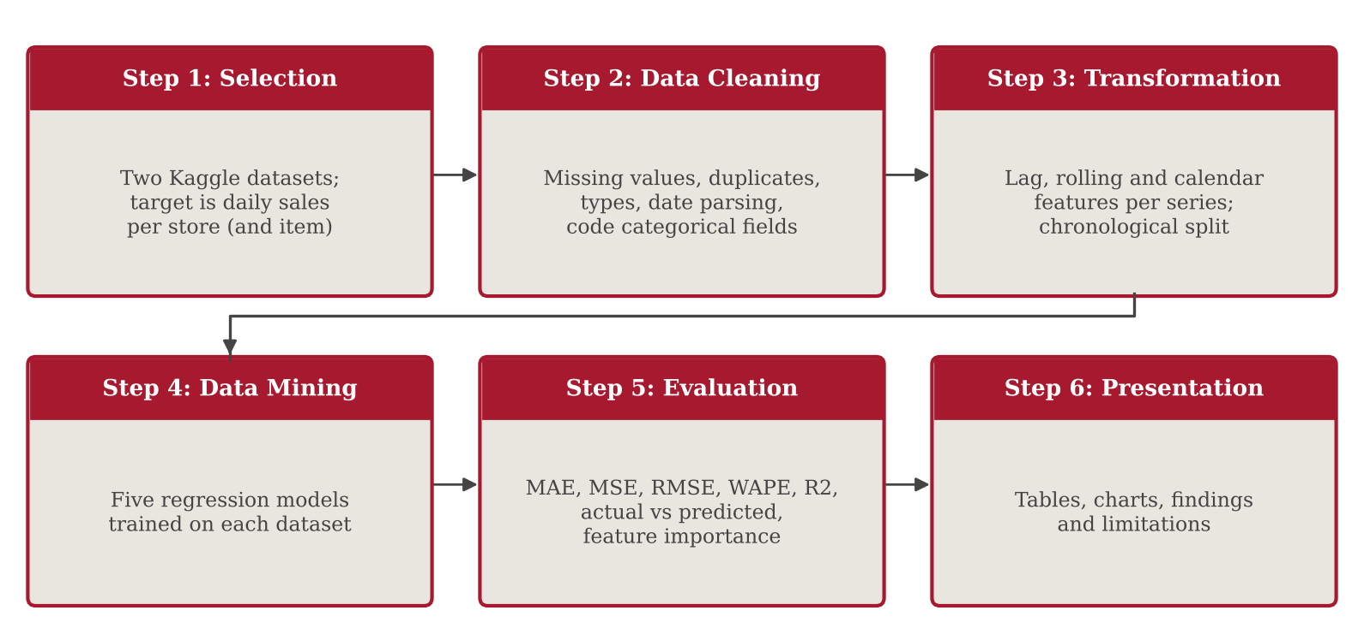
Figure 3.1: Six-step KDD workflow applied to both datasets
Step | KDD stage | Activities carried out in this project
1 | Selection | Chose the Store Item Demand and Rossmann training files (with the Rossmann store file); defined sales as the target and the store-item and store as the forecasting series.
2 | Data cleaning | Checked missing values, duplicates and types; parsed dates; coded StateHoliday, StoreType and Assortment; filled CompetitionDistance with the median; set aside closed-store days.
3 | Transformation | Built lag, rolling-mean and calendar features within each series and a training-only series mean; dropped rows without lag history; split chronologically (last 90 and 42 days held out).
4 | Data mining | Trained Linear Regression, Decision Tree, Random Forest, Gradient Boosting and LightGBM on each training set.
5 | Interpretation and evaluation | Computed MAE, MSE, RMSE, WAPE and R-squared on validation data; plotted actual against predicted sales; extracted feature importance; selected the best model.
6 | Knowledge presentation | Presented comparison tables, charts and findings, and drew conclusions about forecasting and inventory planning.
Table 3.1: Mapping of project activities to the six KDD steps

3.2 Step 1: Selection
Two datasets were selected so that the conclusions are not tied to a single data source. Store Item Demand Forecasting is the training data of a Kaggle forecasting challenge in which each record gives the units sold of one item in one store on one date (Kaggle, n.d.-a). Rossmann Store Sales is the training data of a Kaggle competition in which each record gives the sales of one store on one date together with customer counts and promotion, holiday and opening indicators, and it is accompanied by a store information file (store.csv, 1,115 rows and 10 columns) describing store type, assortment, competition and continuing promotions (Kaggle, n.d.-b). The two sales files cover 1 January 2013 to 31 December 2017 and 1 January 2013 to 31 July 2015 respectively. Table 3.2 summarises their structure as loaded in the notebook.
Property | Store Item Demand | Rossmann Store Sales
Source | Kaggle Store Item Demand Forecasting Challenge | Kaggle Rossmann Store Sales
Rows and columns | 913,000 rows, 4 columns | 1,017,209 rows, 9 columns (store.csv: 1,115 rows, 10 columns)
Columns | date, store, item, sales | Store, DayOfWeek, Date, Sales, Customers, Open, Promo, StateHoliday, SchoolHoliday
Period | 1 Jan 2013 to 31 Dec 2017 | 1 Jan 2013 to 31 Jul 2015
Target variable | sales (units sold) | Sales
Forecasting series | 500 store-item series (10 stores x 50 items) | 1,115 store series
Table 3.2: Structure of the two datasets
The forecasting task is to predict the sales of one series on one day from information available before that day. For Store Item Demand a series is one store-item pair (500 series); for Rossmann a series is one store (1,115 series). Modelling at this level is deliberate, because replenishment is decided for individual items and stores.

3.3 Step 2: Data Cleaning
Data cleaning targeted problems that could distort the models. Both sales files were checked for missing values, duplicate rows, data types and the distribution of sales values. No missing values and no duplicate rows were found in either file. The date columns were converted to datetime format. In the Rossmann store file, CompetitionDistance had 3 missing values, CompetitionOpenSinceMonth and CompetitionOpenSinceYear had 354 each, and Promo2SinceWeek, Promo2SinceYear and PromoInterval had 544 each. Of these, only CompetitionDistance is used as a model input, and its missing values were filled with the median of the column; the other incomplete fields were not used.
The Rossmann StateHoliday field contained mixed types (0 and '0'), so it was mapped to numeric codes (0, a, b, c to 0, 1, 2, 3), and StoreType (a to d) and Assortment (a to c) were coded as integers after the store file was merged with the sales records, giving 18 columns. The Rossmann file contains 172,817 rows for closed stores. A closed store sells exactly zero and its closure is known in advance, so it is not a forecasting problem: these rows were kept only to preserve the lag history and were excluded from training and scoring. Zero-sales observations in the Store Item Demand data were retained, because a zero can be a genuine demand outcome.
Summary statistics, shown in Table 3.3, served as the exploratory data analysis of the sales fields. Rossmann sales per record are larger than Store Item Demand sales by roughly two orders of magnitude, which is why the two datasets are modelled separately and compared through scale-free measures.
Statistic | Store Item Demand (sales) | Rossmann (Sales)
Count | 913,000 | 1,017,209
Mean | 52.25 | 5,773.82
Standard deviation | 28.80 | 3,849.93
Minimum | 0 | 0
25th percentile | 30 | 3,727
Median | 47 | 5,744
75th percentile | 70 | 7,856
Maximum | 231 | 41,551
Table 3.3: Summary statistics of the sales field

3.4 Step 3: Transformation
Lag features. Within each series, the sales of earlier days were added as predictors (the sales of the same series k days earlier). Store Item Demand uses lags of 1, 7, 14, 28 and 364 days: the short lags carry recent momentum, the 7-day lag the weekly pattern, and the 364-day lag the sales on the same weekday one year earlier. Rossmann uses lags of 1, 7, 14, 21 and 28 days. Lags are computed after sorting each series by date and shifting within the series, so a lag never crosses from one store or item into another.
Rolling features. Rolling means of the previous 7 and 28 days were added for both datasets, and a rolling standard deviation of the previous 7 days for Rossmann. The window ends on the day before the prediction date, so the current day is never included. For Rossmann the rolling statistics use open days only, so that closed days do not pull the averages towards zero.
Calendar features. Day of week, month, day of month, year and week of year were derived from the date for both datasets, and day of year for Store Item Demand. Day of week captures the weekly shopping cycle, while month and week of year allow the models to represent annual seasonality. Series mean. The average sales of each series over the training period only (the mean over the training days of series s) was added as a measure of the series' typical volume and was joined to the validation data, so that no validation information enters it.
Other inputs. The Store Item Demand model also receives the store and item identifiers. The Rossmann model receives Promo, Promo2, SchoolHoliday, StateHoliday, StoreType, Assortment and CompetitionDistance, together with the store identifier. In total, 16 features were used for Store Item Demand and 22 for Rossmann (Table 3.4). Rows without a complete lag history were removed: the first 364 days of every Store Item Demand series (182,000 rows, leaving 731,000) and the first 28 days of every Rossmann store, after which only open days were kept.
Feature group | Store Item Demand (16) | Rossmann (22)
Series identifiers | store, item | Store
Lag features | lag_1, 7, 14, 28, 364 | lag_1, 7, 14, 21, 28
Rolling features | roll_mean_7, roll_mean_28 | roll_mean_7, roll_mean_28, roll_std_7
Calendar | dow, month, day, year, woy, doy | dow, month, day, year, woy
Series level | series_mean (training data only) | series_mean (training data only)
Promotion and holiday | none available | Promo, Promo2, SchoolHoliday, StateHoliday
Store attributes | none available | StoreType, Assortment, CompetitionDistance
Table 3.4: Feature sets used for the two datasets
Chronological split and leakage. Each dataset was divided by date without shuffling (Figure 3.2). The last 90 days of Store Item Demand (3 October to 31 December 2017) were held out for validation, giving 686,000 training and 45,000 validation records. The last 42 days of Rossmann (20 June to 31 July 2015) were held out, giving 778,563 training and 40,282 validation records. Temporal order matters because information leaks if a model is trained on observations that lie after the observations it is tested on, which would make the measured error unrealistically optimistic.
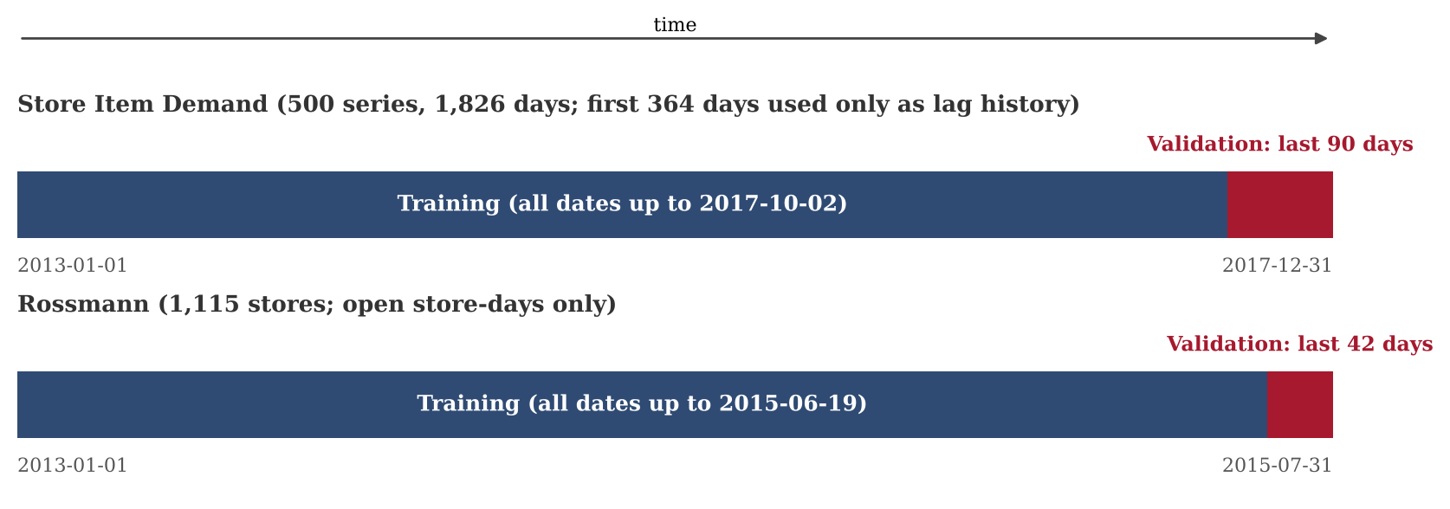
Figure 3.2: Chronological hold-out split for each dataset (schematic, not to scale)

3.5 Step 4: Data Mining
Five regression algorithms were trained independently on each dataset's training period using the feature sets in Table 3.4. Missing feature values were filled with zero, and predictions were clipped at zero because sales cannot be negative. The models span increasing flexibility, so that the benefit of each additional modelling idea can be seen in the results. Table 3.5 gives the settings used; all models use random_state = 42 where applicable.
Model | Family | Settings
Linear Regression | Linear baseline | scikit-learn defaults
Decision Tree | Single tree | max_depth = 12, min_samples_leaf = 10
Random Forest | Bagged tree ensemble | n_estimators = 60, max_depth = 14, min_samples_leaf = 5, max_features = 0.5
Gradient Boosting | Histogram boosting (scikit-learn) | max_iter = 400, learning_rate = 0.08
LightGBM | Gradient boosted trees | n_estimators = 800, learning_rate = 0.05, num_leaves = 63, subsample = 0.8 (every iteration), colsample_bytree = 0.8
Table 3.5: Regression models and settings used in the notebook
Linear Regression models sales as a weighted sum of the features with weights estimated by least squares. It is fast and transparent and is the baseline that any more complex model must beat. Decision Tree Regressor repeatedly splits the data on feature thresholds so that the squared error within the resulting groups is reduced, and predicts the mean of the training sales in each final group; its depth and leaf size were limited to reduce overfitting. Random Forest Regressor averages the predictions of B trees grown on bootstrap samples with random feature subsets, which lowers variance relative to a single tree.
Gradient Boosting here refers to scikit-learn's histogram-based implementation, HistGradientBoostingRegressor. LightGBM is the gradient boosting library of Ke et al. (2017). Both build the model sequentially: starting from an initial prediction, each new tree h is fitted to the errors of the current model and added with a learning rate ν. LightGBM was configured with 800 trees, a learning rate of 0.05, 63 leaves per tree, and row and column subsampling of 0.8, which lets it fit detailed interactions between lag, rolling and calendar features while the subsampling limits overfitting.

3.6 Step 5: Interpretation and Evaluation
Models were evaluated on the validation records using five measures, where y is the actual sales of a validation record, ŷ its prediction, ȳ the mean of the actual validation sales and n the number of validation records. Mean absolute error (Equation 3.1) is the average size of the prediction error in sales units. Mean squared error (Equation 3.2) squares the errors before averaging, and root mean squared error (Equation 3.3) returns this to sales units while penalising large misses more heavily. Weighted absolute percentage error (Equation 3.4) divides the total absolute error by the total actual sales, which makes it comparable across datasets of different scale. The coefficient of determination R-squared (Equation 3.5) is the share of the variation in validation sales that the model explains. Lower is better for MAE, MSE, RMSE and WAPE, and higher is better for R-squared.
 |  | (3.1)

 | 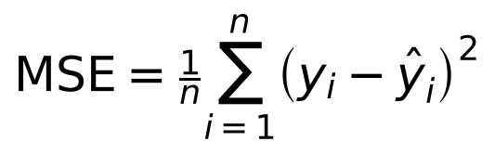 | (3.2)

 |  | (3.3)

 | 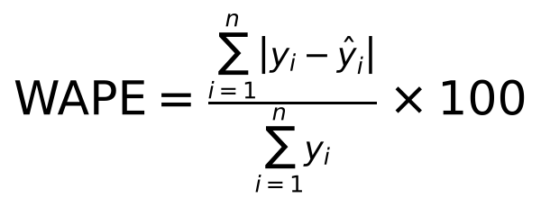 | (3.4)

 | 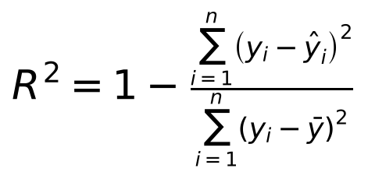 | (3.5)

The best model for each dataset was selected as the one with the lowest validation MAE, and the other measures were examined to see whether they agreed. For the best model, daily actual and predicted sales were plotted and gain-based feature importance was extracted. Because the lag features use the actual sales of previous days, the validation predictions are one-day-ahead forecasts, as discussed in Section 4.7.

3.7 Step 6: Knowledge Presentation
The final step of the KDD process communicates the knowledge obtained from the data, the models and the evaluation in a clear and usable form. In this project the findings are presented through evaluation tables, MAE charts, actual-versus-predicted plots and a feature importance chart, all reported in Chapter 4. The datasets are presented separately and absolute errors are not compared across them; WAPE and MAE as a percentage of mean sales are used where a cross-dataset view is needed. The findings are related to inventory management in Section 4.6, without claiming savings that were not measured.

4. RESULTS AND DISCUSSION

4.1 Experimental Results Overview
Each of the five models was trained on the training period and evaluated on the validation period of each dataset, as described in Chapter 3. All figures reported here come from the notebook's validation output, which uses the chronological hold-out of the labelled training data and not the official Kaggle test labels. Tables 4.1 and 4.2 present the complete results for the two datasets, sorted by MAE. Mean validation sales are 54.63 units per store-item day for Store Item Demand and 6,978.64 per open store-day for Rossmann, so the best model's MAE is 10.75% and 7.91% of mean sales, which equals its WAPE.
Model | MAE | MSE | RMSE | WAPE (%) | R-squared
LightGBM | 5.874 | 57.914 | 7.610 | 10.753 | 0.928
Gradient Boosting | 5.916 | 58.802 | 7.668 | 10.830 | 0.927
Random Forest | 6.121 | 63.537 | 7.971 | 11.204 | 0.921
Decision Tree | 6.532 | 73.061 | 8.548 | 11.956 | 0.910
Linear Regression | 6.766 | 77.767 | 8.819 | 12.385 | 0.904
Table 4.1: Validation results on Store Item Demand (sorted by MAE; 45,000 records)

4.2 Dataset 1: Store Item Demand Forecasting
On Store Item Demand, LightGBM gave the lowest MAE (5.874), MSE (57.914), RMSE (7.610) and WAPE (10.75%) and the highest R-squared (0.928). Gradient Boosting was a close second (MAE 5.916), followed by Random Forest, Decision Tree and the Linear Regression baseline. The gap between the best and the weakest model is modest on this dataset: LightGBM reduces MAE by 13.2% relative to Linear Regression and by 0.7% relative to Gradient Boosting. Figure 4.1 shows the MAE ranking for both datasets.
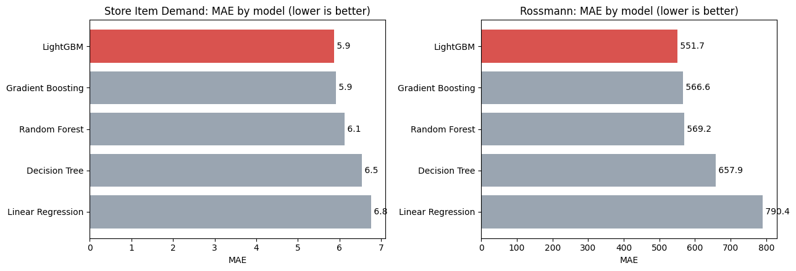
Figure 4.1: Validation MAE of the five models on both datasets (notebook output)
Figure 4.2 compares actual and predicted sales, summed over all store-items for display, over the 90-day validation window. The series shows a strong weekly pattern and a seasonal decline into December; the predictions follow both closely, with visible gaps mainly around the start of December, where actual sales dip below the prediction.
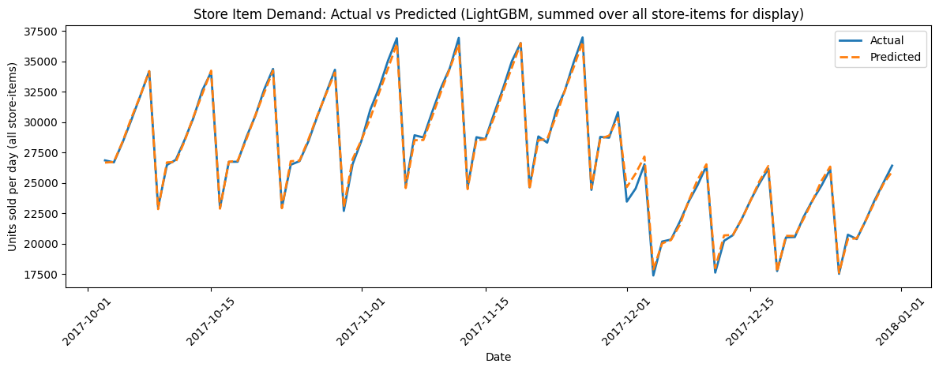
Figure 4.2: Actual and predicted daily sales for the best model (LightGBM) on Store Item Demand, 90-day validation window (notebook output)

4.3 Dataset 2: Rossmann Store Sales
Model | MAE | MSE | RMSE | WAPE (%) | R-squared
LightGBM | 551.714 | 645,598.475 | 803.491 | 7.906 | 0.931
Gradient Boosting | 566.616 | 676,144.462 | 822.280 | 8.119 | 0.928
Random Forest | 569.238 | 694,168.451 | 833.168 | 8.157 | 0.926
Decision Tree | 657.901 | 912,438.546 | 955.216 | 9.427 | 0.902
Linear Regression | 790.370 | 1,231,990.368 | 1,109.951 | 11.326 | 0.868
Table 4.2: Validation results on Rossmann (sorted by MAE; 40,282 open store-days)
On Rossmann, LightGBM was again best on every measure (MAE 551.714, MSE 645,598.475, RMSE 803.491, WAPE 7.91%, R-squared 0.931), followed by Gradient Boosting, Random Forest, Decision Tree and Linear Regression, so the ranking is the same as for Dataset 1 (RQ1). LightGBM reduces MAE by 30.2% relative to the Linear Regression baseline and by 2.6% relative to Gradient Boosting, so the gaps are larger than in Dataset 1. Figure 4.3 shows the actual and predicted daily sales summed over open stores during the 42-day validation window. The weekly rhythm, including the near-zero weekly dips on days when most stores are closed, is reproduced, and the main deviations occur at some of the peaks.
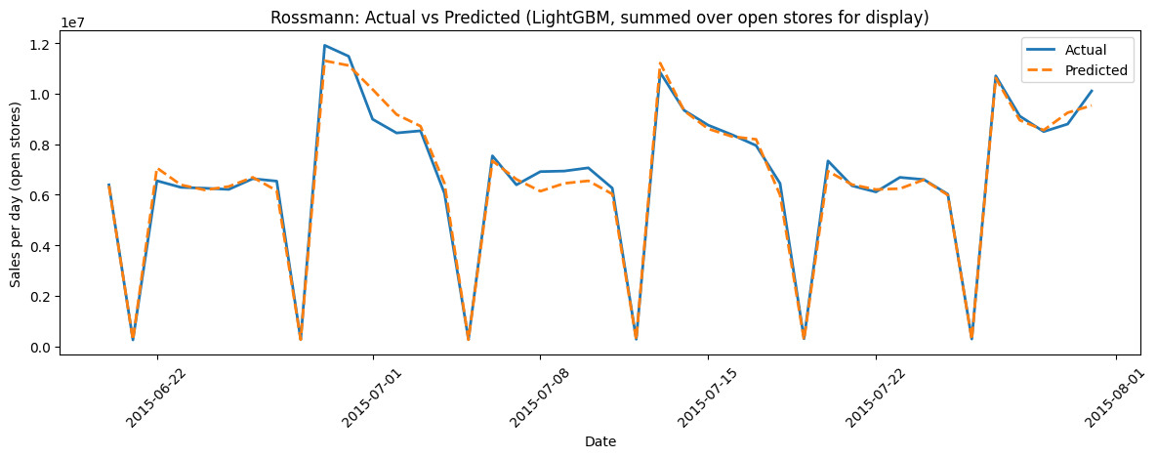
Figure 4.3: Actual and predicted daily sales for the best model (LightGBM) on Rossmann, 42-day validation window (notebook output)

4.4 Feature Importance and Patterns in the Data
LightGBM's gain-based feature importance, shown in Figure 4.4, answers RQ2. For Store Item Demand, features derived from past sales (lags, rolling means and the series mean) account for 97.5% of total importance. The most important feature is lag_364 (49.9%), the sales on the same weekday one year earlier, which captures the annual seasonality of each item in each store, followed by the 7-day rolling mean (24.8%), the 7-day lag (13.0%), the 28-day rolling mean (5.7%) and the 14-day lag (2.1%). Calendar variables and identifiers contribute very little once these lags are available.
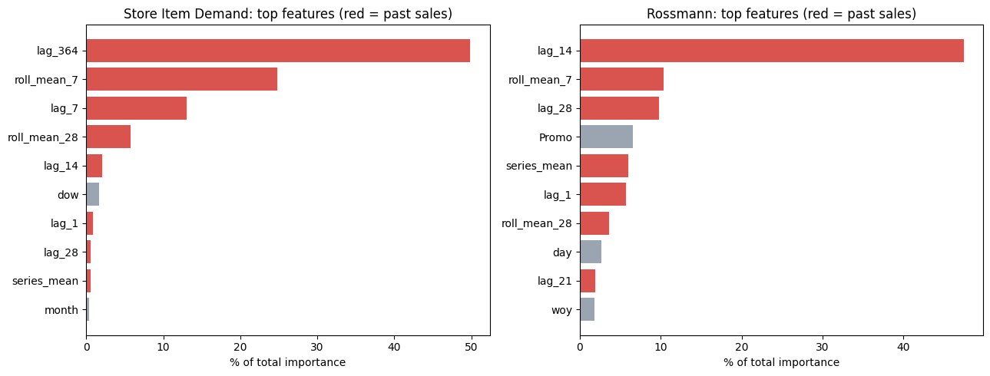
Figure 4.4: Top ten LightGBM features by gain importance for each dataset (notebook output; red bars are features derived from past sales)
For Rossmann, past-sales features account for 85.9% of total importance. The 14-day lag is the most important feature (47.5%), indicating that a store's sales two weeks earlier are the best single guide to its current level, followed by the 7-day rolling mean (10.4%), the 28-day lag (9.8%) and the series mean (6.0%). Promo, with 6.6%, is the most important feature that is not derived from sales, which shows that promotions drive a measurable part of store demand. Importance by gain describes how the fitted model uses its inputs and is not a causal statement about demand.

4.5 Interpretation of the Metrics and Model Differences
The five measures agree on the best and worst models in both experiments, but they are not independent evidence. Within one dataset, WAPE equals the MAE divided by the mean actual validation sales, so it necessarily ranks the models in the same order as MAE; the same holds for MSE and RMSE. The independent confirmation comes from the squared-error measures and R-squared, all of which also rank LightGBM first. For LightGBM the RMSE-to-MAE ratio is 1.30 on Store Item Demand and 1.46 on Rossmann, so large misses weigh somewhat more on Rossmann. Table 4.3 quantifies the margin of LightGBM over the runner-up and the baseline.
Measure | D1 vs Grad. Boosting | D2 vs Grad. Boosting | D1 vs Linear Reg. | D2 vs Linear Reg.
MAE reduction (%) | 0.7 | 2.6 | 13.2 | 30.2
RMSE reduction (%) | 0.8 | 2.3 | 13.7 | 27.6
WAPE reduction (points) | 0.08 | 0.21 | 1.63 | 3.42
R-squared gain | 0.001 | 0.003 | 0.024 | 0.063
Table 4.3: Margin of LightGBM over Gradient Boosting and over Linear Regression
The experiments establish that LightGBM had the lowest error on both validation sets; they do not isolate the cause. A plausible explanation, consistent with the literature, is that sales depend on non-linear interactions between recent sales, seasonal lags and day of week, which a linear model cannot represent, and that boosting fits these interactions more finely than a single tree or a bagged forest (Friedman, 2001; Ke et al., 2017). The margin over the other boosting implementation is small (0.7% and 2.6% in MAE), so the ranking of these two should not be over-interpreted on a single validation window, whereas the advantage over the linear baseline is large on both datasets. This explanation was not tested through tuning or ablation, and the result does not show that LightGBM is generally superior.

4.6 Practical Implications for Demand and Inventory Planning
The scale-free measures answer RQ3. On a typical store-item day of about 55 units, the best model is wrong by about 5.9 units on average, and on a typical open Rossmann store-day of about 6,979 the average error is about 552, which is 7.9% of sales. Rossmann, forecast at store level with promotion and holiday information, is the easier of the two on the percentage scale (WAPE 7.91% against 10.75%), while R-squared is similar (0.931 against 0.928). Item-level forecasts are harder in relative terms because individual item sales are small.
For replenishment planning, forecasts of this accuracy can support reorder quantities, safety stock levels and store allocation, because the error in each series is known and can be fed into the safety-stock calculation (Chopra & Meindl, 2019). The importance results suggest that a year of daily history per item and reliable promotion calendars are worth maintaining. The report does not quantify inventory cost savings, which would need to be evaluated in a real supply chain setting.

4.7 Limitations and Evaluation Caveats
Several caveats apply. First, the lag and rolling features use the actual sales of the preceding days, so every validation prediction is a one-day-ahead forecast; a planner forecasting a week or more ahead would not have those inputs, and accuracy would be lower. Second, each dataset has a single chronological hold-out (90 and 42 days) of different length and season, so the results may not generalise to other periods. Third, hyperparameters were fixed by hand and not tuned, so the ranking of close competitors could change. Fourth, the Rossmann evaluation covers open store-days only, and the raw errors of the two datasets are on different scales. Finally, no seasonal naive or statistical benchmark was included.

5. CONCLUSION
This project applied the six-step KDD methodology to the problem of forecasting daily retail demand at store and store-item level. Two Kaggle datasets, Store Item Demand Forecasting (913,000 records, 500 series) and Rossmann Store Sales (1,017,209 records, 1,115 stores), were selected and treated as separate experiments. Data cleaning found no missing values or duplicate rows in the sales files, handled the incomplete competition fields of the Rossmann store file, encoded categorical fields and set aside closed-store days. The transformation step produced lag, rolling and calendar features within each series (16 features for Store Item Demand and 22 for Rossmann) and a chronological split with 686,000 training and 45,000 validation records for the first dataset, and 778,563 training and 40,282 validation records for the second.
Five regression models, Linear Regression, Decision Tree, Random Forest, Gradient Boosting and LightGBM, were trained and compared using MAE, MSE, RMSE, WAPE and R-squared. LightGBM achieved the lowest error on both datasets. On Store Item Demand it reached an MAE of 5.874 units, a WAPE of 10.75% and an R-squared of 0.928, and on Rossmann an MAE of 551.714, a WAPE of 7.91% and an R-squared of 0.931. These results answer the research questions: the same model was best on both datasets and the ranking of all five models was identical; features derived from past sales, led by the 364-day lag for Store Item Demand and the 14-day lag for Rossmann, dominated the importance of the best model, with promotion the leading non-sales feature for Rossmann; and the errors amount to about 10.8% and 7.9% of mean sales.
The results indicate that gradient-boosted trees built on simple lag, rolling and calendar features can forecast store-level and item-level retail demand well, and that boosted and ensemble tree models clearly outperformed the linear baseline in these experiments, by 13.2% and 30.2% in MAE for the best model. The findings do not show that LightGBM is universally best, and no deployment or real-world business saving was measured.
The main limitations are the one-day-ahead evaluation that uses actual previous sales, the single chronological hold-out window per dataset, the hand-set hyperparameters, the different scales of the two datasets and the absence of a seasonal naive benchmark. Realistic future improvements include multi-week forecasting without observed lags (recursive or direct multi-step approaches), rolling-origin validation over several windows, systematic hyperparameter tuning, and additional demand drivers such as price, weather, local events and inventory availability. Such work would show how far the results carry into the decisions that inventory and supply chain planners actually make.

6. REFERENCES
Bergmeir, C., & Benítez, J. M. (2012). On the use of cross-validation for time series predictor evaluation. Information Sciences, 191, 192-213.
Breiman, L. (2001). Random forests. Machine Learning, 45(1), 5-32.
Chopra, S., & Meindl, P. (2019). Supply chain management: Strategy, planning, and operation (7th ed.). Pearson.
Fayyad, U., Piatetsky-Shapiro, G., & Smyth, P. (1996). From data mining to knowledge discovery in databases. AI Magazine, 17(3), 37-54.
Fildes, R., Ma, S., & Kolassa, S. (2022). Retail forecasting: Research and practice. International Journal of Forecasting, 38(4), 1283-1318.
Kaggle. (n.d.-a). Store item demand forecasting challenge [Competition dataset]. https://www.kaggle.com/c/demand-forecasting-kernels-only
Kaggle. (n.d.-b). Rossmann store sales [Competition dataset]. https://www.kaggle.com/c/rossmann-store-sales

