Symbiosis Institute of Technology, Nagpur
Bachelor of Technology
in
Computer Science and Engineering
“Demand Forecasting for Supply Chain Optimization Using Historical Sales Data”
Submitted by
VISMAYAA RAJAN
PRN: 23070521169
Semester: VII
Section: C
Course : Predictive Analytics
Faculty
Prof. Deepak S Asudani
Academic Year: 2026

Symbiosis International (Deemed University),
Pune


DECLARATION
I hereby declare that the project report submitted herein, titled “Demand Forecasting for Supply Chain Optimization Using Historical Sales Data”, has been carried out by me as part of the Predictive Analytics course towards the partial fulfillment of the requirements for the award of the Degree of Bachelor of Technology in Computer Science and Engineering. The work is original and has not been submitted earlier, in whole or in part, for the award of any degree or diploma at this or any other Institution / University.
I hereby assign all copyright rights in this work, including any revised or expanded derivative works, to Symbiosis Institute of Technology, Nagpur. Any content sourced from references, manuals, datasets, or other external materials has been duly acknowledged and appropriately cited.

Name of Student:
Vismayaa Rajan (PRN: 23070521169)
Place: Nagpur
Date: October 9, 2026
ACKNOWLEDGEMENT
I would like to express my sincere gratitude to Symbiosis Institute of Technology, Nagpur, for providing me with the opportunity to undertake this project as part of the Predictive Analytics course. Working on demand forecasting for supply chain optimization has been a valuable learning experience, helping me develop practical skills in data analysis, predictive modelling, and the interpretation of results.
I am deeply thankful to my course faculty, Prof. Deepak S Asudani, for his valuable guidance, constructive feedback, and encouragement throughout the completion of this project. His teaching and support played an important role in improving my understanding of Knowledge Discovery in Databases, time series forecasting, and the practical application of predictive analytics.
I am immensely grateful to our academic institution, Symbiosis Institute of Technology, Nagpur, for providing the necessary academic environment, resources, and support required to successfully complete this project.
I would also like to express my sincere appreciation to the faculty members of the Department of Computer Science and Engineering. Their guidance and academic support helped me strengthen my understanding of the concepts involved in this project and apply them effectively.
Lastly, I would like to acknowledge my family and friends for their unwavering support, encouragement, and motivation throughout the completion of this project. Their constant encouragement and positive support gave me the confidence to successfully complete the project and overcome challenges along the way.
I sincerely thank everyone who contributed directly or indirectly to the successful completion of this project. Their valuable support, guidance, and encouragement have made this learning experience meaningful and rewarding.
ABSTRACT
Accurate demand forecasting is central to supply chain planning, because inventory, replenishment and staffing decisions depend on expectations of future sales. This project applies the Knowledge Discovery in Databases (KDD) process to historical retail sales from the Store Sales - Time Series Forecasting dataset of Corporación Favorita, a grocery retailer in Ecuador. Seven CSV files make up the dataset. Its 3,000,888-row training table covers 54 stores and 33 product families between 1 January 2013 and 15 August 2017, and contains no missing values or duplicate rows.
The date column was converted and calendar features were engineered. Store, oil price and holiday information was integrated, sales were aggregated into a daily total across all stores and product families, and seven-day and fourteen-day lag features were created. A Random Forest Regression model with 100 trees and a maximum depth of 12 was trained on the earliest 80 percent of days and tested on the most recent 20 percent. On the test period the model achieved a Mean Absolute Error (MAE) of 78,460.90 and a Root Mean Squared Error (RMSE) of 119,450.47, compared with 108,539.92 and 170,606.81 for a baseline that repeats the sales of seven days earlier. These are reductions of about 27.7 percent and 30.0 percent. Sales seven days earlier was the most influential feature.
The model forecasts total daily sales, not the sales of individual stores or products, so it supports aggregate planning and not store-level inventory decisions. No inventory savings were measured. The report sets out the workflow, results, limitations and directions for future work.
Keywords: demand forecasting, predictive analytics, KDD, time series, Random Forest Regression, retail sales, supply chain
CONTENTS
1 Introduction 1
1.1 Background 1
1.2 Problem Statement 1
1.3 Motivation 1
1.4 Objectives 1
1.5 Scope 2
1.6 Significance 2
1.7 Overview of the Report 2
2 Literature Review 3
2.1 Knowledge Discovery in Databases and Predictive Analytics 3
2.2 Time Series Forecasting 3
2.3 Random Forest Regression 3
2.4 Retail Demand Forecasting 4
2.5 Summary and Relevance to the Project 4
3 Workflow / Predictive Modelling Process 5
3.1 Overview of the Workflow 5
3.2 Stage 1: Problem Identification and Understanding 5
3.3 Stage 2: Data Selection and Understanding 6
3.4 Stage 3: Data Preprocessing 7
3.5 Stage 4: Data Transformation and Feature Engineering 8
3.6 Stage 5: Exploratory Data Analysis 8
3.7 Stage 6: Predictive Modelling 10
3.8 Stage 7: Model Evaluation 10
3.9 Stage 8: Interpretation 10
4 Results and Discussion 11
4.1 Model Performance 11
4.2 Actual versus Predicted Sales 11
4.3 Feature Importance 12
4.4 Why the Model Beats the Baseline 13
4.5 Implications for Supply Chain Planning 13
4.6 Limitations 13
5 Conclusion 15
5.1 Summary of the Work 15
5.2 Key Findings 15
5.3 Future Work 15
6 References 16
LIST OF FIGURES
Figure 3.1: Predictive analytics workflow followed in the project, based on the KDD process [3] 5
Figure 3.2: Integration of the source files and construction of the daily modelling table 7
Figure 3.3: Daily total sales, 2013 to 2017 9
Figure 3.4: Total sales by product family 9
Figure 3.5: Average sales per record by month 9
Figure 4.1: MAE and RMSE of the baseline and the Random Forest on the test set 11
Figure 4.2: Actual and predicted daily sales on the test set 12
Figure 4.3: Feature importance in the Random Forest model 12
LIST OF TABLES
Table 1.1: Scope of the project 2
Table 2.1: Literature themes and their use in the project 4
Table 3.1: Mapping of project stages to the KDD process 5
Table 3.2: Dataset files used in the project 6
Table 3.3: Data quality results for the training table 6
Table 3.4: Summary statistics of the training table 7
Table 3.5: Features and target of the daily model 8
Table 3.6: Random Forest configuration and data split 10
Table 4.1: Test-set error of the Random Forest and the baseline 11
Table 4.2: Approximate feature importance values read from Figure 4.3 12
Table 4.3: Potential supply chain uses and requirements before use 13

1. INTRODUCTION

1.1 Background
Retail supply chains operate under uncertainty about how much customers will buy. Orders to suppliers, warehouse stock, delivery schedules and staffing are all committed before sales are known, so these decisions rest on forecasts of future demand [1]. When forecasts are poor, the consequences spread through the chain. Too little stock causes lost sales. Too much stock ties up capital and, for perishable goods, creates waste. Swings in orders can also grow larger at each upstream stage, a pattern known as the bullwhip effect [2]. Grocery retail is a demanding setting because assortments are wide, products are bought frequently, and sales are shaped by weekly rhythms, paydays, holidays and promotions.
Predictive analytics addresses this problem by learning patterns from historical data and using them to estimate future outcomes. Knowledge Discovery in Databases (KDD) offers a structured process for doing so, moving from raw data through selection, preprocessing, transformation, data mining and interpretation [3]. This project follows that process on the Store Sales - Time Series Forecasting dataset, published for a Kaggle competition using data from Corporación Favorita, a large grocery retailer based in Ecuador [4]. The dataset links daily sales of 33 product families in 54 stores with store attributes, holidays and events, transaction counts and the daily price of oil.

1.2 Problem Statement
Raw transaction tables do not tell a planner directly what to expect next week. The training table alone holds 3,000,888 records, and the supporting files describe stores, holidays, oil prices and transactions in separate tables with different structures. The problem addressed in this project is: given historical daily sales and related contextual information, can a predictive model forecast daily sales more accurately than a simple rule that repeats the sales of seven days earlier, and which inputs does the model rely on most?

1.3 Motivation
Three considerations motivated the project. First, a baseline matters. A machine learning model is useful only if it beats an easy alternative, so the project compares its model against a seven-day-lag rule instead of reporting error figures in isolation. Second, retail data become valuable only once they are integrated and prepared, so data understanding, cleaning and transformation are treated as part of the problem and not as preliminaries. Third, forecasts must be understood to be trusted, so the project examines which features drive the model’s predictions.

1.4 Objectives
The objectives of the project are:
- To understand the structure, quality and coverage of the Corporación Favorita sales data and its supporting files.
- To prepare the data by converting dates, engineering calendar features, and integrating store, oil price and holiday information.
- To explore sales patterns over time, across product families and across months of the year.
- To build a daily sales series and create seven-day and fourteen-day lag features.
- To train a Random Forest Regression model using a chronological 80/20 train-test split.
- To evaluate the model with MAE and RMSE and compare it with a seven-day-lag baseline.
- To identify the influential features and discuss how the forecasts could support supply chain planning, stating the limitations plainly.

1.5 Scope
The project covers the full predictive analytics workflow for one forecasting problem. Table 1.1 states what is and is not included, so that the results are read at the right level.
Aspect | Included in this project | Not included
Forecast target | Total daily sales summed across all 54 stores and 33 product families | Forecasts for individual stores, product families or items
Data | train, stores, holidays_events and oil files used in the modelling pipeline; transactions and test files loaded and inspected | Predictions for the competition test file, which has no sales labels
Model | Random Forest Regression with lag, calendar, promotion, oil price and holiday features | Other algorithms, hyperparameter tuning, ensembles
Evaluation | MAE and RMSE on a chronological hold-out set; seven-day-lag baseline | Cross-validation, prediction intervals, other metrics
Supply chain use | Interpretation of how forecasts could inform planning | Measured inventory, cost or service-level savings
Table 1.1: Scope of the project

1.6 Significance
The work shows, on real retail data, how a complete KDD workflow can be carried out with openly available tools and how a model can be judged against a transparent baseline. For a planner, the finding that last week’s sales dominate the forecast, and that a Random Forest can improve on simply repeating them, is a practical starting point for more detailed models. For the course, the project demonstrates every stage from problem identification to interpretation.

1.7 Overview of the Report
Chapter 2 reviews the literature on KDD, predictive analytics, time series forecasting, Random Forest Regression and retail demand forecasting. Chapter 3 describes the predictive modelling process stage by stage and links each stage to KDD. Chapter 4 presents and discusses the results, including the comparison with the baseline, feature importance, supply chain implications and limitations. Chapter 5 concludes the report and suggests future work. Chapter 6 lists the references.

2. LITERATURE REVIEW

2.1 Knowledge Discovery in Databases and Predictive Analytics
Fayyad, Piatetsky-Shapiro and Smyth define KDD as the nontrivial process of identifying valid, novel, potentially useful and ultimately understandable patterns in data [3]. Their process consists of data selection, preprocessing, transformation, data mining, and interpretation or evaluation, with iteration between the stages. It separates the data mining step, in which algorithms are applied, from the wider effort of preparing data and interpreting the output. CRISP-DM, a widely used industry process, describes a similar cycle of business understanding, data understanding, data preparation, modelling, evaluation and deployment [5]. The two frameworks differ in vocabulary but agree that modelling is one step among several, and that understanding the problem and the data comes first.
Predictive analytics applies this kind of process to estimate unknown or future values from historical data. Forecasting is a special case in which the target is a future value of a time-ordered quantity. This project uses the KDD stages as its organising structure and adopts the problem-understanding emphasis of CRISP-DM for its first stage.

2.2 Time Series Forecasting
Time series data differ from ordinary tabular data because observations are ordered in time and neighbouring values are usually related. Hyndman and Athanasopoulos describe series in terms of trend, seasonality and cyclic behaviour, and stress that forecasts should be judged on data the model has not seen, using training and test periods that respect time order [6]. They also present simple benchmark methods, including the seasonal naïve method, which forecasts each value with the last observation from the same season. For daily data with a weekly pattern, that is the value from seven days earlier. Benchmarks of this kind are important because a sophisticated method that cannot beat them adds complexity without benefit.
Classical statistical approaches such as ARIMA models formalise the dependence of a series on its own past values and errors [7]. More recently, machine learning methods have been applied by recasting forecasting as supervised regression, in which past values are supplied as lagged input features alongside calendar and other explanatory variables [8]. Validation needs care in this setting. Bergmeir and Benítez examine cross-validation for time series predictors [9], and Cerqueira, Torgo and Mozetič report from an empirical study that out-of-sample hold-out evaluation tends to give more reliable performance estimates for non-stationary series [10]. The daily sales series in this project rises over the years (Figure 3.3), so a chronological hold-out split is a reasoned choice.

2.3 Random Forest Regression
Breiman introduced random forests as ensembles of decision trees in which each tree is grown on a bootstrap sample of the data and uses randomness in how splits are chosen. For regression, the forest’s prediction is the average of the individual tree predictions [11]. Averaging many trees reduces variance compared with a single tree, and Breiman showed that the generalisation error converges as trees are added, so adding trees does not by itself cause overfitting [11]. Random forests can capture nonlinear relationships and interactions between inputs without requiring feature scaling, and they provide measures of variable importance [11, 12]. The implementation used in this project is the RandomForestRegressor of scikit-learn [13].
Two limitations matter here. A regression forest predicts averages of training targets, so it cannot produce values outside the range seen in training [12], which is a concern for trending series. In addition, importance scores computed from the fitted trees describe how much the model uses a feature, not whether the feature causes sales [12].

2.4 Retail Demand Forecasting
Retail forecasting has distinct features. Fildes, Ma and Kolassa review research and practice and show that retail forecasts are needed at many levels of aggregation, from single items in stores to totals across a chain, and that promotions, calendar events and the link to inventory decisions are central concerns [14]. Chopra and Meindl give three general characteristics of forecasts that bear directly on this project: forecasts are always wrong and should come with a measure of error, longer horizons are less accurate than shorter ones, and aggregate forecasts are more accurate than disaggregate ones [1]. The consequences of forecast error reach beyond one retailer, as the bullwhip effect shows [2].
The M5 competition, built on Walmart unit sales, provided a large retail benchmark in which the best methods were machine learning approaches, notably gradient boosting with LightGBM, and in which calendar, event and price information was available as inputs [15]. Ahmed et al. compared several machine learning models on a large collection of time series and found that performance differed across methods, so the choice of algorithm should be tested and not assumed [8]. The Favorita dataset used here was released for a competition that asks for sales forecasts of product families at individual stores over a 16-day horizon, scored with a logarithmic error metric [4]. This project works at a more aggregate level and uses MAE and RMSE, so its results should not be compared with leaderboard scores.

2.5 Summary and Relevance to the Project
Table 2.1 summarises how each strand of the literature informs the methodology used in this project.
Theme | Key sources | Insight from the literature | Use in this project
KDD process | [3, 5] | Staged process with iteration between stages | Organises the workflow in Chapter 3
Time series evaluation | [6, 9, 10] | Respect time order; compare with simple benchmarks | Chronological 80/20 split; seven-day-lag baseline
Random Forest | [11, 12, 13] | Averaged trees capture nonlinearity; importance scores available | RandomForestRegressor with 100 trees and depth 12; importance chart
Error measures | [16] | MAE and RMSE are scale-dependent and suit comparison on the same series | MAE and RMSE compared on one test set
Retail forecasting | [1, 8, 14, 15] | Promotions and calendar matter; aggregates are more accurate; machine learning is competitive | Promotion, holiday and calendar features; aggregate target
Supply chain impact | [1, 2] | Forecast error propagates through the chain | Motivation and discussion in Section 4.5
Table 2.1: Literature themes and their use in the project
The literature supports the main design choices of the project: a staged KDD workflow, a chronological split, a simple benchmark, a tree ensemble with lag and calendar features, and an aggregate target. It also shows what the project does not do. It does not tune hyperparameters, use time series cross-validation or compare several algorithms, and these are natural extensions (Section 5.3).

3. WORKFLOW / PREDICTIVE MODELLING PROCESS

3.1 Overview of the Workflow
The project follows eight stages that map onto the KDD process [3]. They are problem identification, data selection and understanding, preprocessing, transformation and feature engineering, exploratory data analysis, predictive modelling, model evaluation, and interpretation. Figure 3.1 shows the sequence, and Table 3.1 links each stage to the work carried out in the Google Colab notebook. The work was done in Python, using pandas [17] and NumPy [18] for data handling, matplotlib [19] for charts, and scikit-learn [13] for modelling and evaluation.
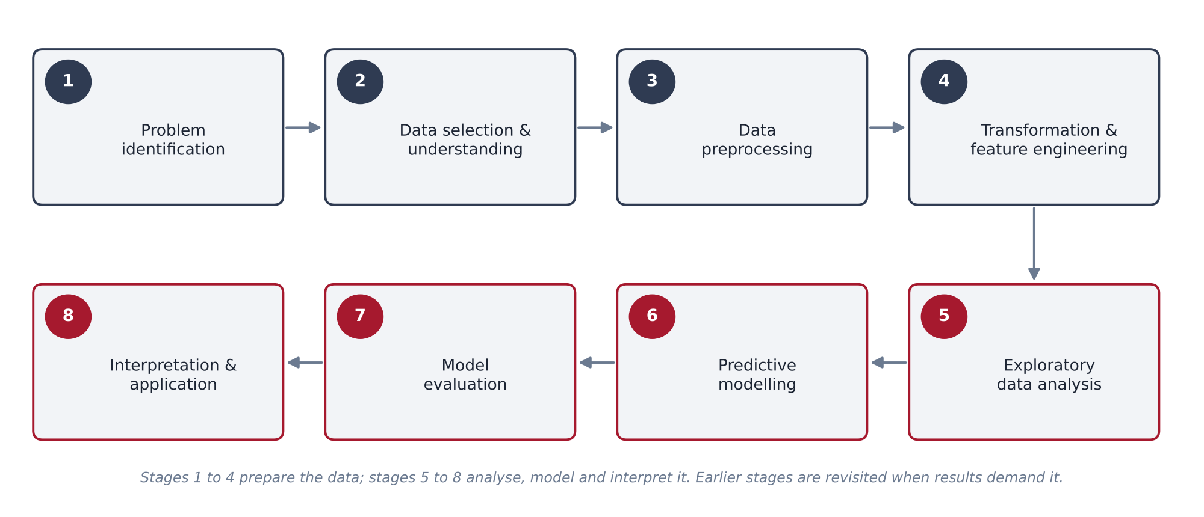
Figure 3.1: Predictive analytics workflow followed in the project, based on the KDD process [3]
Stage | KDD step | Work carried out in the notebook
1. Problem identification | Understanding the goal | Defined the forecasting problem and objective for supply chain planning
2. Data selection and understanding | Selection | Loaded the CSV files; inspected shapes, data types, missing values, duplicates, summary statistics, store and product family counts, and date range
3. Data preprocessing | Preprocessing | Converted dates; filled oil price gaps; built a holiday indicator; merged store, oil and holiday data with sales
4. Transformation and feature engineering | Transformation | Extracted year, month, day and day of week; aggregated to a daily series; created lag_7 and lag_14
5. Exploratory data analysis | Exploration | Plotted daily sales, total sales by product family and average sales by month
6. Predictive modelling | Data mining | Trained a Random Forest Regressor on the first 80 percent of days
7. Model evaluation | Evaluation | Computed MAE and RMSE on the last 20 percent; compared with the seven-day-lag baseline; validated the lag features
8. Interpretation | Interpretation | Plotted actual against predicted sales; analysed feature importance; discussed supply chain use and limits
Table 3.1: Mapping of project stages to the KDD process

3.2 Stage 1: Problem Identification and Understanding
The business question is how much a retail chain should expect to sell in total on a given day, given what it sold in recent weeks and what is known about the calendar, promotions and the economy. The task is a supervised regression problem on a time series. The target is total daily sales, and the inputs are features available for the forecast date. Success is defined as a lower MAE and RMSE than a seven-day-lag baseline on a test period that comes after the training period.
The model forecasts at the aggregate level, with sales summed across all 54 stores and 33 product families. This choice simplifies the problem, since aggregate forecasts are generally more accurate than disaggregate ones [1], but it limits the decisions the forecast can support (Section 4.6).

3.3 Stage 2: Data Selection and Understanding
The data come from the Store Sales - Time Series Forecasting competition [4]. Table 3.2 lists the files and the dimensions reported when they were loaded in the notebook.
File | Rows × columns | Contents | Use in the project
train.csv | 3,000,888 × 6 | id, date, store_nbr, family, sales, onpromotion | Source of the sales target and promotion counts
stores.csv | 54 × 5 | store_nbr, city, state, type, cluster | Merged with sales
holidays_events.csv | 350 × 6 | date, type, locale, locale_name, description, transferred | Source of the date-level holiday indicator
oil.csv | 1,218 × 2 | date, dcoilwtico | Daily oil price feature
transactions.csv | 83,488 × 3 | date, store_nbr, transactions | Loaded; not used in the model
test.csv | 28,512 × 5 | id, date, store_nbr, family, onpromotion | Loaded; has no sales labels, so not used for evaluation
sample_submission.csv | not loaded | Competition submission format | Not used
Table 3.2: Dataset files used in the project
The training table was then inspected in detail. Table 3.3 reports the quality checks. The table has no missing values and no duplicate rows, so no records needed to be removed. There are 1,782 records for every date (54 stores times 33 product families), which gives 3,000,888 / 1,782 = 1,684 distinct dates. The range from 1 January 2013 to 15 August 2017 spans 1,688 calendar days, so four calendar dates have no records. This is consistent with stores being closed on Christmas Day, although the notebook did not list the missing dates.
Check | Result
Missing values in train.csv (all six columns) | 0
Duplicate rows in train.csv | 0
Number of stores | 54
Number of product families | 33
Date range | 2013-01-01 to 2017-08-15
Distinct dates (3,000,888 / 1,782) | 1,684
Data type of date on loading | object (text); converted to datetime in Stage 3
Table 3.3: Data quality results for the training table
Table 3.4 gives the summary statistics for the sales and promotion columns. Sales are strongly right-skewed. A quarter of all records are zero, the median record is 11 units against a mean of 357.78, and the maximum is 124,717. Many store and product family combinations therefore sell little or nothing on a given day, while a few sell very large amounts. The sales column can hold fractional values because some products are sold by weight [4].
Statistic | sales | onpromotion
count | 3,000,888 | 3,000,888
mean | 357.78 | 2.60
standard deviation | 1,101.998 | 12.22
minimum | 0.00 | 0
25th percentile | 0.00 | 0
median | 11.00 | 0
75th percentile | 195.85 | 0
maximum | 124,717.00 | 741
Table 3.4: Summary statistics of the training table

3.4 Stage 3: Data Preprocessing
Preprocessing prepared the separate files for joint analysis. The date columns of the training, oil and holiday tables were converted from text to datetime values so that they can be sorted, merged and used to extract calendar features.
Three further steps were taken. First, store attributes (city, state, type and cluster) were merged into the sales records using store_nbr. Second, the oil price was merged by date. The oil file holds 1,218 daily records, fewer than the 1,684 sales dates, so some dates have no price after merging, as seen in the first records of the merged table. After the data were aggregated to daily level, these gaps were filled by carrying the last known price forward and then back. The backward fill affects only the dates at the start of the series that precede the first recorded price. Third, a holiday indicator was created: any date that appears in the holidays and events file was marked 1, and all other dates 0. This indicator is deliberately simple. It does not separate national holidays from local or regional ones, or holidays from other events, a limitation discussed in Section 4.6.
All merges were left joins, so no sales records were lost. The merged table has 3,000,888 rows and 16 columns, which equals the ten columns of the training table after date features were added, four store columns, the oil price and the holiday indicator. Figure 3.2 summarises how the files were combined into the daily series used for modelling.
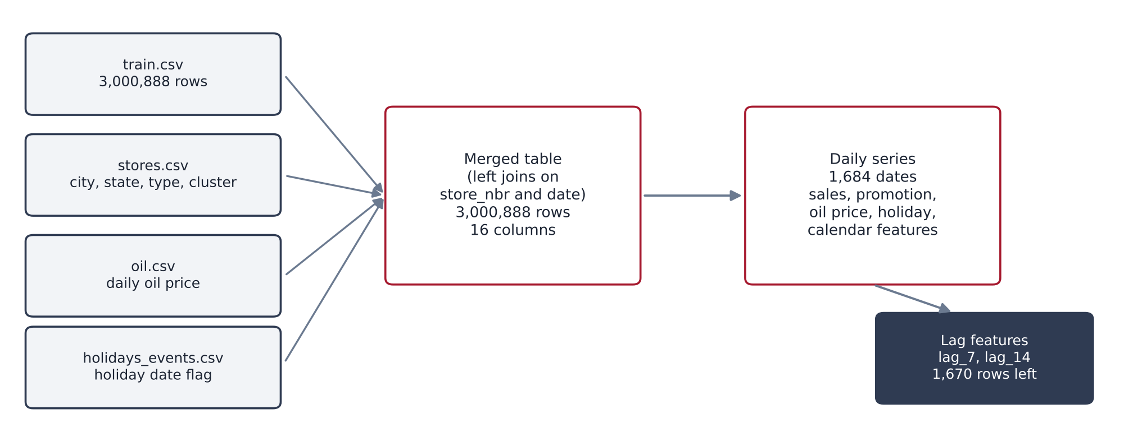
Figure 3.2: Integration of the source files and construction of the daily modelling table

3.5 Stage 4: Data Transformation and Feature Engineering
Transformation converted the prepared data into the form needed by the model. Year, month, day and day of week were extracted from the date to capture calendar effects. The merged table was then aggregated by date, summing sales and promotion counts across all stores and product families, averaging the oil price and taking the maximum of the holiday indicator. This produced a daily series of 1,684 rows.
Lag features were added to carry recent sales history into each record. The feature lag_7 holds the total sales recorded seven rows earlier and lag_14 the total sales fourteen rows earlier. The first fourteen rows have no lag values and were dropped, leaving 1,670 rows. Because lag_7 is the shortest lag, each prediction uses sales information that is at least seven days old, which corresponds to a forecast horizon of seven days or more. The lags are record-based. Around each of the four dates with no records, the lag refers to a date one day earlier than exactly seven or fourteen calendar days. Table 3.5 lists the nine model features and the target.
Variable | Definition | Type
sales (target) | Total sales on the date across all stores and product families | Target
promotion | Sum of onpromotion across all stores and product families | Numeric
oil_price | Average daily oil price (dcoilwtico), gaps filled forward then backward | Numeric
is_holiday | 1 if the date appears in the holidays and events file, else 0 | Binary
year, month, day | Calendar components of the date | Numeric
day_of_week | Day of the week from 0 (Monday) to 6 (Sunday) | Numeric
lag_7 | Total sales seven rows earlier | Numeric
lag_14 | Total sales fourteen rows earlier | Numeric
Table 3.5: Features and target of the daily model
The lag construction was checked in the notebook by comparing the lag columns with the sales column shifted by the same number of rows. For example, the lag_7 value for 15 August 2017 (717,766) equals the sales recorded on 8 August 2017, confirming that lag features use only earlier values and carry no information from the forecast date or later.

3.6 Stage 5: Exploratory Data Analysis
Exploratory analysis was carried out on the training data to understand time patterns and product mix. Figure 3.3 shows the daily total sales. Sales rise over the period, from roughly 0.3 to 0.5 million per day in early 2013 to roughly 0.7 to 1.2 million by 2017. The series shows a strong, regular short-term oscillation, which suggests a weekly cycle and supports the use of day_of_week and lag_7. Sales also fall to almost zero on 1 January of each year. The first lag_14 value in the model table, 2,511.62 for sales on 1 January 2013, is consistent with this. The notebook does not verify why, but such dips are consistent with stores being closed or largely inactive on that day.
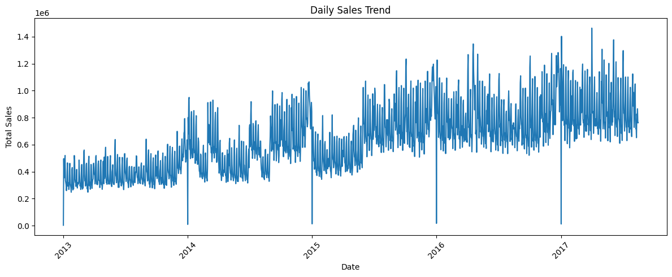
Figure 3.3: Daily total sales, 2013 to 2017
Figure 3.4 shows total sales by product family. Sales are concentrated in a few families. Reading the chart, GROCERY I is largest with roughly 3.4 × 10⁸ units, followed by BEVERAGES at roughly 2.2 × 10⁸, PRODUCE, CLEANING and DAIRY. Many families, such as books, baby care and hardware, contribute very little. Because the model uses the daily total, its forecast is dominated by the largest families.
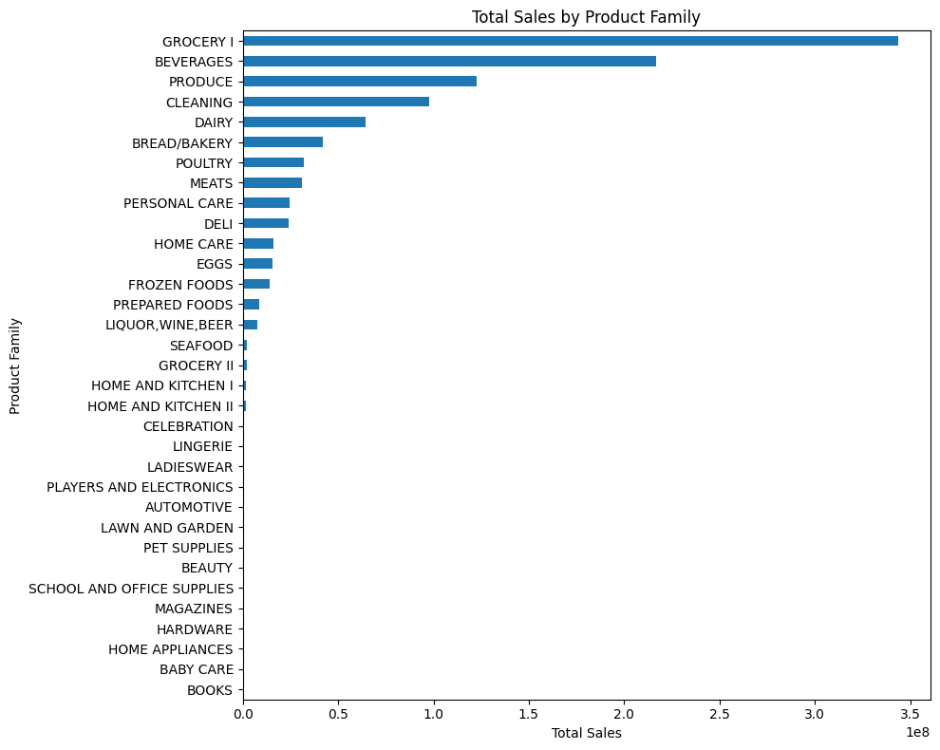
Figure 3.4: Total sales by product family
Figure 3.5 shows the average sales per record for each month. December is clearly the highest at roughly 455, and the other months range from roughly 320 to 375. This pattern is consistent with a festive-season peak. The chart averages over all years and records, so it mixes seasonality with the upward trend, and September to December appear only in the four years 2013 to 2016 because the data end in August 2017. It is therefore indicative and not a precise seasonal estimate.
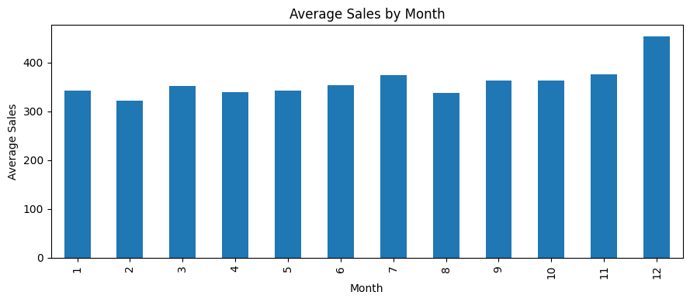
Figure 3.5: Average sales per record by month

3.7 Stage 6: Predictive Modelling
Random Forest Regression was chosen because it can model nonlinear relationships and interactions between lag, calendar and promotion features without feature scaling, and because it provides importance scores that help interpretation [11, 12]. The model was built with scikit-learn [13] and the configuration is given in Table 3.6. The notebook reports a single configuration, and no hyperparameter search is reported.
Item | Setting
Algorithm | RandomForestRegressor (scikit-learn)
Number of trees (n_estimators) | 100
Maximum tree depth (max_depth) | 12
Random seed (random_state) | 42
Parallel jobs (n_jobs) | -1 (all available cores)
Other parameters | scikit-learn defaults
Features (9) | promotion, oil_price, is_holiday, year, month, day, day_of_week, lag_7, lag_14
Target | Total daily sales
Split | Chronological: first 80 percent of days for training, last 20 percent for testing
Table 3.6: Random Forest configuration and data split
The 1,670 daily records were split in time order. The first 1,336 records (80 percent) form the training set and the last 334 records (20 percent) form the test set, which covers about mid-September 2016 to 15 August 2017. No shuffling was used, so the model never sees data from after the period it is asked to predict, which mirrors real use [6, 10]. The baseline for comparison is the seasonal naïve rule [6], in which the forecast for a day equals the sales of seven days earlier. It is simply the lag_7 column of the test set.

3.8 Stage 7: Model Evaluation
Predictions on the test set were compared with actual sales using two error measures. The Mean Absolute Error is the average size of the errors, and the Root Mean Squared Error is the square root of the average squared error, which gives more weight to large misses.
MAE = (1/n) Σ | yᵢ − ŷᵢ | RMSE = √( (1/n) Σ ( yᵢ − ŷᵢ )² )
Here yᵢ is the actual sales on test day i, ŷᵢ is the prediction, and n = 334. Both measures are in the units of sales and lower values are better. They are scale-dependent, which makes them suitable for comparing methods on the same series but not across series of different size [16]. The model and the baseline were evaluated on exactly the same 334 test days. The lag validation described in Section 3.5 was also run as part of this stage.

3.9 Stage 8: Interpretation
The final stage interprets the model output. It plots actual against predicted sales over the test period, ranks the features by importance, and considers how the forecasts could support supply chain planning and where they fall short. These results are presented and discussed in Chapter 4.

4. RESULTS AND DISCUSSION

4.1 Model Performance
Table 4.1 and Figure 4.1 compare the Random Forest with the seven-day-lag baseline on the 334 test days. The Random Forest has lower error on both measures. Its MAE is 78,460.90 against 108,539.92 for the baseline, a reduction of 30,079.02 or about 27.7 percent. Its RMSE is 119,450.47 against 170,606.81, a reduction of 51,156.34 or about 30.0 percent.
Model | MAE | RMSE
Seven-day-lag baseline | 108,539.92 | 170,606.81
Random Forest Regression | 78,460.90 | 119,450.47
Reduction (absolute) | 30,079.02 | 51,156.34
Reduction (percent) | 27.7% | 30.0%
Table 4.1: Test-set error of the Random Forest and the baseline
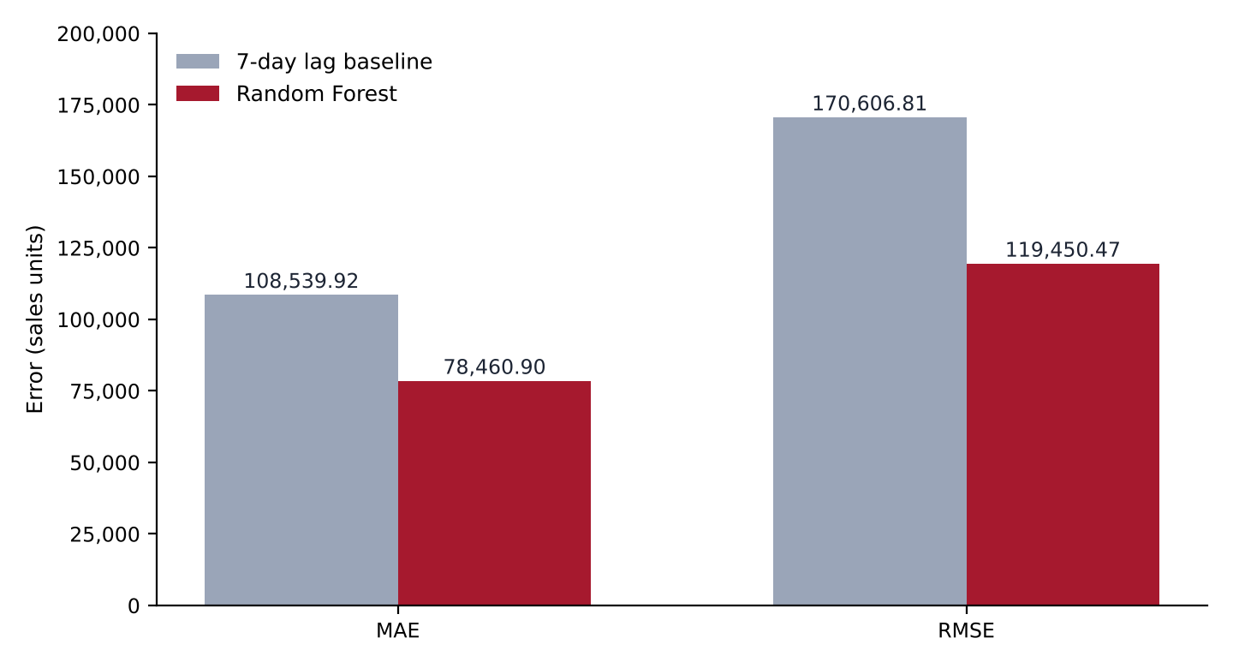
Figure 4.1: MAE and RMSE of the baseline and the Random Forest on the test set
To put the size of the error in context, the mean record in the training table is 357.78 units and there are 1,782 records per date, so the average daily total over the whole period is roughly 638,000. The model’s MAE is therefore about 12 percent of that figure. Sales in the test period are higher than the all-period average (Figure 3.3), so the relative error within the test period is probably smaller, but this was not computed. In both models RMSE is about one and a half times MAE, which indicates that a few large misses contribute heavily to the squared error.

4.2 Actual versus Predicted Sales
Figure 4.2 plots actual and predicted daily sales over the test period. The predictions follow the weekly cycle and the general level of sales closely. Two weaknesses are visible. The predictions are smoother than the actual series, so the highest peaks, such as the spike in early April 2017 at roughly 1.4 million, are underestimated, and some troughs are overestimated. The largest single miss is 1 January 2017, when actual sales fell to almost zero but the model predicted roughly 800,000.
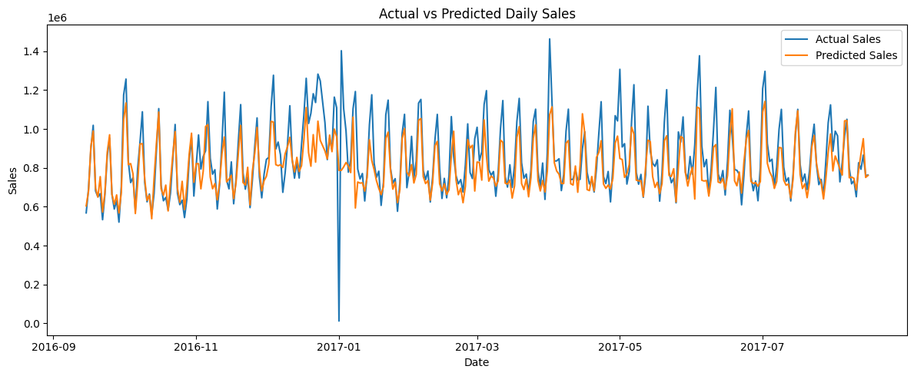
Figure 4.2: Actual and predicted daily sales on the test set
This one miss is worth examining. Reading the value from the chart, an error of about 800,000 on a single day would on its own account for roughly one eighth of the total squared error behind the RMSE. A plausible explanation is that the model saw few examples of this event. Because the first fourteen rows were dropped, the training set contains only three 1 January observations (2014, 2015 and 2016), and the holiday indicator has very low importance (Section 4.3). This explanation is a hypothesis and was not tested in the notebook.

4.3 Feature Importance
Figure 4.3 shows the feature importance scores of the fitted forest. Table 4.2 lists approximate values read from the chart. Sales seven days earlier (lag_7) is by far the most influential feature at roughly 0.65, and sales fourteen days earlier (lag_14) is second at roughly 0.15. Together the two lag features account for about 80 percent of the total importance.
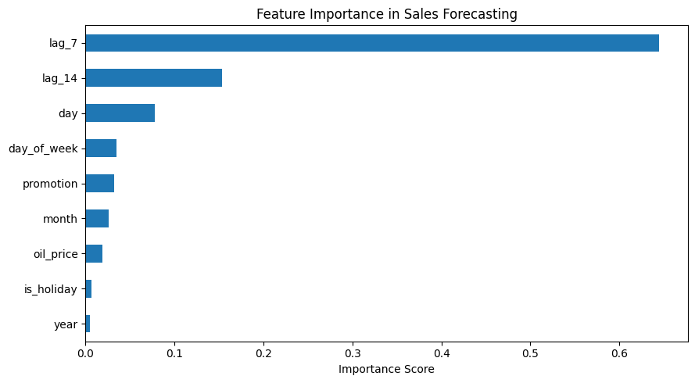
Figure 4.3: Feature importance in the Random Forest model
Feature | Approximate importance | Feature | Approximate importance
lag_7 | 0.645 | month | 0.026
lag_14 | 0.153 | oil_price | 0.019
day | 0.078 | is_holiday | 0.007
day_of_week | 0.035 | year | 0.005
promotion | 0.032
Table 4.2: Approximate feature importance values read from Figure 4.3
Several points follow. The weekly cycle seen in the exploratory analysis is captured mainly through lag_7, which helps explain why day_of_week ranks lower than might be expected, since the lag already carries the weekday pattern. Day of the month ranks third. The dataset description notes that public-sector wages are paid on the 15th and the last day of each month [4], which may be related, although this project did not test that link. Promotion, month and oil price contribute modestly, and the holiday indicator and year contribute least. The low weight of the holiday flag is consistent with its coarse construction (Section 3.4) and with the small number of holiday examples.
These scores come from the structure of the fitted trees, and the values in Table 4.2 are read from a chart, so they are approximate. Correlated features such as lag_7 and lag_14 share importance, and the scores describe what the model uses, not what causes sales [12]. No experiment removing features was run.

4.4 Why the Model Beats the Baseline
The baseline copies a single day, so any one-off noise in last week’s figure is passed straight into the forecast. The Random Forest combines two lags with the day of the month, promotion counts and other inputs, and averages over 100 trees, which is likely to smooth some of that noise. The improvement is consistent across both error measures. The evidence for this explanation is the lower MAE and RMSE and the importance ranking. Without further experiments, such as testing the model with lag_7 alone, the explanation cannot be confirmed.

4.5 Implications for Supply Chain Planning
Forecasts of this kind could support planning at the level of the whole chain. Table 4.3 sets out potential uses and what would be needed before each could be relied on. These are possible applications. The project did not measure any inventory, cost or service-level benefit.
Potential use | How the forecast could help | What is still needed
Chain-level capacity planning | Anticipate total daily demand for warehouse, transport and staffing capacity | Evaluation at the planning horizon; link to capacity costs
Replenishment planning | Indicate expected demand level when scheduling supplier orders | Store-level and product-level forecasts, which this model does not provide
Safety stock setting | Use the error size (MAE, RMSE) to size buffers | Error estimates by product and store, plus prediction intervals
Promotion planning | Flag periods of high expected sales | Analysis of promotion effects, which this model does not isolate
Table 4.3: Potential supply chain uses and requirements before use
The sizes of the errors should also be kept in view. A typical daily miss of about 78,000 units is meaningful relative to a daily total of roughly 638,000 on average, and large misses on special days such as 1 January show that planners would still need judgement for known events. Forecast error also matters beyond one firm, since order variability can be amplified upstream [2].

4.6 Limitations
The results should be read with the following limitations in mind:
- Aggregate target. The model predicts total daily sales across all stores and product families. It does not predict the demand of any store or product, so it cannot directly drive store-level inventory decisions.
- Single split and no tuning. Results come from one chronological split and one configuration. They give no measure of variability, and different periods or settings could give different errors.
- Limited comparison. Only one baseline and one algorithm were evaluated. Other methods may perform better.
- Coarse holiday indicator. Any date listed in the holidays and events file is flagged, regardless of type or locale, so local and regional holidays count as national ones.
- Same-day inputs. Oil price and promotion counts for the forecast date are used as inputs. In practice, promotion plans may be known in advance but the oil price would have to be forecast or lagged.
- Record-based lags. Around the four dates with no records, lag features refer to a date one day earlier than the intended seven or fourteen days.
- Unused data. The transactions file and store attributes were not used in the daily model.
- No extrapolation. A regression forest cannot predict beyond the range of sales seen in training [12], which matters if sales keep trending upward.
- No measured business benefit. No inventory savings or cost reductions were measured.

5. CONCLUSION

5.1 Summary of the Work
This project applied the KDD process to forecast daily retail sales from the Corporación Favorita data. The work covered data understanding and quality checks, preprocessing and integration of store, oil price and holiday information, feature engineering including seven-day and fourteen-day lags, exploratory analysis, Random Forest modelling with a chronological split, evaluation against a baseline, and interpretation.

5.2 Key Findings
- The Random Forest achieved an MAE of 78,460.90 and an RMSE of 119,450.47 on the test period, against 108,539.92 and 170,606.81 for the seven-day-lag baseline. These are reductions of about 27.7 percent and 30.0 percent.
- Sales seven days earlier was the most influential feature, followed by sales fourteen days earlier. Together they account for about 80 percent of the importance, and the weekly pattern in sales is therefore central to the forecast.
- The model follows the weekly cycle and overall level well but smooths peaks and misses special days such as 1 January 2017 by a large margin.
- The forecasts are of total daily sales, and no inventory savings were measured. The results show potential value for aggregate planning, not proven business impact.

5.3 Future Work
The project can be extended in several directions:
- Forecast at store and product-family level, for example with a single model trained across many series, to support replenishment decisions.
- Compare more algorithms, including gradient boosting and statistical methods such as ARIMA, and tune hyperparameters.
- Use rolling-origin evaluation to measure how stable the errors are over time, and add a scale-free measure such as MASE [16].
- Improve the inputs by separating national, regional and local holidays, using the transactions file, and using lagged or forecast values of external variables.
- Add prediction intervals so that planners can size buffers from the uncertainty of the forecast.
- Connect forecasts to an inventory policy to measure whether they reduce stockouts, waste or holding cost.

6. REFERENCES
[1] S. Chopra and P. Meindl. Supply Chain Management: Strategy, Planning, and Operation. Pearson, 7th edition, 2019.
[2] H. L. Lee, V. Padmanabhan, and S. Whang. The bullwhip effect in supply chains. Sloan Management Review, 38(3):93-102, 1997.
[3] U. Fayyad, G. Piatetsky-Shapiro, and P. Smyth. From data mining to knowledge discovery in databases. AI Magazine, 17(3):37-54, 1996.
[4] Kaggle. Store Sales - Time Series Forecasting (data from Corporación Favorita). https://www.kaggle.com/competitions/store-sales-time-series-forecasting
[5] C. Shearer. The CRISP-DM model: The new blueprint for data mining. Journal of Data Warehousing, 5(4):13-22, 2000.
[6] R. J. Hyndman and G. Athanasopoulos. Forecasting: Principles and Practice. OTexts, 3rd edition, 2021. https://otexts.com/fpp3/
[7] G. E. P. Box, G. M. Jenkins, G. C. Reinsel, and G. M. Ljung. Time Series Analysis: Forecasting and Control. Wiley, 5th edition, 2015.
[8] N. K. Ahmed, A. F. Atiya, N. El Gayar, and H. El-Shishiny. An empirical comparison of machine learning models for time series forecasting. Econometric Reviews, 29(5-6):594-621, 2010.
[9] C. Bergmeir and J. M. Benítez. On the use of cross-validation for time series predictor evaluation. Information Sciences, 191:192-213, 2012.
[10] V. Cerqueira, L. Torgo, and I. Mozetič. Evaluating time series forecasting models: An empirical study on performance estimation methods. Machine Learning, 109:1997-2028, 2020.
[11] L. Breiman. Random forests. Machine Learning, 45(1):5-32, 2001.
[12] T. Hastie, R. Tibshirani, and J. Friedman. The Elements of Statistical Learning: Data Mining, Inference, and Prediction. Springer, 2nd edition, 2009.
[13] F. Pedregosa et al. Scikit-learn: Machine learning in Python. Journal of Machine Learning Research, 12:2825-2830, 2011.
[14] R. Fildes, S. Ma, and S. Kolassa. Retail forecasting: Research and practice. International Journal of Forecasting, 38(4):1283-1318, 2022.
[15] S. Makridakis, E. Spiliotis, and V. Assimakopoulos. M5 accuracy competition: Results, findings, and conclusions. International Journal of Forecasting, 38(4):1346-1364, 2022.
[16] R. J. Hyndman and A. B. Koehler. Another look at measures of forecast accuracy. International Journal of Forecasting, 22(4):679-688, 2006.
[17] W. McKinney. Data structures for statistical computing in Python. Proceedings of the 9th Python in Science Conference, pages 56-61, 2010.
[18] C. R. Harris et al. Array programming with NumPy. Nature, 585:357-362, 2020.
[19] J. D. Hunter. Matplotlib: A 2D graphics environment. Computing in Science and Engineering, 9(3):90-95, 2007.

