BASIC COMPUTER NETWORKING DEVICES
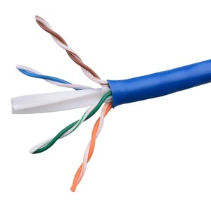
- UTP (Unshielded Twisted Pair) Cables:

- Router:
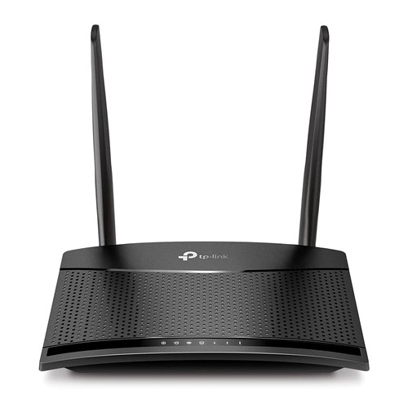

- RJ 45 Connector:
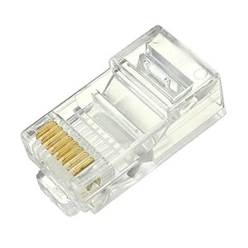

- Crimping Tool:

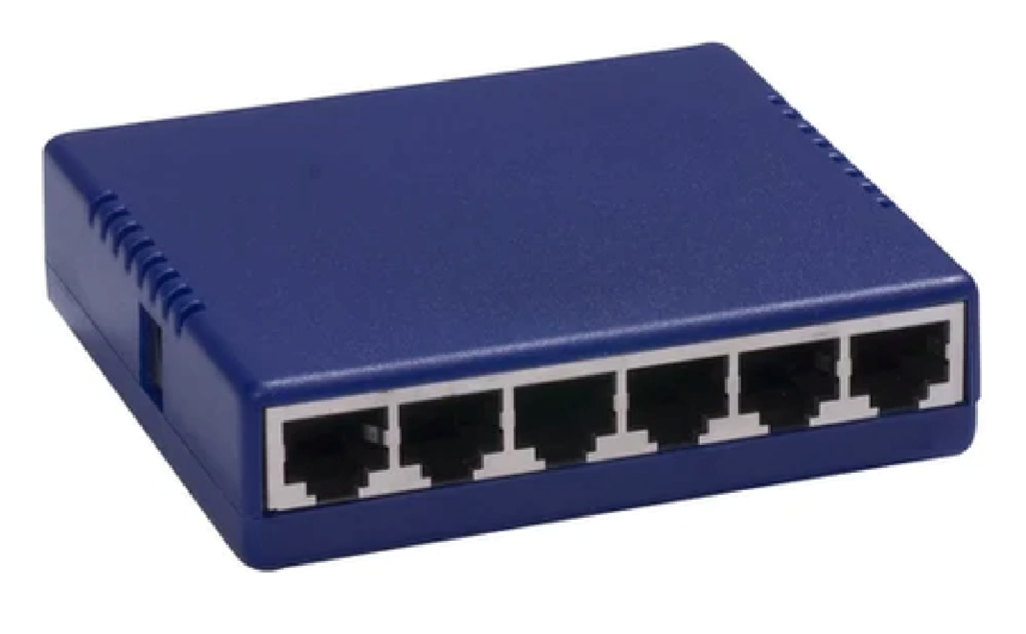
- Hub or Switch:

- Computer or Node:




