ANALYSIS OF APPLICATION LAYER PACKETS (DNS)
(using DNS commands and Wireshark in Windows)
- Generate DNS traffic:
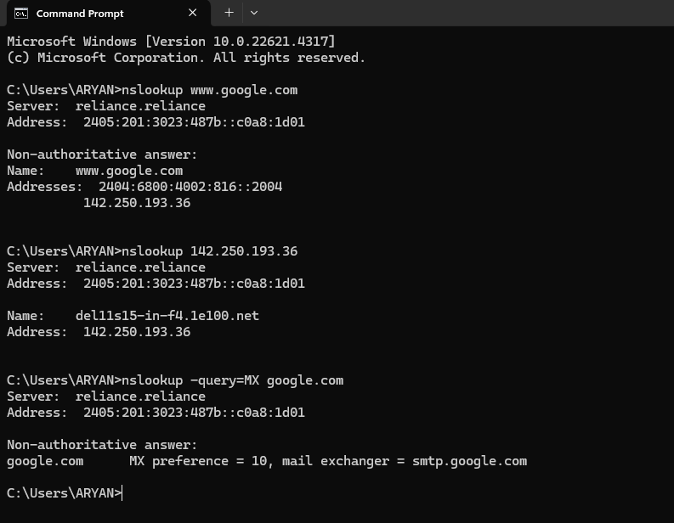

- Capture and Analyse DNS Packets:




