BASIC NETWORKING COMMANDS
(in Windows Command Prompt)
- ping and tracert:
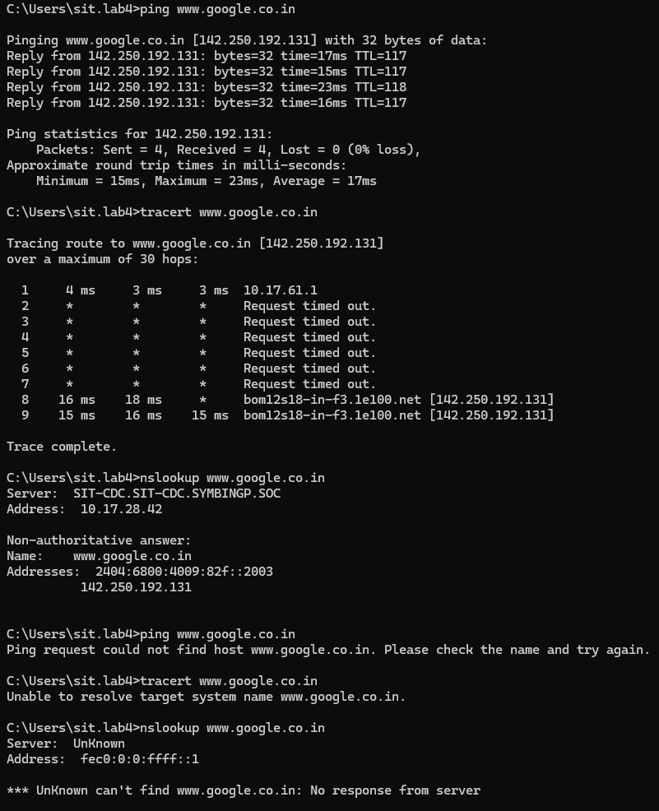

- nslookup:
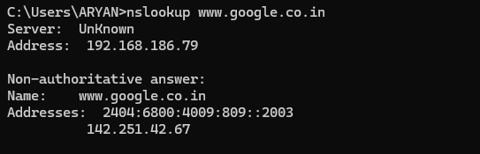
- ipconfig/all:
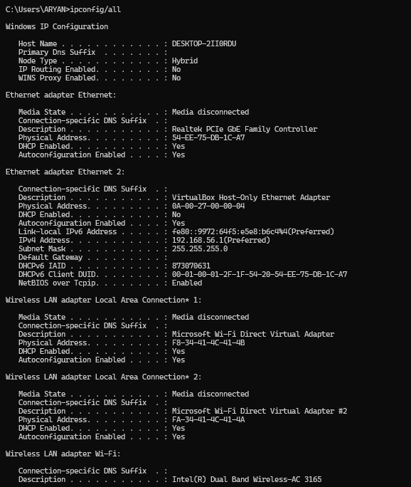

- netstat:
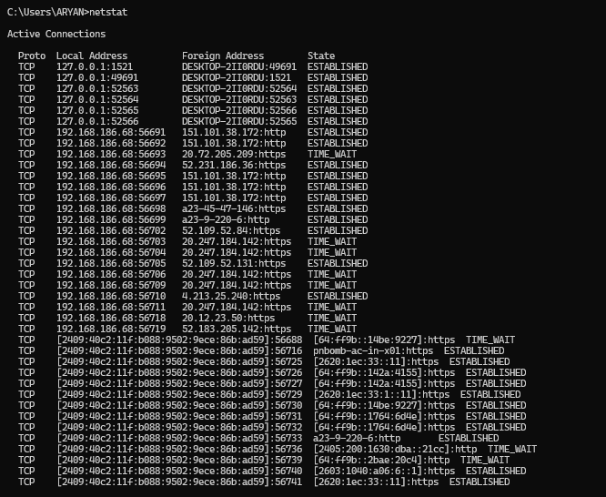
- getMac:
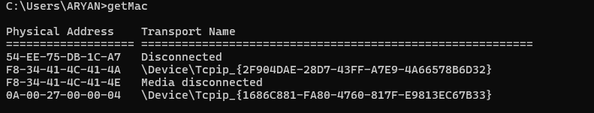
- hostname:
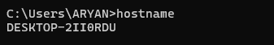

- route print:
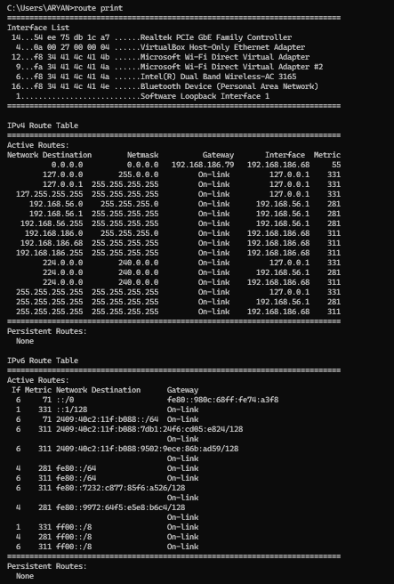

- arp:
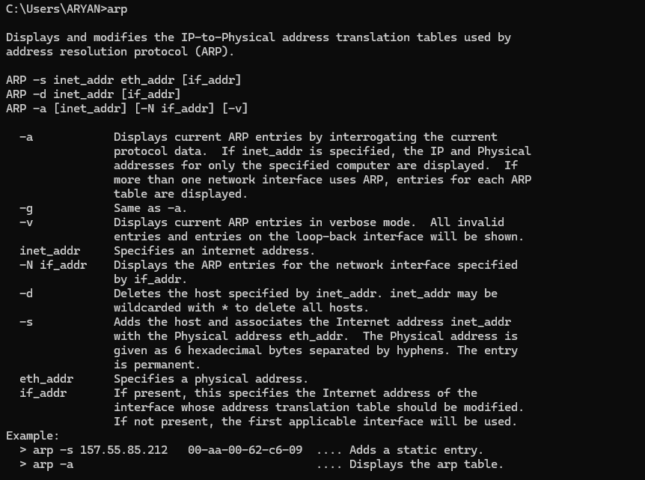
- pathping:




