# MOBILE APPLICATION DEVELEPOMENT LAB

**Name: vismaya mohan**

**Roll No: 54**

**Batch: RMCA B Date: 01-11-2022**

**Experiment No.:9**

# Aim

Implement Adapters and perform exception handling

# Procedure

**activity_main.xml**

<?xml version="1.0" encoding="utf-8"?>

<RelativeLayout xmlns:android="[http://schemas.android.com/apk/res/android"](http://schemas.android.com/apk/res/android) xmlns:app="[http://schemas.android.com/apk/res-auto"](http://schemas.android.com/apk/res-auto) xmlns:tools="[http://schemas.android.com/tools"](http://schemas.android.com/tools) android:layout_width="match_parent" android:layout_height="match_parent"

tools:context=".MainActivity">

<ListView android:id="@+id/myList"

android:layout_width="match_parent" android:layout_height="match_parent"

tools:layout_editor_absoluteX="8dp" tools:layout_editor_absoluteY="8dp" />

</RelativeLayout>

**mainActivity.java**

package com.example.adapter;

import androidx.annotation.NonNull;

import androidx.appcompat.app.AppCompatActivity;

import android.os.Bundle;

import android.widget.AdapterView; import android.widget.ArrayAdapter; import android.widget.ListView;

public class MainActivity extends AppCompatActivity {

@Override

protected void onCreate(Bundle savedInstanceState) { super.onCreate(savedInstanceState); setContentView(R.layout.activity_main);

ListView myLisView=findViewById(R.id.myList);

String items[]=new String[]{"1st item", "2nd item", "3rd item"}; ArrayAdapter<String> myAdapter=new ArrayAdapter<String>(MainActivity.this,

android.R.layout.simple_list_item_1,items); myLisView.setAdapter(myAdapter);

}

}

}

}

**OUTPUT**

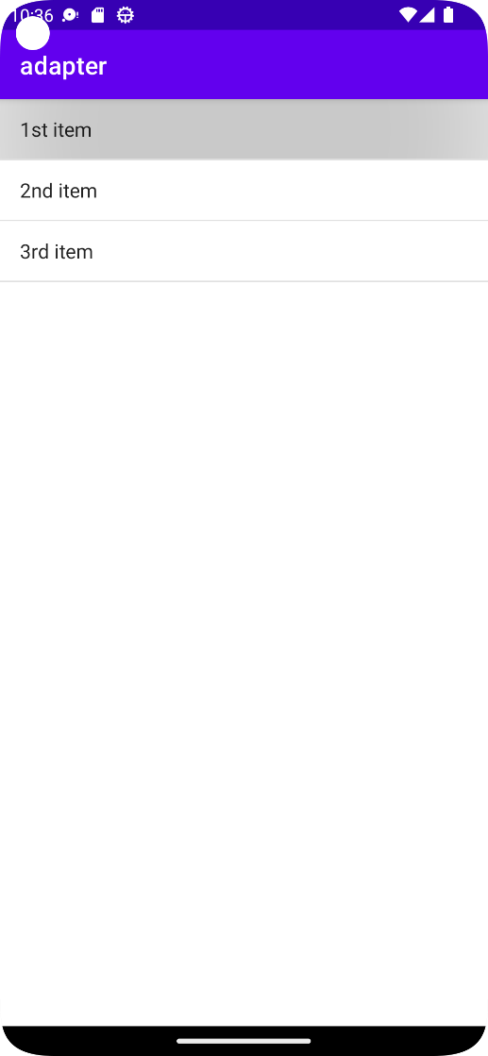

# MOBILE APPLICATION DEVELEPOMENT LAB

**Experiment No.:10**

# Aim

Implement Intent to navigate between multiple activities

# Procedure

**Xml file**

<?xml version="1.0" encoding="utf-8"?>

<LinearLayout

xmlns:android="http://schemas.android.com/apk/res/android"

xmlns:tools="http://schemas.android.com/tools"

android:layout_width="match_parent"

android:layout_height="match_parent"

android:orientation="vertical"

tools:context=".MainActivity"

tools:ignore="HardcodedText">

<EditText

android:id="@+id/fn"

android:layout_width="match_parent"

android:layout_height="wrap_content"

android:layout_marginStart="16dp"

android:layout_marginTop="16dp"

android:layout_marginEnd="16dp"

android:hint="type a url"

android:inputType="text" />

<Button

android:id="@+id/proceed"

android:layout_width="397dp"

android:layout_height="wrap_content"

android:layout_marginEnd="16dp"

android:backgroundTint="@color/black"

android:text="PROCEED"

android:textColor="@android:color/white"

tools:ignore="ButtonStyle" />

</LinearLayout>

**Java**

package com.example.program5;

import androidx.appcompat.app.AppCompatActivity;

import android.content.Intent;

import android.net.Uri;

import android.os.Bundle;

import android.view.View;

import android.widget.Button;

import android.widget.EditText;

public class MainActivity extends AppCompatActivity {

@Override

protected void onCreate(Bundle savedInstanceState) {

super.onCreate(savedInstanceState);

setContentView(R.layout.activity_main);

EditText fn=(EditText)findViewById(R.id.fn);

Button proceed=(Button)findViewById(R.id.proceed);

proceed.setOnClickListener(new View.OnClickListener() {

@Override

public void onClick(View v) {

String url=fn.getText().toString();

Intent intent=new Intent(Intent.ACTION_VIEW, Uri.parse(url));

startActivity(intent);

}

});

}

}

**Output**

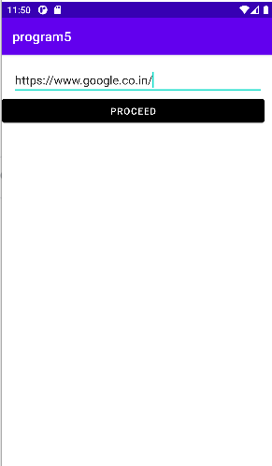 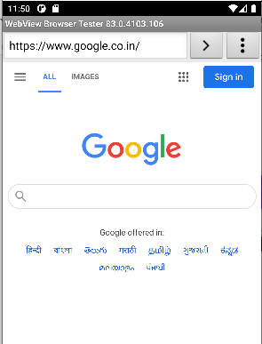

# MOBILE APPLICATION DEVELEPOMENT LAB

**Experiment No.:11**

# Aim

Develop application that works with explicit intents

# Procedure

**Xml file**

<?xml version="1.0" encoding="utf-8"?>

<androidx.constraintlayout.widget.ConstraintLayout xmlns:android="http://schemas.android.com/apk/res/android"

xmlns:app="http://schemas.android.com/apk/res-auto"

xmlns:tools="http://schemas.android.com/tools"

android:layout_width="match_parent"

android:layout_height="match_parent"

tools:context=".MainActivity">

<TextView

android:id="@+id/editText"

android:layout_width="match_parent"

android:layout_height="wrap_content"

android:text="good morning"

android:textAlignment="center"

android:textSize="28sp"

app:layout_constraintBottom_toBottomOf="parent"

app:layout_constraintEnd_toEndOf="parent"

app:layout_constraintHorizontal_bias="0.0"

app:layout_constraintStart_toStartOf="parent"

app:layout_constraintTop_toTopOf="parent" />

<Button

android:id="@+id/btn1"

android:text="next Screen"

android:onClick="newsScreen"

android:layout_width="wrap_content"

android:layout_height="wrap_content"

app:layout_constraintBottom_toBottomOf="parent"

app:layout_constraintEnd_toEndOf="parent"

app:layout_constraintStart_toStartOf="parent"

app:layout_constraintTop_toBottomOf="@+id/editText" />

</androidx.constraintlayout.widget.ConstraintLayout>

**Java file-1**

package com.example.program6;

import androidx.appcompat.app.AppCompatActivity;

import android.content.Intent;

import android.os.Bundle;

import android.view.View;

public class MainActivity extends AppCompatActivity {

@Override

protected void onCreate(Bundle savedInstanceState) {

super.onCreate(savedInstanceState);

setContentView(R.layout.activity_main);

}

public void newsScreen(View view) {

Intent i = new Intent(getApplicationContext(), MainActivity2.class);

startActivity(i);

}

}

**Xml file-2**

<?xml version="1.0" encoding="utf-8"?>

<androidx.constraintlayout.widget.ConstraintLayout xmlns:android="http://schemas.android.com/apk/res/android"

xmlns:app="http://schemas.android.com/apk/res-auto"

xmlns:tools="http://schemas.android.com/tools"

android:layout_width="match_parent"

android:layout_height="match_parent"

tools:context=".MainActivity2">

<TextView

android:id="@+id/editText"

android:layout_width="match_parent"

android:layout_height="wrap_content"

android:text="good evening"

android:textAlignment="center"

android:textSize="28sp"

app:layout_constraintBottom_toBottomOf="parent"

app:layout_constraintEnd_toEndOf="parent"

app:layout_constraintHorizontal_bias="0.0"

app:layout_constraintStart_toStartOf="parent"

app:layout_constraintTop_toTopOf="parent" />

<Button

android:id="@+id/btn2"

android:text="next Screen"

android:onClick="next Screen"

android:layout_width="wrap_content"

android:layout_height="wrap_content"

app:layout_constraintBottom_toBottomOf="parent"

app:layout_constraintEnd_toEndOf="parent"

app:layout_constraintStart_toStartOf="parent"

app:layout_constraintTop_toBottomOf="@+id/editText" />

</androidx.constraintlayout.widget.ConstraintLayout>

**Java file-2**

package com.example.program6;

import androidx.appcompat.app.AppCompatActivity;

import android.content.Intent;

import android.os.Bundle;

import android.view.View;

public class MainActivity2 extends AppCompatActivity {

@Override

protected void onCreate(Bundle savedInstanceState) {

super.onCreate(savedInstanceState);

setContentView(R.layout.activity_main2);

}

public void newsScreen(View view) {

Intent i = new Intent(getApplicationContext(), MainActivity2.class);

startActivity(i);

}

}

**Output**

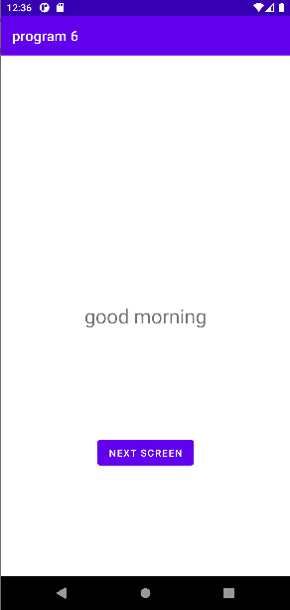 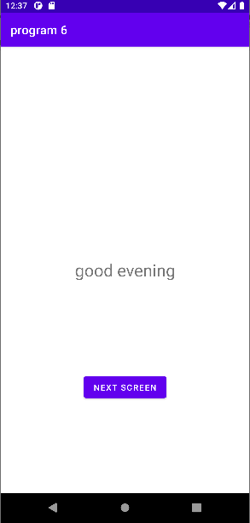

# MOBILE APPLICATION DEVELEPOMENT LAB

**Experiment No.:12**

# Aim

Implement options menu to navigate to activities

# Procedure

**Xml file**

**<?xml** version="1.0" encoding="utf-8"**?>**

**<android.support.design.widget.CoordinatorLayout** xmlns:android="http://schemas.android.com/apk/res/android"

    xmlns:app="http://schemas.android.com/apk/res-auto"

    xmlns:tools="http://schemas.android.com/tools"

    android:layout_width="match_parent"

    android:layout_height="match_parent"

     tools:context="example.javatpoint.com.optionmenu.MainActivity"**>**

**<android.support.design.widget.AppBarLayout**

        android:layout_width="match_parent"

        android:layout_height="wrap_content"

        android:theme="@style/AppTheme.AppBarOverlay"**>**

**<android.support.v7.widget.Toolbar**

            android:id="@+id/toolbar"

            android:layout_width="match_parent"

            android:layout_height="?attr/actionBarSize"

            android:background="?attr/colorPrimary"

            app:popupTheme="@style/AppTheme.PopupOverlay" **/>**

**</android.support.design.widget.AppBarLayout>**

**<include** layout="@layout/content_main" **/>**

**</android.support.design.widget.CoordinatorLayout>**

*context_main.xml*

**<?xml** version="1.0" encoding="utf-8"**?>**

**<android.support.constraint.ConstraintLayout** xmlns:android="http://schemas.android.com/apk/res/android"

    xmlns:app="http://schemas.android.com/apk/res-auto"

    xmlns:tools="http://schemas.android.com/tools"

    android:layout_width="match_parent"

    android:layout_height="match_parent"

    app:layout_behavior="@string/appbar_scrolling_view_behavior"

    tools:context="example.javatpoint.com.optionmenu.MainActivity"

    tools:showIn="@layout/activity_main"**>**

**<TextView**

        android:layout_width="wrap_content"

        android:layout_height="wrap_content"

        android:text="Hello World!"

        app:layout_constraintBottom_toBottomOf="parent"

         app:layout_constraintLeft_toLeftOf="parent"

        app:layout_constraintRight_toRightOf="parent"

        app:layout_constraintTop_toTopOf="parent" **/>**

**</android.support.constraint.ConstraintLayout>**

*menu_main.xml*

<menu xmlns:android="http://schemas.android.com/apk/res/android"

    xmlns:app="http://schemas.android.com/apk/res-auto"

    xmlns:tools="http://schemas.android.com/tools"

    tools:context="example.javatpoint.com.optionmenu.MainActivity">

    <item  android:id="@+id/item1"

        android:title="Item 1"/>

    <item  android:id="@+id/item2"

        android:title="Item 2"/>

    <item  android:id="@+id/item3"

        android:title="Item 3"

        app:showAsAction="withText"/>

</menu>

Java

package example.javatpoint.com.optionmenu;

import android.os.Bundle;

import android.support.v7.app.AppCompatActivity;

import android.support.v7.widget.Toolbar;

import android.view.Menu;

import android.view.MenuItem;

import android.widget.Toast;

public class MainActivity extends AppCompatActivity {

   @Override

 protected void onCreate(Bundle savedInstanceState) {

        super.onCreate(savedInstanceState);

        setContentView(R.layout.activity_main);

        Toolbar toolbar = (Toolbar) findViewById(R.id.toolbar);

        setSupportActionBar(toolbar);

    }

    @Override

    public boolean onCreateOptionsMenu(Menu menu) {

        // Inflate the menu; this adds items to the action bar if it is present.

        getMenuInflater().inflate(R.menu.menu_main, menu);

        return true;

    }

    @Override

    public boolean onOptionsItemSelected(MenuItem item) {

      int id = item.getItemId();

       switch (id){

            case R.id.item1:

                Toast.makeText(getApplicationContext(),"Item 1 Selected",Toast.LENGTH_LONG).show();

                return true;

            case R.id.item2:

                Toast.makeText(getApplicationContext(),"Item 2 Selected",Toast.LENGTH_LONG).show();

                return true;

            case R.id.item3:

                Toast.makeText(getApplicationContext(),"Item 3 Selected",Toast.LENGTH_LONG).show();

                return true;

            default:

                return super.onOptionsItemSelected(item);

        }

    }

}

OUTPUT

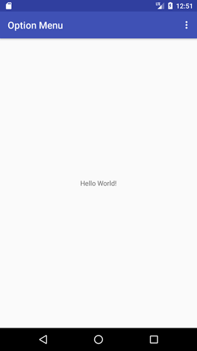

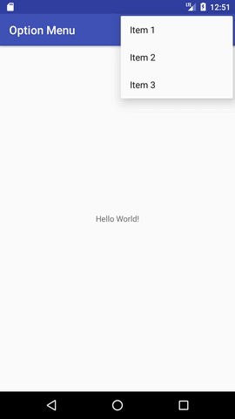

# MOBILE APPLICATION DEVELEPOMENT LAB

**Experiment No.:13**

# Aim

Develop an application that uses Array Adapter with listview

# Procedure

**Xml file**

**Xml:**

*<?*xml version="1.0" encoding="utf-8"*?>*<FrameLayout xmlns:android="http://schemas.android.com/apk/res/android"  
 xmlns:app="http://schemas.android.com/apk/res-auto"  
 xmlns:tools="http://schemas.android.com/tools"  
 android:layout_width="match_parent"  
 android:layout_height="match_parent"  
 tools:context=".MainActivity">  
  
 <ListView  
 android:layout_width="wrap_content"  
 android:layout_height="wrap_content"  
 android:id="@+id/studlist"  
 />  
  
</FrameLayout>

Xml2:

*<?*xml version="1.0" encoding="utf-8"*?>*

<LinearLayout xmlns:android="http://schemas.android.com/apk/res/android"

xmlns:app="http://schemas.android.com/apk/res-auto"

xmlns:tools="http://schemas.android.com/tools"

android:orientation="horizontal"

android:layout_width="match_parent"

android:layout_height="match_parent">

<ImageView

android:id="@+id/list_icon"

android:layout_width="65dp"

android:layout_height="65dp"

android:layout_margin="5dp" />

<TextView

android:id="@+id/list_title"

android:layout_width="match_parent"

android:layout_height="65dp"

android:layout_margin="5dp" />

</LinearLayout>

Java:

package com.example.program10;

import androidx.appcompat.app.AppCompatActivity;

import android.os.Bundle;

import android.widget.ListView;

import android.widget.SimpleAdapter;

import java.util.ArrayList;

import java.util.HashMap;

public class MainActivity extends AppCompatActivity {

ListView studlist;

String[] studnames = {"alan","binu","albin","amil","devis","febin"};

int[] studicons = {R.drawable.*img1*,R.drawable.*img2*,R.drawable.*img3*,R.drawable.*img4*,R.drawable.*img5*,R.drawable.*img6*};

@Override

protected void onCreate(Bundle savedInstanceState) {

super.onCreate(savedInstanceState);

setContentView(R.layout.*activity_main*);

studlist = findViewById(R.id.*studlist*);

ArrayList<HashMap<String, Object>> arrayList= new ArrayList<>();

for (int i=0; i < studnames.length; i++){

HashMap<String,Object> map = new HashMap<>();

map.put("studnames",studnames[i]);

map.put("studicons",studicons[i]);

arrayList.add(map);

}

String[] from ={"studnames","studicons"};

int to[] ={R.id.*list_title*,R.id.*list_icon*};

SimpleAdapter adapter= new SimpleAdapter(this,arrayList, R.layout.*listitem*,from, to);

studlist.setAdapter(adapter);

}

}

**output**

