PROJECT REPORT
Customized Routing Simulator
A Discrete-Event Simulation and Evaluation of the RPL Routing Protocol for Low-Power and Lossy Networks

Author: [AUTHOR NAME — PLACEHOLDER]
Student ID: [STUDENT ID — PLACEHOLDER]
Course / Module: [COURSE NAME — PLACEHOLDER]
Institution: [INSTITUTION — PLACEHOLDER]
Date: May 2026

Implemented in Python 3 with the SimPy discrete-event simulation framework

Table of Contents
Right-click this line and choose “Update Field” to build the table of contents.

Abstract
This report presents the design, implementation, and evaluation of a customized routing simulator built in Python using the SimPy discrete-event simulation framework. The simulator models the IPv6 Routing Protocol for Low-Power and Lossy Networks (RPL, RFC 6550), including the construction of a Destination-Oriented Directed Acyclic Graph (DODAG); the DIS, DIO, and DAO control messages; two objective functions (OF0 and MRHOF); and the Trickle algorithm (RFC 6206) for adaptive control-message timing. A route-over architecture with IPv6 /128 host addressing is assumed. The protocol is evaluated across a range of network sizes (5–80 nodes), per-link packet-loss rates (0–40%), and with the Trickle algorithm both enabled and disabled. The results show that the implementation achieves full network connectivity in every tested scenario, that control overhead grows only linearly with node count, and that the Trickle algorithm reduces DIO control traffic by approximately 70–75%. The principal trade-off observed is between robust upward (node-to-root) routing, which is self-healing under packet loss, and downward (root-to-node) routing, which degrades sharply because Destination Advertisement messages are not acknowledged.

1 Introduction to RPL

1.1 Low-Power and Lossy Networks and the Routing Problem
A Low-Power and Lossy Network (LLN) is a class of network composed of large numbers of embedded devices — typically wireless sensors, actuators, and other constrained nodes — that operate under severe resource limitations. Individual nodes possess little processing power, small memories, and, most critically, a finite battery energy budget; the wireless links between them are characterized by high and time-varying packet loss, low data rates, and limited stability. Such networks underpin many Internet-of-Things (IoT) applications, including environmental monitoring, smart metering, industrial automation, and building management.
Conventional IP routing protocols are poorly suited to this environment. Link-state protocols such as OSPF require every router to maintain a complete topological database and to flood link-state advertisements, while traditional distance-vector and ad-hoc protocols generate substantial control traffic and assume comparatively reliable links. In an LLN, where every transmitted bit consumes scarce energy and where links may fail intermittently, this overhead is unsustainable. The Internet Engineering Task Force (IETF) Routing Over Low-power and Lossy networks (ROLL) working group therefore specified a purpose-built protocol, RPL — the IPv6 Routing Protocol for Low-Power and Lossy Networks — in RFC 6550 [1].
RPL is a distance-vector routing protocol optimized for the dominant traffic pattern of LLNs: multipoint-to-point traffic, in which many nodes report data to a small number of collection points. It also supports point-to-multipoint traffic (from a collection point down to the nodes) and, less efficiently, point-to-point traffic. RPL is designed to keep per-node state small, to minimize control overhead in the steady state, and to tolerate unreliable links.

1.2 The DODAG: RPL’s Topological Abstraction
RPL organizes the physical network into one or more logical routing topologies called Destination-Oriented Directed Acyclic Graphs (DODAGs). A DODAG is a directed graph that (a) is acyclic, which guarantees loop-free routing, and (b) is oriented toward a single distinguished destination — the DODAG root. The root is typically a Low-power and lossy network Border Router (LBR) that connects the LLN to a larger network or to the wider Internet.
Within a DODAG, every non-root node selects one or more parents — neighboring nodes that are topologically closer to the root — and designates one of them as its preferred parent. The directed edge from a node to its preferred parent defines the default upward route toward the root; following preferred-parent edges from any node necessarily terminates at the root. The collection of these edges forms the DODAG.
Each node is assigned a rank: a scalar value that increases monotonically and strictly along any path from the root outward. The root holds the lowest rank, and a node’s rank is always strictly greater than that of its parent. Rank is not itself a routing metric but an abstract measure of a node’s topological position relative to the root, and it serves as RPL’s primary loop-avoidance mechanism — a node may only select a parent of strictly lower rank. The precise rule for computing rank from a parent’s rank and the quality of the link to that parent is delegated to a pluggable Objective Function (OF), identified by an Objective Code Point (OCP). Two standard objective functions are Objective Function Zero (OF0, RFC 6552 [3]), which derives rank purely from hop count, and the Minimum Rank with Hysteresis Objective Function (MRHOF, RFC 6719 [4]), which uses a link-quality metric such as the Expected Transmission Count (ETX).

1.3 RPL Control Messages: DIO, DIS, and DAO
RPL builds and maintains DODAGs using three ICMPv6 control messages [1]:
- DODAG Information Object (DIO) — the central message of RPL. It is multicast by every node that has joined a DODAG and advertises the existence of that DODAG together with the information a receiver needs to join it: the DODAG identifier, the DODAG version number, the advertising node’s rank, the mode of operation, and the objective code point. The propagation of DIOs outward from the root is the mechanism by which the DODAG is constructed.
- DODAG Information Solicitation (DIS) — sent by a node that has not yet joined a DODAG, or that wishes to refresh its information, to actively solicit DIOs from any neighbors within range. It is analogous to a router solicitation: rather than waiting passively for the next periodic DIO, an unassociated node can probe its neighborhood and provoke an immediate response.
- Destination Advertisement Object (DAO) — whereas DIOs propagate downward, from the root toward the leaves, and establish upward routes, the DAO propagates upward and establishes downward routes. A node sends a DAO toward the root to advertise the IPv6 destination prefix(es) it can serve, allowing the root — and, in storing mode, every intermediate ancestor — to populate downward routing-table entries. Without DAOs, the root could receive data from the nodes but would have no route by which to send data back to them. The standard also defines a DAO-Acknowledgement message for reliable DAO delivery.

1.4 DODAG Formation and Maintenance
DODAG construction begins at the root. The root, configured administratively, begins multicasting DIOs that advertise its own rank (the minimum rank) and its DODAG identity. A neighboring node that receives this DIO records the sender in its neighbor table, uses the active objective function to compute the rank it would obtain by attaching through that neighbor, and — if the neighbor is a feasible parent — joins the DODAG, adopts the neighbor as its preferred parent, and assigns itself the computed rank. Having joined, the node in turn begins to multicast its own DIOs. The process therefore ripples outward from the root, one hop at a time, until every node that is physically reachable has joined the DODAG. Once a node has a parent, it issues a DAO upward so that downward routes are installed along its path to the root.
Maintenance is continuous. Nodes periodically re-advertise DIOs and re-evaluate their parent sets as new information arrives. If a node hears a DIO indicating a better path, a topology change, or a new DODAG version, it may switch parents or update its rank, propagating the change to its own descendants. RPL provides two repair mechanisms: global repair, in which the root increments the DODAG version number to rebuild the entire graph, and local repair, in which a node that has lost its parent attempts to re-attach using only local information, without a global rebuild. The strict rank rule ensures that, even during these transient reconfigurations, routing remains loop-free.

1.5 The Trickle Algorithm
A naive implementation would transmit DIOs at a fixed period. This is inefficient: a short fixed period wastes energy when the network is stable and nothing has changed, whereas a long fixed period delays convergence when the network is changing. RPL resolves this tension by governing DIO transmissions with the Trickle algorithm, defined in RFC 6206 [2].
Trickle adapts the transmission interval to the observed stability of the network. It maintains a current interval I that begins at a small value Imin. At a random point in the second half of each interval, a node transmits — unless it has already heard a configurable number k of “consistent” messages from its neighbors, in which case it suppresses its own transmission. This “polite gossip” principle prevents redundant flooding in dense neighborhoods. At the end of each interval, if the network has remained consistent, the interval is doubled, up to a maximum Imax. Consequently, in a stable network the DIO interval grows exponentially and steady-state control traffic falls to a negligible level. When a node detects an inconsistency — a topology change, a new neighbor, a rank change, or a received DIS — it resets I to Imin, causing the interval to collapse so that DIOs are emitted rapidly and the new information propagates quickly. Trickle thus delivers both fast convergence when it is needed and low overhead when it is not, a property that is central to RPL’s energy efficiency.

2 Performance Metrics
To evaluate the protocol meaningfully, a set of quantitative metrics is required. Each metric defined below is accompanied by a justification of why it matters specifically in the context of a Low-Power and Lossy Network, where energy, reliability, and scale are the dominant concerns.

2.1 DODAG Convergence (Formation) Time
Definition. The elapsed simulated time from the moment the root begins advertising its DODAG until the last reachable node has joined the DODAG — that is, has acquired a preferred parent and a finite rank.
Relevance. Before convergence, the network is only partially usable: an unjoined node can neither originate nor relay traffic. In LLN deployments, particularly after a power-up or a global repair, a long convergence time represents a window of degraded service. Convergence time also reflects how efficiently DIOs propagate hop by hop through the network.

2.2 Network Connectivity and Reachability
Definition. The fraction of non-root nodes that successfully join the DODAG by the end of the simulation — the convergence fraction. A value of 1.0 indicates that every node found a route to the root.
Relevance. A node that fails to join is, for routing purposes, lost: it cannot participate in the network. Connectivity is therefore the most fundamental correctness measure of the protocol, answering whether RPL actually connects the network it is given.

2.3 Control-Message Overhead
Definition. The total volume of RPL control traffic — DIS, DIO, and DAO — generated during the simulation, measured both as a message count and as a total number of bytes transmitted, using a representative wire size for each message type.
Relevance. Every control transmission occupies the shared radio medium and, critically, consumes energy at battery-powered nodes. Because radio communication dominates the energy budget of a constrained node, control overhead is a direct proxy for network lifetime. A protocol that connects the network but exhausts its batteries doing so has failed in practice.

2.4 Per-Type Message Counts (DIS, DIO, DAO)
Definition. The number of each individual control-message type exchanged over the run.
Relevance. The breakdown localizes where overhead is incurred. DIS traffic is expected only transiently, while nodes are joining; DIO traffic reflects the cost of building and maintaining the DODAG and is governed by Trickle; DAO traffic reflects the cost of maintaining downward routes. Examining the three separately reveals which part of the protocol dominates the energy cost and whether each behaves as designed.

2.5 Scalability with Node Count
Definition. The manner in which the preceding metrics grow as the number of nodes in a fixed deployment area increases.
Relevance. Real LLN deployments range from a handful of nodes to many hundreds. A protocol is scalable only if its per-node overhead and its convergence time do not grow sharply with network size. Super-linear growth in control overhead, in particular, would impose a hard ceiling on the deployable network size.

2.6 Effect of the Trickle Algorithm on Message Frequency
Definition. The difference in DIO message frequency, and hence in total overhead, between simulations run with the Trickle algorithm enabled and an otherwise identical baseline that emits DIOs at a fixed period.
Relevance. Trickle is the principal mechanism by which RPL controls its steady-state energy cost. Quantifying the reduction in DIO traffic that it produces directly measures the value of the algorithm and the trade-off it makes against convergence speed.

2.7 Packet Delivery Ratio and Average Hop Count
Packet delivery ratio (PDR). Under the lossy channel model, the ratio of successfully delivered transmissions to total transmission attempts. It quantifies the impact of link unreliability on the protocol and is a standard measure of effective link quality.
Average hop count. The mean number of hops along the preferred-parent path from each non-root node to the root. It is a proxy both for end-to-end latency and for per-packet energy cost, since each hop entails an additional transmission and reception, and it indirectly reflects the depth, and therefore the shape, of the DODAG.

2.8 Local-Repair Recovery Time
Definition. The elapsed time from the loss of a node’s preferred parent until that node has re-attached to the DODAG with a valid parent and a finite rank.
Relevance. Links in an LLN fail routinely, owing to interference, node failure, or energy depletion. The speed with which RPL recovers from such failures determines the resilience of the network and the duration of any service interruption. As discussed in Section 4.6, the present simulator implements the local-repair procedure but does not yet trigger it automatically, so this metric is reported as a placeholder.

3 Implementation Description

3.1 Simulator Architecture and Technology Stack
The simulator is implemented in Python and built on SimPy, a process-based discrete-event simulation framework [5]. In a discrete-event simulation, the passage of time is modeled not by a real-time clock but by an ordered sequence of events; SimPy advances a virtual simulation clock from one scheduled event to the next, which makes the simulation both fully deterministic, given a fixed random seed, and far faster than wall-clock time. Each RPL node is modeled as one or more SimPy processes — Python generator functions that yield timeout and event objects — and all protocol timing, including Trickle intervals, message propagation delay, and periodic transmissions, is expressed through SimPy events.
The codebase is organized as a Python package, rpl_sim, containing seven modules with clearly separated responsibilities:
- messages.py — the DIS, DIO, DAO, and DAO-Acknowledgement control messages, defined as dataclasses;
- rpl.py — the objective functions (OF0 and MRHOF) and the per-neighbor state record;
- trickle.py — the Trickle timer;
- node.py — the RPL node, its state machine, and its message handlers;
- network.py — the radio medium, topology construction, and message delivery;
- metrics.py — telemetry collection and CSV export;
- visualize.py — DODAG and message-timeline plotting.
Supporting these are config.py, which defines a SimConfig dataclass holding every tunable parameter; main.py, a command-line entry point; and an experiments package containing automated parameter sweeps. This separation of concerns keeps the protocol logic (node.py, rpl.py, trickle.py) independent of the physical-layer model (network.py) and of the measurement subsystem (metrics.py).

3.2 Network and Node Abstractions in SimPy
The physical network is represented by a Network class. It owns the complete set of node instances, maintains a bidirectional adjacency list describing which nodes are within radio range of one another, and models the wireless medium. Message delivery is itself a SimPy process: when a node transmits, the Network schedules a delivery event for each in-range neighbor after a fixed propagation delay (one millisecond in the current configuration), so that message reception is correctly ordered in simulated time rather than occurring instantaneously.
Each node is represented by a Node class and behaves as an independent SimPy actor. A node runs a persistent receive process that blocks on a SimPy Store — an event-driven message queue acting as the node’s inbox — and dispatches each arriving message to the appropriate handler. An unassociated node additionally runs a solicitation process that periodically transmits DIS messages, and the root runs a dedicated start-up process that seeds the DODAG. DIO transmission is driven either by the Trickle timer, itself a SimPy process, or, when Trickle is disabled, by a fixed-period process. Each node maintains an explicit RPL state — UNASSOCIATED, ASSOCIATED, or ROOT — together with its rank, preferred parent, DODAG identity, neighbor table, and downward routing table. Two factory functions, for random and for deterministic grid placement, construct complete networks ready for simulation.

3.3 Neighbor Discovery
Neighbor discovery operates at two levels. The first is physical reachability. After all nodes have been placed, the Network computes, for every pair of nodes, the Euclidean distance between them and establishes a bidirectional link whenever that distance does not exceed the radio range of both nodes. This range-limited adjacency naturally restricts every node’s links to the geographically nearest nodes, reproducing the locality of a real wireless deployment; there is no global coordination, only local proximity. To guarantee that the scenario is solvable, the random-network factory repeatedly regenerates node placements, up to twenty attempts, until the resulting radio graph is fully connected — that is, until every node is reachable from the root — a property verified by a breadth-first traversal.
The second level is logical, protocol-driven discovery. A node learns the identity and routing state of its neighbors by receiving their control messages. Each time a DIO is received, the sender is inserted into, or updated within, the receiving node’s neighbor table as a neighbor-entry record holding the neighbor’s rank, DODAG identifier and version, the estimated link metric, and the time the neighbor was last heard. This table is the raw material for parent selection. An unassociated node accelerates the process by multicasting DIS messages to provoke its neighbors into replying with DIOs.

3.4 The DIO Message and DODAG Formation
The DIO message carries the DODAG identifier, the DODAG version number, the sender’s rank, the grounded flag, the mode of operation, the DAO Trigger Sequence Number, and the objective code point. When a node receives a DIO, it first updates the corresponding neighbor-table entry and determines whether the DIO is consistent with what it already knew, a determination that drives the Trickle timer (Section 3.6). It then attempts to join, or to update its position within, the DODAG.
Parent selection is delegated to the active objective function. The node assembles the set of candidate parents — neighbors advertising a finite rank and a valid DODAG identity — and asks the objective function to choose the best among them. Objective Function Zero (OF0) selects the candidate of lowest rank, breaking ties deterministically by node identifier, and computes the node’s own rank as the parent’s rank plus a fixed per-hop increment. MRHOF instead ranks candidates by an ETX-weighted path cost, excludes links whose quality is below a threshold, and applies hysteresis so that a node abandons its current parent only when an alternative offers a significant improvement, thereby suppressing route oscillation. Once a parent is chosen, the implementation enforces the feasibility rule that the node’s new rank must be strictly greater than the parent’s; the node then transitions from UNASSOCIATED to ASSOCIATED, begins emitting its own DIOs, and schedules a DAO. Because each newly joined node becomes a DIO source, the DODAG grows outward from the root one tier at a time. The number of nodes and their neighbor sets are fully parameterized: network size is set on the command line or swept automatically by the experiments package, while different random seeds yield different placements and therefore different neighbor sets.

3.5 The DIS Message
The DIS message is implemented and is used by unassociated nodes to solicit DIOs. After an initial random jitter, a node in the UNASSOCIATED state multicasts a DIS and continues to do so at a fixed interval until it joins a DODAG. When an associated node or the root receives a DIS, it treats the solicitation as a reason to advertise sooner: it signals an inconsistency to its Trickle timer, which collapses the DIO interval to its minimum and so produces a prompt DIO in reply, or, when Trickle is disabled, transmits a DIO directly. The DIS therefore shortens the time an isolated node must wait to discover the DODAG.

3.6 The Trickle Algorithm Implementation
The Trickle algorithm is implemented as a dedicated timer class faithful to RFC 6206 and integrated with the SimPy event loop. The timer is parameterized by the minimum interval Imin, the number of doublings that defines the maximum interval Imax, and the redundancy constant k. Its operation, expressed as a SimPy process, follows the standard algorithm: a transmission instant is chosen uniformly at random from the second half of the current interval; at that instant the node transmits only if the count of consistent messages it has heard is below k; and at the end of the interval the interval length is doubled, up to Imax, while the consistency counter is reset. Reception of a consistent DIO increments the counter and may suppress the next transmission, whereas detection of an inconsistency resets the interval to Imin — realized by interrupting the running SimPy process so that it restarts with the collapsed interval.
One point of terminology should be made explicit. In RPL, and in this simulator, the Trickle algorithm governs the timing of DIO messages: the timer’s transmission callback is the node’s DIO-send routine. DIS messages are not governed by Trickle; they are emitted at a fixed solicitation interval by unassociated nodes. This follows the division of responsibility defined in RFC 6550 and RFC 6206, under which Trickle’s exponential back-off applies to the steady, topology-maintaining DIO traffic rather than to transient solicitation traffic.

3.7 Node Addressing Plan and Architectural Assumption
The simulator assumes a route-over architecture. In a route-over design, routing is performed at the IPv6 layer and every node acts as a full IP router: each radio hop is also an IP hop, and a node’s rank corresponds directly to its position in the IP-layer routing topology. The alternative, a mesh-under architecture, performs forwarding at the link layer and hides multi-hop paths beneath a single IP hop. The route-over assumption is adopted here because it is the model for which RPL’s rank semantics and objective functions are defined: rank is meaningful precisely because it counts IP-layer hops or accumulates IP-layer path cost. A mesh-under design would conceal the very hop structure that RPL’s objective functions reason about, and is therefore incompatible with the protocol as specified in RFC 6550.
The addressing plan follows from this choice. Every node is assigned a unique IPv6 Unique Local Address from the fd00::/8 ULA space: node k receives the address fd00::k with a /128 prefix length — a host route identifying exactly that node. The DODAG root additionally advertises the covering fd00::/64 prefix, the aggregate from which all node addresses are drawn. Because each node owns a distinct /128 host route, downward routes to individual destinations can be advertised, hop by hop, by DAO messages, while the root’s /64 aggregate represents the network as a whole to any external network. The mode of operation is set to storing mode (MOP 2), meaning that downward routing state is distributed across the DODAG rather than concentrated solely at the root.

3.8 The DAO Message and Prefix Distribution
Downward routes — the routes that allow the root to reach individual nodes — are established by DAO messages. Shortly after a node joins the DODAG, it unicasts a DAO to its preferred parent. The DAO carries one or more RPL Target options, each advertising an IPv6 destination prefix; a node’s initial DAO advertises its own /128 host prefix. The wire size of a DAO is modeled as a small fixed base plus a fixed cost per advertised prefix, so that its overhead grows with the number of destinations it carries.
Because the simulator operates in storing mode, every node — not only the root — processes the DAOs that pass through it. When a node receives a DAO, it installs a downward routing-table entry for each advertised prefix, mapping that prefix to the neighbor from which the DAO arrived as the next hop toward the destination. A non-root node then forwards the DAO onward to its own preferred parent, first appending its own host prefix to the set of targets. In this way a DAO accumulates prefixes as it climbs the DODAG, and each ancestor along the path installs the routing state needed to forward traffic downward to every descendant beneath it. By the time the DAO reaches the root, the root has learned a route to the originating node, and every intermediate node has learned routes to the descendants on that branch. The distribution of prefixes through the DODAG is therefore an emergent result of this hop-by-hop upward forwarding. The protocol also defines a DAO-Acknowledgement message, and the corresponding message type is present in the simulator, although acknowledged DAO delivery is not currently exercised (see Section 5.3).

3.9 DODAG Local Repair
The node implementation includes a local-repair procedure. When invoked, it models the response of a node that has lost its preferred parent: the node marks the lost parent as unreachable, relinquishes its rank and returns to the UNASSOCIATED state, advertises an infinite rank in a “poisoning” DIO so that its own descendants detach rather than route through a broken path, and then immediately attempts to select a new parent from the remaining entries in its neighbor table. If no feasible parent remains, the node falls back to soliciting with DIS messages. This procedure constitutes local repair in the RFC 6550 sense — recovery using only local neighbor information, without a global version increment.
It should be stated clearly that, in the current version of the simulator, this procedure is implemented but is not automatically triggered: no link-failure event or parent-timeout watchdog invokes it during a normal simulation run, and a parent-timeout constant defined for this purpose is presently unused. Local repair is therefore available as a mechanism but is not exercised by the experiments reported here. Section 5.3 identifies this as the primary candidate for future work.

3.10 Code Organization and Version Control
The project is maintained as a Git repository, satisfying the requirement that the simulator be organized and documented in a software repository. The commit history is incremental, and each commit message describes a coherent unit of work: the project scaffold, the message and objective-function definitions, the Trickle timer, the node and network model, the command-line interface and visualization, and the experiment and test suites were each introduced in a distinct, conventionally prefixed commit. The repository is documented by a README that explains the project layout, the command-line interface, the parameter sweeps, and the key architectural decisions, and every module carries explanatory docstrings. Correctness is supported by a test suite, written for the pytest framework, that exercises the message definitions, both objective functions, the Trickle timer, and full DODAG-formation scenarios including grid topologies and lossy channels.

4 Simulation Results and Analysis

4.1 Experimental Setup
All results in this section were produced by the simulator itself; the reported figures are taken directly from its CSV output and its generated plots. Unless otherwise stated, simulations use a random topology in a 100 m × 100 m area, a radio range of 35 m, the OF0 objective function, the Trickle algorithm enabled with Imin = 1 s, eight doublings (Imax = 256 s) and redundancy constant k = 10, and a simulated duration of 300 s. The single-run baseline uses random seed 42; every swept data point is the mean of three independent runs with different seeds. Four experiments are reported: a baseline 20-node run, a sweep of network size from 5 to 80 nodes, a comparison of the network with and without the Trickle algorithm, and a sweep of per-link packet loss from 0% to 40%.

4.2 Baseline DODAG Formation
Figure 1 shows the DODAG formed in the baseline 20-node scenario, drawn as a hierarchical tree in which the root occupies the top tier and each tier downward corresponds to one further hop from the root. The twenty nodes are placed uniformly at random within the deployment area — with the root at its centre — producing a radio graph of 50 bidirectional links over which the DODAG is then constructed. The resulting DODAG has three tiers below the root: seven nodes attach directly to the root and obtain rank 1024, eight nodes attach at the second tier with rank 1792, and the four remaining nodes occupy the third tier with rank 2560. These rank values follow directly from OF0, under which the root holds rank 256 and each hop adds a fixed increment of 768.
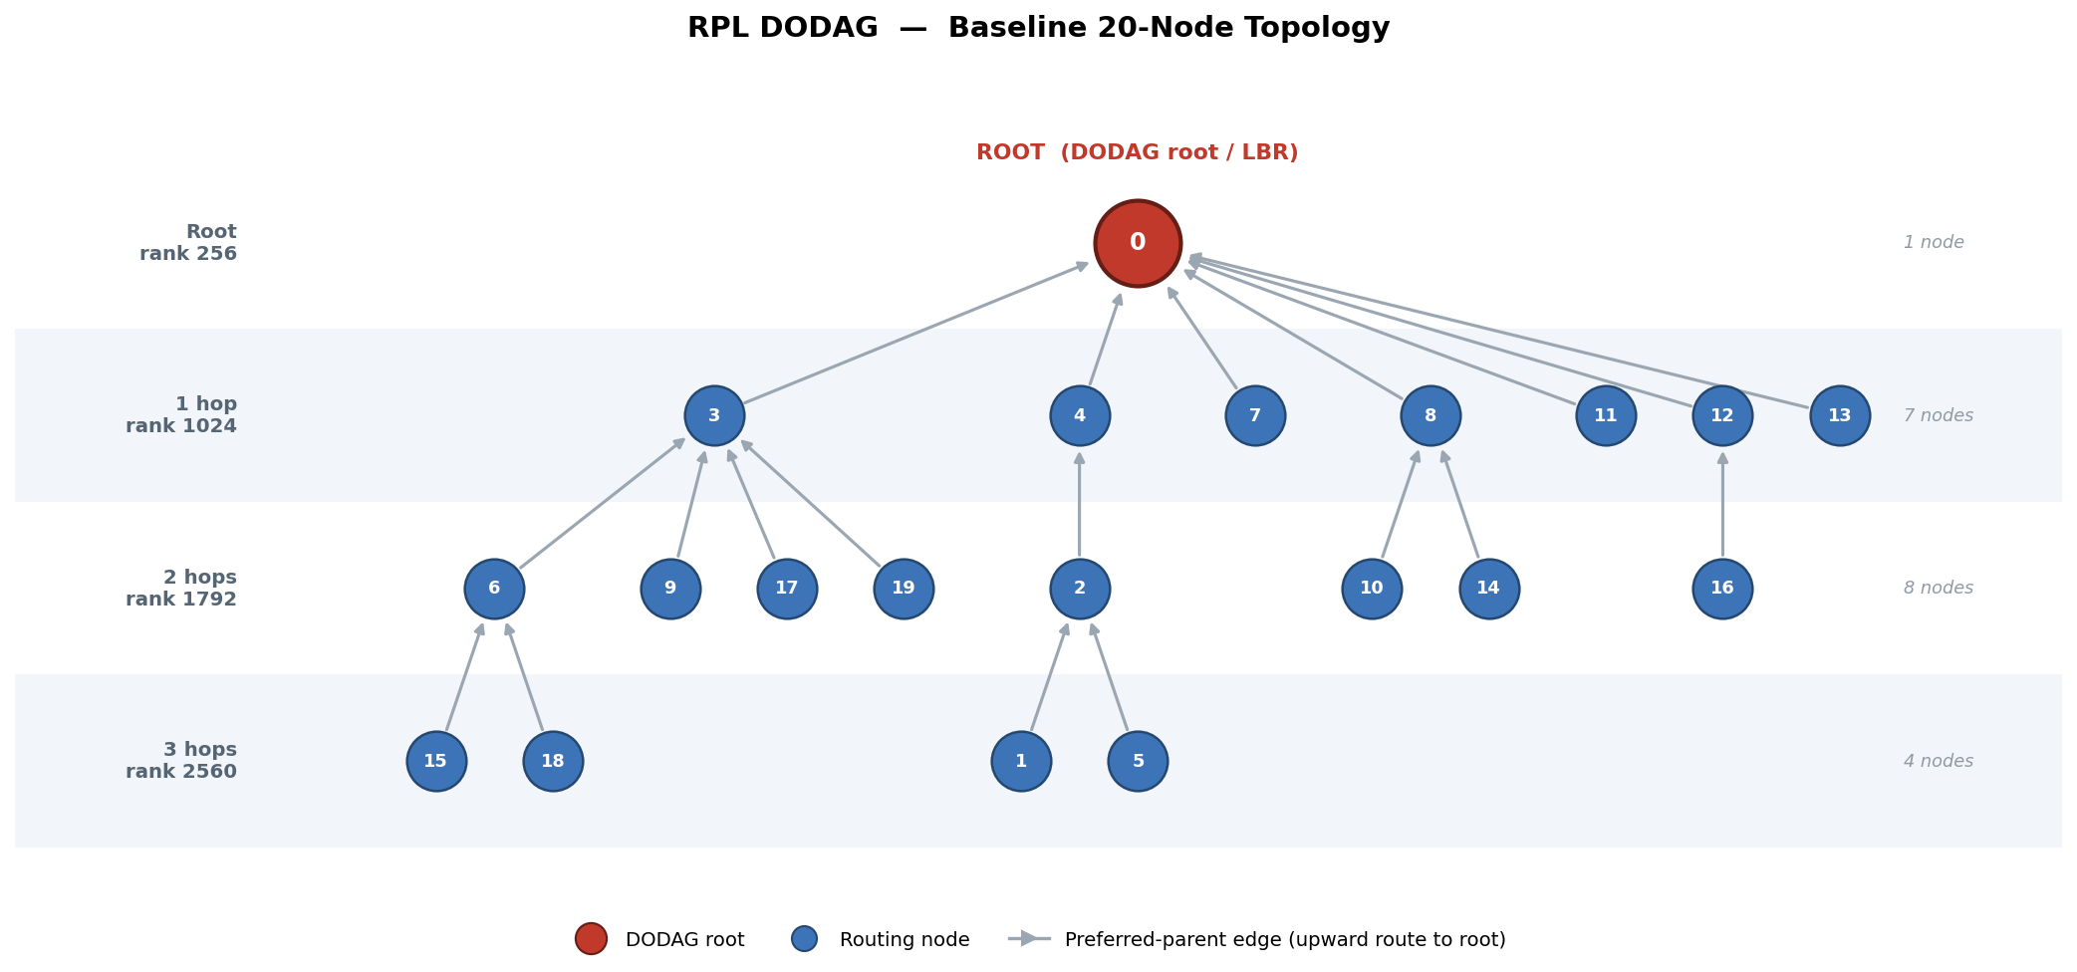
Figure 1. The DODAG formed in the baseline 20-node scenario, drawn as a hierarchical tree. The root occupies the top tier; each tier downward represents one further hop from the root and a rank higher by 768 (OF0). Arrows run from each node to its preferred parent — the direction of upward routing toward the root.
Table 1 summarizes the run. All twenty nodes joined the DODAG, giving a convergence fraction of 1.0, and the network converged in 2.45 s of simulated time. The log of join events shows the expected outward ripple: the first tier joined at approximately t = 0.87 s, the second tier at approximately t = 1.5 s, and the last nodes at t = 2.5 s. The validity check confirms that the graph is loop-free and that rank increases strictly along every path to the root. Control traffic for the whole 300 s run totalled 8 100 bytes, of which DIO messages account for 6 800 bytes (84%), DAO messages for 1 240 bytes (15%), and DIS messages for only 60 bytes (under 1%). With a lossless channel the packet delivery ratio is 1.0, and the average node sits 1.84 hops from the root. Nineteen downward routes — one for every non-root node — were installed at the root, confirming that prefix distribution by DAO is complete.
Table 1. Configuration and results of the baseline 20-node simulation (random seed 42).
Configuration
Topology | Random placement, 100 m × 100 m area
Number of nodes | 20 (1 root + 19 nodes)
Radio range | 35 m
Radio links formed | 50 bidirectional links
Objective function | OF0 (hop-count metric)
Trickle algorithm | Enabled (Imin = 1 s, Imax = 256 s, k = 10)
Per-link packet loss | 0%
Simulated duration | 300 s
Random seed | 42
Results
Nodes joined | 20 / 20 (convergence fraction 1.00)
Convergence time | 2.45 s
DODAG valid (loop-free) | Yes
Average hop count to root | 1.84
DIS messages | 15 (60 bytes)
DIO messages | 170 (6 800 bytes)
DAO messages | 35 (1 240 bytes)
Total control overhead | 8 100 bytes
Packet delivery ratio | 1.00
Downward routes at root | 19 / 19
Figure 2 plots control-message transmissions over time. It shows a pronounced burst of DIS and DIO traffic during the first few seconds, while the DODAG is forming, after which DIO traffic decays rapidly: as the network stabilizes, the Trickle interval doubles repeatedly and the steady-state DIO rate falls to a very low level. DAO messages appear in a small cluster shortly after the formation burst, when newly joined nodes advertise their prefixes. This timeline is the visual signature of Trickle’s adaptivity — high traffic exactly when the network is changing, and near-silence once it is stable.
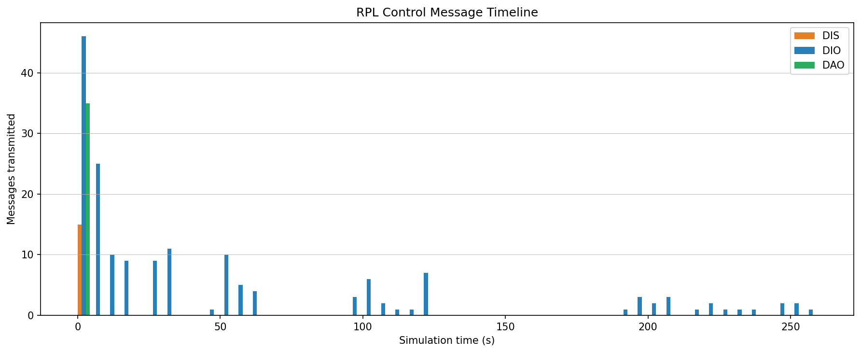
Figure 2. Control-message transmissions over time in the baseline scenario, binned in 5 s intervals. DIO traffic dominates the formation burst and then decays as Trickle intervals grow.

4.3 Scalability with Node Count
Table 2 and Figure 3 report how the protocol behaves as the network grows from 5 to 80 nodes within the same fixed area. Three results stand out.
First, connectivity is unconditional: at every network size, all nodes joined the DODAG (convergence fraction 1.0) and the resulting graph passed the loop-free validity check. The number of downward routes installed at the root equals the number of non-root nodes in every case, so prefix distribution remained complete as the network scaled.
Second, control overhead grows only approximately linearly with the number of nodes. Total control traffic rises from about 2 000 bytes at 5 nodes to about 22 600 bytes at 80 nodes — a sixteen-fold increase in node count for roughly an eleven-fold increase in bytes. The overhead per node therefore does not grow with network size; if anything it falls slightly, because in a denser network Trickle’s suppression mechanism is more effective: a node with more neighbors is more likely to hear k consistent DIOs and stay silent. The DIO count exhibits the same sub-linear behavior, rising from 43 to 451 as the node count rises from 5 to 80. This linear-or-better scaling is the key scalability result — RPL’s overhead does not explode with network size.
Third, convergence time does not degrade with scale. It remains within a narrow band of roughly 2–3.4 s across the whole range and is, in fact, lowest at the largest network sizes. The accompanying fall in average hop count — from about 2.3 hops at 15 nodes to about 1.7 hops at 80 nodes — explains why: as more nodes are packed into the fixed area, network density rises, more nodes fall within direct range of the root, and the DODAG becomes broader and shallower. A shallower DODAG converges in fewer hop-by-hop DIO rounds. The slightly higher convergence times at 10–15 nodes correspond to sparser topologies in which longer, more chain-like paths must be built.
Table 2. Scalability of key metrics with network size. Each row is the mean of three independent runs; Trickle enabled, 0% loss, 300 s simulated duration.
Nodes | Conv. time (s) | DIS | DIO | DAO | Control bytes | Avg. hops | Routes
5 | 2.21 | 3 | 43 | 7 | 2 007 | 1.83 | 4
10 | 3.27 | 6 | 86 | 19 | 4 240 | 2.11 | 9
15 | 3.41 | 10 | 128 | 33 | 6 612 | 2.33 | 14
20 | 2.36 | 13 | 170 | 35 | 8 105 | 1.84 | 19
30 | 2.50 | 17 | 243 | 50 | 11 504 | 1.74 | 29
40 | 2.18 | 22 | 294 | 66 | 14 048 | 1.70 | 39
60 | 2.15 | 35 | 385 | 102 | 18 916 | 1.73 | 59
80 | 2.06 | 47 | 451 | 134 | 22 617 | 1.70 | 79
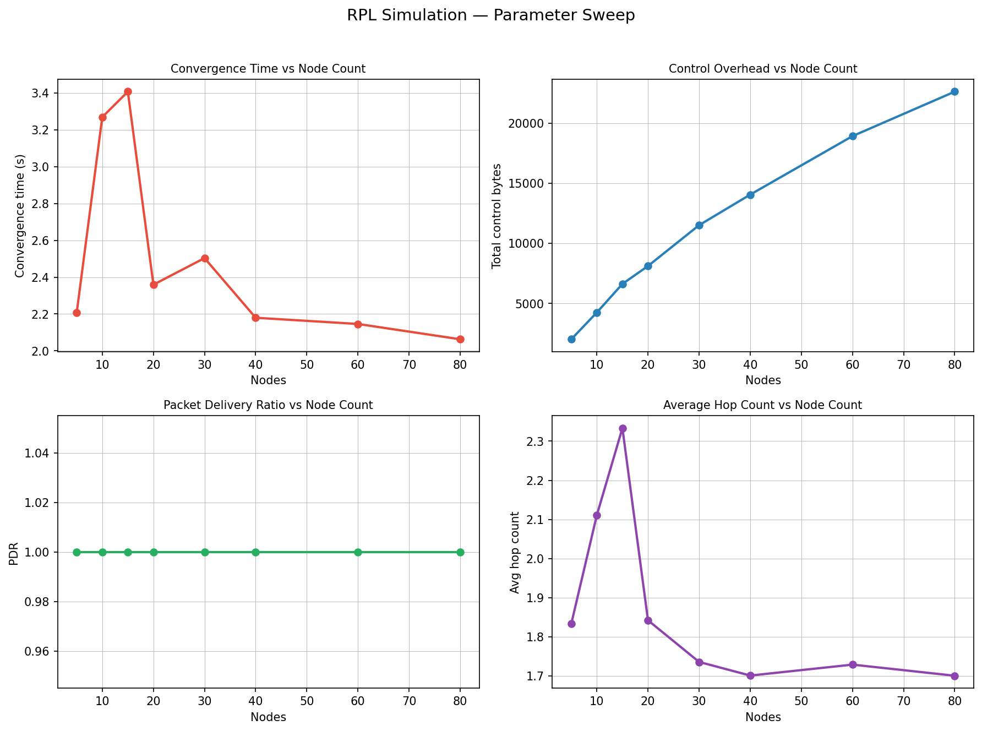
Figure 3. Scalability of key metrics with network size (5–80 nodes): convergence time, total control overhead, packet delivery ratio, and average hop count.

4.4 Effect of the Trickle Algorithm
Table 3 and Figure 4 compare the network with Trickle enabled against an otherwise identical network in which Trickle is disabled and DIOs are emitted at a fixed period. The effect on control overhead is large and consistent. With Trickle disabled, the number of DIO messages transmitted over the 300 s run increases by a factor of roughly 3.5 to 4.2; at 20 nodes, DIO transmissions rise from 170 to 611, and at 40 nodes from 294 to 1 233. Total control traffic rises in proportion, by a factor of roughly three to nearly four. Moreover, the ratio widens as the network grows, indicating that the value of Trickle increases with network size. Expressed the other way around, enabling Trickle reduces DIO control traffic by approximately 70–75%.
Table 3. Control overhead with the Trickle algorithm enabled versus disabled. Each value is the mean of three runs over a 300 s simulated duration.
Nodes | DIO  (Trickle ON) | DIO  (Trickle OFF) | Increase | Control bytes  (ON) | Control bytes  (OFF) | Increase
5 | 43 | 152 | 3.5× | 2 007 | 6 356 | 3.2×
10 | 86 | 305 | 3.6× | 4 240 | 13 004 | 3.1×
15 | 128 | 457 | 3.6× | 6 612 | 19 747 | 3.0×
20 | 170 | 611 | 3.6× | 8 105 | 25 669 | 3.2×
30 | 243 | 913 | 3.8× | 11 504 | 38 237 | 3.3×
40 | 294 | 1 233 | 4.2× | 14 048 | 51 495 | 3.7×
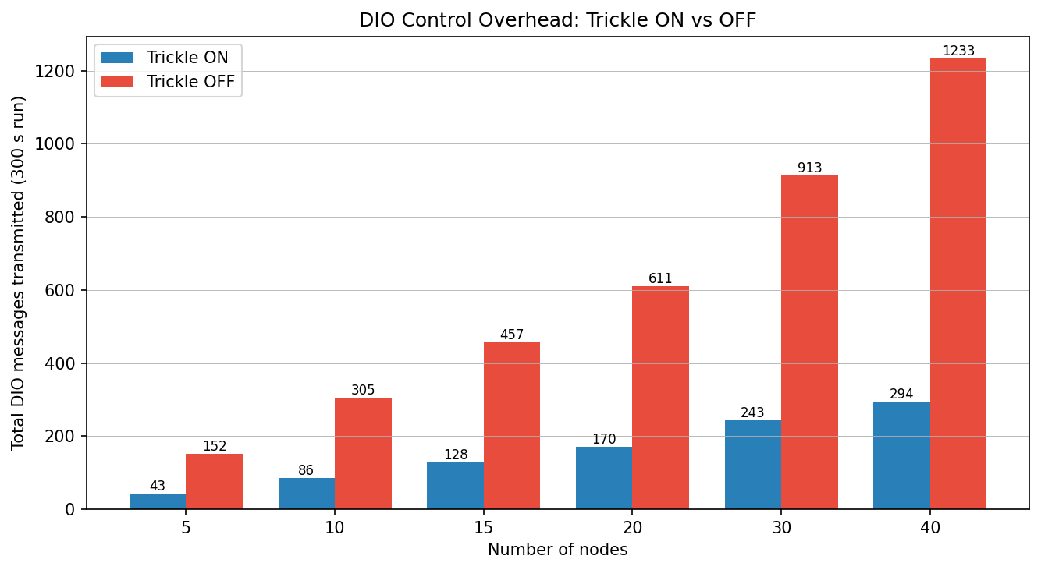
Figure 4. Total DIO messages transmitted over a 300 s run, with the Trickle algorithm enabled and disabled, for network sizes from 5 to 40 nodes.
This saving has a cost, and the cost is paid in convergence time. With Trickle enabled, the network converges in roughly 2–3.4 s, as the randomized first interval (between Imin/2 and Imin) defers each node’s initial DIO. With Trickle disabled, the fixed-period DIO engine emits its first DIO immediately and every newly joined node does likewise, so the DODAG forms within a few propagation delays; the measured convergence time falls below the resolution of the metric and is effectively zero. This apparent advantage of disabling Trickle is, however, illusory: it is the result of unthrottled flooding — the very behavior whose three- to fourfold overhead penalty the same experiment quantifies. Over a 300 s operational lifetime, a one-time convergence delay of two to three seconds is a negligible price for a sustained 70–75% reduction in energy-consuming control traffic. The experiment therefore confirms the central design rationale of RPL: Trickle trades a small, bounded, one-time delay for a large and continuing saving in overhead.

4.5 Robustness to Packet Loss
Table 4 and Figure 5 examine the effect of an unreliable channel, sweeping the per-link packet-loss probability from 0% to 40% in a 20-node network. The results reveal a sharp asymmetry between RPL’s upward and downward routing.
Upward routing — the DODAG itself — proved highly robust. At every loss rate up to and including 40%, all twenty nodes still joined the DODAG and the graph remained loop-free. The packet delivery ratio fell in direct proportion to the loss rate, from 1.00 to 0.59, exactly as expected for an independent per-link Bernoulli loss model. Convergence time degraded only gradually, from 2.4 s to 2.8 s as loss rose to 30%, before rising more steeply to 4.2 s at 40% loss. This resilience is attributable to Trickle: a lost DIO is registered as an inconsistency, the interval collapses to Imin, and the message is rapidly re-sent. The experiment confirms this — the DIO count rises with the loss rate, from 170 to 222, as Trickle compensates for dropped messages with additional transmissions. Upward routing is, in effect, self-healing.
Table 4. Effect of per-link packet loss on a 20-node network. Each value is the mean of three runs; Trickle enabled, 300 s simulated duration.
Loss (%) | Conv. time (s) | DIO messages | PDR | Routes at root | DODAG valid
0 | 2.36 | 170 | 1.00 | 19.0 | Yes
5 | 2.43 | 176 | 0.95 | 17.0 | Yes
10 | 2.43 | 183 | 0.90 | 15.3 | Yes
15 | 2.54 | 187 | 0.84 | 13.3 | Yes
20 | 2.54 | 190 | 0.79 | 11.7 | Yes
30 | 2.79 | 208 | 0.69 | 8.3 | Yes
40 | 4.16 | 222 | 0.59 | 5.3 | Yes
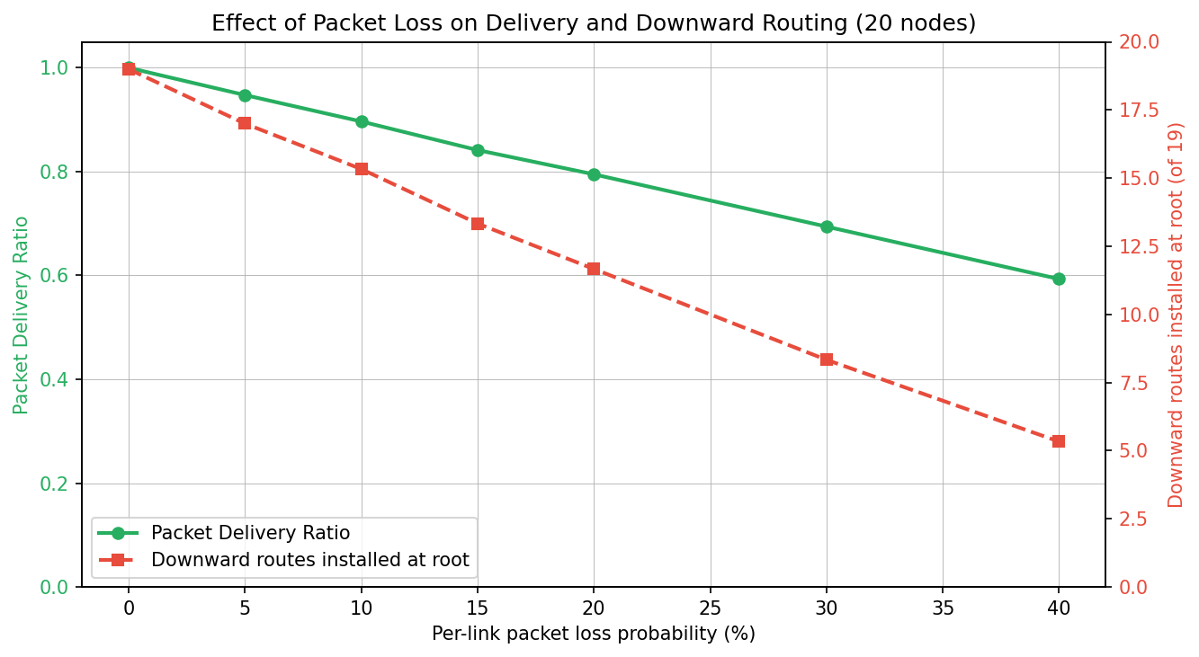
Figure 5. Effect of per-link packet loss on the packet delivery ratio and on the number of downward routes installed at the root (20-node network). Delivery and downward routing both degrade as loss rises.
Downward routing did not fare as well. The number of downward routes installed at the root collapsed from 19 at 0% loss to about 5 at 40% loss; at the highest loss rate, the root had no route to roughly three-quarters of the network. The cause is structural: DAO messages are unicast once toward the preferred parent and are neither acknowledged nor retransmitted in the current implementation. A single lost DAO therefore silently and permanently fails to install a downward route, with no recovery mechanism. Whereas DIO traffic benefits from Trickle’s repetition, DAO traffic has no equivalent protection.
This asymmetry is the most important trade-off observed in the study. RPL, at least as implemented here, keeps the network strongly connected for multipoint-to-point traffic — nodes reporting to the root — even under severe loss, while point-to-multipoint traffic — the root reaching individual nodes — degrades sharply. Closing this gap would require acknowledged, retransmitted DAOs; the DAO-Acknowledgement message needed to do so is defined in RFC 6550 and is already present in the simulator’s message set.

4.6 Local-Repair Recovery Time
[PLACEHOLDER — NO DATA AVAILABLE]
As described in Section 3.9, the simulator implements the local-repair procedure but does not currently trigger it automatically: no link-failure event or parent-timeout watchdog invokes it during a run. Consequently, local-repair recovery time could not be measured in this study, and no data is reported for this metric. To populate this section, the simulator would need to be extended with an explicit link- or node-failure event that invokes the repair procedure, after which recovery time could be measured as the interval between the induced parent loss and successful re-attachment. This extension is identified as future work in Section 5.3.

5 Conclusion

5.1 Summary
This project delivered a customized routing simulator that implements and evaluates the RPL protocol within a SimPy discrete-event framework. The simulator models a wireless network and its nodes as SimPy processes; performs range-based neighbor discovery; constructs and maintains a DODAG through DIO messages and a pluggable objective function (OF0 or MRHOF); supports DIS-based solicitation; governs DIO timing with a faithful implementation of the Trickle algorithm; adopts a route-over architecture with a coherent IPv6 /128 host-addressing plan; and distributes network prefixes through the DODAG using DAO messages in storing mode. The protocol was evaluated against a defined set of LLN-relevant metrics across network sizes from 5 to 80 nodes, packet-loss rates from 0% to 40%, and with the Trickle algorithm both enabled and disabled.

5.2 Key Findings
The evaluation produced four principal findings.
- Correctness and reliability. Every tested configuration achieved full connectivity, with all nodes joining a verified, loop-free DODAG.
- Scalability. Control overhead grows only linearly — and per-node overhead slightly sub-linearly — with network size, and convergence time does not degrade as the network grows.
- Effectiveness of Trickle. The Trickle algorithm reduces DIO control traffic by approximately 70–75%, in exchange for a bounded, one-time convergence delay of a few seconds.
- Robustness asymmetry under loss. Upward routing is self-healing, owing to Trickle’s retransmission of lost DIOs, whereas downward route installation degrades severely because DAO messages are unacknowledged.

5.3 Limitations and Future Work
Several limitations bound the present study and define the natural directions for future work. The most significant is that the local-repair procedure, although implemented, is never triggered; adding an explicit link- or node-failure event and a parent-timeout watchdog would both exercise the existing code and allow the local-repair recovery-time metric to be measured. Second, DAO delivery is unacknowledged; implementing the DAO-Acknowledgement handshake with retransmission would address the downward-routing fragility identified in Section 4.5. Third, the simulator currently models only the RPL control plane and does not generate application data traffic, so end-to-end data latency and goodput cannot yet be measured; adding a data-traffic generator would enable this. Further extensions include global repair through DODAG version increments, support for multiple DODAGs and multiple roots, a more sophisticated wireless channel model incorporating interference and asymmetric links, and node mobility. Finally, a direct comparative study of the two implemented objective functions, OF0 and MRHOF, under identical lossy conditions would quantify the benefit of MRHOF’s link-quality awareness and hysteresis.

6 References
[1] T. Winter, P. Thubert, A. Brandt, J. Hui, R. Kelsey, P. Levis, K. Pister, R. Struik, J. P. Vasseur, and R. Alexander, “RPL: IPv6 Routing Protocol for Low-Power and Lossy Networks,” RFC 6550, Internet Engineering Task Force (IETF), March 2012.
[2] P. Levis, T. Clausen, J. Hui, O. Gnawali, and J. Ko, “The Trickle Algorithm,” RFC 6206, Internet Engineering Task Force (IETF), March 2011.
[3] P. Thubert, “Objective Function Zero for the Routing Protocol for Low-Power and Lossy Networks (RPL),” RFC 6552, Internet Engineering Task Force (IETF), March 2012.
[4] O. Gnawali and P. Levis, “The Minimum Rank with Hysteresis Objective Function (MRHOF),” RFC 6719, Internet Engineering Task Force (IETF), September 2012.
[5] Team SimPy, “SimPy: Discrete-Event Simulation for Python — Documentation,” version 4. [Online]. Available: https://simpy.readthedocs.io/

