Think, Plan, Code
A learner’s guide to algorithms, flowcharts, Scratch and Micro:bit
Grade 8 • Coding • Work on your own or with a partner

How to use this guide
You will learn one big habit: plan first, then code. First you write the steps (an algorithm), then you draw them (a flowchart), then you build them (in Scratch or on the micro:bit). Read a section, then do the activities in the coloured boxes.
KEY IDEA | The big ideas and definitions. Make sure you can say these in your own words.
TAKE NOTES | Stop and write or draw in your exercise book. Good notes help you in class and in tests.
TRY IT | A hands-on activity. Do it on paper or on a computer.
CHECK IT | Self-check questions. Try them first, then look at the answers on pages near the end.
GO FURTHER | Optional extras if you want to learn more.

You will need: a computer with internet, an exercise book, a pencil and a ruler. All the tools are free and run in your browser.

What you will be able to do
Section | By the end, I can…
1. Algorithms | - say what an algorithm is, in my own words;  - write clear steps in the right order;  - explain why planning first means fewer mistakes.
2. Flowcharts | - name the oval, rectangle and diamond and say what each is for;  - draw a flowchart on paper and in draw.io;  - read a flowchart and follow its Yes and No paths.
3. Scratch | - use an event, a loop and a condition in a script;  - turn a flowchart into a Scratch script;  - draw regular shapes using 360 ÷ sides, and fix bugs.
4. MakeCode | - build and test a script in the micro:bit simulator;  - say what is the same and what is different from Scratch.
5. Put it together | - plan, flowchart, code, test and debug a small project on my own.
SECTION 1

Algorithms: a plan before you code

1.1 What is an algorithm?
KEY IDEA Algorithm
An algorithm is an ordered set of steps that solves a problem or gets a job done.

You already use algorithms every day: a recipe, the steps to wash your hands, directions to a friend’s house, or how you get ready for school. A computer follows an algorithm too, but with one big difference: a computer does exactly what it is told and cannot guess what you meant. So the steps must be clear.

A good algorithm…
- has steps in the right order;
- has one action in each step;
- is clear: no vague words like “a bit” or “some”. Say “move 100 steps”;
- has a start and an end;
- works every time someone follows it.

1.2 Why plan before you code?
A bug is a mistake in a plan or in code. If you start coding without a plan, you find missing or unclear steps only after the program goes wrong. If you plan first, you find them on paper, where they are quick and cheap to fix.
TAKE NOTES
- Copy the definition of algorithm in your own words.
- List three algorithms you follow every day (for example: making tea, packing a school bag, logging in to a computer).
- Write one sentence: “Planning first helps because…”

TRY IT The robot classmate
Work with a partner.
- Each of you writes an algorithm for drawing a square on paper. Use numbered steps.
- Swap papers. Your partner is a robot and must do exactly what the steps say, nothing more.
- Circle every step that was missing or unclear (for example “turn” with no direction or angle).
- Rewrite your algorithm to fix the problems.

TRY IT Play the game
Open Sipho’s Morning: An Algorithm Story and help Sipho get to school on time. Every time you choose, you are making a decision in an algorithm. At the end you will see your own flowchart. Keep it: you will use it in Section 2.

CHECK IT Self-check 1
- In your own words, what is an algorithm?
- Why is the step “go forward a bit” a poor step in an algorithm? How could you fix it?
- Give one reason to plan before you code.
Answers are on the answer pages near the end.

GO FURTHER
Computer Science Unplugged (csunplugged.org) has free, offline activities about algorithms. Try one with a friend and write down what you learned.

SECTION 2

Flowcharts: a picture of the plan

2.1 What is a flowchart?
KEY IDEA Flowchart
A flowchart is a picture of an algorithm. It uses shapes joined by arrows to show the steps and the order they happen in.
The algorithm is the plan. The flowchart is the picture of the plan.

A flowchart is not code. It does not look like blocks, and it is not tied to one tool. The same flowchart can be coded in Scratch, on the micro:bit, or in any other language.

2.2 The three symbols
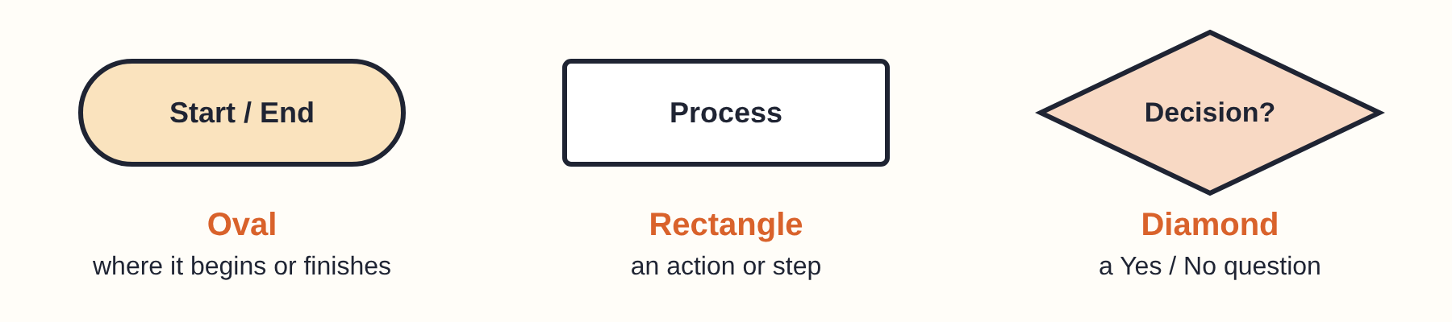
Shape | Name | Use it for…
Oval | Start / End (terminator) | The first and last shape. Write “Start” or “End” inside.
Rectangle | Process | One action or step, for example “Walk to school” or “Move 100 steps”.
Diamond | Decision | A Yes/No question, for example “Is it raining?”. It always has two exits, labelled Yes and No.

Flowchart rules
- Begin with one Start oval and finish with an End oval.
- Read from the top down (or left to right). Arrows show the order.
- Every rectangle has one arrow in and one arrow out.
- Every diamond has one arrow in and two out: Yes and No. Label both.
- Keep the words short: an action word and what it acts on.

2.3 Reading a flowchart
Put a finger on Start and follow the arrows. At a diamond, answer the question and follow the matching arrow.
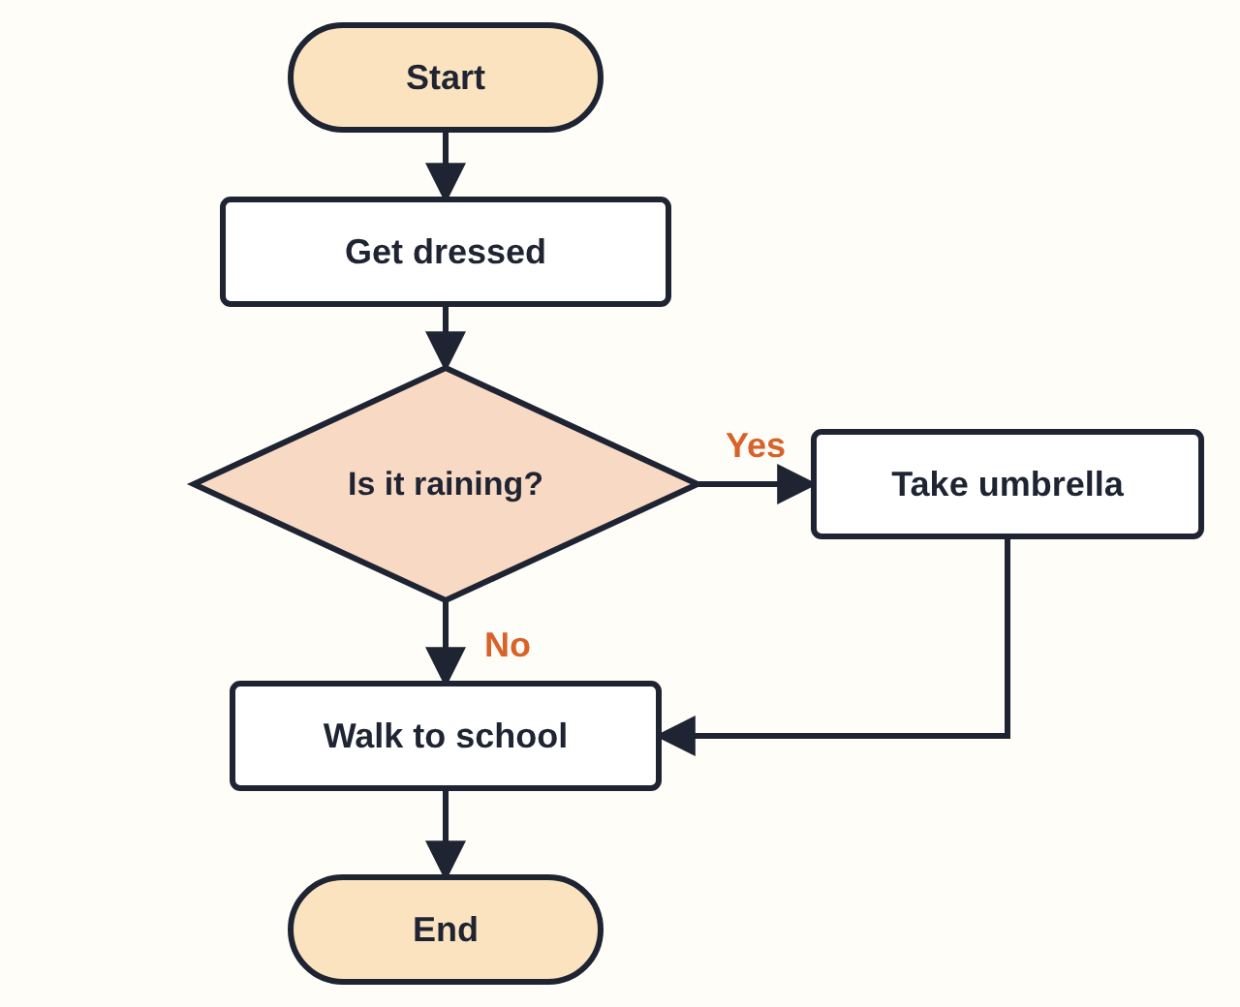
Getting to school: the decision “Is it raining?” gives two paths.
A flowchart can also loop back. In the square flowchart below, the No arrow goes back up to “Move 100 steps”. That arrow is a loop: the steps repeat until the answer to “4 sides drawn?” is Yes.
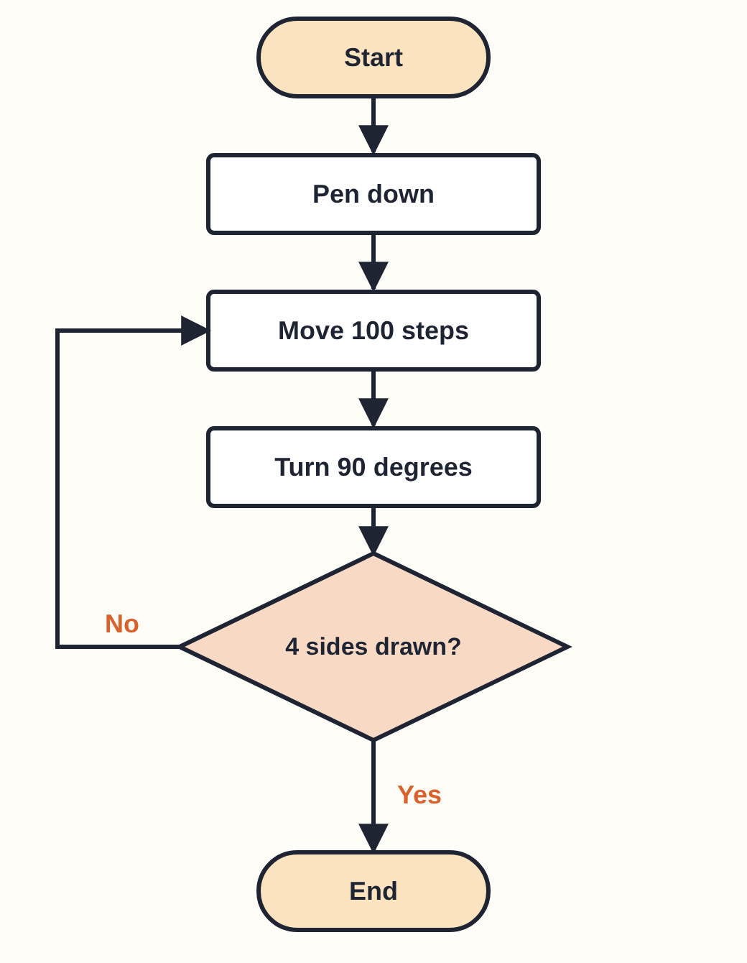
Drawing a square. The No arrow makes the steps repeat.
TAKE NOTES
- Sketch the three symbols and write what each one means.
- Copy the five flowchart rules in your own words.
- Explain in one sentence how a flowchart shows a loop.

2.4 Drawing flowcharts on paper
- Write your algorithm as numbered steps.
- Decide for each step: is it an action (rectangle) or a Yes/No question (diamond)?
- Draw Start, then the shapes in order, using a ruler.
- Join them with arrows. Label every diamond exit Yes or No.
- Test it: trace it with your finger. Can someone else follow it?

2.5 Drawing flowcharts with draw.io (free, online)
draw.io (also called diagrams.net) is a free flowchart tool that works in your browser. Go to app.diagrams.net. You do not need an account.
- Open app.diagrams.net. If it asks where to save, choose Device so the file stays on your computer.
- Choose Create New Diagram, then Blank Diagram, then Create.
- On the left, find the shape groups. If you cannot see Flowchart, click + More Shapes (bottom of the left panel), tick Flowchart and click Apply.
- Drag shapes onto the page: Terminator (or Start) for Start/End, Process for an action, Decision for a Yes/No question.
- Double-click a shape and type its words.
- To join shapes, hover over a shape until small blue arrows appear, then drag a blue arrow to the next shape.
- To label an arrow, double-click the arrow and type Yes or No.
- Save with File → Save. To hand in a picture, use File → Export as → PNG.
TIP
Menus can look a little different on your screen or language. Look for the shape names in the Flowchart group. Use the same fill colour for the same kind of shape so your flowchart is easy to read.

Common mistakes
- Every step is a rectangle, even the questions. (Questions go in diamonds.)
- A diamond with only one exit. (It needs Yes and No.)
- Arrows missing, or no End shape.
- Long sentences inside the shapes.
TRY IT Flowchart practice
- Annotate: take your flowchart from Sipho’s Morning. Label every Start/End, Process and Decision. Choose one decision and write what happens on its Yes path and its No path.
- Your morning: draw a flowchart for getting ready for school with at least one decision (for example “Is it raining?”). Use paper or draw.io.
- Square: draw the flowchart for drawing a square on your own, then compare it with the one in 2.3.
- Compare: swap with a partner. Find where your two flowcharts are different.

CHECK IT Self-check 2
- Match each shape to its job: oval, rectangle, diamond → (a) a Yes/No question, (b) start or end, (c) an action.
- How many exits does a diamond have? What are they labelled?
- In the “Getting to school” flowchart, which steps do you do when it is not raining?
- In the square flowchart, which arrow makes the steps repeat?
- True or false: a flowchart is code. Explain.
- Spot the mistake: a flowchart has “Is the light red?” in a rectangle with one arrow out. What is wrong?

GO FURTHER
Search for “draw.io flowchart tutorial” to see short videos on the tool. Then redraw your morning flowchart with colours and a title.

SECTION 3

Scratch: turning plans into scripts

3.1 Scratch words
Scratch is a free block-based coding tool at scratch.mit.edu. Click Create to start. You build programs by snapping coloured blocks together.
Word | What it means
Stage | The white area where your program runs and your sprite moves.
Sprite | The character or object you control (the cat to begin with).
Block | One instruction. Blocks snap together like puzzle pieces.
Script | A stack of blocks that work together.
Event | Something that starts a script, for example “when green flag clicked” or “when space key pressed”.
Loop | Blocks that repeat the blocks inside them, for example “repeat 4”.
Condition | A true/false test that decides what happens next, for example “touching edge?”. “If … then” runs its blocks only when the test is true.

3.2 From flowchart to Scratch
Your flowchart is the plan; Scratch is where you build it. Each flowchart shape has a matching block idea:
Flowchart | Scratch
Start (oval) | An event block at the top, such as when green flag clicked.
Process (rectangle) | One block, for example move 100 steps or pen down.
Decision (diamond) | An if … then (or if … then … else) block with a true/false test.
A “No” arrow that goes back up | A loop, such as repeat or forever.
End (oval) | The script runs out of blocks and stops.

3.3 Step by step: draw a square with a loop
- Go to scratch.mit.edu and click Create.
- Click the blue Add Extension button (bottom-left) and choose Pen. This gives you the drawing blocks.
- From Events, drag when green flag clicked into the code area.
- From Pen, snap erase all and pen down underneath. (Without pen down, nothing is drawn.)
- From Control, add repeat 10 and change the 10 to 4.
- Put move 10 steps inside the repeat. Change 10 to 100.
- Put turn 15 degrees under it, inside the repeat. Change 15 to 90.
- Click the green flag. You should see a square.
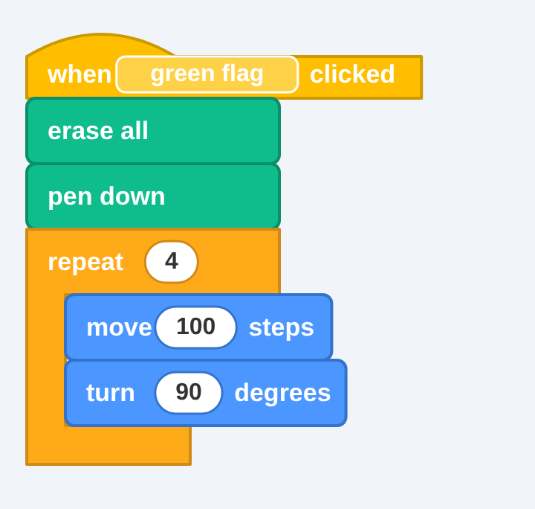
The finished square script.

Why 90? The angle rule
KEY IDEA Turn angle = 360 ÷ number of sides
The repeat number is the number of sides. The turn angle is the angle you turn at each corner: 360 ÷ sides. The move number only changes the size.

Shape | Sides (repeat) | Turn angle | Check
Triangle | 3 | 120 | 360 ÷ 3 = 120
Square | 4 | 90 | 360 ÷ 4 = 90
Pentagon | 5 | 72 | 360 ÷ 5 = 72
Hexagon | 6 | 60 | 360 ÷ 6 = 60
Octagon | 8 | 45 | 360 ÷ 8 = 45

Watch out: the turn is not the inside angle of the shape (a square’s inside angle is 90 but a hexagon’s is 120, not 60). Walk a square in the classroom: at each corner you turn 90 degrees. The turn is the outside angle.

3.4 Events and conditions: a bouncing sprite
Blocks left loose in the code area do nothing, because no event starts them. Every script needs an event at the top.
An if block checks its condition once each time it is reached. To keep checking, put it inside a loop. In this script the sprite keeps moving, and every time it touches the edge it turns around:
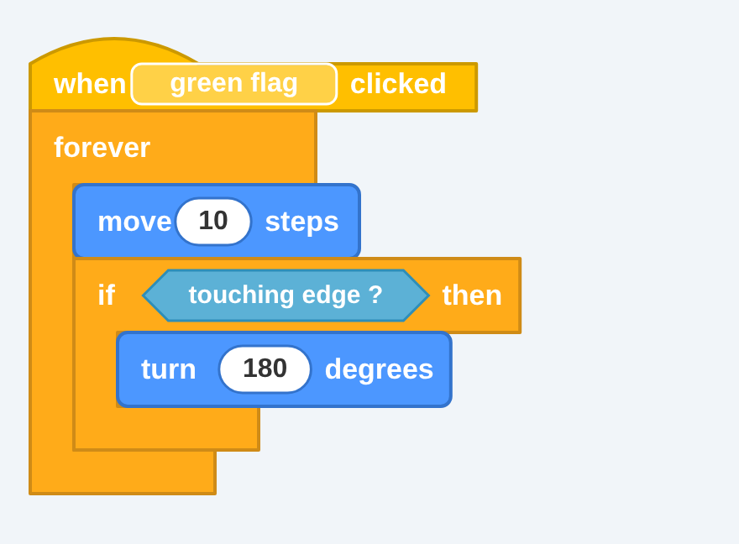
“forever” keeps checking the condition. Find touching in Sensing and choose “edge”.
TIP
Where to find the blocks: when green flag clicked (Events), forever and if then (Control), move and turn (Motion), touching … ? (Sensing).

3.5 Fixing bugs (debugging)
KEY IDEA Debug
To debug is to find and fix mistakes in your code. Change one thing at a time and test again.

- Read your script from the top, like an algorithm. Does it match your flowchart?
- Is there an event block at the top?
- Is pen down in the script?
- Is the angle right (360 ÷ sides)?
- Is the if inside the loop?
TAKE NOTES
- Write one sentence each for event, loop and condition, with an example from Scratch.
- Write the steps for adding the Pen extension.
- Copy the angle rule and the table for triangle, square, hexagon.

TRY IT Scratch practice
- Square: build the script in 3.3 and make it work.
- Triangle and hexagon: change the numbers. Fill in the repeat and angle for each, then test.
- Debug: this script should draw a hexagon but it does not close. Find the bug and fix it.
- Bounce: build the bouncing sprite. Then add “if touching edge then change colour effect” as an extra.
- Extension: draw a star with repeat 5 and turn 144. Why does 360 ÷ sides not work for a star? Add a comment about your rule.

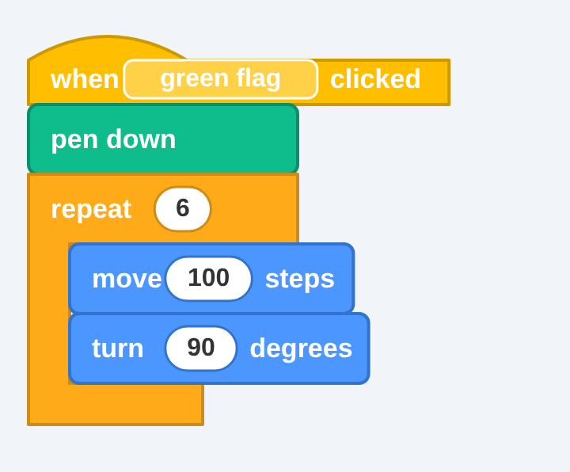
Script for the debug activity.
CHECK IT Self-check 3
- What is the difference between an event and a condition?
- What are the repeat number and turn angle for an octagon?
- The hexagon script above uses turn 90. What should it be?
- A learner built a script but nothing happens when they click the green flag. What is the most likely problem?
- Why must “if touching edge” be inside the forever loop?
- Which Scratch block does a flowchart decision become?
- What changes if you change “move 100” to “move 150” in the square?

GO FURTHER
At scratch.mit.edu/ideas you will find step-by-step tutorials. The Scratch Wiki (en.scratch-wiki.info) explains every block.

SECTION 4

MakeCode and the micro:bit

4.1 What is a micro:bit?
The micro:bit is a tiny, pocket-sized computer made for learning to code. It has a grid of 25 red LEDs (5 rows and 5 columns), two buttons (A and B) and some sensors. MakeCode is a free block-coding website for it at makecode.microbit.org. It has a simulator: a virtual micro:bit on your screen, so you do not need the real device.
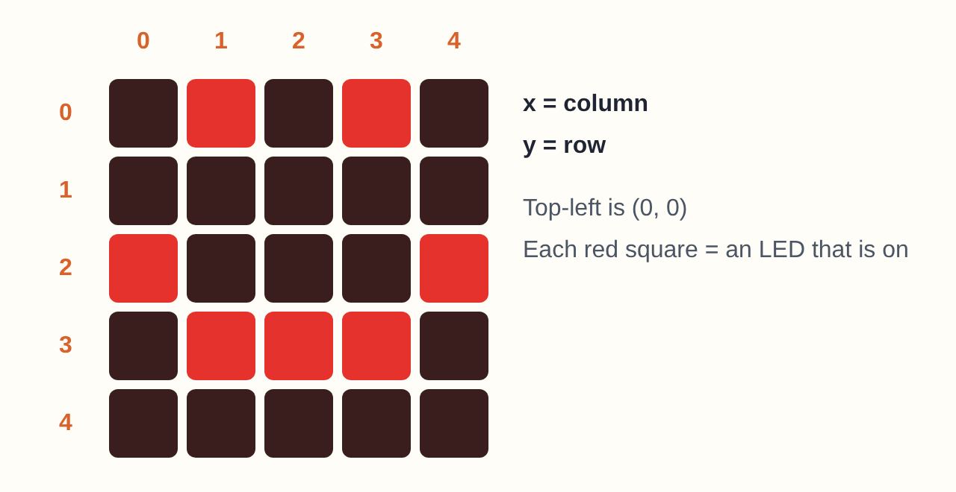
The 5×5 LED grid. This pattern is a happy face.

4.2 Getting started
- Go to makecode.microbit.org.
- Click New Project, type a name and click Create.
- You will see the simulator (the virtual micro:bit), the toolbox (lists of blocks) and the workspace where you build.
- Open a toolbox group and drag blocks into the workspace so they snap together.
- The simulator runs your code straight away. Click the A and B buttons on the virtual micro:bit to test.
- Use the Save button to keep your project.
TIP Where to find blocks
- Input: on button A pressed
- Basic: show icon, show leds, show number, pause (ms)
- Loops: repeat 4 times
- Logic: if … then … else

4.3 Same ideas, different tool
If you can do it in Scratch, you can do it on the micro:bit. The algorithm is the same; only the tool changes.
Idea | Scratch | micro:bit (MakeCode)
Event | when green flag clicked | on button A pressed
Loop | repeat 4 | repeat 4 times
Condition | if … then | if … then (Logic)
Movement | move 100 steps, turn 90 degrees | forward, turn right (your teacher will show you where to find these in the simulator)
Output | The stage and sprite | The 5×5 LED grid

4.4 Step by step: happy face and sad face
- In Input, drag on button A pressed into the workspace.
- In Basic, drag show icon inside it. Click the icon and choose a happy face.
- Do the same for button B and choose a sad face.
- For a third state, add another “on button pressed” block and use the drop-down to choose A+B. Choose a neutral face.
- Test all three in the simulator.
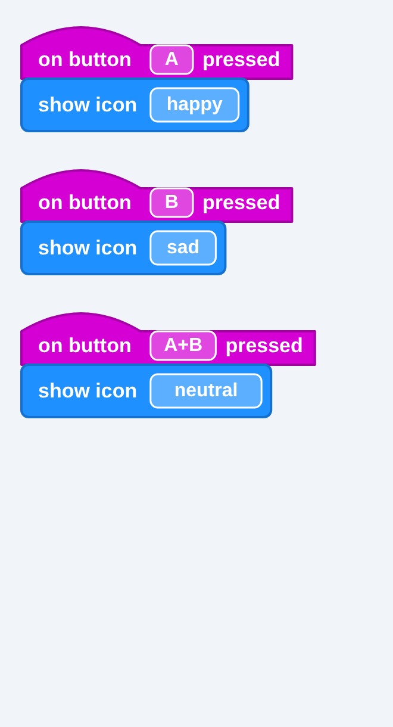
Three events, three faces. Each button shows a different pattern.
You can also draw your own picture with show leds: click the squares to turn LEDs on and off.

4.5 A shape on the micro:bit
Plan with the same algorithm you used in Scratch: repeat 4 times, move forward, turn 90. For a triangle use repeat 3 and turn 120.
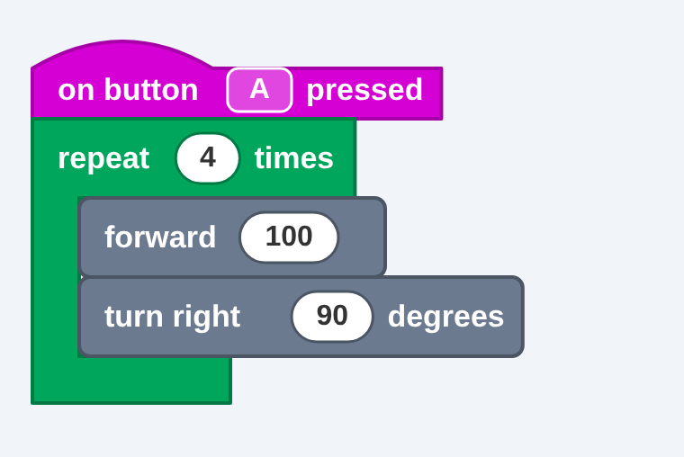
Example layout. Your simulator’s movement blocks may look a little different.
TIP
On a 5×5 grid a triangle may look rough. What matters is that your numbers are right (repeat 3, turn 120), not how neat the picture is.

4.6 Fixing bugs on the micro:bit
Test every button in the simulator. If pressing A shows the sad face when you wanted the happy one, the two patterns (or the two buttons) are swapped. Swap them back and test again.
TAKE NOTES
- Write the steps for starting a new MakeCode project.
- Copy the Scratch vs micro:bit table in your own words.
- Note which toolbox group each block comes from.

TRY IT micro:bit practice
- Faces: build the happy (A), sad (B) and neutral (A+B) script.
- Debug: swap the happy and sad patterns on purpose, then fix them.
- Shape: build a square on button A, then a triangle on button B.
- Plan first: on paper, plan and draw a flowchart for a script with a third state, then build it.
- Loop it: can you shorten the triangle script with a loop (6 blocks become 3)? Write why a loop is better.

CHECK IT Self-check 4
- Name two things that are the same in Scratch and on the micro:bit.
- Name one thing that is different.
- Which block makes button A show a happy face?
- Pressing A shows the sad face but should show the happy face. How do you fix it?
- Why might a triangle look rough on the LED grid, and what should you check instead?

GO FURTHER
On the makecode.microbit.org home page, try one of the Tutorials. The micro:bit support site (support.microbit.org) has guides for the real device.

SECTION 5

Plan, flowchart, code
Now you put everything together. Follow the same four steps every time:
# | Step | What you do
1 | Algorithm | Write numbered, clear steps on a planning sheet.
2 | Flowchart | Draw it with the right symbols. Include a loop and a decision where they make sense.
3 | Code | Build it in Scratch or MakeCode. Your script needs an event, a loop and a condition.
4 | Test and debug | Run it, compare it with the flowchart, and fix one thing at a time.

Worked example: a countdown from 3 to 1
Challenge: when button A is pressed, the micro:bit counts down 3, 2, 1 on the LEDs.
1. Algorithm: (1) start; (2) show 3; (3) pause 1 second; (4) show 2; (5) pause 1 second; (6) show 1; (7) end.
2. Flowchart and 3. Code: the flowchart on the left matches the script on the right, block for block.
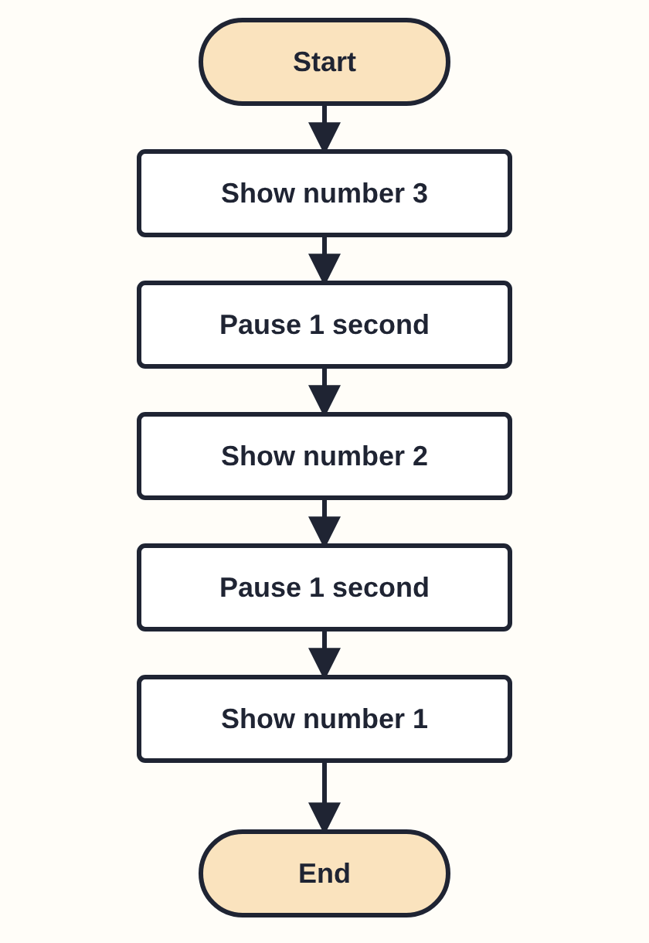 | 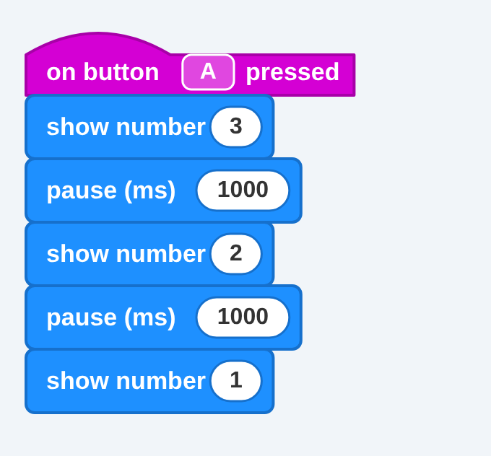
4. Test and debug: press A in the simulator. Does it show 3, then 2, then 1? If the numbers go by too fast, check the pause values: 1000 ms is 1 second.
Improve it: this plan has no loop and no decision yet. Where could you add one? For example, “repeat” could count down on its own, or an “if button B pressed” could stop it.
TRY IT Your challenge
Your teacher will give you a challenge card. Some ideas: a star in Scratch (repeat 5, turn 144), a bouncing ball in Scratch, a traffic light on the micro:bit (red, green, amber with pauses), or a shape plus smiley on the micro:bit. Follow the four steps and use this checklist:
☐ My algorithm is complete, in order and clear.
☐ My flowchart uses the right symbols, with a loop and a decision.
☐ My script runs and matches my flowchart.
☐ My script has an event, a loop and a condition.
☐ I can explain why I made each choice.

TAKE NOTES Reflect
Write three sentences: (1) what your plan got right, (2) one bug you found and how you fixed it, (3) what you would plan differently next time.

CHECK IT Self-check 5
- Put these in order: code, flowchart, test and debug, algorithm.
- Which flowchart symbols does the countdown use? Does it have a decision?
- Why compare your script with your flowchart when something goes wrong?

SECTION A

Answers to the CHECK IT questions
Try the questions first. Then check, and fix anything you got wrong.

Self-check 1: Algorithms
- An ordered set of steps that solves a problem or gets a job done.
- It is vague: a computer cannot guess how far. Fix it by being exact, for example “move 100 steps”.
- Planning finds missing or unclear steps before coding, so there are fewer bugs.

Self-check 2: Flowcharts
- Oval → (b) start or end; rectangle → (c) an action; diamond → (a) a Yes/No question.
- Two exits, labelled Yes and No.
- Get dressed, then walk to school (you skip “Take umbrella”).
- The No arrow from “4 sides drawn?” back to “Move 100 steps”.
- False. A flowchart is a plan in pictures. The same flowchart can be coded in Scratch, on the micro:bit or in another tool.
- A question must be a diamond with two exits (Yes and No), not a rectangle with one arrow.

Self-check 3: Scratch
- An event starts a script. A condition is a true/false test that decides what happens next.
- Repeat 8, turn 45 (360 ÷ 8).
- 60 (360 ÷ 6).
- There is no event block (“when green flag clicked”) at the top of the script.
- An if block checks its condition only once each time it is reached. Inside forever, it is checked again and again.
- An if … then (or if … then … else) block.
- The square gets bigger. It is still a square, because only the move number changes the size.
Practice answers: triangle = repeat 3, turn 120; hexagon = repeat 6, turn 60; star = repeat 5, turn 144 (a star skips corners, so the rule 360 ÷ sides does not apply).

Self-check 4: MakeCode
- Any two: events (green flag / button A), loops (repeat), movement (move/turn and forward/turn), and the algorithm itself.
- The micro:bit has a 5×5 LED grid instead of a stage, and physical buttons.
- on button A pressed → show icon (happy).
- Swap the two patterns (or the two buttons) so A shows happy.
- The grid is only 5×5, so shapes look rough. Check the numbers: repeat 3, turn 120.

Self-check 5: Put it together
- Algorithm, flowchart, code, test and debug.
- Start/End ovals and rectangles (actions). It has no decision yet.
- Your flowchart is your plan. Comparing shows you exactly where the script differs from it.
SECTION B

Glossary
Term | Meaning
Algorithm | An ordered set of steps that solves a problem or gets a job done.
Arrow (flow line) | Shows which step comes next in a flowchart.
Block | One coloured instruction in Scratch or MakeCode that snaps to others.
Bug | A mistake in a plan or in code.
Button (A, B) | A physical button on the micro:bit. Pressing it can start a script.
Condition | A true/false test that decides what happens next.
Debug | To find and fix bugs.
Decision (diamond) | A flowchart shape holding a Yes/No question, with two exits.
Event | Something that starts a script, such as a green flag click or a button press.
Exterior (turn) angle | The angle you turn at each corner of a shape: 360 ÷ sides.
Flowchart | A picture of an algorithm using shapes and arrows.
If … then (else) | A block that runs blocks only when a condition is true (and something else when it is false).
LED | A small light. The micro:bit has a 5×5 grid of 25 LEDs.
Loop | Blocks that repeat the steps inside them.
MakeCode | A free block-coding website for the micro:bit.
Micro:bit | A tiny computer for learning to code, with LEDs, two buttons and sensors.
Process (rectangle) | A flowchart shape for one action or step.
Repeat | A loop block that runs the blocks inside it a set number of times.
Script | A stack of blocks that work together.
Simulator | A virtual micro:bit on your screen, so you do not need the real one.
Sprite | The character or object you control in Scratch.
Stage | The area in Scratch where your program runs.
Start / End (oval) | The first and last flowchart shapes (also called terminators).

Further reading and tools
- Sipho’s Morning: An Algorithm Story: vissitingliam.github.io/sipho-algorithm-story: play again and make different choices.
- draw.io / diagrams.net: app.diagrams.net: free flowcharts in your browser.
- Scratch: scratch.mit.edu (and scratch.mit.edu/ideas for tutorials); Scratch Wiki: en.scratch-wiki.info.
- MakeCode for micro:bit: makecode.microbit.org (try the Tutorials); support.microbit.org for the real device.
- Computer Science Unplugged: csunplugged.org: offline activities about algorithms.
Web pages change. If a link has moved, search for the name or ask your teacher.

