Grade 8 Coding / Digital Technology

Grade : 8
Subject : Coding / Digital Technology
Topic : Algorithms and Flowcharts
Duration : 30 minutes

Total: 20 marks
Name: ______________________ Date: ____________ Mark: ______ / 20

Instructions
- Answer all questions.
- Write clearly and show your understanding.
- For the flowchart activity, use the correct symbols and arrows.

Activity 1

1.1. What is an algorithm? (1)
1.2. What does an oval represent in a flowchart? (1)
1.3. Which flowchart symbol represents an action or process? (1)
1.4. What does a diamond represent? (1)
1.5. Give one reason why we should plan before coding. (1)
[5]

Activity 2: Complete the Flowchart
A learner wants to draw a square using Scratch. The algorithm must start, draw four sides, check whether four sides have been completed, repeat if necessary and end.
Use these steps to complete or redraw the flowchart: Start → Put pen down → Have 4 sides been drawn? → If No, move 100 steps and turn 90°, then return to the decision. If Yes, End.
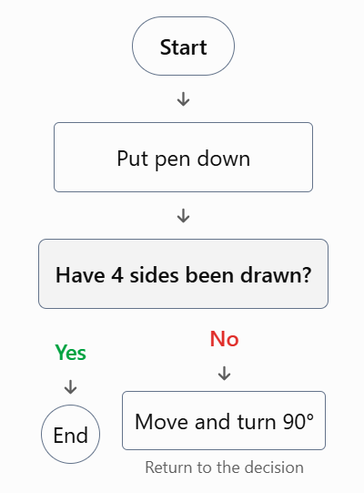
2.1. Which symbol represents Start and End? (1)
2.2. Which symbol represents “Put pen down”? (1)
2.3. Which symbol represents the question about four sides? (1)
2.4. What should happen if the answer is No? (1)
2.5. Why must the flowchart use arrows? (1)
[5]

Activity 3: Find and Correct the Error
A learner writes this algorithm to draw a square:
- Start.
- Repeat 4 times.
- Move 100 steps.
- Turn 60 degrees.
- End.

3.1. Identify the mistake. (1)
3.2. What should the turning angle be? (1)
3.3. How many times should the instructions repeat? (1)
3.4. What is the purpose of the repeat loop? (1)
3.5. What should the learner check if the square does not close? (1)
[5]

Activity 4: Exit Ticket
Draw a simple flowchart for brushing your teeth. Include Start, at least one Process step and End.
Criterion | Marks
Correct Start symbol | 1
Correct Process symbol | 1
Correct End symbol | 1
Steps in logical order with arrows | 1
Flowchart complete and understandable | 1
Total | 5

